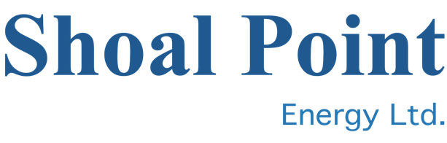
July 4, 2022 CSE: SHP

Production casing set in third Pratt County well

Vancouver BC – Mark Jarvis, CEO of Shoal Point Energy Ltd. (CSE – SHP), announced today that operator Shelby Resources has installed production casing on the joint venture’s third well in Pratt County, the N-S Unit #1, and that an attempt will be made to complete the well as a commercial producer.
“Logs and drill stem tests are encouraging,” said Mr. Jarvis. “The completion program is being designed and we will move in to complete and equip the well after giving the cement 10 – 14 days to cure.”
The operator expects to spud a fourth well in the Pratt County area in late July.

About Shoal Point Energy Ltd.

Shoal Point Energy Ltd. is a public company listed on the CSE exchange under the symbol “SHP”. The company is focused on oil and gas exploration in Kansas and retains its oil and gas interests in the Humber Arm Allochthon play in western Newfoundland. The company is also actively evaluating new opportunities.

For further information, please contact:
Mr. Mark Jarvis, Chief Executive Officer
Tel: 416-637-2181 extension 310

The Canadian Securities Exchange (CSE) has neither approved nor disapproved the contents of this news release.

