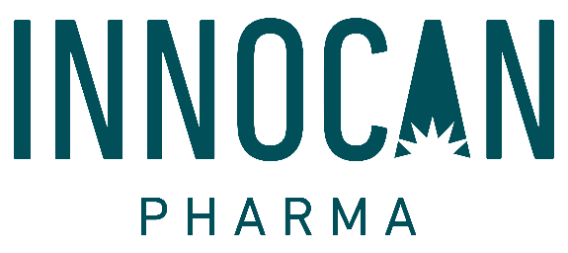

Innocan Pharma completes its Trademark registration in the EU, UK and Switzerland

Herzliya, Israel and Calgary, Alberta - (December 10, 2020) - Innocan Pharma Corporation (CSE: INNO) (FSE: IP4) (OTC:INNPF) (the “Company” or “Innocan”), is pleased to announce the completion of the registration of its trademarks: Innocan Pharma, Relief & Go and SHIR in the EU, UK and Switzerland. These trademarks represent Innocan's OTC and derma cosmetic brand products that were recently launched in the German and UK markets.
“We are excited to have a Registered Trademark for our Brands in time to allow us to initiate the sales effort in the EU, UK and Switzerland”, says Iris Bincovich, Founder and CEO of Innocan, “This is another way that we have added value to the Company that will be recognized in 2021".
www.facebook.com/Innocanpharma
https://www.instagram.com/theinnocanpharma/
About Innocan
The Company, through its wholly owned Israeli subsidiary, Innocan Pharma Ltd. (“Innocan Israel”), is a pharmaceutical tech company that focuses on the development of several drug delivery platforms combining cannabidiol (“CBD”). Innocan Israel and Ramot at Tel Aviv University are collaborating on a new, revolutionary exosome-based technology that targets both central nervous system (CNS) indications and the Covid-19 Corona Virus using CBD. CBD-loaded exosomes hold the potential to help in the recovery of infected lung cells. This product, which is expected to be administrated by inhalation, will be tested against a variety of lung infections.
Innocan Israel signed a worldwide exclusive license agreement with Yissum, the commercial arm of the Hebrew University of Jerusalem to develop a CBD drug delivery platform based on a unique-controlled release liposome to be administrated by injection. Innocan Israel plans, together with Professor Berenholtz, Head of the Laboratory of Membrane and Liposome Research of the Hebrew University, to test the liposome platform on several potential indications. Innocan Israel is also working on a dermal product that integrates CBD with other pharmaceutical ingredients as well as the development and sale of CBD-integrated pharmaceuticals, including, but not limited to, topical treatments for relief of psoriasis symptoms as well as the treatment of muscle pain and rheumatic pain. The founders and officers of Innocan have commercially successful track records in the pharmaceutical and technology sectors in Israel and globally.
For further information, please contact:
For Innocan Pharma Corporation:
Iris Bincovich, CEO
+972-54-3012842
info@innocanpharma.com
NEITHER THE CANADIAN SECURITIES EXCHANGE NOR ITS REGULATION SERVICES PROVIDER HAVE REVIEWED OR ACCEPT RESPONSIBILITY FOR THE ADEQUACY OR ACCURACY OF THIS RELEASE.
Caution regarding forward-looking information
Certain information set forth in this news release, including, without limitation, information regarding the markets, requisite regulatory approvals and the anticipated timing for market entry, is forward-looking information within the meaning of applicable securities laws. By its nature, forward-looking information is subject to numerous risks and uncertainties, some of which are beyond Innocan's control. The forward-looking information contained in this news release is based on certain key expectations and assumptions made by Innocan, including expectations and assumptions concerning the anticipated benefits of the products, satisfaction of regulatory requirements in various jurisdictions and satisfactory completion of requisite production and distribution arrangements.
Forward-looking information is subject to various risks and uncertainties which could cause actual results and experience to differ materially from the anticipated results or expectations expressed in this news release. The key risks and uncertainties include but are not limited to: general global and local (national) economic, market and business conditions; governmental and regulatory requirements and actions by governmental authorities; and relationships with suppliers, manufacturers, customers, business partners and competitors. There are also risks that are inherent in the nature of product distribution, including import / export matters and the failure to obtain any required regulatory and other approvals (or to do so in a timely manner) and availability in each market of product inputs and finished products. The anticipated timeline for entry to markets may change for a number of reasons, including the inability to secure necessary regulatory requirements, or the need for additional time to conclude and/or satisfy the manufacturing and distribution arrangements. As a result of the foregoing, readers should not place undue reliance on the forward-looking information contained in this news release concerning the timing of launch of product distribution. A comprehensive discussion of other risks that impact Innocan can also be found in Innocan's public reports and filings which are available under Innocan's profile at www.sedar.com.
Readers are cautioned that undue reliance should not be placed on forward-looking information as actual results may vary materially from the forward-looking information. Innocan does not undertake to update, correct or revise any forward looking information as a result of any new information, future events or otherwise, except as may be required by applicable law.

