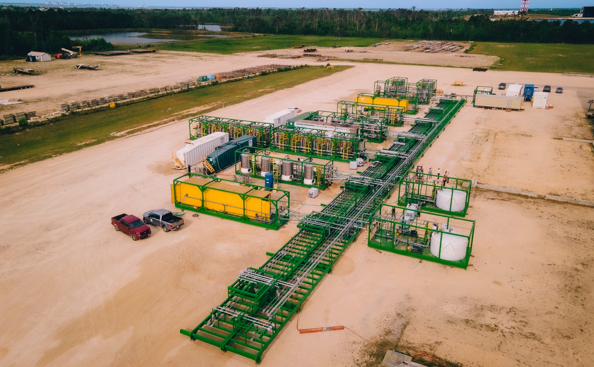

IBAT Engages SLR to Validate Lithium Recovery for Modular, Mobile Lithium Plant
First-of-its-Kind Commercial-Scale Plant Has Been Extracting Lithium Since May

VANCOUVER, BC, June 28, 2022 /PRNewswire/ - International Battery Metals Ltd. (the "company") (CSE: IBAT) (OTC: IBATF) today announced that it has engaged SLR International Corporation (SLR) to review and validate the processes and lithium recovery results from its first-of-its-kind modular, mobile lithium extraction plant, currently operating in Lake Charles, Louisiana.

The modular plant has been flow-testing lithium-bearing brine since early May, and extracting lithium chloride (LiCl) since mid-May, making IBAT the first company globally to successfully operate a commercial-scale mobile lithium extraction plant. The brine is sourced in the U.S. and is being delivered in significant volume via tanker truck.

SLR is a global leader in environmental and advisory solutions with a team of more than 2,300 professionals offering strategic advice and technical solutions from a network of over 100 offices in Europe, the US, Latin America, Canada, Asia-Pacific, and Africa. SLR specializes in energy, mining and minerals, infrastructure, built environment, manufacturing and industry, financial services, and power sectors.

“We are pleased to be working with a team as experienced, technically innovative and globally-renowned as SLR to assess our processes and review our results,” said IBAT CEO Dr. John Burba. “From the design stage, our goal has been to create a Mobile Direct Lithium Extraction (MDLE) technology that is environmentally superior to any technology currently in operation, yet able to achieve commercial scale and superior lithium recovery at a vastly lower cost. We believe this modular plant represents that evolution and third-party validation of our results is a key milestone in that journey.”

SLR is expected to begin its review and assessment later this summer.

The unique modular design of the company's lithium extraction plant allows for rapid deployment and swift onsite assembly. As currently configured in Lake Charles, the plant has the potential to produce 5,000 metric tons of commercial-grade lithium chloride on a lithium carbonate equivalent basis, each year. Thanks to its modular design, this same plant also has the potential to be expanded to produce up to 20,000 metric tons of LiCl per year, based on the capacity and composition of the brine resource.

The Lake Charles plant completed a full range of Factory Acceptance Tests (FAT) in early May, which evaluated the equipment during and after the assembly process by verifying that it is built and operating in accordance with all design specifications.

IBAT anticipates that its patented modular and mobile design will allow access and a means to capitalize on a more diverse range of lithium-bearing brine resources, including smaller sites in varied terrain – including in the US – that are currently considered uneconomical due to the current, dominant extraction technologies. Its sustainable environmental performance is also poised to enable the creation of a thriving, clean lithium extraction industry in the US now and into the future.

“We believe that our modular plant technology, which can be built, deployed and brought on-line in a fraction of the time of traditional lithium mining plants and at a fraction of the price, can be an important step forward in lithium supply security in North America,” Dr. Burba said.

###

Neither Canadian Securities Exchange nor its Regulation Services Provider (as that term is defined in the policies of the Canadian Securities Exchange) accepts responsibility for the adequacy or accuracy of this release.

This news release may contain assumptions, estimates, and other forward-looking statements regarding future events. Such forward-looking statements involve inherent risks and uncertainties and are subject to factors, many of which are beyond the Company's control that may cause actual results or performance to differ materially from those currently anticipated in such statements.

Forward–looking and cautionary statements
This press release shall not constitute an offer to sell or the solicitation of an offer to buy any securities, nor shall there be any sale of securities in any state in the United States in which such offer, solicitation or sale would be unlawful. Any securities of the Company referred to herein have not been and will not be registered under the United States Securities Act of 1933, as amended, and may not be offered or sold in the United States absent registration or an applicable exemption from registration requirements. This release may contain statements within the meaning of safe harbour provisions as defined under securities laws and regulations.

This release may contain certain forward–looking statements with respect to the financial condition, results of operations and business of the Company and certain of the plans and objectives of the Company with respect to the same. There is no assurance that the company's apparatus will be able to commercially produce lithium at the stated capacity. The purpose of the tests is to determine if it will be able to do so and successful completion of the tests cannot be assured as they are subject to risks and uncertainties associated with any new mineral processing method and characteristics of the material being processed.

By their nature, forward–looking statements involve risk and uncertainty because they relate to events and depend on circumstances that will occur in the future and there are many factors that could cause actual results and developments to differ materially from those expressed or implied by these forward–looking statements.

