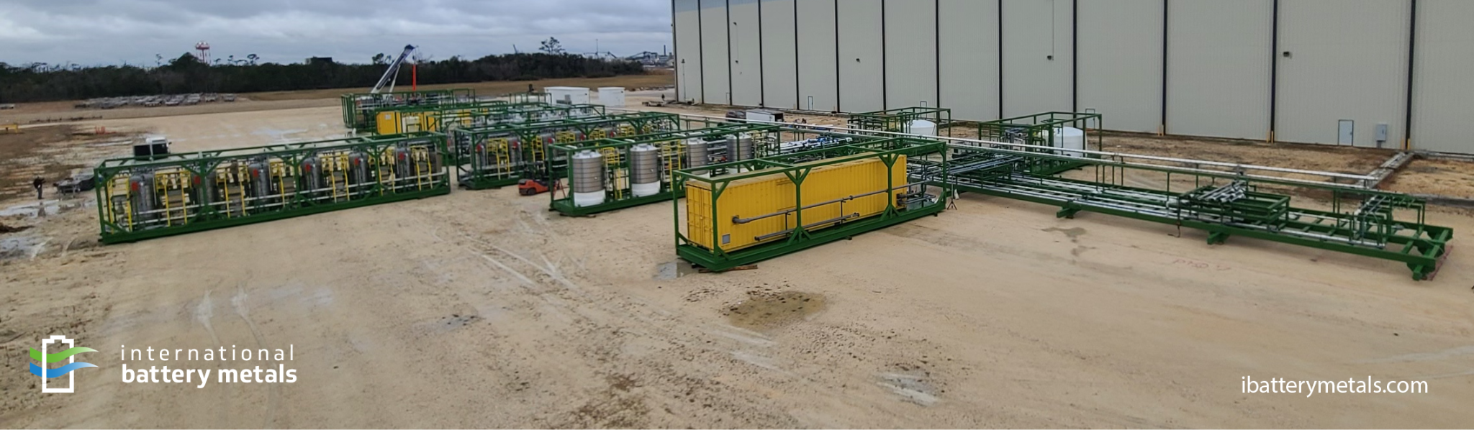

INTERNATIONAL BATTERY METALS LTD. ANNOUNCES ASSEMBLY OF COMMERCIAL LITHIUM EXTRACTION PLANT

Vancouver, British Columbia, Canada – March 14, 2022 - International Battery Metals Ltd. (the “Company”) (CSE: “IBAT”) (OTC: IBATF), is pleased to announce the successful assembly of the first commercial-scale, Mobile Lithium Extraction Plant.

Chief Executive Officer, John Burba, Ph.D., unveiled and explained the versatility of the Company’s assembled plant to a group of interested parties during a site visit in Lake Charles, Louisiana, directly following Dr. Burba’s presentation at the BMO Capital Markets 31st Global Metals & Mining Conference held at the end of February. The plant is currently undergoing factory acceptance testing and once completed it will begin brine acceptance testing and producing lithium-chloride (LiCl).

“Not only have we developed patented, proprietary technology that allows for the rapid extraction of lithium-chloride, but our system uses virtually no chemicals allowing for minimal production of wastewater,” stated Dr. John Burba. “Our holistic approach sets a new standard of environmental care which we are calling ‘Rapid, Ethical Lithium Production.’”

The unique modular design of the Company’s lithium extraction plant allows for rapid plant deployment and onsite assembly. The plant, currently being tested in Louisiana, was assembled in an astonishing ten-day period by a small, nine-man crew, demonstrating the versatility of the plant's design and the feasibility of moving the plant between multiple lithium-bearing brine resources. An official time-lapse video of the plant assembly can be viewed here.

While the Company’s technology represents a novel application of a proprietary, patented process, the fundamentals of the direct lithium extraction (DLE) process are proven and have been implemented for decades at FMC’s operation in Argentina, which was designed by Dr. John Burba.

“I am particularly excited about this innovation to DLE,” stated Dr. John Burba. “This modular plant demonstrates a fundamental advancement on the initial DLE patents I filed with Dr. Bauman in the 1980s and 1990s, and commercialized through FMC in the 1990s.”

The Company is anticipating that its patented design will allow access and a means to capitalize on diverse lithium-bearing brine resources. The current plant is capable of producing 5,000 metric tons of commercial-grade LiCl, on a lithium carbonate equivalent basis, each year. The same plant can be quickly expanded to produce up to 20,000 metric tons of LiCl per year, based on the capacity and unique composition of the brine resource.

To learn more about International Battery Metals’ innovative approach to ecologically responsible and sustainable lithium extraction, visit ibatterymetals.com.

ON BEHALF OF THE BOARD

“Dr. John Burba”

Dr. John Burba, CEO & Chairman of the Board of Directors

Neither Canadian Securities Exchange nor its Regulation Services Provider (as that term is defined in the policies of the Canadian Securities Exchange) accepts responsibility for the adequacy or accuracy of this release.

This news release may contain assumptions, estimates, and other forward-looking statements regarding future events. Such forward-looking statements involve inherent risks and uncertainties and are subject to factors, many of which are beyond the Company's control that may cause actual results or performance to differ materially from those currently anticipated in such statements.

Forward‐looking and cautionary statements
This press release shall not constitute an offer to sell or the solicitation of an offer to buy any securities, nor shall there be any sale of securities in any state in the United States in which such offer, solicitation or sale would be unlawful. Any securities of the Company referred to herein have not been and will not be registered under the United States Securities Act of 1933, as amended, and may not be offered or sold in the United States absent registration or an applicable exemption from registration requirements. This release may contain statements within the meaning of safe harbour provisions as defined under securities laws and regulations.

This release may contain certain forward‐looking statements with respect to the financial condition, results of operations and business of the Company and certain of the plans and objectives of the Company with respect to the same. There is no assurance that the company’s apparatus will be able to commercially produce lithium at the stated capacity. The purpose of the tests is to determine if it will be able to do so and successful completion of the tests cannot be assured as they are subject to risks and uncertainties associated with any new mineral processing method and characteristics of the material being processed.

By their nature, forward‐looking statements involve risk and uncertainty because they relate to events and depend on circumstances that will occur in the future and there are many factors that could cause actual results and developments to differ materially from those expressed or implied by these forward‐looking statements.

