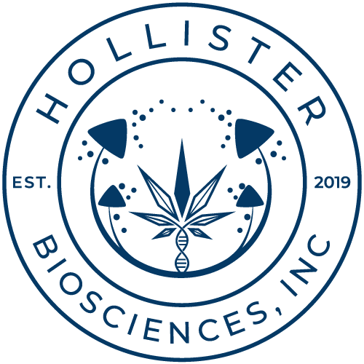

Hollister Provides Comment on Approval of Recreational Cannabis in Arizona

Vancouver, BC, November 4th, 2020 - Hollister Biosciences Inc. (CSE: HOLL) (OTC: HSTRF) (FRANKFURT: HOB) (the "Company", "Hollister Cannabis Co." or "Hollister") a diversified cannabis branding company with products in over 280 dispensaries throughout California, and over 80 dispensaries throughout Arizona provides comment on the successful passage of Proposition 207 – legalizing the cultivation, sale and consumption of recreational cannabis in the state of Arizona.

“Seeing recreational Cannabis legalized in the state is an encouraging sign and is hopefully another step toward federal legalization. It should lead to increased tax revenue and job creation. The recreational cannabis market in Arizona could be valued at up to US $760 million by 2024¹, significantly expanding the total addressable market for Cannabis in the state. We look forward to making our product line available to both the medical and recreational end user.” Shared Jacob Cohen, Founder of Venom Extracts, Hollister’s 100% owned subsidiary based in Arizona.

Arizona Presence

Hollister, through its 100% owned subsidiary, Venom Extracts (“Venom”), is one of Arizona’s premier extract brands and one of the state’s largest producers of award-winning medical cannabis distillate and related products. With an experienced management team and unparalleled reputation for quality, Venom prides itself as a differentiated extraction company by producing legal cannabis products at a price point that allows retailers to generate higher profits. Focused on proprietary efficiencies, Venom is able to produce more product per square foot than its competition, maintaining lower costs and risks than a typical extraction company.

Website: www.venomextracts.com

About Hollister Biosciences Inc.

Hollister Biosciences Inc. is a multi-state cannabis company with a vision to be the sought-after premium brand portfolio of innovative, high-quality cannabis & hemp products. Hollister uses a high margin model, controlling the whole process from manufacture to sales to distribution or seed to shelf. Products from Hollister Biosciences Inc. include HashBone, the brand’s premier artisanal hash-infused pre-roll, along with concentrates (shatter, budder, crumble), distillates, solvent-free bubble hash, pre-packaged flower, pre-rolls, tinctures, vape products, and full-spectrum high CBD pet tinctures. Hollister Cannabis Co. additionally offers white-labeling manufacturing of cannabis products. Our wholly owned California subsidiary Hollister Cannabis Co is the 1st state and locally licensed cannabis company in the city of Hollister, CA birthplace of the “American Biker”.

Website: www.hollistercannabisco.com

HOLLISTER BIOSCIENCES INC.:

Investor Relations Contact

Melanie Barbeau: mbarbeau@renmarkfinancial.com

Tel: (416) 644-2020 or (212) 812-7680

www.renmarkfinancial.com

Company Contact

Kelvin Lee: klee@k2capital.ca

Tel: 604-961-0296

The CSE, nor its regulation services provider, does not accept responsibility for the adequacy or accuracy of this release.
Forward-Looking Information: This news release includes certain statements that may be deemed “forward-looking statements”. The use of any of the words “anticipate”, “continue”, “estimate”, “expect”, “may”, “will”, “would”, “project”, “should”, “believe” and similar expressions are intended to identify forward-looking statements. Although the Company believes that the expectations and assumptions on which the forward-looking statements are based are reasonable, undue reliance should not be placed on the forward-looking statements because the Company can give no assurance that they will prove to be correct. Since forward-looking statements address future events and conditions, by their very nature they involve inherent risks and uncertainties. These statements speak only as of the date of this News Release. Actual results could differ materially from those currently anticipated due to a number of factors and risks including various risk factors discussed in the Company’s disclosure documents which can be found under the Company’s profile on www.sedar.com.

¹Source: Marijuana Business Daily

