HI HO SILVER RESOURCES INC.

FOR IMMEDIATE RELEASE

HI HO SILVER RESOURCES ISSUES STOCK OPTIONS

Vancouver, British Columbia—(Newsfile Corp. - November 1, 2018) - Hi Ho Silver Resources Inc. (“Hi Ho” or the “Company”) (CSE:HHS)(OTC Pink:HHSRF)(FSE:H9T1) announces that it has granted an aggregate of 5,200,000 stock options to certain directors and consultants of the Company. The options are exercisable at $0.06 per share for five years from the date of grant and vest immediately. The grants are subject to the provisions of the Company’s Stock Option Plan, the policies of the Canadian Securities Exchange and applicable securities laws.

About the Company

Hi Ho Silver Resources Inc. is a Vancouver based mineral exploration company dedicated to the exploration and development of precious and base metal mineral deposits and other mineral opportunities in North America and elsewhere.

For further information contact:
William G. Jorgenson
C. 778-989-0770
Email: bill@hihoresources.com
Website: www.hihoresources.com

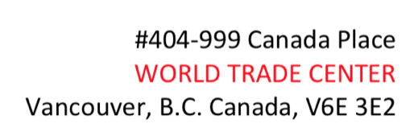

The Canadian Securities Exchange (CSE) has not reviewed and does not accept responsibility for the adequacy or the accuracy of the contents of this news release.

This news release includes certain statements that may be deemed “forward-looking statements”. The use of any of the words “anticipate’, “continue”, “estimate”, “expect”, “may”, “will”, “would”, “project”, “should”, “believe” and similar expressions are intended to identify forward-looking statements. Although the Company believes that the expectations and assumptions on which the forward-looking statements are based are reasonable, undue reliance should not be placed on the forward-looking statements because the Company can give no assurance that they will prove to be correct. Since forward-looking statements address future events and conditions, by their very nature they involve inherent risks and uncertainties. These statements speak only as of the date of this news release. Actual results could differ materially from those currently anticipated due to a number of factors and risks including various risk factors discussed in the Company’s disclosure documents which can be found under the Company’s profile on www.sedar.com.

