Generic Gold Commences Drilling for Gold and VMS on Belvais Project, Québec

Toronto, Canada -- (June 1, 2021) - Generic Gold Corp. (CSE: GGC) (FSE: 1WD) (OCTQB: GGCPF) ("Generic Gold" or "Generic" or the "Company") is pleased to announce that drilling is underway on the Company's inaugural diamond drill program on its Belvais Project, located in the Abitibi Greenstone Belt of Québec, along the Normétal Fault Zone. This large, fully funded 7,500m drill program will be drilled in two phases and will target both orogenic gold and gold-rich VMS targets. The initial 3,000m for Phase 1 has commenced, with the additional 4,500m of Phase 2 planned upon receipt of Phase 1 assays. As previously announced (see release dated May 6, 2021), drill targets were generated following compilation of all available data, including recently completed VTEM and soil sampling surveys, as well as historical drilling analysis and geophysical work. As shown in Figure 1, the Belvais project lies directly south-east of Amex Exploration's Perron Project, which recently announced a new high-grade gold discovery (the 210 Zone) along the Normétal Fault (Amex Press Release dated February 17th, 2021), and is also directly east and south-east of Starr Peak's NewMétal Project, which recently announced high-grade VMS mineralization on their Normetmar target (Starr Peak Press Release dated May 4th, 2021). Both of these new discoveries occur along the Normétal Fault which is of particular significance for Generic Gold, as the Company holds over 20 km of the Normétal Fault on its Belvais claims and is one of the largest landholders in the area with 12,563 hectares.

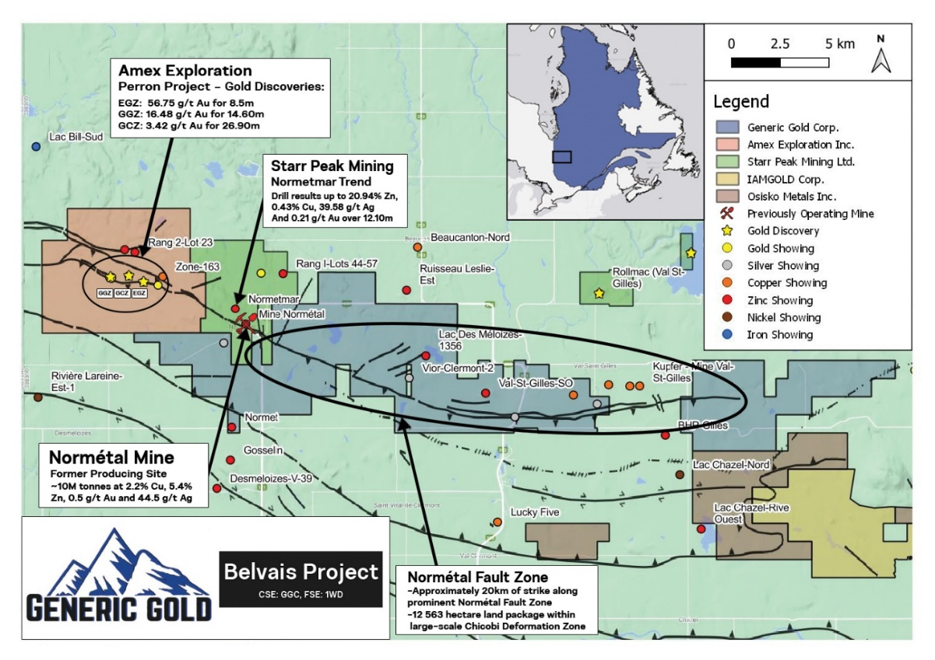
Figure 1: Generic Gold's Belvais project with respect to Amex Exploration's Perron project and Starr Peak's NewMétal project. Note the Normétal fault zone, which extends for approximately 20 km along the Belvais project.
Aaron Stone, Vice President Exploration of Generic Gold, said "We are very excited to begin this drill program having made fantastic progress in advancing this project to the drill-ready stage. We have modelled some very prospective and high-priority EM plates using multiple data points. Some of our targets are surrounding and along strike to the historic Normétal mine and Starr Peak's new discovery on their NewMétal project. A full structural interpretation of the property has also been completed by an external geophysicist utilizing MAG data which has also provided additional gold and VMS targets (see Figure 2 below)."
Interpretation and modelling of MAG and EM data has provided an additional 14 gold and 10 VMS targets to be tested by the Company, as seen in Figure 2 below. In addition, Generic has interpreted historical drilling across the property which the Company believes missed EM conductor plates. Some of these historical results show anomalous silver and base metal values. The majority of targets are in proximity to the historical Normétal mine and important major structures, such as the Normétal and Fermont faults.
Figure 2: TMI (Total Magnetic Intensity) Map of the Belvais property showing the 14 gold and 10 VMS targets selected across the project generated from a combination of magnetic and EM anomalies.

The Company will continue to keep the market updated with drill results once they become available and are compiled.
Qualified Person
Hugues Guérin-Tremblay P.Geo, (OGQ – 1584), an Independent Qualified Person ("QP") as such term is defined by National Instrument 43-101 - Standards of Disclosure for Mineral Projects, has reviewed and approved the geological information reported in this news release. The Qualified Person has not completed sufficient work to verify the historic information on the Property and in the vicinity, particularly in regards to historical drill results and historical mine production. However, the Qualified Person believes that these results were completed to industry standard practices. The information provides an indication of the exploration potential of the Property but may not be representative of expected results. Also, mineralization hosted on adjacent and/or nearby properties is not necessarily indicative of mineralization hosted on the Company's property.
About Generic Gold
Generic Gold is a Canadian mineral exploration company focused on gold projects in the Tintina Gold Belt in the Yukon Territory of Canada and the Abitibi Greenstone Belt in Quebec, Canada. The Company's Quebec exploration portfolio consists of four properties covering 12,563 hectares proximal to the town of Normétal, and east of Amex Exploration's Perron project and the past-producing Normétal mine. The Company's Yukon exploration portfolio consists of several projects with a total land position of greater than 35,000 hectares, all of which are 100% owned by Generic Gold. Several of these projects are in close proximity to significant gold deposits, including Goldcorp's Coffee project, Victoria Gold's Eagle Gold project, White Gold's Golden Saddle project, and Western Copper & Gold's Casino project. Generic Gold's board of directors and management team is led by experienced mining industry professionals, with expertise in exploration, finance, capital markets, and mine development. For information on the Company's property portfolio, visit the Company's website at genericgold.ca.
For further information contact:
Generic Gold Corp.
Aaron Stone, VP Exploration
Tel: (514) 235-6012
astone@genericgold.ca
NEITHER THE CANADIAN SECURITIES EXCHANGE NOR THEIR REGULATION SERVICES PROVIDERS ACCEPT RESPONSIBILITY FOR THE ADEQUACY OR ACCURACY OF THIS RELEASE.
Certain statements in this press release are "forward-looking" statements within the meaning of Canadian securities legislation. All statements, other than statements of historical fact, included herein are forward-looking information. Forward-looking statements are necessarily based upon the current belief, opinions and expectations of management that, while considered reasonable by the Company, are inherently subject to business, economic, competitive, political and social uncertainties and other contingencies. Many factors could cause the Company's actual results to differ materially from those expressed or implied in the forward-looking statements. Accordingly, readers should not place undue reliance on forward-looking statements and forward-looking information. The Company does not undertake to update any forward-looking statements or forward-looking information that are incorporated by reference herein, except in accordance with applicable securities laws. Investors are cautioned not to put undue reliance on forward-looking statements due to the inherent uncertainty therein. We seek safe harbour.

