GENERATION MINING IDENTIFIES VTEM CONDUCTORS ON Pb-Zn-Cu PROPERTIES IN NOVA SCOTIA

Toronto, Ontario – Nov 21, 2018 - Generation Mining Limited (CSE:GENM, the “Company”) is pleased to announce initial results from the 2018 airborne VTEM survey, part of the base metals exploration program in central Nova Scotia. The program has identified a number of anomalies representing high-priority drill targets on the recently-staked Rawdon East property. A 222 line-km VTEM survey, completed in August, has identified VTEM anomalies in geologic units which host a number of historical lead-zinc deposits. Since the late 1800s, the Middle Stewiacke region has been known to host numerous carbonate-hosted base metal and barite deposits (Figure 1) hosted by marine sedimentary rocks and evaporites in the Windsor Group of rocks.

Notable deposits hosted in this formation are the Walton Ba-Pb-Zn-Cu-Ag deposit (located 50 km west of the Rawdon East property), which produced 4.3 million tons of barite along with 412,000 tons of sulphide mineralization grading 4.28% lead, 1.29% zinc, 0.52% copper and 350 grams/tonne silver; the Gays River mine (located 25 km south) which has a current measured and indicated resource of 12,205,000 tonnes grading 2.76% zinc and 1.60% lead in several deposits; and the Smithfield deposit (located within the Rawdon West property on claims not owned by Generation Mining) which produced briefly in the 1880s, and in the 1950s reported a 500,000 ton deposit grading 3.5% zinc and 2.7% lead. A drill hole in the 1990s returned 10.5 metres grading 28.25% zinc and 1.48% lead. On the north side of the deposit a drill hole in 1984 returned 8.23 metres grading 11.82% combined lead-zinc at a depth of 220 metres near the boundary with the Generation Mining property. The base-metal deposit at Smithfield has a strong structural control in a setting very similar to the Walton deposit.

The VTEM conductors of primary interest lie within the prospective lower units of the Windsor Group rocks, coincident with discrete basement magnetic anomalies and a broader magnetic expression indicating near surface proximity to the basement rocks. As shown in Figure 2., on the west side of the Rawdon East property, the VTEM survey has detected a large area (>3x3km) of discrete, conductive source rocks, associated with an unexplored area of lower Windsor Group rocks, that are believed to be prospective for Pb-Zn-Cu deposits. Consequently, the conductive responses may be indicative of base metal sulphide mineralization, within 200m of the surface.

Generation Mining continues to review exploration data for nearby Rawdon West (formerly Kennetcook) property which was also the subject to a large airborne VTEM program this year, and results will be released as they are interpreted. The Company plans to begin drilling the highest priority anomalies in early 2019, subject to financing and permitting.

Qualified Person

Kevin M. Stevens, P. Geo, is a "qualified person" for the purposes of National Instrument 43-101 - Standards of Disclosure for Mineral Properties and the Company's Professional Consulting Geophysicist. He has prepared or supervised the preparation of the information contained in this news release.

About Generation Mining Limited

Generation Mining Limited is a base metal exploration and development company with various property interests throughout Canada. Its primary business objective is to explore and further develop these properties, and to continue to increase its portfolio of base and precious metal property assets through acquisition.

For further information please contact:

Jamie Levy
President and Chief Executive Officer
(416) 640-2934
(416) 567-2440
jlevy@genmining.com

Forward-Looking Information

This release includes certain statements that may be deemed “forward-looking statements”. All statements in this release, other than statements of historical facts, that address future production, reserve potential, exploration drilling, exploitation activities and events or developments that the Company expects are forward-looking statements. Although the Company believes the expectations expressed in such statements are based on reasonable assumptions, such statements are not guarantees of future performance and actual results or developments may differ materially from those in the statements. There are certain factors that could cause actual results to differ materially from those in forward-looking statements. These include market prices, exploitation and exploration successes, continued availability of capital and financing, and general economic, market or business conditions. Investors are cautioned that any such statements are not guarantees of future performance and actual results or developments may differ materially from those projected in the forward-looking statements. For more information on the Company, investors are encouraged to review the Company’s public filings at www.sedar.com. The Company disclaims any intention or obligation to update or revise any forward- looking statements, whether as a result of new information, future events or otherwise, other than as required by law.

1700-80 Richmond Street West Phone: 416 567-2440
Toronto, Ontario, Canada M5H 2A4 Email: jlevy@genmining.com

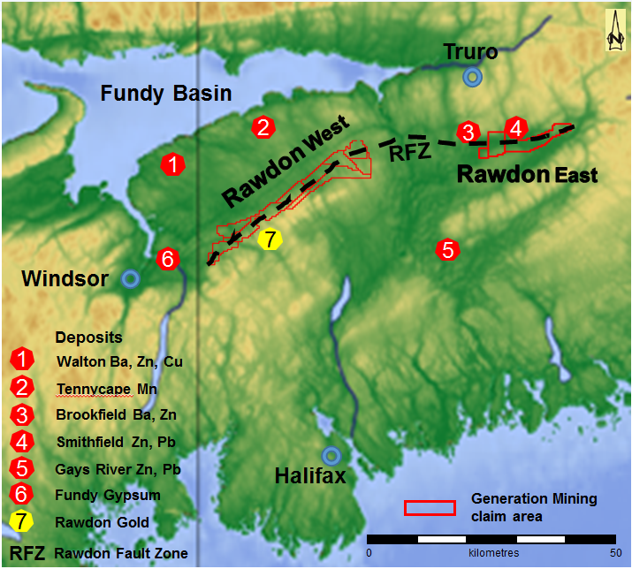

Figure 1. Topographic map of central Nova Scotia showing the location of historic base metal, gold and gypsum mining. Generation Mining mineral licenses are outlined in red and comprise the Rawdon West and Rawdon East properties straddling the Rawdon Fault Zone (RFZ).

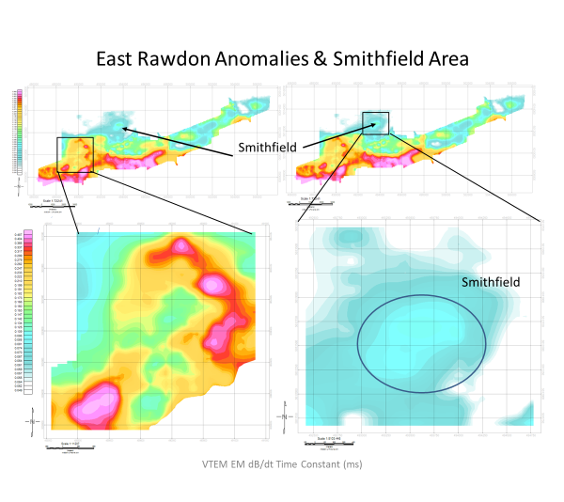
Figure 2: VTEM EM map from the East Rawdon property and the Smithfield area, showing the location of conductors.

