Getchell Gold Corp Exhibiting at Booth 2341, PDAC 2023 Convention in Toronto, March 5-8
Vancouver--(Newsfile Corp. – March 1, 2023) - Getchell Gold Corp (CSE:GTCH) (OTCQB:GGLDF) invites all shareholders and precious metals investors to visit us at Booth #2341 at the Prospectors & Developers Association of Canada’s (PDAC) Convention at the Metro Toronto Convention Centre (MTCC) from Sunday, March 5 to Wednesday, March 8, 2023. President Mike Sieb will lead a contingent exhibiting in the Investor Exchange that includes our senior exploration team that will gladly address any technical or investment questions.
This will mark the first major global conference attended since the Fondaway Canyon Mineral Resource Estimate (MRE) Technical Report was published on February 1, 2023. That report models both an open pit and underground operation, similar to existing Nevada gold producers.
Mineral Resource Estimate Key Highlights*
- Large ‘at surface’ Mineral Resource Estimate in a premier gold mining jurisdiction;
- Inferred Mineral Resource of 38.3 million tonnes at an average grade of 1.23 g/t Au for
1,509,100 ounces of gold;
- Indicated Mineral Resource of 11.0 million tonnes at an average grade of 1.56 g/t Au for an additional 550,800 ounces of gold;
- Gold mineralization remains open for further expansion in all contributing zones; and
- Technical report available on the Company’s website and on SEDAR.
“This year’s PDAC is perfectly timed for Getchell Gold.”, states President Mike Sieb, adding “This is the mining community’s largest ‘in person’ investor event and this year’s attendance coincides with the release of our new Mineral Resource Estimate that has received significant attention and is expected to generate many quality meetings with mining influencers and investors this week. For anyone interested in discussing this major milestone and the future plans at our advanced exploration stage gold project situated a short drive from Reno, Nevada, please reach out to our team and drop by booth #2341.”
About PDAC
PDAC 2023: The World’s Premier Mineral Exploration & Mining Convention is the leading event for people, companies and organizations connected to mineral exploration.
This annual convention in Toronto, Canada is known for attracting up to 30,000 attendees from over 130+ countries for its educational programming, networking events, outstanding business opportunities and fun. Since it began in 1932, the PDAC Convention has grown in size, stature and influence. Today, it is the event of choice for the world’s mineral industry hosting more than 1,100 exhibitors and 2,500 investors.
For more information and/or to register for the conference please visit: https://www.pdac.ca/convention/attend/registration.
Fondaway Canyon Mineral Resource Estimate
The results of the Mineral Resource Estimate are as follows:
Table 1: Fondaway Canyon Global Mineral Resources Estimate at a price of US$ 1,650 per ounce.
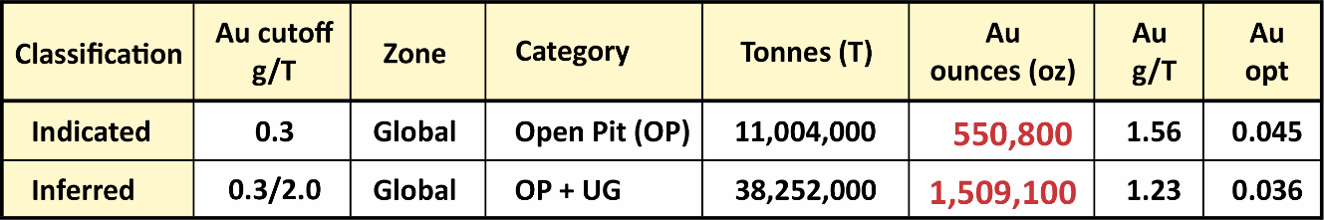
Table 2: Fondaway Canyon Mineral Resource Estimate by Zone
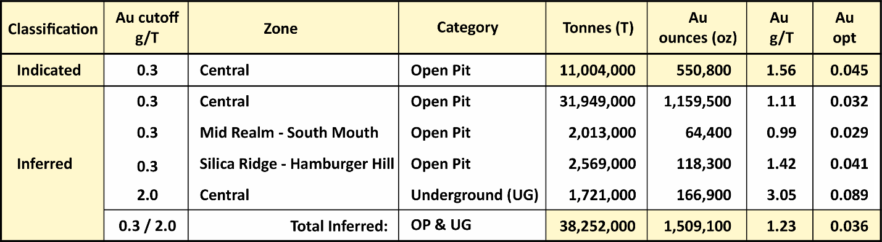

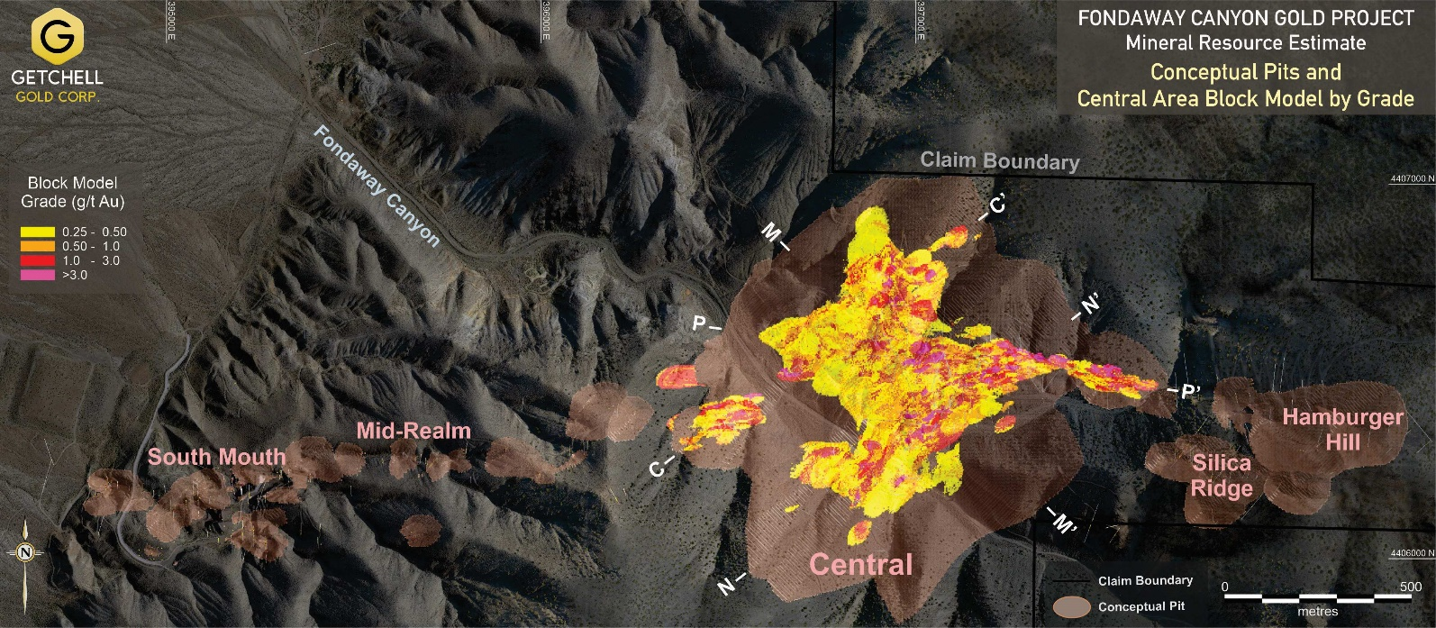
Figure 1: Fondaway Canyon Project MRE showing conceptual pits and Central Zone gold grade block model in plan view.

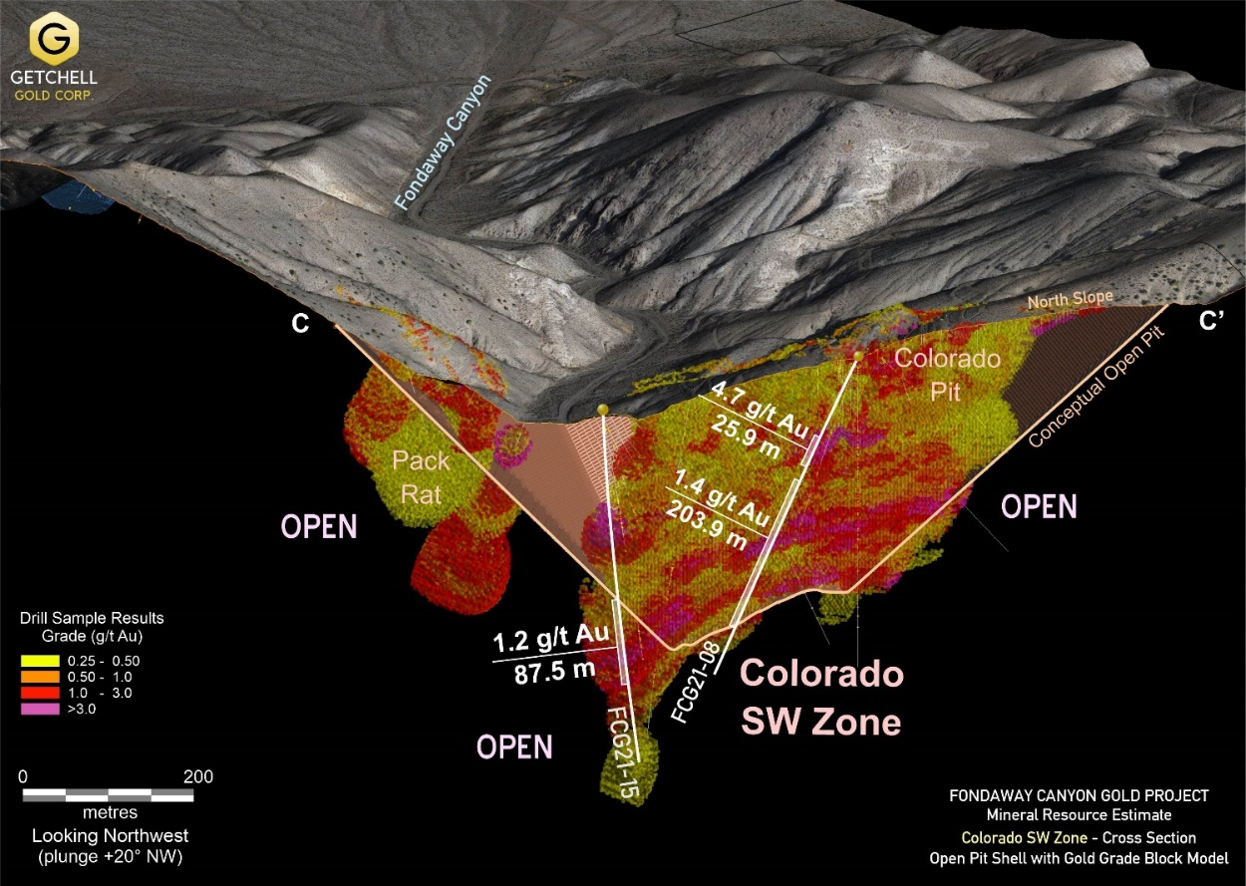
Figure 2: Fondaway Canyon MRE 3D gold grade block model sliced through the Colorado SW zone showing select drill hole gold intervals.
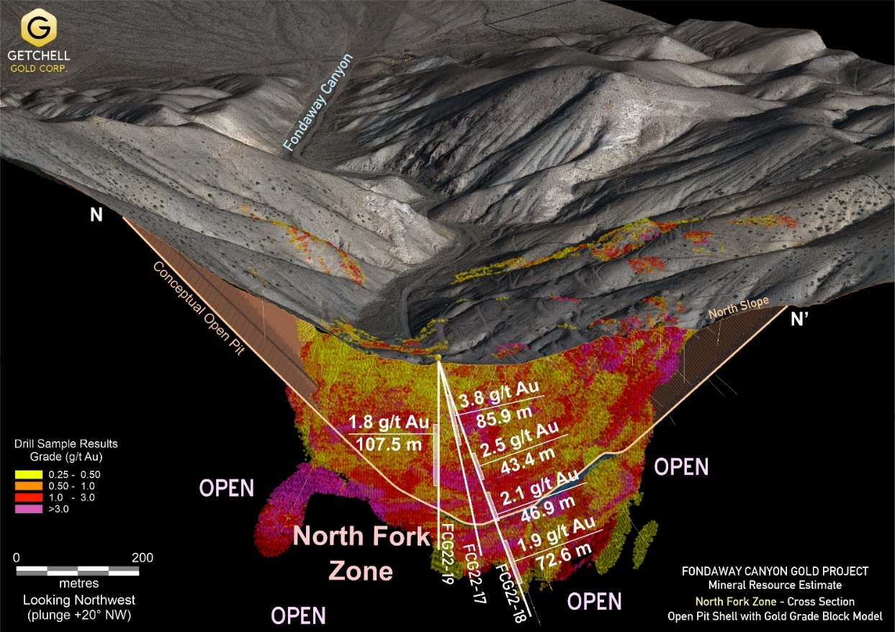
Figure 3: Fondaway Canyon Project MRE 3D gold grade block model sliced through the North Fork zone showing select drill hole gold intervals.

*The Fondaway Canyon Mineral Resources Estimate is based on 518 reverse circulation and diamond drill holes totaling 52,395 metres (171,900 feet) spanning over forty years to the present along a 3.5 km East-West gold trend (Figure 1).
The MRE represents a significant expansion to a historic Mineral Resources Estimate published by a previous operator in 2017 by:
- Primarily modelling the Mineral Resources as a bulk tonnage target with a conceptual open pit mining scenario versus a solely underground extraction scenario;
- The addition of new assay results from 26 diamond drill holes (2017 to 2022) that were completed subsequent to the release of the historic 2017 Mineral Resources Estimate; and
- Major discoveries in 2020 and expansion of the new zones drilled through 2022.
Nineteen (19) drill holes, FCG20-01 to FCG22-19, totaling 6,973 metres (22,877 feet) drilled by the Company in 2020, 2021, and 2022, were considered in the current MRE and represent a significant component of the expanded gold mineralization.
Nine (9) holes drilled in 2022, FCG22-20 through FCG22-28, totaling 3,473 metres (11,394 feet) were completed subsequent to the cut-off for inclusion into the MRE. The assay results from these nine 2022 holes will be incorporated into a future Mineral Resources Estimate.
Notes on the Mineral Resource Estimate:
- The independent and qualified person for the mineral resources estimate, as defined by NI 43-101, is Michael Dufresne, P.Geo., from APEX Geoscience Ltd.
- Mineral Resources, which are not Mineral Reserves, do not have demonstrated economic viability. There has been insufficient exploration to define the inferred resources tabulated above as an indicated or measured mineral resource, however, it is reasonably expected that the majority of the Inferred Mineral Resources could be upgraded to Indicated Mineral Resources with continued exploration. There is no guarantee that any part of the mineral resources discussed herein will be converted into a mineral reserve in the future. The estimate of Mineral Resources may be materially affected by environmental, permitting, legal, marketing, or other relevant issues. The mineral resources in this report were estimated using the Canadian Institute of Mining, Metallurgy and Petroleum standards on mineral resources and reserves, definitions, and guidelines prepared by the CIM standing committee on reserve definitions and adopted by the CIM council (CIM 2014 and 2019).
- The effective date of the Mineral Resources Estimate is December 15, 2022, and the related technical report, titled “Technical Report Mineral Resource Estimate Fondaway Canyon Project, Nevada, USA” published on February 1, 2023, is available for download on the Company’s website and on SEDAR.
- For additional notes on the MRE, refer to the Company’s news release dated December 15, 2022, or the technical report.
Scott Frostad, P.Geo., is the Qualified Person (as defined in NI 43-101) who reviewed and approved the content and scientific and technical information in the news release.

About Getchell Gold Corp.
The Company is a Nevada focused gold and copper exploration company trading on the CSE: GTCH and OTCQB: GGLDF. Getchell Gold is primarily directing its efforts on its most advanced stage asset, Fondaway Canyon, a past gold producer with a significant in-the-ground Mineral Resources Estimate. Complementing Getchell’s asset portfolio is the Star project, a past high-grade copper, gold, and silver small-scale producer, the Dixie Comstock project, a past gold producer with a historic resource, and one earlier stage exploration project, Hot Springs Peak (Au). Getchell has the option to acquire 100% of the Fondaway Canyon and Dixie Comstock properties, Churchill County, Nevada.
For further information please visit the Company’s website at www.getchellgold.com or contact the Company by e-mail at info@getchellgold.com or by phone at +1 647 249-4798.

Mr. William Wagener, Chairman & CEO
Getchell Gold Corp.
1-647-249-4798
getchellgold.com

The Canadian Securities Exchange has not reviewed this press release and does not accept responsibility for the adequacy or accuracy of this news release.

Certain information contained herein constitutes “forward-looking information” under Canadian securities legislation. Forward-looking information includes, but is not limited to, statements with respect to the use of proceeds. Generally, forward-looking information can be identified by the use of forward-looking terminology such as “will” or variations of such words and phrases or statements that certain actions, events or results “will” occur. Forward-looking statements are based on the opinions and estimates of management as of the date such statements are made and they are subject to known and unknown risks, uncertainties and other factors that may cause the actual results to be materially different from those expressed or implied by such forward-looking statements or forward-looking information. Although management of Getchell have attempted to identify important factors that could cause actual results to differ materially from those contained in forward-looking statements or forward-looking information, there may be other factors that cause results not to be as anticipated, estimated or intended. There can be no assurance that such statements will prove to be accurate, as actual results and future events could differ materially from those anticipated in such statements. Accordingly, readers should not place undue reliance on forward-looking statements and forward-looking information. The Company will not update any forward-looking statements or forward-looking information that are incorporated by reference herein, except as required by applicable securities laws.

