Getchell Gold Corp. Extends Colorado SW Zone Along Strike with Two Holes Intersecting
Gold Mineralization over a 200m Drill Length Including 1.1 g/t Au over 83.8m,
1.3 g/t Au over 58.0, and 0.8 g/t Au over 98.0m, at Fondaway Canyon, NV
Vancouver, BC – January 18, 2023 – Getchell Gold Corp. (CSE: GTCH) (OTCQB: GGLDF) ("Getchell" or the "Company") is pleased to provide assay results for drill holes FCG22-26 to FCG22-28 that continue to demonstrate significant intervals of gold mineralization and have extended the Colorado SW zone towards the southeast in the Central Area of the Fondaway Canyon project, Nevada.
Key Highlights Colorado SW Gold Zone
- Colorado SW extended 40m to the southeast on new drill section by holes FCG22-26 and 28;
- FCG22-26 intersected three significant gold mineralized intervals including 1.8 g/t Au over 29.4 m and 1.1 g/t Au over 83.8 m;
- FCG22-27 drilled 1.2 g/t Au over 29.9 m partway through the targeted zone prior to the hole being lost;
- FCG22-28 intersected three significant gold mineralized intervals including 0.8 g/t Au over 98.0 m and 1.3 g/t Au over 58.0 m;
- Colorado SW zone remains open in all directions.
“Stepping out into a new area comes with its risks and rewards. In this instance, our drilling has successfully demonstrated that the Colorado SW gold zone clearly extends along strike to the southeast while maintaining a considerable thickness.” states Mike Sieb, President, Getchell Gold Corp. “Once again, we finished a drill season on a high note by expanding the limits of our recent gold discoveries and continuing to reveal the exceptional exploration potential at Fondaway Canyon.”
Drill Hole FCG22-26 and FCG22-28
Drill holes FCG22-26 and FCG22-28 were centered on a new drill section, a 40 metre step out to the southeast from previous drilling that included FCG20-05 grading 1.8 g/t Au over 90.0 m (Figures 1 to 3).
Both holes revealed excellent gold grade consistency and mineralized thickness in respect to the adjoining drill section, intersecting the Colorado SW zone over a 200m down hole length with highlighted gold intervals detailed in Table 1.
Getchell Gold has now traced the Colorado SW zone for over 300m on this section with the mineralization remaining open up and down dip as well as along strike to the southeast, a region absent of any drilling.
Drill Hole FCG22-27
Drill hole FCG22-27 was designed to test the up-dip continuation of the Colorado SW zone on section with hole FCG20-06 that intersected 1.5 g/t Au over 37.7 m and 1.1 g/t Au over 38.3 m.
FCG22-27 intersected an upper interval returning 1.2 g/t Au over 29.9 m, but the drill rods became stuck and the hole was lost partway through the targeted zone at a depth of 240m (Figure 3).
The Company has traced the Colorado SW zone for over 300m on this section with the mineralization remaining open both up and down dip.
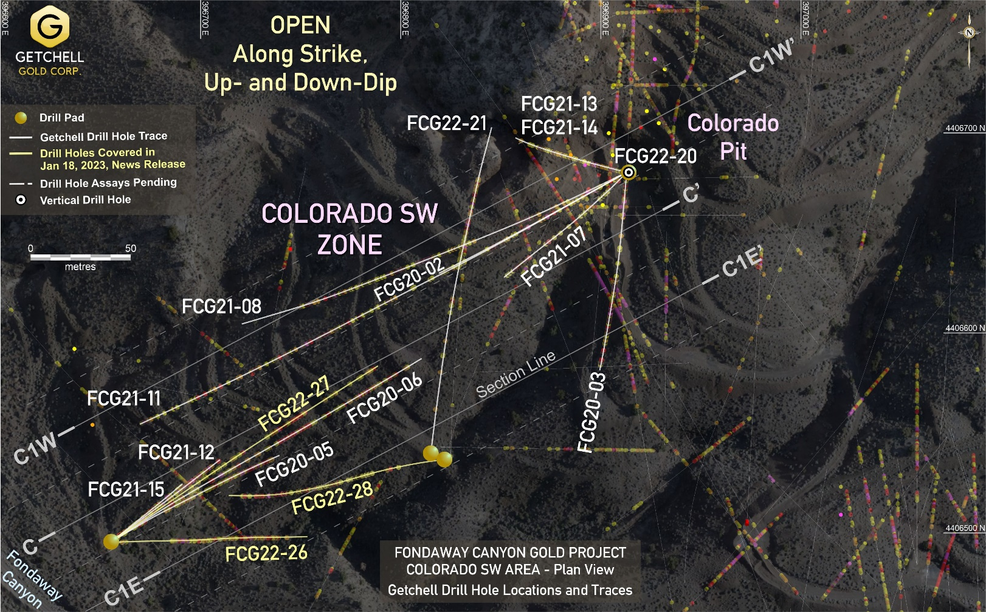
Figure 1: Fondaway Canyon Central Area drill location plan map.
Table 1: Drill Hole FCG22-26 to FCG22-28 Notable Colorado SW Gold Intervals
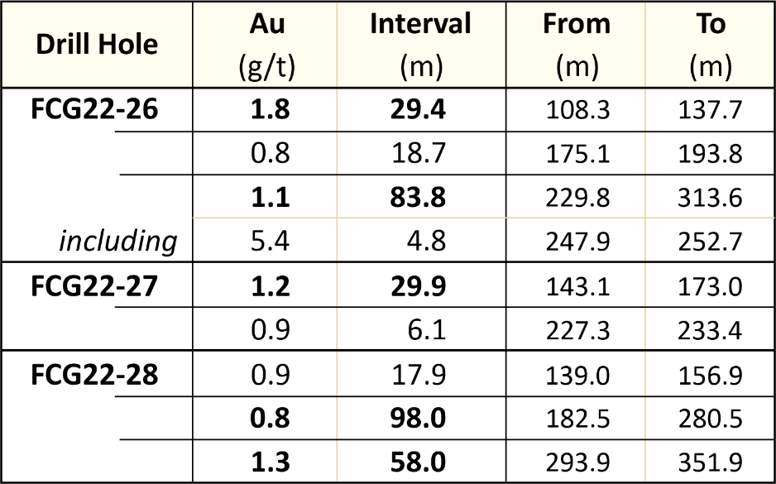

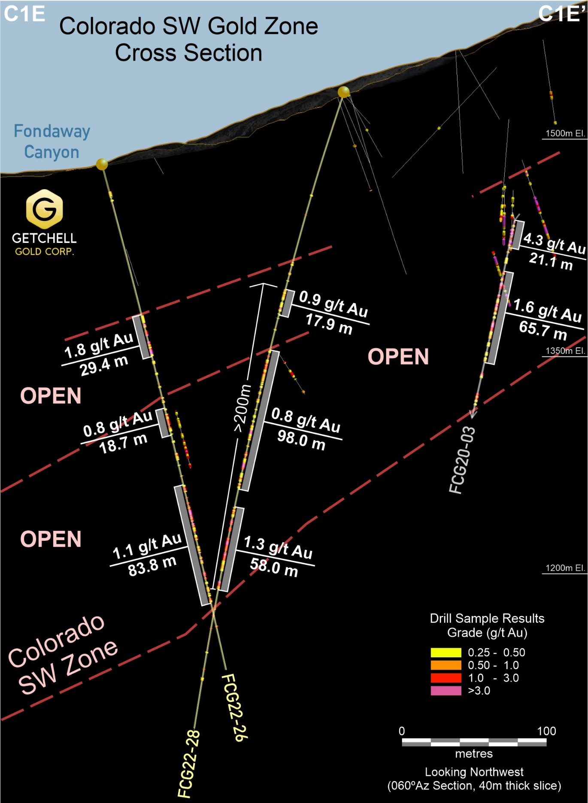
Figure 2: Cross section highlighting drill holes FCG22-26 and FCG22-28’s gold intervals.
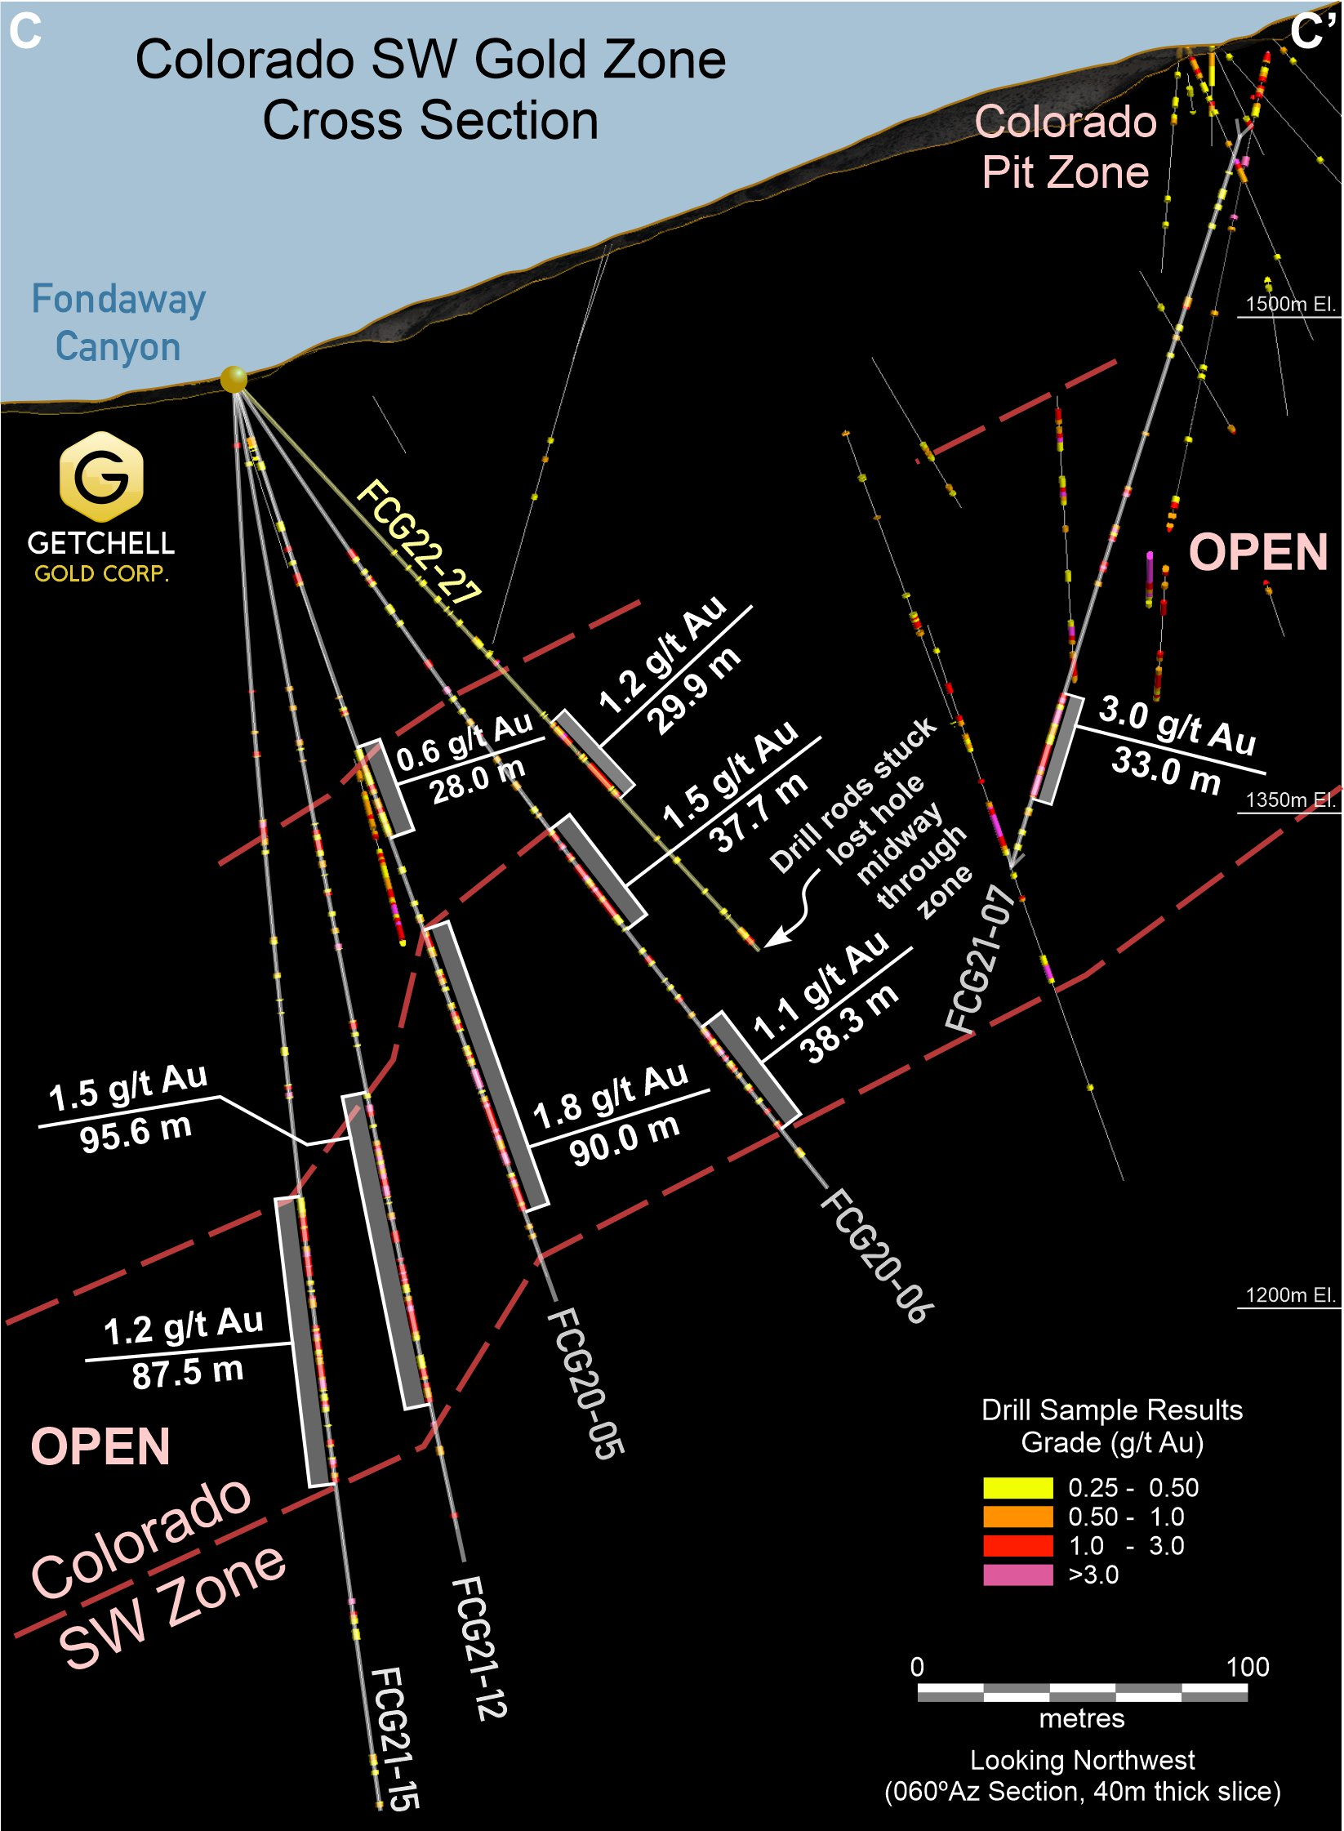
Figure 3: Cross section highlighting drill hole FCG22-27’s gold intervals.
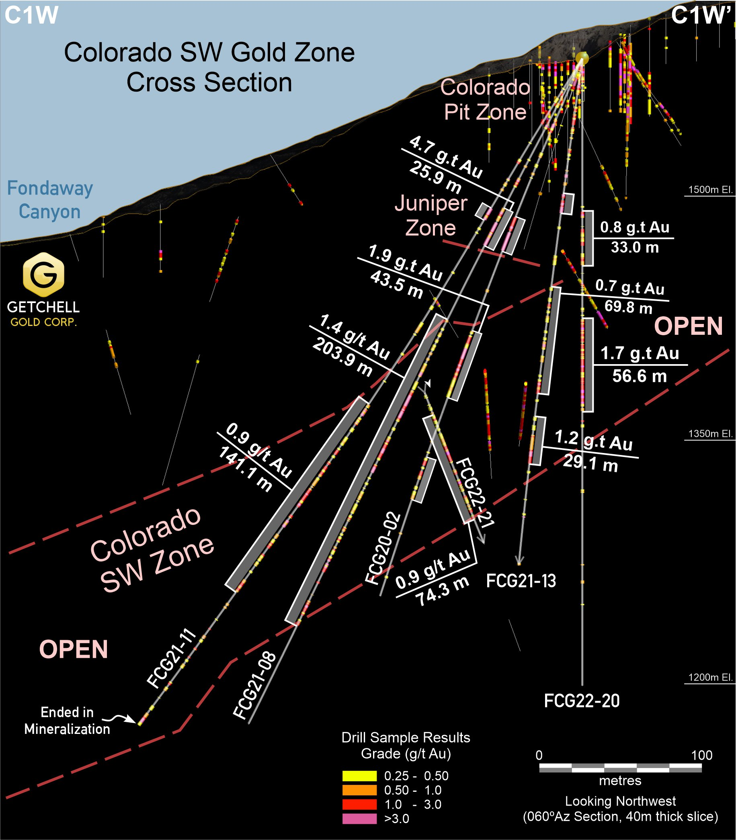
Figure 4: Colorado SW Zone cross section C1W highlighting drill hole gold intervals.
Figure 4 shows the Company’s previous drill results on the section 40 metres to the northwest with excellent gold grade consistency and mineralized thickness.
This section is highlighted by holes FCG21-08 and FCG21-11 that intersected the Colorado SW zone grading 1.4 g/t Au over 203.9 m and 0.9 g/t Au over 141.1 m respectively.
Of note, this section is the most northwestern drilled section and is bounded to the northwest by a region absent of any drilling.
Hole FCG22-28 marks the last hole drilled during a very successful 2022 drill program with all gold zones drill tested remaining open along strike and up and down dip.
The Company’s technical team is in the process of compiling and analyzing the results from the 2022 drill program for the planning of this year’s drill program at Fondaway Canyon.
Scott Frostad, P.Geo., is the Qualified Person (as defined in NI 43-101) who reviewed and approved the content and scientific and technical information in the news release.
The 2022 drill core is being processed using the same methods as the 2020 and 2021 drill programs. The core is cut at Bureau Veritas Laboratories’ (“BVL”) facilities in Sparks, Nevada, with the samples analyzed for gold and multi-element analysis in BVL’s Sparks, Nevada and Vancouver, BC laboratories respectively. Gold values are produced by fire assay with an Atomic Absorption finish on a 30-gram sample (BV code FA430) with over limits re-analyzed using method FA530 (30g Fire Assay with gravimetric finish). The multi-element analyses are performed by ICP-MS following aqua regia digestion on a 30g sample (BV code AQ250). Quality control measures in the field include the systematic insertion of standards and blanks.
Highlighted drill intervals are based on minimum interval lengths of 3.3 metres (10 feet), a 0.25 g/t Au cut-off, and a maximum of 3.3 metres of internal dilution, with no top cut applied. Broader reported Intervals may include internal dilution in the calculated average weighted grades. All intervals are reported as downhole drill lengths and additional work is required to determine the true widths.
About Getchell Gold Corp.
The Company is a Nevada focused gold and copper exploration company trading on the CSE: GTCH and OTCQB: GGLDF. Getchell Gold is primarily directing its efforts on its most advanced stage asset, Fondaway Canyon, a past gold producer with a significant resources estimate and on the Star project, a past high-grade copper, gold, and silver small-scale producer. Complementing Getchell’s asset portfolio is Dixie Comstock, a past gold producer with a historic resource and one earlier stage exploration project, Hot Springs Peak (Au). Getchell has the option to acquire 100% of the Fondaway Canyon and Dixie Comstock properties, Churchill County, Nevada.
For further information please visit the Company’s website at www.getchellgold.com or contact the Company by e-mail at info@getchellgold.com or by phone at +1 647 249-4798.

Mr. William Wagener, Chairman & CEO
Getchell Gold Corp.
The Canadian Securities Exchange has not reviewed this press release and does not accept responsibility for the adequacy or accuracy of this news release.

Certain information contained herein constitutes “forward-looking information” under Canadian securities legislation. Forward-looking information includes, but is not limited to, statements with respect to the use of proceeds. Generally, forward-looking information can be identified by the use of forward-looking terminology such as “will” or variations of such words and phrases or statements that certain actions, events or results “will” occur. Forward-looking statements are based on the opinions and estimates of management as of the date such statements are made and they are subject to known and unknown risks, uncertainties and other factors that may cause the actual results to be materially different from those expressed or implied by such forward-looking statements or forward-looking information. Although management of Getchell have attempted to identify important factors that could cause actual results to differ materially from those contained in forward-looking statements or forward-looking information, there may be other factors that cause results not to be as anticipated, estimated or intended. There can be no assurance that such statements will prove to be accurate, as actual results and future events could differ materially from those anticipated in such statements. Accordingly, readers should not place undue reliance on forward-looking statements and forward-looking information. The Company will not update any forward-looking statements or forward-looking information that are incorporated by reference herein, except as required by applicable securities laws.

