Getchell Gold Corp. Intersects 3.4 g/t Au Over 44.6m and 3.4 g/t Au Over 31.4m
at the North Fork Zone, Fondaway Canyon, NV
Vancouver, BC – January 10, 2023 – Getchell Gold Corp. (CSE: GTCH) (OTCQB: GGLDF) ("Getchell" or the "Company") is pleased to provide assay results for drill holes FCG22-23 and FCG22-25 that continue to demonstrate significant intervals of gold mineralization at the North Fork zone in the Central Area of the Fondaway Canyon project in Nevada.
Key Highlights
- FCG22-23 intersected four significant gold mineralized intervals including 3.4 g/t Au over 44.6 m and 1.8 g/t Au over 12.8 m;
- FCG22-25 intersected four significant gold mineralized intervals including 3.4 g/t Au over 31.4 m and 1.3 g/t Au over 17.4 m;
- Both holes extend North Fork mineralization by 25 m to the north and 30 m up-dip respectively;
- North Fork zone remains open in all directions;
- Assay results from three holes (FCG22-26 to 28) drilled at the Colorado SW zone are still pending; and
- FCG22-24, drilled 2 kms west on the Pediment, intersected two intervals indicative of gold mineralization peripheral to a main zone.
“Every hole drilled on the North Fork zone in 2022 successfully intersected and extended the gold mineralization. North Fork is shaping up to be a major center for gold mineralization that remains open in all directions and will continue to be a drill priority in 2023.” states Mike Sieb, President, Getchell Gold Corp. “Being able to say, ‘we have yet to test the limits of the gold mineralization’ after three drill campaigns is an excellent position to be in and highlights the overall potential of the Fondaway Canyon gold project.”
Drill Hole FCG22-23
Drill hole FCG22-23, the sixth hole of the 2022 drill program at Fondaway Canyon (the “Project”) (Figure 1), was drilled as a 45m up-dip step out to the northeast of the high-grade gold mineralization encountered in hole FCG21-16 that graded 6.3 g/t Au over 50.7 m.
FCG22-23 successfully extended the high-grade North Fork gold mineralization reporting 3.4 g/t Au over 44.6 m and demonstrates excellent continuity and consistency of the North Fork zone (Figure 2). In addition, FCG22-23 encountered a shallow interval, 60 metres below surface, which graded 1.8 g/t Au over 12.8 m and multiple additional gold intervals lower down in the drill hole as highlighted in Table 1.
Drill Hole FCG22-25
Drill hole FCG22-25 was primarily designed to test the up-dip continuation of the lower series of gold intervals encountered at North Fork by FCG22-18 that includes 2.1 g/t Au over 46.9 m.
FCG22-25 encountered a significant gold interval grading 3.4 g/t Au over 31.5 m that correlates well and represents a 30 m extension to the lower zone of mineralization at North Fork zone. In addition, FCG22-25 encountered multiple gold intervals above and below this one that are highlighted in Table 1.
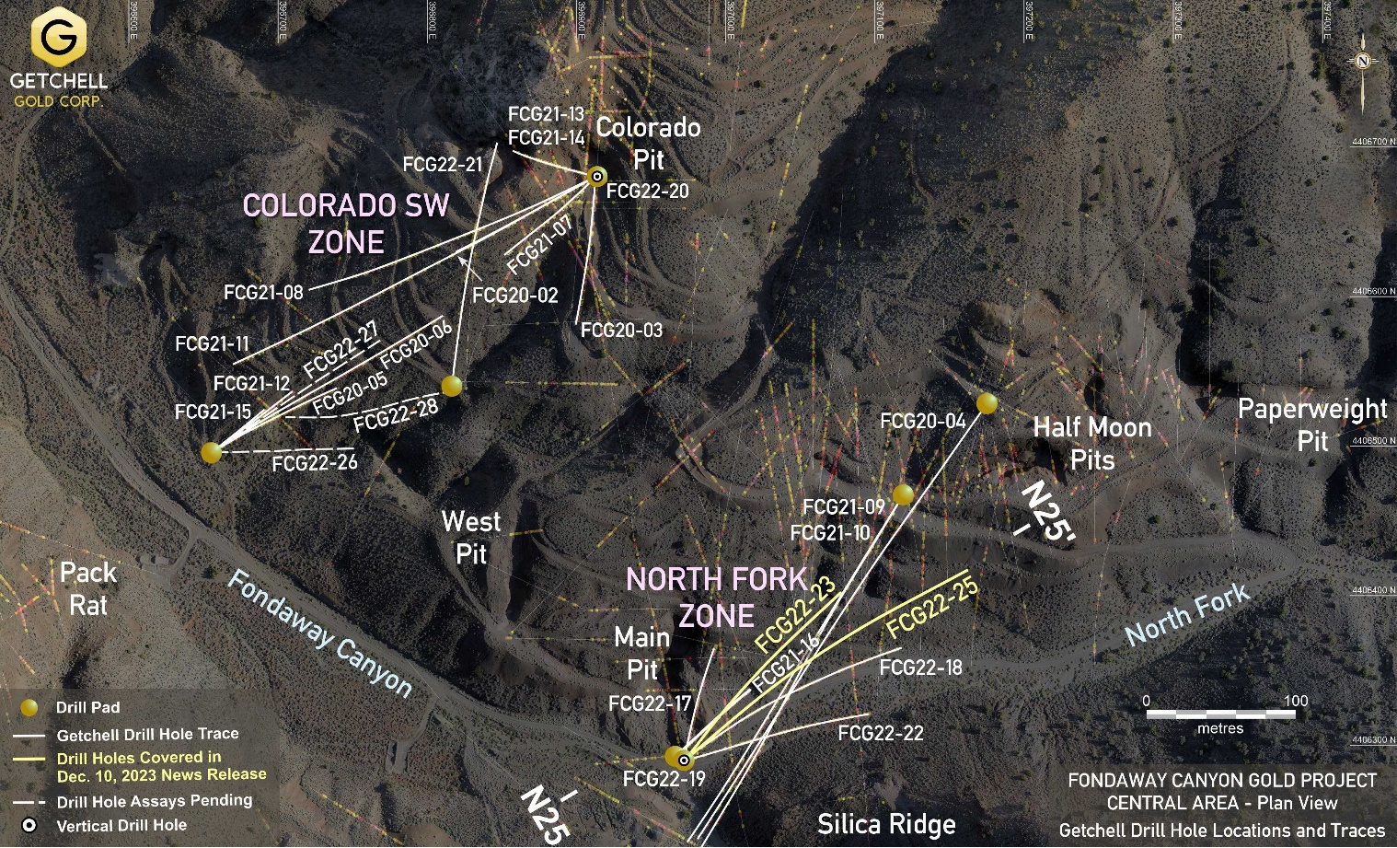
Figure 1: Fondaway Canyon Central Area drill location plan map.
Table 1: Drill Hole FCG22-23 and FCG22-25 Notable North Fork Gold Intervals
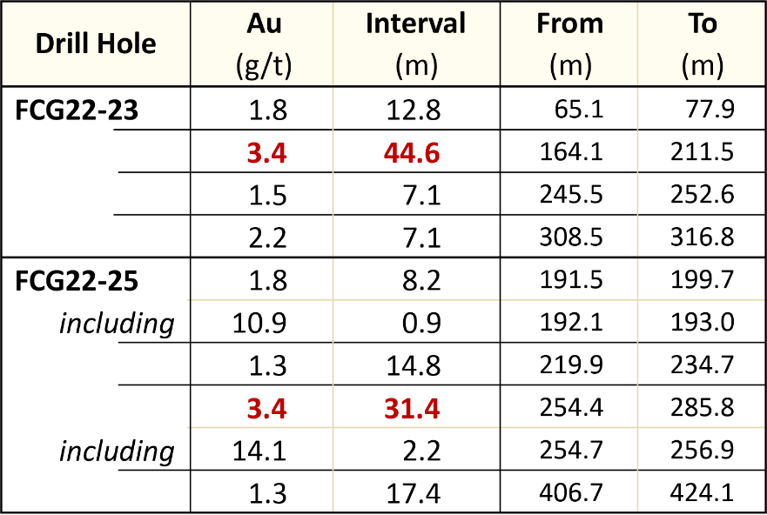

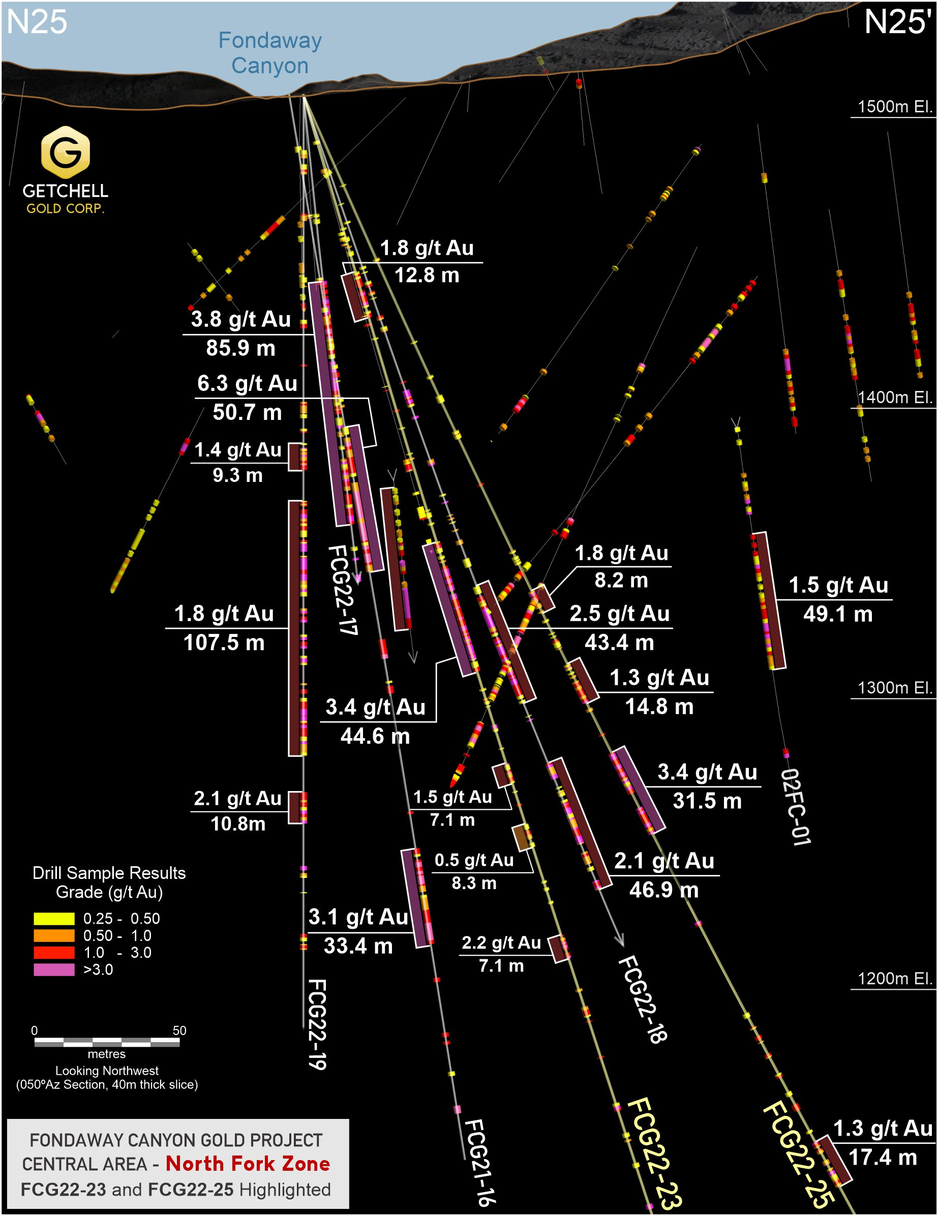
Figure 2: Cross-section highlighting drill holes FCG22-23 and FCG22-25’s gold intervals.
Drill hole FCG22-25 is the last North Fork drill hole completed during the 2022 drill program at Fondaway Canyon. Every hole drilled at North Fork by Getchell Gold in these first three drill campaigns have returned substantive and high-grade gold mineralization. North Fork remains open in all directions along strike and up and down dip and will continue to be a priority drill target in 2023.
With the release of results from hole FCG22-25, there are three drill holes, FCG22-26 to FCG22-28, with assays pending from the 2022 drill program at Fondaway Canyon. FCG22-26 and 27, stationed near the canyon floor on the same pad as FCG21-12 and 15, were respectively designed to test the eastern extent of the Colorado SW zone, while FCG22-28, stationed midway up the north slope, was designed to test the down-dip extent of the Colorado SW zone. Assay results from all three holes are expected in the coming weeks.
Pediment Target
Hole FCG22-24 was designed to test the Pediment target located 2 km to the west of the Central Area. The Pediment target is the westernmost known gold mineralized occurrence along the 3.5 km long E-W trending Fondaway Canyon gold mineralization corridor. The Pediment target is the site of two vertical drill holes completed in 2002, 02FC-10 and 02FC-11, collared 185 metres apart that intersected 27.4 m grading 0.82 g/t Au and 36.6 m grading 0.52 g/t Au respectively.
FCG22-24, drilled to the southeast targeting midway between holes 02FC-10 and 02FC-11’s gold intersections, encountered two mineralized intervals grading 0.72 g/t Au over 3.0 m and 0.64 g/t Au over 1.6 m at respective down hole depths of 140.0 and 239.3 metres. Both mineralized intervals are hosted within a shear structure and exhibit characteristics indicative of mineralization peripheral to a main zone.
We await receipt of the full suite of geochemical analysis, that will assist us with interpretation and vectoring of the gold mineralization in the Pediment target area.

Scott Frostad, P.Geo., is the Qualified Person (as defined in NI 43-101) who reviewed and approved the content and scientific and technical information in the news release.
The 2022 drill core is being processed using the same methods as the 2020 and 2021 drill programs. The core is cut at Bureau Veritas Laboratories’ (“BVL”) facilities in Sparks, Nevada, with the samples analyzed for gold and multi-element analysis in BVL’s Sparks, Nevada and Vancouver, BC laboratories respectively. Gold values are produced by fire assay with an Atomic Absorption finish on a 30-gram sample (BV code FA430) with over limits re-analyzed using method FA530 (30g Fire Assay with gravimetric finish). The multi-element analyses are performed by ICP-MS following aqua regia digestion on a 30g sample (BV code AQ250). Quality control measures in the field include the systematic insertion of standards and blanks.
Highlighted drill intervals are based on minimum interval lengths of 3.3 metres (10 feet), a 0.25 g/t Au cut-off, and a maximum of 3.3 metres of internal dilution, with no top cut applied. Broader reported Intervals may include internal dilution in the calculated average weighted grades. All intervals are reported as downhole drill lengths and additional work is required to determine the true widths.
About Getchell Gold Corp.
The Company is a Nevada focused gold and copper exploration company trading on the CSE: GTCH and OTCQB: GGLDF. Getchell Gold is primarily directing its efforts on its most advanced stage asset, Fondaway Canyon, a past gold producer with a significant resources estimate and on the Star project, a past high-grade copper, gold, and silver small-scale producer. Complementing Getchell’s asset portfolio is Dixie Comstock, a past gold producer with a historic resource and one earlier stage exploration project, Hot Springs Peak (Au). Getchell has the option to acquire 100% of the Fondaway Canyon and Dixie Comstock properties, Churchill County, Nevada.
For further information please visit the Company’s website at www.getchellgold.com or contact the Company by e-mail at info@getchellgold.com or by phone at +1 647 249-4798.

Mr. William Wagener, Chairman & CEO
Getchell Gold Corp.
The Canadian Securities Exchange has not reviewed this press release and does not accept responsibility for the adequacy or accuracy of this news release.

Certain information contained herein constitutes “forward-looking information” under Canadian securities legislation. Forward-looking information includes, but is not limited to, statements with respect to the use of proceeds. Generally, forward-looking information can be identified by the use of forward-looking terminology such as “will” or variations of such words and phrases or statements that certain actions, events or results “will” occur. Forward-looking statements are based on the opinions and estimates of management as of the date such statements are made and they are subject to known and unknown risks, uncertainties and other factors that may cause the actual results to be materially different from those expressed or implied by such forward-looking statements or forward-looking information. Although management of Getchell have attempted to identify important factors that could cause actual results to differ materially from those contained in forward-looking statements or forward-looking information, there may be other factors that cause results not to be as anticipated, estimated or intended. There can be no assurance that such statements will prove to be accurate, as actual results and future events could differ materially from those anticipated in such statements. Accordingly, readers should not place undue reliance on forward-looking statements and forward-looking information. The Company will not update any forward-looking statements or forward-looking information that are incorporated by reference herein, except as required by applicable securities laws.

