FORM 7
MONTHLY PROGRESS REPORT
Name of Listed Issuer: GLOBAL HEMP GROUP INC. (the “Issuer”).
Trading Symbol: GHG

Number of Outstanding Listed Securities: 188,197,016
Date: November 7, 2019

- Provide a general overview and discussion of the development of the Issuer’s business and operations over the previous month. Where the Issuer was inactive disclose this fact.

Scio, Oregon Hemp Project – Covered Bridge Acres (CBA)
Harvesting began in early October and is now 100% complete. As with many areas of Oregon this year, Scio also experienced some weather challenges during the end of the growing season prior to harvest. Ultimately periods of dry weather extended long enough into October to have a successful harvest.
The last batch of hemp plants harvested have just competed the drying process. All biomass from the 2019 harvest will be ready for sale and/or further processing in the coming week. As drying and shucking are completed, the biomass will be weighed and prepared for storage before processing and/or sale.
This year genetics used at the farm were of vastly superior quality as compared to last year. The most recent independent test results of the current harvest was 18.48% Total CBD and compliant with non-detectable Delta 9 THC. Not only was there a 50% increase in CBD content over the previous year’s harvest, there were virtually no males found in the field through the entire growing season. These improved genetics have produced higher quality trimmable flower that is being separated from the general biomass that will be processed into CBD crude oil. Trimmable flower prices are currently selling for upwards of $250 per pound, whereas biomass for extraction last season was priced at $30 to $40 per pound depending on quality.
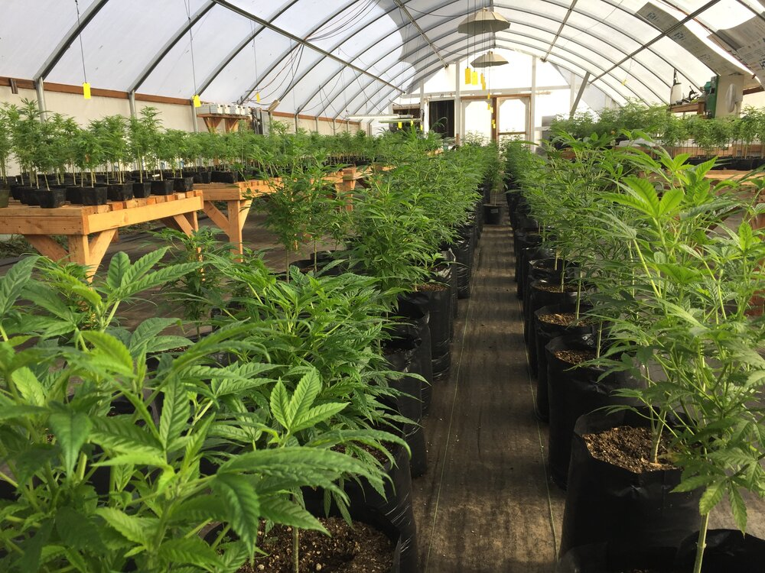
Greenhouse #4 - Winter Crop
The Company has expanded growing operations to include year-round production from its greenhouses. The first greenhouse (approx. 3,000 sq ft) is on track for harvest in January. Expansion into the adjacent greenhouses, will occur over the next 30 days. Drying flower in the larger greenhouses is complete and cultivation will soon expand into all of the greenhouses on the farm. An additional 4,000 sq ft greenhouse will be constructed in Q1 2020 to increase the available indoor growing area. Management is currently evaluating additional greenhouse expansion plans in order to generate a year-round revenue stream for the Company.

Development of a Hemp Biocomposite Drone for Commercial Agricultural Monitoring with Q Worx LLC (“QWorx”)
The “Field Agent” hemp drone has made its inaugural flight over Global Hemp’s joint venture hemp farm in Scio, Oregon. The flight was a great success and marked the beginning of the beta testing phase of the Hemp-Fiber biocomposite drone developed specifically for agricultural monitoring. Further beta testing will be conducted over the coming weeks to continue the development of Field Agent as the project moves into Phase II to begin developing the manufacturing and marketing plan.
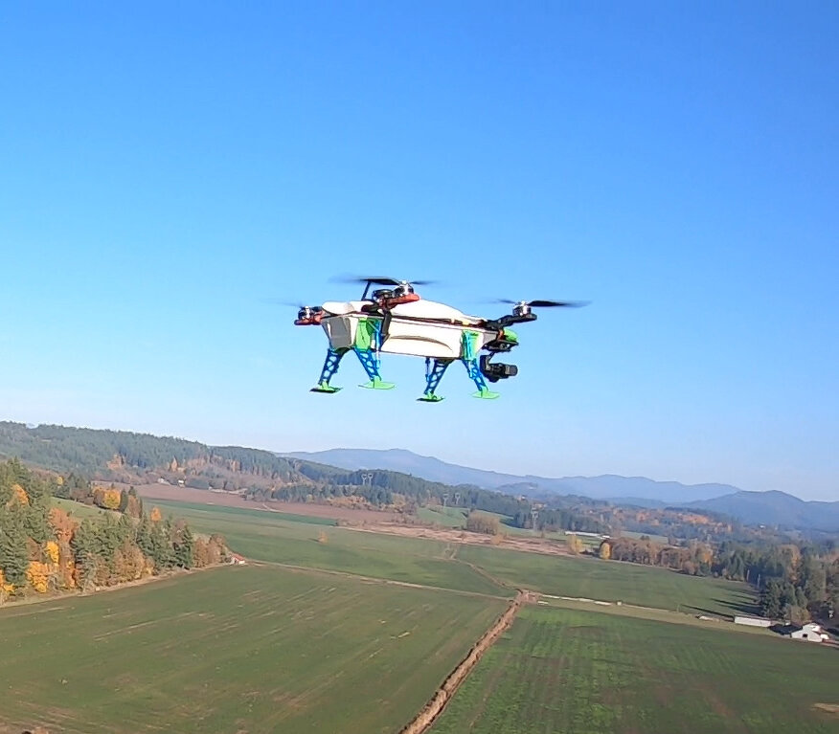
GHG has been impressed with the progress QWorx has made on the development of the Field Agent prototype. In light of this, the Company is excited to announce that it has entered into a second Technology Development Agreement with QWorx to develop a cold air rapid drying system specially designed for drying hemp and cannabis flower. This unique drying system will deliver a much more efficient solution than traditional drying systems that use heat. By using cold air for drying and curing versus the traditional warm air, degradation of cannabinoids that occurs when heat is applied will be greatly reduced.

Instagram
Follow the development of the Scio Oregon Hemp Project and the Field Agent on Instagram @hemp_global

- Provide a general overview and discussion of the activities of management.
See above.

- Describe and provide details of any new products or services developed or offered. For resource companies, provide details of new drilling, exploration or production programs and acquisitions of any new properties and attach any mineral or oil and gas or other reports required under Ontario securities law.

None

- Describe and provide details of any products or services that were discontinued. For resource companies, provide details of any drilling, exploration or production programs that have been amended or abandoned.

None

- Describe any new business relationships entered into between the Issuer, the Issuer’s affiliates or third parties including contracts to supply products or services, joint venture agreements and licensing agreements etc. State whether the relationship is with a Related Person of the Issuer and provide details of the relationship.
None

- Describe the expiry or termination of any contracts or agreements between the Issuer, the Issuer’s affiliates or third parties or cancellation of any financing arrangements that have been previously announced.
None

- Describe any acquisitions by the Issuer or dispositions of the Issuer’s assets that occurred during the preceding month. Provide details of the nature of the assets acquired or disposed of and provide details of the consideration paid or payable together with a schedule of payments if applicable, and of any valuation. State how the consideration was determined and whether the acquisition was from or the disposition was to a Related Person of the Issuer and provide details of the relationship.

None

- Describe the acquisition of new customers or loss of customers.

None

- Describe any new developments or effects on intangible products such as brand names, circulation lists, copyrights, franchises, licenses, patents, software, subscription lists and trade-marks.

None

- Report on any employee hirings, terminations or lay-offs with details of anticipated length of lay-offs.

None

- Report on any labour disputes and resolutions of those disputes if applicable.

None

- Describe and provide details of legal proceedings to which the Issuer became a party, including the name of the court or agency, the date instituted, the principal parties to the proceedings, the nature of the claim, the amount claimed, if any, if the proceedings are being contested, and the present status of the proceedings.

None

- Provide details of any indebtedness incurred or repaid by the Issuer together with the terms of such indebtedness.

None

- Provide details of any securities issued and options or warrants granted.
Security | Number Issued | Details of Issuance | Use of  Proceeds ⁽¹⁾
 |  |  | N/A
⁽¹⁾ State aggregate proceeds and intended allocation of proceeds.

- Provide details of any loans to or by Related Persons.

None

- Provide details of any changes in directors, officers or committee members.

None

- Discuss any trends which are likely to impact the Issuer including trends in the Issuer’s market(s) or political/regulatory trends.

None

Certificate of Compliance

The undersigned hereby certifies that:
- The undersigned is a director and/or senior officer of the Issuer and has been duly authorized by a resolution of the board of directors of the Issuer to sign this Certificate of Compliance.
- As of the date hereof there where is no material information concerning the Issuer which has not been publicly disclosed.
- The undersigned hereby certifies to CNSX that the Issuer is in compliance with the requirements of applicable securities legislation (as such term is defined in National Instrument 14-101) and all CNSX Requirements (as defined in CNSX Policy 1).
- All of the information in this Form 7 Monthly Progress Report is true.
Dated: November 7, 2019 .
Charles Larsen
Name of Director or Senior Officer

“Charles Larsen”
Signature

CEO
Official Capacity

Issuer Details  Name of Issuer  Global Hemp Group, Inc. | For Month End  October 2019 | Date of Report  YY/MM/DD  2019/10/06
Issuer Address #106 – 1169 Mt. Seymour Road
City/Province/Postal Code  North Vancouver, BC V7H 2Y4 | Issuer Fax No.  N/A | Issuer Telephone No.  (424) 354-2998
Contact Name  Charles Larsen | Contact Position  CEO | Contact Telephone No.  (424) 354-2998
Contact Email Address  info@globalhempgroup.com | Web Site Address  www.globalhempgroup.com

