Vejii Signs Agreement to Distribute Franklin Farms™ Plant-Based Meats on ShopVejii.com

Franklin Farms full line of plant-based meat products including its newly launched soy-free, low-fat, and allergen-free chickpea tofu

Vancouver, BC, Canada – December 2nd 2021 – Vejii Holdings Ltd., (CSE: VEJI) (“Vejii” or the “Company”), is pleased to announce that Franklin Farms’ unique line of plant-based meat products will be launching on ShopVejii.com in the US this January.

Franklin Farms™, a division of Keystone Natural Holdings, is known for its extensive portfolio of plant-based protein options including plant-based burgers, seitan, tofu, tempeh, fusion tofu and a newly launched chickpea tofu. The brand aims to be a one-stop-shop for plant-based protein options.

“Franklin Farms builds trust with our customers through our focus on ingredients, experience, and convenience - or farm, flavor and function, as we like to say,” said Cindy Wong, Vice President of Sales, Franklin Farms. “Our new line of tofu made from chickpeas offers consumers a soy-free option that is low-fat and allergen-free. Franklin Farms is excited to partner with Vejji as there is a high-demand for online shopping for our consumer base. We are excited that consumers will have a very convenient way to access our great-tasting meatless options.”

“Online shopping has become a key part of so many consumers’ routines after the COVID-19 pandemic, and now, with new COVID variants continuing to emerge - online grocery options are likely to continue to hold strong and even grow in popularity, with our nationwide distribution, and ability to deliver items contact-free, cold packed within 2-3 days, we are proud to be able to support large brands like Franklin Farms with their online strategy during this time of transition,” said Kory Zelickson, CEO of Vejii Holdings. “Adding further selection for our customers, and expanding one of the best selling categories on our site with a brand such as Franklin Farms is an exciting opportunity for our company. With US Ecommerce grocery sales expected to reach over $100 billion dollars in the coming years, Vejji is well positioned to capitalize on this market opportunity.”
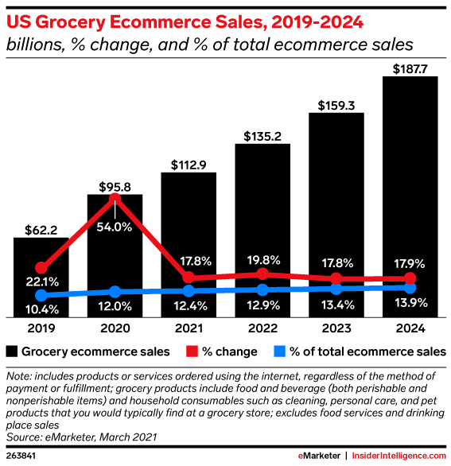

The Vejii marketplace was built for rapid scale allowing brands to reach national exposure utilizing Vejii's existing infrastructure of data, tech, marketing and logistics. Recent data show more shoppers are opting for plant-based foods during the pandemic, and sales of meat alternatives are expected to accelerate as the nation faces temporarily tighter supplies of meat, dairy, and eggs. ^{[2]}

[1] https://www.emarketer.com/content/2021-online-grocery-sales-will-surpass-100-billion
[2] https://www.adweek.com/brand-marketing/plant-based-food-continued-to-sprout-during-the-pandemic/
About Franklin Foods

Franklin Farms began over 20 years ago as a simple mushroom farm in Franklin, Connecticut. Since then, they have been creating exciting yet good-for-you meatless meals from field to table. Great ingredients make great foods which is why Franklin Farms starts with flavor-forward, high-quality plant proteins. They offer a range of health-conscious plant-based protein products that span day parts, meal types, and taste profiles. From end to end, Franklin Farms makes it easy and delicious for consumers to cook with and eat great-tasting plant-based proteins.

About Vejii Holdings Inc.
Headquartered in Kelowna B.C., Vejii is a unified digital marketplace and fulfillment platform featuring thousands of plant-based and sustainable-living products from a growing list of hundreds of vendors. The platform offers an easy-to-use, omnichannel experience for both vendors and buyers, leveraging big data and artificial intelligence to elegantly connect brands with a targeted consumer base, both organically and through specialized marketing programs. Dynamic fulfillment services empower brands to offer fast and reliable delivery, with ongoing engagement being driven through features like smart lists, subscription programs, reordering functions, sampling programs, and more.
Information on the Company and its many products can be accessed through the links below.
VejiiHoldings.com
ON BEHALF OF THE BOARD OF DIRECTORS:
Kory Zelickson
Director and CEO
For investor inquiries or further information, please contact: IR@VejiiHoldings.com
Find Vejii on Social Media: on Instagram, Facebook, Twitter and LinkedIn
No securities regulatory authority has either approved or disapproved of the contents of this news release.
This news release does not constitute an offer to sell or a solicitation of an offer to buy any securities of Vejii in any jurisdiction in which such offer, solicitation or sale would be unlawful. The securities have not been and will not be registered under the United States Securities Act of 1933, as amended (the “U.S. Securities Act“), or any state securities laws. Accordingly, the securities may not be offered or sold within the U.S. or to U.S. persons (as defined in Regulation S under the U.S. Securities Act) unless registered under the U.S. Securities Act and applicable state securities laws, or pursuant to exemptions from the registration requirements of the U.S. Securities Act and applicable state securities laws.
CAUTION REGARDING FORWARD-LOOKING STATEMENTS
This press release contains certain forward-looking statements within the meaning of federal securities laws with respect to Vejii Holdings Ltd (the "Company"), including statements relating to the Company's future performance; data shared for reference of market size, on-boarding of vendors and product categories; and expectations regarding the Company's rollout plan; and the effect of COVID-19 on the Company's business. These forward-looking statements generally are identified by words such as "believe," "project," "expect," "anticipate," "estimate," "intend," "strategy," "future," "opportunity," "plan," "may," "should," "will," "would," and similar expressions. Forward-looking statements are predictions, projections, and other statements about future events that are based on current expectations and assumptions and, as a result, are subject to risks and uncertainties. Many factors could cause actual future events to differ materially from the forward-looking statements in this press release. Forward-looking statements speak only as of the date they are made. Readers are cautioned not to put undue reliance on forward-looking statements, and, except as required by law, the Company assumes no obligation and does not intend to update or revise these forward-looking statements, whether as a result of new information, future events, or otherwise.--

