FORM 7
MONTHLY PROGRESS REPORT
Name of Listed Issuer: Golden Independence Mining Corp. (the “Issuer”).
Trading Symbol: IGLD
Number of Outstanding Listed Securities: 62,705,922
Date: November 10, 2022
This Monthly Progress Report must be posted before the opening of trading on the fifth trading day of each month. This report is not intended to replace the Issuer’s obligation to separately report material information forthwith upon the information becoming known to management or to post the forms required by Exchange Policies. If material information became known and was reported during the preceding month to which this report relates, this report should refer to the material information, the news release date and the posting date on the Exchange website.
This report is intended to keep investors and the market informed of the Issuer’s ongoing business and management activities that occurred during the preceding month. Do not discuss goals or future plans unless they have crystallized to the point that they are "material information" as defined in the Policies. The discussion in this report must be factual, balanced and non-promotional.
General Instructions
- Prepare this Monthly Progress Report using the format set out below. The sequence of questions must not be altered nor should questions be omitted or left unanswered. The answers to the items must be in narrative form. State when the answer to any item is negative or not applicable to the Issuer. The title to each item must precede the answer.
- The term “Issuer” includes the Issuer and any of its subsidiaries.
- Terms used and not defined in this form are defined or interpreted in Policy 1 – Interpretation and General Provisions.
Report on Business
- Provide a general overview and discussion of the development of the Issuer’s business and operations over the previous month. Where the Issuer was inactive disclose this fact.
Golden Independence Mining Corp (Formerly, 66 Resources Corp.) (“the Company”) was incorporated on May 31, 2017 under the laws of British Columbia. The address of the Company’s corporate office and its principal place of business is 503-905 Pender Street W, Vancouver, British Columbia, Canada.
On September 8, 2020, the Company’s name was changed from 66 Resources Inc. to Golden Independence Mining Corp. and the Company began trading under the stock symbol “IGLD”. The Company’s CUSIP number for the common shares was also updated on September 8, 2020 to 381083104.
The Company’s principal business activities include the acquisition and exploration of mineral property assets.
On January 20, 2022, Golden Independence announced that Christos Doulis has resigned as the Chief Executive Officer and a director of the Company effective to pursue other endeavours. Jeremy Poirier, a director of the Company, has been appointed as Interim Chief Executive Officer until a suitable permanent replacement is located.
On February 8, 2022, Golden Independence announced the filing the independent preliminary economic assessment (PEA) for the company's Independence project. Independence PEA highlights include:
• After-tax NPV (net present value) (5-per-cent discount rate) of $35-million (U.S.) with an IRR (internal rate of return) of 18 per cent at $1,700 (U.S.) per ounce (oz) gold and $24 (U.S.) per oz silver;
• Significant leverage to metal prices with after-tax NPV (5-per-cent discount rate) of $45-million (U.S.) and IRR of 22 per cent at spot prices;
• Average annual production of 32,050 oz gold at an AISC (all-in sustaining cost) of $1,078 (U.S.) per oz (net of silver credits);
• LOM production of 195,443 oz gold and 1,281,420 oz silver;
• LOM after-tax cash flow of $59-million (U.S.) at base case prices and $72-million (U.S.) at spot prices;
• Initial capital of $63-million (U.S.), including working capital and contingencies;
• Mine life of 6.1 years exploiting only 60 per cent of the near-surface resource contained within a $1,800 (U.S.) per oz gold price pit.
The report, dated Jan. 24, 2022, and entitled "Preliminary Economic Assessment NI 43-101 Technical Report on the Independence Heap Leach Project, Ladner County, Nevada, USA,", has been filed on SEDAR under the company's user profile and on the company's website. 9 This PEA is preliminary in nature and includes inferred mineral resources that are considered too speculative geologically to have the economic considerations applied to them that would enable them to be categorized as mineral reserves and there is no certainty that the PEA will be realized.
On March 4, 2022, Golden Independence announced director Don McDowell has resigned from the board.
On March 9, Golden Independence provided an update on the continuing permitting activities for the company's Independence oxide heap leach project. The Company announced the engagement of EM Strategies, a WestLand Resources Inc. company, to conduct baseline biological and cultural studies to facilitate an engineering study for the power line (and production water pipeline) route to develop and operate the project. The results of the 2022 field surveys will be presented in a baseline biology report (BBR), which will include data from field surveys performed in 2021 and incorporate relevant botanical and wildlife data from previous surveys performed at the adjacent Phoenix mine and will be submitted to the Nevada Bureau of Land Management (BLM) for review. These studies will support the engagement with the numerous state and federal agencies to permit the utility corridor for the proposed power and water lines, as outlined in the preliminary economic assessment (PEA) and inclusive of a 300-foot buffer..
On March 16, Golden Independence provided an update from continuing exploration activities at the company's Independence oxide heap leach project. Since tabling a preliminary economic assessment for near-surface heap-leach operation at the project, the Company has been focused on improving the metrics of the project which yielded an after-tax net present value at a 5-per-cent discount of $45-million (U.S.) and internal rate of return of 22 per cent. Specifically, exploration has been focused on delineating additional near-surface oxide resources to expand the open pit and reclassify waste with mineralized material. Both of the aforementioned would have the possibility to increase the production profile, extend the mine life and improve project economics from a cost and valuation perspective. 4 The exploration program consists of surface sampling both within the current open pit and to the east and west of the pit boundary, in addition to sampling of previously unsampled drilling done by previous operators. A total of 152 grab samples were taken, with 76, or half, of the samples taken returning values of 0.4 gram per tonne gold or better, the assumed average grade from the PEA. Forty-five returned values in excess of one g/t gold, 16 returned values in excess of five g/t gold and eight returned values in excess of 10 g/t gold to a maximum of 43.9 g/t gold. The sampling has loosely defined three target areas:
• Central Hill -- largely undrilled 200-metre-in-diameter area between the north and south pits;
• Structural zone -- a probable linear structure along the eastern boundary of the south pit, approximately 500 metres in length;
• Rebel zone -- a loosely defined 300-metre-long trend near the eastern boundary of the property.
Figure 2022-Mar-16-1. Independence Surface Sampling
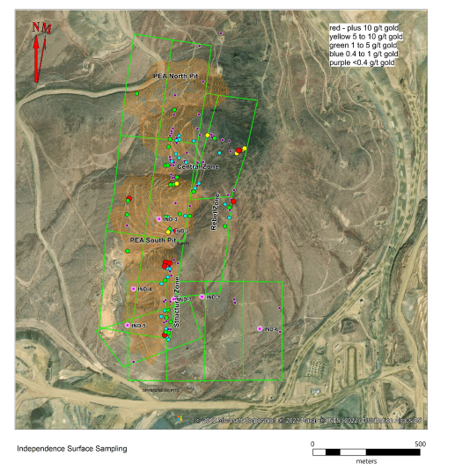
A number of the 0.4-g/t-gold-or-better samples lie within the boundaries of the PEA pits, largely in the central and south. The company is very encouraged with the assay results as the sampling suggests the 5 company may find additional mineralization, and potentially additional ounces, within the PEA pit, thereby potentially enhancing the project economics.
Table 2022-Mar-16-1. Surface Sampling Highlights
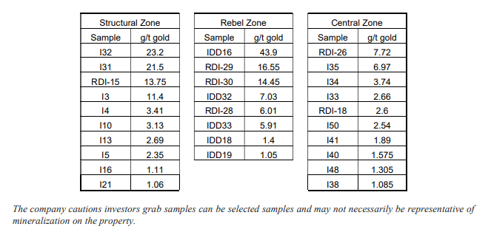
The company is also revisiting the seven deep core holes drilled by previous operators in the southern portion of the claim block to evaluate the deep skarn, which forms the basis of the company's inferred resource of 3.8 million tonnes grading 6.53 g/t gold (796,200 ounces of gold), which ranges in depth from 2,800 to 2,900 feet (850 to 880 metres). Only one of the seven holes was sampled through the top section (zero to 500 feet) of these holes, while the near-surface potential of the remaining holes in unknown. The core has been stored on site and the company plans to relog and sample the upper 500-plus feet of the holes.
On March 30, 2022, Golden Independence announced the acquisition by staking of the Fraser Lake copper project located in the Quesnel Trough of Central British Columbia. The project is comprised of three claim blocks totalling approximately 9,900 hectares and are located between 40 to 55 kilometres northwest of Fraser Lake, BC.
On April 12, 2022, Golden Independence announced that Ben Hinkle has been appointed to the Board of Directors of the Company.
On April 19, 2022, Golden Independence announced that Jordan Carroll has been appointed to the Board of Directors of the Company.
On June 8, 2022, Golden Independence provided an update on continuing permitting and project-related activities at its Independence heap-leach development project in Nevada.
The State of Nevada Division of Environmental Protection (NDEP) has approved the Company's geochemical sampling and analysis plan for the proposed open-pit heap-leach operation as outlined in the January 2022 Preliminary Economic Assessment. This represents the culmination of over one year's worth of humidity cell testing and analysis of 150 selected representative samples.
The Company engaged NV Energy, the leading power and utility company servicing northern and southern Nevada, to provide an engineering study on providing independent power services for the development and operation of the Independence project. The commencement of this study comes as a result of successful wildlife and fauna studies across the proposed new corridor for independent power and services to support the proposed project. 6
The Company has filed two (2) amended Notice of Intent permits with the Nevada Bureau of Land Management (Nevada BLM) for additional oxide resource expansion and geotechnical drilling consisting of 41 proposed drill holes totaling an estimated 27,500 feet.
The Company has also undertaken a program of relogging and resampling of historical drilling, as the deeper drilling on the project targeting the skarn mineralization left the upper portions of mineralization uninvestigated. Specifically, 725 feet of samples from IND#1 (from 144.5 - 136.5 ft and 325 - 607 ft) and IND#7 (8 - 97 ft, 197.5 - 213 ft, 236 - 312 ft, and 2,604 - 2,703 ft) have been sent to the lab for assays.
On September 06, 2022, Golden Independence announced an update on the its newly acquired Fraser Lake copper project located proximal to the Quesnel Trough of Central British Columbia. The 9,900-hectare project is comprised of three claim blocks located between 40 to 55 kilometres northwest of Fraser Lake, BC.
The Company engaged an Independent Qualified Person, as defined in National Instrument 43-101, to perform an assessment of the project. Mr. Warren Robb, P.Geo, completed a property visit in early August to review the geology, collect rock samples for background litho-geochemistry, and review the topography and geomorphology to design an exploration program for the upcoming technical report on the porphyry copper-molybdenum project. Mr. Robb is a seasoned exploration geologist with over 35 years of mineral exploration experience and has worked with numerous senior and junior mining companies throughout Canada, the United States, China, Africa and South America. Mr. Robb graduated from the University of British Columbia in 1987 with a Bachelor of Science in Geology. The exploration target is porphyry copper and molybdenum associated with a series of Endako plutons intruding Cache Creek complex, carbonate, clastic and volcanic rocks. The Quest West regional lake sediment geochemistry identified areas of anomalous copper and/or molybdenum in the drainage systems from the low ridges hosting the plutons. A 2008 AeroTEM III airborne electromagnetic and magnetometer survey identified magnetic and/or electromagnetic anomalies up drainage from the anomalous geochemistry and make compelling exploration targets.

Figure 1. Fraser Lake Claim Blocks
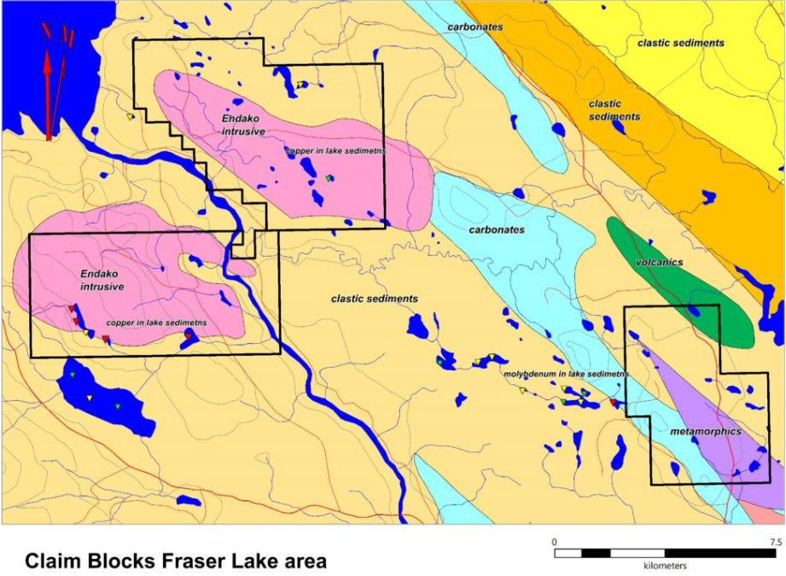

On October 21, 2022, Golden Independence announced that subject to the approval of the Canadian Securities Exchange, it intends to consolidate its issued share capital on the basis of one (1) new common share without par value for every 15 existing common shares without par value (the “Share Consolidation“). No fractional shares will be issued in connection with the Share Consolidation and any fractional shares arising upon the Share Consolidation comprising less than one-half of one share will be deemed to have been tendered by the shareholder to the Company by way of gift and for cancellation and returned to the authorized but unissued share structure of the Company and any fractional shares arising upon the Share Consolidation comprising greater than or equal to one-half of one share will be converted into one whole share. The Company’s name and trading symbol will remain the same.

- Provide a general overview and discussion of the activities of management.
Please see Item #1.
- Describe and provide details of any new products or services developed or offered. For resource companies, provide details of new drilling, exploration or production programs and acquisitions of any new properties and attach any mineral or oil and gas or other reports required under Ontario securities law.
None.
- Describe and provide details of any products or services that were discontinued. For resource companies, provide details of any drilling, exploration or production programs that have been amended or abandoned.
None.
- Describe any new business relationships entered into between the Issuer, the Issuer’s affiliates or third parties including contracts to supply products or services, joint venture agreements and licensing agreements etc. State whether the relationship is with a Related Person of the Issuer and provide details of the relationship.
None.
- Describe the expiry or termination of any contracts or agreements between the Issuer, the Issuer’s affiliates or third parties or cancellation of any financing arrangements that have been previously announced.
None.
- Describe any acquisitions by the Issuer or dispositions of the Issuer’s assets that occurred during the preceding month. Provide details of the nature of the assets acquired or disposed of and provide details of the consideration paid or payable together with a schedule of payments if applicable, and of any valuation. State how the consideration was determined and whether the acquisition was from or the disposition was to a Related Person of the Issuer and provide details of the relationship.
None.
- Describe the acquisition of new customers or loss of customers.
None.
- Describe any new developments or effects on intangible products such as brand names, circulation lists, copyrights, franchises, licenses, patents, software, subscription lists and trade-marks.
None.
- Report on any employee hirings, terminations or lay-offs with details of anticipated length of lay-offs.
None.
- Report on any labour disputes and resolutions of those disputes if applicable.
None.
- Describe and provide details of legal proceedings to which the Issuer became a party, including the name of the court or agency, the date instituted, the principal parties to the proceedings, the nature of the claim, the amount claimed, if any, if the proceedings are being contested, and the present status of the proceedings.

None.
- Provide details of any indebtedness incurred or repaid by the Issuer together with the terms of such indebtedness.
None.
- Provide details of any securities issued and options or warrants granted.
Please see Item #1.
- Provide details of any loans to or by Related Persons.
None.
- Provide details of any changes in directors, officers or committee members.
None.
- Discuss any trends which are likely to impact the Issuer including trends in the Issuer’s market(s) or political/regulatory trends.
In March 2020, the World Health Organization declared coronavirus COVID-19 a global pandemic. At this time it is not possible for the Issuer to predict the duration or magnitude of the adverse results of the outbreak and its effects on the Issuer’s business however the Issuer is moving forward with its planned exploration on its mineral properties.

Certificate of Compliance
The undersigned hereby certifies that:
- The undersigned is a director and/or senior officer of the Issuer and has been duly authorized by a resolution of the board of directors of the Issuer to sign this Certificate of Compliance.
- As of the date hereof there were is no material information concerning the Issuer which has not been publicly disclosed.
- The undersigned hereby certifies to the Exchange that the Issuer is in compliance with the requirements of applicable securities legislation (as such term is defined in National Instrument 14-101) and all Exchange Requirements (as defined in CNSX Policy 1).
- All of the information in this Form 7 Monthly Progress Report is true.
Dated November 10,2022
Jeremy Poirier
Name of Director or Senior Officer
“Jeremy Poirier”

Signature

CEO
Official Capacity

Issuer Details  Name of Issuer  Golden Independence Mining Corp. | For Month End  October 31, 2022 | Date of Report  YY/MM/D  November 10, 2022
Issuer Address
503-905 West Pender Street
City/Province/Postal Code  Vancouver, BC V6C 1L6 | Issuer Fax No.  (N/A) | Issuer Telephone No.  (1.604.722.9842)
Contact Name  Jeremy Poirier | Contact Position  CEO | Contact Telephone No.  (1.604.722.9842)
Contact Email Address  info@goldenindependence.co | Web Site Address  goldenindependence.co

