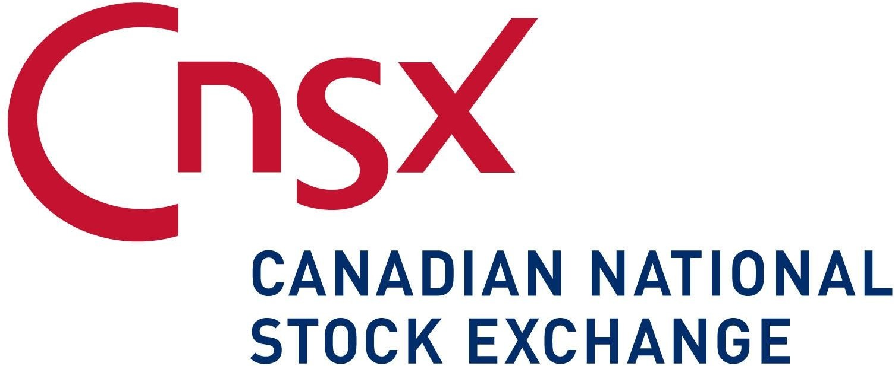
FORM 7

MONTHLY PROGRESS REPORT
Name of CNSX Issuer: James Bay Resources Limited (“the Company”)

Trading Symbol: JBR

Number of Outstanding Listed Securities: 51,014,068 common shares

Date: August 6, 2020

This Monthly Progress Report must be posted before the opening of trading on the fifth trading day of each month. This report is not intended to replace the Issuer’s obligation to separately report material information forthwith upon the information becoming known to management or to post the forms required by the CNSX Policies. If material information became known and was reported during the preceding month to which this report relates, this report should refer to the material information, the news release date and the posting date on the CNSX.ca website.

This report is intended to keep investors and the market informed of the Issuer’s ongoing business and management activities that occurred during the preceding month. Do not discuss goals or future plans unless they have crystallized to the point that they are "material information" as defined in the CNSX Policies. The discussion in this report must be factual, balanced and non-promotional.

General Instructions

- Prepare this Monthly Progress Report using the format set out below. The sequence of questions must not be altered nor should questions be omitted or left unanswered. The answers to the items must be in narrative form. State when the answer to any item is negative or not applicable to the Issuer. The title to each item must precede the answer.

- The term “Issuer” includes the Issuer and any of its subsidiaries.

- Terms used and not defined in this form are defined or interpreted in Policy 1 – Interpretation and General Provisions.

Report on Business

- Provide a general overview and discussion of the development of the Issuer’s business and operations over the previous month. Where the Issuer was inactive disclose this fact.
The Company remains focused on its efforts to complete a transaction in relation to its interest in Crestar Integrated Natural Resources Limited (“Crestar”) and OML 25 in Nigeria. In addition, the Company continues to hold its investment in Cerrado Gold Inc, which operates an exploration project and an operating mine in South America.
There were no significant developments over the previous month. The global outbreak of COVID-19 (coronavirus), had a significant impact on businesses through restrictions put in place by the Canadian government regarding travel, business operations and isolations/quarantine orders. This has restricted the Company’s business development of its investments. While the extent of the impact is unknown, the President and CEO of the Company has continued to extend loans to finance the working capital of the Company.

- Provide a general overview and discussion of the activities of management.
The Company continued to negotiate with various parties on the potential sale of its interest in OML 25 but has not yet progressed to a point of reaching a binding agreement. The Company through its subsidiary (Crestar) continues to be involved in litigation in Nigeria in relation to its interests in OML 25, and there have been no material developments in that ongoing litigation recently.

- Describe and provide details of any new products or services developed or offered. For resource companies, provide details of new drilling, exploration or production programs and acquisitions of any new properties and attach any mineral or oil and gas or other reports required under Ontario securities law.
None to report for the period

- Describe and provide details of any products or services that were discontinued. For resource companies, provide details of any drilling, exploration or production programs that have been amended or abandoned.
None to report for the period

- Describe any new business relationships entered into between the Issuer, the Issuer’s affiliates or third parties including contracts to supply products or services, joint venture agreements and licensing agreements etc. State whether the relationship is with a Related Person of the Issuer and provide details of the relationship.
None to report for the period
- Describe the expiry or termination of any contracts or agreements between the Issuer, the Issuer’s affiliates or third parties or cancellation of any financing arrangements that have been previously announced.
None to report for the period

- Describe any acquisitions by the Issuer or dispositions of the Issuer’s assets that occurred during the preceding month. Provide details of the nature of the assets acquired or disposed of and provide details of the consideration paid or payable together with a schedule of payments if applicable, and of any valuation. State how the consideration was determined and whether the acquisition was from or the disposition was to a Related Person of the Issuer and provides details of the relationship.
None to report for the period

- Describe the acquisition of new customers or loss of customers.
None to report for the period

- Describe any new developments or effects on intangible products such as brand names, circulation lists, copyrights, franchises, licenses, patents, software, subscription lists and trade-marks.
None to report for the period

- Report on any employee hirings, terminations or lay-offs with details of anticipated length of lay-offs.
None to report for the period

- Report on any labour disputes and resolutions of those disputes if applicable.
None to report for the period

- Describe and provide details of legal proceedings to which the Issuer became a party, including the name of the court or agency, the date instituted, the principal parties to the proceedings, the nature of the claim, the amount claimed, if any, if the proceedings are being contested, and the present status of the proceedings.

In October 2019, the Company has commenced legal proceedings in the State of California to recover overdue amounts owed pursuant to a secured loan agreement with CBH. The legal proceeding is also commenced against companies related to the Borrower (collectively, the "Borrowers"), along with David Bunevacz, a consultant of the Borrower, Mary Hayca Bunevacz, an executive and major shareholder of the Borrower, and 2 individuals who personally guaranteed the obligations of the Borrowers. The legal action involves filing a Complaint with the Superior Court of the State of California, County of Los Angeles, for breach of contract, unjust enrichment, fraud, recovery of possession of personal property, and appointment of a receiver.

Under the terms of the Secured Loan Agreement, James Bay advanced in aggregate US$3.5 million to the Borrower (the "Secured Loan"), with the Secured Loan plus all accrued and unpaid interest repayable on the six-month anniversary of advancing the funds (the "Maturity Date"). The Secured Loan is fully secured by all of the assets, undertaking and business of the Borrowers, and personally guaranteed by Mary Hayca Bunevacz along with 2 other individuals associated with the Borrowers. Up to and since the Maturity Date, James Bay had been working with the Borrower and its management in attempts to sell various inventories and receive payment of its Secured Loan, but those efforts have proven fruitless. With interest and expenses, the total amount currently outstanding under the Secured Loan Agreement is approximately US$4.3 million, all of which is being claimed by James Bay in the legal proceedings.

- Provide details of any indebtedness incurred or repaid by the Issuer together with the terms of such indebtedness.
None to report for the period

- Provide details of any securities issued and options or warrants granted.

On August 5, 2020, the Company announced the closing of a non-brokered private placement (the "Offering") of 4,316,667 units ("Units") at a price of $0.06 per Unit, for aggregate gross proceeds of $259,000. Each Unit is comprised of one common share (a "Common Share") and one Common Share purchase warrant (each a "Warrant") in the capital of James Bay. Each Warrant comprising part of the Units is exercisable for a Common Shares at a price of $0.12 for 2 years from the date of issuance.

- Provide details of any loans to or by Related Persons.
The Company’s President and CEO continued to extent loan to JBR to finance working capital. As at July 31, 2020, the Company owed a balance of $234,416. The loan bears an interest rate of 4.75% and due on demand.
- Provide details of any changes in directors, officers or committee members.
None to report for the perio
- Discuss any trends which are likely to impact the Issuer including trends in the Issuer’s market(s) or political/regulatory trends.
The Company, through its subsidiary, holds an interest in a petroleum property in Nigeria. As such, it is exposed to the laws governing the Nigerian Petroleum industry with respect to matters such as taxation, environmental compliance, and other regulatory and political factors as well as shifts in politics and labour unrest. Any of which could adversely affect the Company and its future exploration and production activities.

Certificate of Compliance

The undersigned hereby certifies that:

- The undersigned is a director and/or senior officer of the Issuer and has been duly authorized by a resolution of the board of directors of the Issuer to sign this Certificate of Compliance.

- As of the date hereof there were is no material information concerning the Issuer which has not been publicly disclosed.

- The undersigned hereby certifies to CNSX that the Issuer is in compliance with the requirements of applicable securities legislation (as such term is defined in National Instrument 14-101) and all CNSX Requirements (as defined in CNSX Policy 1).

- All of the information in this Form 7 Monthly Progress Report is true. Dated August 6, 2020

Stephen Shefsky
Name of Director or Senior Officer

“Stephen Shefsky”
Signature

Director, President and CEO
Official Capacity

Issuer Details  Name of Issuer  James Bay Resources Limited | For Month End  July 31, 2020 | Date of Report YY/MM/DD  2020/08/06
Issuer Address
110 Yonge Street | Suite 501
City/Province/Postal Code  Toronto, ON M5C 1T4 | Issuer Fax No.  (416) 366-4201 | Issuer Telephone No.  (416) 366-4200
Contact Name  Jennifer Ta, CPA, CA | Contact Position  Corporate Controller | (416) 366-4200
Contact Email Address  jta@jbrlimited.com | Web Site Address  www.jamesbayresources.com

