Adastra Announces Successful Soft Launch
of Endgame Brand in BC
Langley, BC, April 7, 2022 – Adastra Holdings Ltd. (CSE:XTRX) (FRA:D2EP) ("Adastra" or the “Company”), a Health Canada Licensed cannabis company focused on processing, sales, organoleptic and analytical testing, is excited to announce that its newly developed brand, Endgame, which was soft-launched last week, sold out in less than 24 hours of delivery to the British Columbia Liquor Distribution Branch (“BCLDB”). Endgame’s initial SKU delivery included two varieties of vaporizer cartridges: Mosa x Blood Orange and White Rhino x Raspberry Lemon.
“We are thrilled to bring Endgame, our first exclusive in-house brand, to market,” said Michael Forbes, Chief Executive Officer, Corporate Secretary and Director of Adastra. “Selling out on day one of launch demonstrates consumer appetite for a lower cost vaporizer that delivers on quality, flavour and convenience. With added production capacity, new orders are quickly being shipped to supply our customers.”

In early April, Adastra plans to deliver two new Endgame shatter products to the BCLDB: Black Cherry Punch x Jack Herer and White Rhino. These hydrocarbon extracted cannabis concentrates are gaining popularity in the Canadian cannabis market for their full spectrum extract potency and flavour.

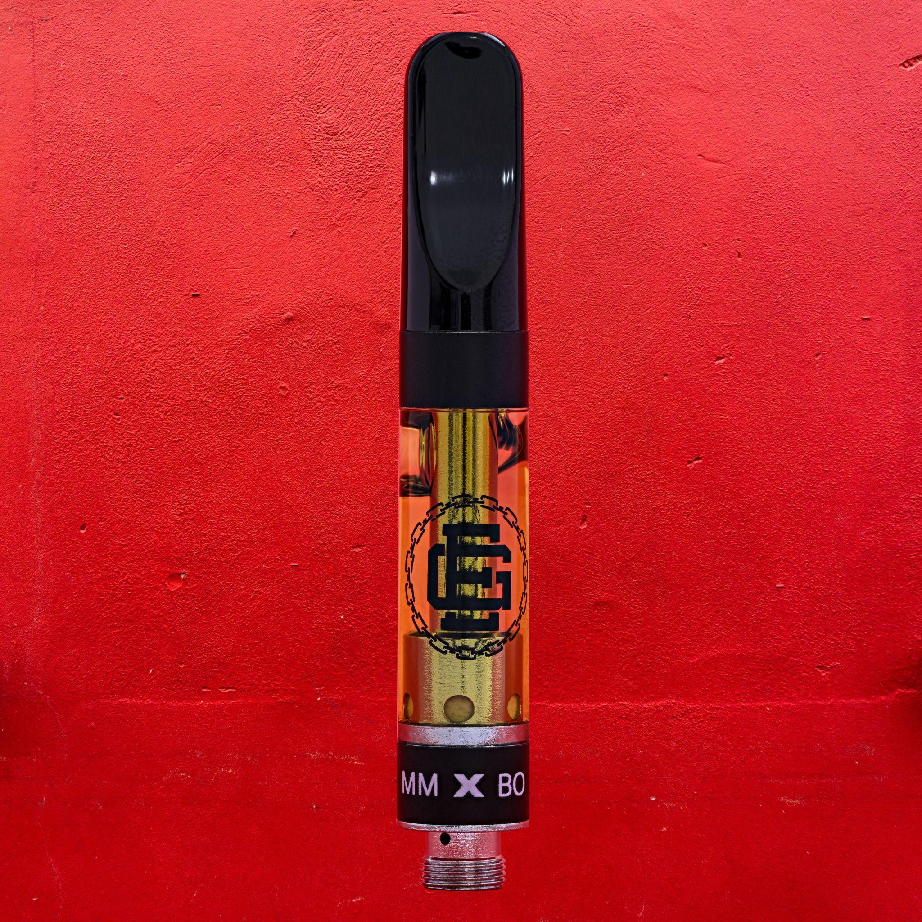

About Adastra Holdings Ltd.
Founded in 2018 and formerly known as Phyto Extractions Inc., Adastra is a leading manufacturer and supplier of innovative ethnobotanical and cannabis science products designed for the adult-use and medical markets and forward-looking therapeutic applications. Adastra is recognized as a high-capacity processor and co-manufacturer throughout Canada. Adastra is known for its popular line of Phyto Extractions branded cannabis concentrate products available on shelves at over 1,400 adult-use retailers across the country. The Company also operates Adastra Labs, a 13,500 sq. ft. agricultural-scale Health Canada licensed facility located in Langley, BC, focused on extraction, distillation, and manufacturing of cannabis-derived products. Adastra has successfully taken steps in becoming a licensed cultivator, tester, extractor, and seller of controlled substances, including Psilocybin, Psilocin, MDMA, N-Dimethyltryptamine (DMT), 5- MeO-DMT, and LSD by applying for a Controlled Substances Dealer’s Licence, which is under review by Health Canada. Pending Health Canada approval, Adastra is poised to be a drug formulation and development leader in this emerging sector. In addition, with the recent acquisition of 1225140 B.C. Ltd., doing business as PerceiveMD, Adastra operates a multidisciplinary centre for medical cannabis and psychedelic therapies, working alongside doctors and healthcare professionals within the regulated environment to help create efficacious remedies that address the actual needs of patients.

For further information:

Michael Forbes, CEO, Corporate Secretary & Director
P: (778) 715 5011
E: michael@adastraholdings.ca

Forward-Looking Information
This news release contains forward-looking information within the meaning of Canadian securities legislation concerning the business of the Company. Forward-looking information is based on certain key expectations and assumptions made by the management of the Company. Although the Company believes that the expectations and assumptions on which such forward‐looking information is based are reasonable, undue reliance should not be placed on the forward‐looking information because the Company can give no assurance that they will prove to be correct. Forward‐looking information in this news release includes statements with respect to: Endgame brand’s initial SKU launch and sell through; and the anticipated launch of new Endgame shatter products at the BCLDB this month. There are numerous risks and uncertainties that could cause actual results and the Company’s plans and objectives to differ materially from those expressed in the forward‐looking information. Important factors that could cause actual results to differ materially from those expressed in the forward-looking information include: the availability of a qualified workforce; changes in regulations or licensing affecting the Company’s business; reduced demand for cannabis and cannabis related products; reductions in the Company’s retail space and store locations; and other factors beyond the control of the Company. These and all subsequent written and oral forward‐looking information are based on estimates and opinions of management on the dates they are made and are expressly qualified in their entirety by this notice. Except as required by law, the Company does not intend to update these forward‐looking statements.
SOURCE Adastra Holdings Ltd.

