FansUnite Entertainment Announces Strategic Technology Partnership with TGS Esports Inc.
-The partnership will launch prediction games for major live esports events-

VANCOUVER, British Columbia (March 17, 2021) – FansUnite Entertainment Inc. (CSE: FANS) (OTCQB: FUNFF) (“FansUnite” or the “Company”) is pleased to announce that it has entered into a strategic partnership with TGS Esports Inc. (TSXV: TGS) ("TGS"), a leading esports solutions provider, to launch live esports tournament prediction games.

TGS partners with organizations and brands to build and grow their esports communities via tournaments, broadcast production and events. Through the partnership, FansUnite will incorporate its wagering solutions into TGS events to establish a new platform where live audience predictions can be placed on multiple match outcomes within every white-label esports event run by TGS. Viewers can make live predictions during TGS events for which they can win prizes if their selections are correct. This will enable FansUnite to showcase the prediction platform to a large audience of gaming spectators who participate regularly in TGS tournaments and other related esports events.

Additionally, the prediction games from the platform will be featured on TGS’ Pepper esports platform which will enable all tournament organizers to offer predictions and rivalry challenges in their tournaments to their viewers.

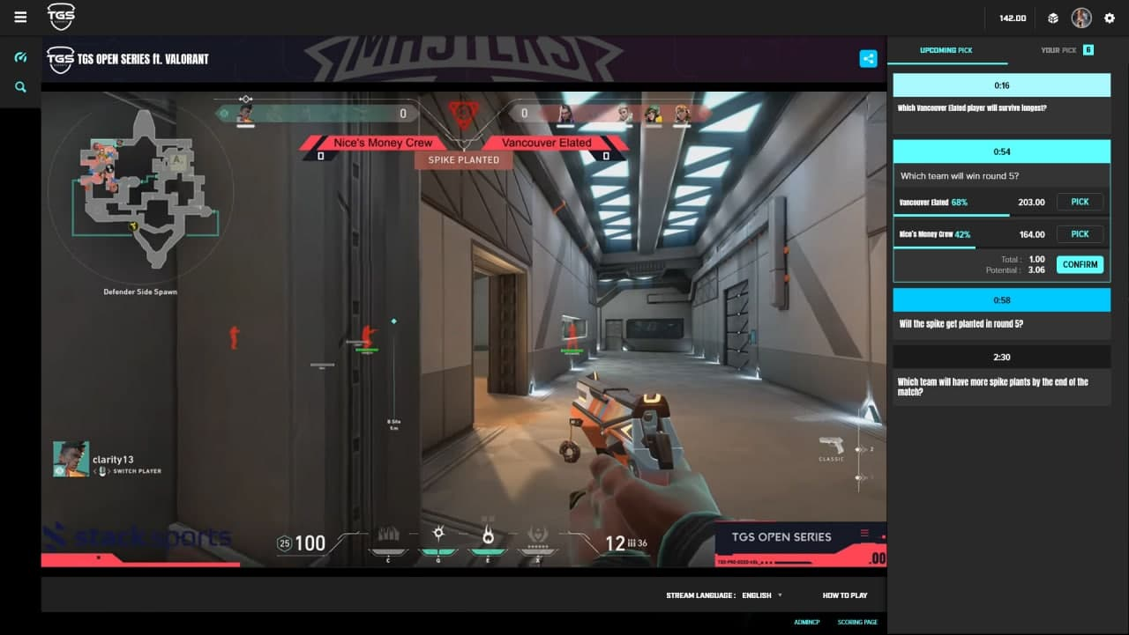
TGS livestream demo showcasing FansUnite's stream prediction platform.

The partnership will showcase FansUnite’s ability to incorporate their proprietary stream prediction platform into any esports event or tournament, whether online or live in-stadium.

Esports revenue in 2020 was over $1 billion¹, excluding revenues from betting. TGS has built white-label esports experiences for over 15 brands, interacting with over 200,000 gamers and by offering prediction games, TGS is able to increase the level of engagement between fans and brands.

“The partnership with TGS Esports brings forth a new platform that will enable us to capture new opportunities within the fast-growing esports market,” said Scott Burton, CEO of FansUnite. “TGS collaborates with numerous esports event organizers who have a large following of enthusiastic esports gamers that participate in their events. Our online betting solutions coupled with TGS esports platform will enable us to attract a new and widening audience from these events.”

“Live predictions is a feature our brand partners have been asking us to implement for a long time,” said Spiro Khouri, CEO of TGS Esports Inc. “By implementing FansUnite’s technology into our esports events, TGS is able to increase the level of engagement between its fans and brands."

About TGS Esports Inc.

TGS partners with Fortune 500 brands, schools, and tournament organizers to build out their esports community via tournaments, broadcast production, and events. TGS has commercialized an esports solution that allows brands and gamers to interact on its end to end platform. The combination of TGS esports event expertise and next generation software creates an unparalleled esports experience that allows sponsors and brands to reach their desired gaming demographic.

About FansUnite Entertainment Inc.

FansUnite is a sports and entertainment company, focusing on technology related to regulated and lawful online gaming and other related products. The principal business is operating the FansUnite Sportsbook and the website of its wholly-owned subsidiary, McBookie Limited, offering online gaming services to the UK market. FansUnite is also a provider of technology solutions, products and services in the gaming and entertainment industry and looks to acquire technology platforms and assets with high-growth potential in new or developing markets.

For further information, please contact:

Prit Singh, Investor Relations at FansUnite
ir@fansunite.com
(905) 510-7636

Scott Burton, Chief Executive Officer of FansUnite
scott@fansunite.com

Darius Eghdami, President of FansUnite
darius@fansunite.com

NEITHER THE CANADIAN SECURITIES EXCHANGE NOR ITS REGULATIONS SERVICES PROVIDERS HAVE REVIEWED ‎OR ACCEPT RESPONSIBILITY FOR THE ADEQUACY OR ACCURACY OF THIS RELEASE.

FORWARD-LOOKING STATEMENTS: Certain information contained herein may constitute "forward-‎‎‎looking information" under Canadian securities legislation. Generally, forward-looking information can be ‎‎‎identified by the use of forward-looking terminology such as "believes," "belief," "expects," "intends," ‎‎‎‎"anticipates," "potential," "should," "may," "will," "plans," "continue" or similar expressions to be uncertain ‎‎‎and forward-looking. Forward-looking statements may include, without limitation, statements relating to ‎‎‎the successful integration of TGS and FansUnite’s esports tournament prediction games, the continue growth of the esports market and revenue; the ability of FansUnite and TGS to implement their licensing strategy; FansUnite’s ability to ‎fulfill technology needs with its ‎platform; business development ‎plans of ‎FansUnite; the Company’s unique portfolio of assets; and discussion of future plans, ‎projections, ‎objectives, estimates ‎and forecasts and the timing related thereto. Forward-looking statements ‎are based ‎on the Company's ‎estimates and are subject to known and unknown risks, uncertainties and ‎other factors ‎that may cause the ‎actual results, level of activity, performance or achievements of ‎FansUnite to be ‎materially different from ‎those expressed or implied by such forward-looking statements or ‎forward-looking ‎information. Additional ‎information regarding the risks and uncertainties relating to the ‎Company’s business ‎are contained under ‎the heading "Risk Factors" in the Company’s Non-Offering ‎Prospectus dated March 27, ‎‎2020 filed on its ‎issuer profile on SEDAR at www.sedar.com and risks related ‎to global pandemics, ‎including the novel ‎coronavirus (COVID-19) global health pandemic, and the spread of ‎other viruses or ‎pathogens and influence ‎of macroeconomic developments. Accordingly, readers should not ‎place undue ‎reliance on forward-looking ‎statements and forward-looking information. The forward-looking ‎statements in ‎this news release are made ‎as of the date of this release. FansUnite disclaims and does not ‎undertake to ‎update or revise any forward-‎looking statements or forward-looking information, whether as a ‎result of new ‎information, future events or ‎otherwise, except as required by applicable securities laws.‎

1https://venturebeat.com/2020/02/25/newzoo-global-esports-will-top-1-billion-in-2020-with-china-as-the-top-market/

