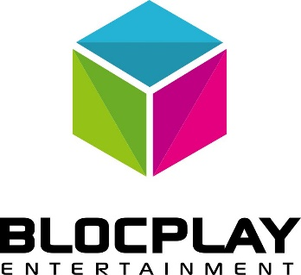

BlocPlay Entertainment announces Development Agreement with Shopify Plus Partner - The Jibe to design a modern user experience for Token Play’s decentralized distribution app.
February 12, 2018 Toronto, Ontario – BlocPlay Entertainment (CSE: PLAY) ("BlocPlay" or the "Company") is pleased to announce that it’s subsidiary Token Play has entered into agreement with Vancouver based Shopify Plus Partner - The Jibe to design the ecommerce experience of our blockchain based videogame distribution app. The Jibe development team has agreed to design our ecommerce experience using modern technologies. This is a multi-phased project with the first major deliverable due in March.
Vince McMullin, Chief Technology Officer of the Company, said: “The Jibe are deeply experienced ecommerce strategists, app designers, and developers with a passion for building high-quality, high-performance and ROI-centric solutions. I believe The Jibe team will excite the video games industry and gamers with a modern token-based ecommerce experience using the same UI technologies powering some of the most successful apps used by gamers today.”
The Jibe is an eCommerce agency in Vancouver. Steve Krueger, COO of The Jibe, said "Blockchain, applied within the gaming industry, has the potential disrupt the way we interact with in-game payments. We're excited to be working with TokenPlay, and their talented team, on helping to build such an innovative platform. Typical web design teams think in terms of features. We build outcomes. We focus on real value, not assumptions. From omnichannel and eCommerce solutions, to conversion-centred websites for technology vendors, to productivity tools for cross-functional teams - beautifully simple technology and better value are at the heart of our work.”
About BlocPlay Entertainment
BlocPlay Entertainment is the world's first peer-to-peer, de-centralized digital entertainment company. Supporting video gamers, developers, and content creators - worldwide. Each day billions of consumers worldwide enjoy digital entertainment products. BlocPlay Entertainment plans to deliver a fully transparent distribution, publishing, and marketing platform for videogames and eSports events through our innovative tokenization system known as Token Play. BlocPlay Entertainment develops in-house entertainment technologies including video games and services.
About TokenPlay
Token is a technology company involved in the development of blockchain technology in the video game space, which will seek to provide a platform for the exchange of in-game currencies and tokens.

For further information, please contact:

Jon Gill
BlocPlay Entertainment Inc.
Tel: 416-722-1166
Email: jgill@stompybot.com

Forward-Looking Information

Certain information set forth in this news release may contain forward-looking information that involve substantial known and unknown risks and uncertainties. This forward-looking information is subject to numerous risks and uncertainties, certain of which are beyond the control of the Company, including, but not limited to, the impact of general economic conditions, industry conditions, failure to enter into a definitive agreement and complete the Acquisition, and dependence upon regulatory approvals. Readers are cautioned that the assumptions used in the preparation of such information, although considered reasonable at the time of preparation, may prove to be imprecise and, as such, undue reliance should not be placed on forward-looking information. The parties undertake no obligation to update forward-looking information except as otherwise may be required by applicable securities law.

