January 26, 2022 | CSE: FABL

Fabled Copper Continues to Sample High Grade Copper
Including 25.60% Cu at the 8A Occurrence

Vancouver, British Columbia – Fabled Copper Corp. (“Fabled Copper” or the “Company”) (CSE: FABL) is pleased to announce the third set of results of the 2021 surface field work program on it’s Muskwa Copper Project comprised of the Neil Property (previously referred to as the North Block) and the Toro Property (previously referred to as the South Block) in Northwestern British Columbia. The Company also holds rights to the Bronson Property. See Figure 1 below.

Figure 1 – Location Map

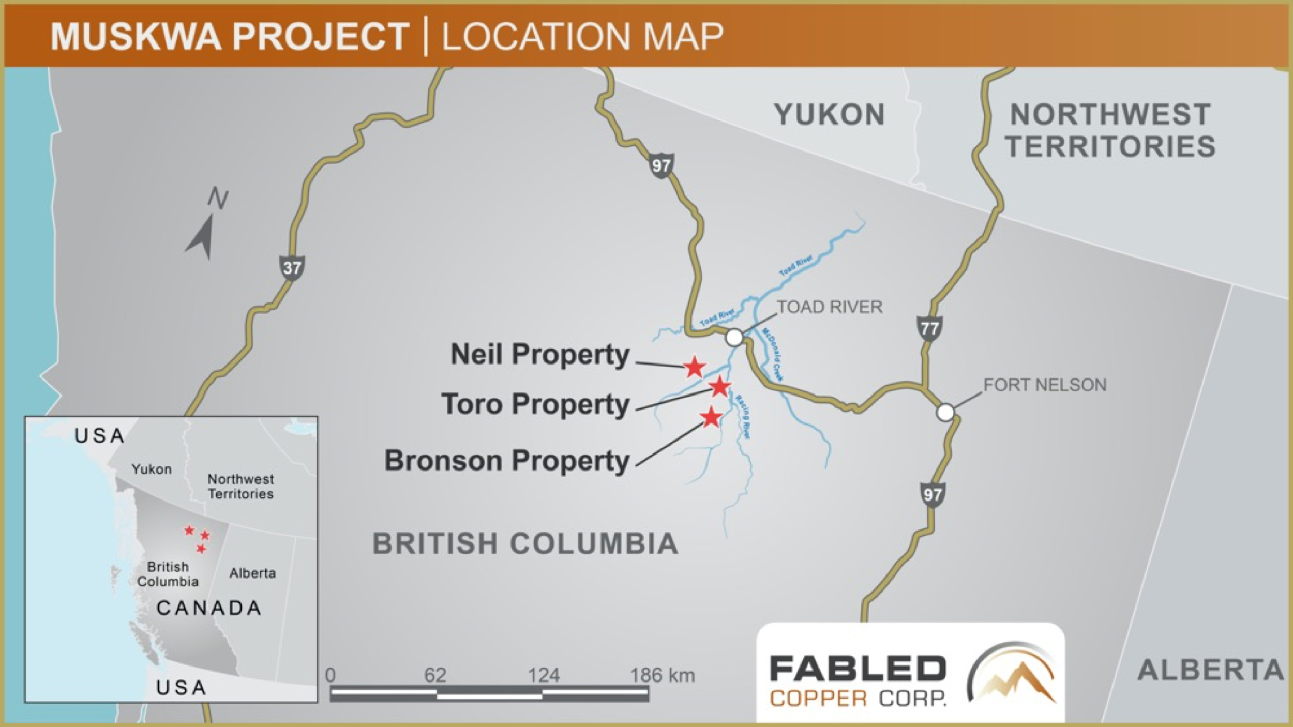

Peter J Hawley, President, CEO reports; “We started the New Year by reporting our findings on the Lady Luck occurrence at the south end of the Neil Property, followed by the Mac occurrence to the north, and now we move further north to the 8A copper occurrence, See Figure 2 below.
As seen with previously reported results from the Lady Luck and Mac occurrences, the 8A occurrence also displays high grade copper values. 9 samples were collected, once again, by the old fashioned boots on the ground, high altitude, sampling of the vein structure, over a vertical distance of 1,003 meters, starting at an altitude of 1,900 meters (approximately 1.9 kilometers vertically above sea level).”
Of the 9 samples collected, 5, reported less than 1% copper as expected; 4 reported greater than 1%, copper, 3 greater than 10% copper and 1 greater than 20% copper, (1% copper = 22.20 pounds). See Table 1 below.

Figure 2- Neil Property, 8A Location
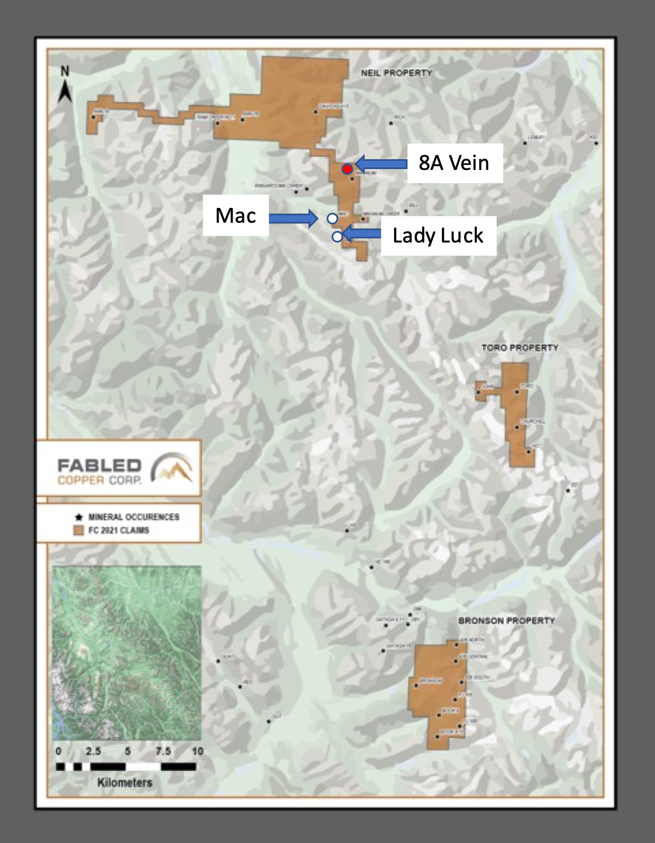
Float Sample # D-723394, taken at the lowest elevation of 1,900 meters, was composed of white quartz with carbonate, moderate to abundant siltstone fragments, moderate malachite staining and contained 1.20 % copper. See Table 1 below.
Grab Sample # D- 723395 was taken at the same elevation and was composed of the wall rock of the mineralization which was A weakly sheared and fractured siltstone with minor quartz veinlets and stringers with less than 1% disseminated chalcopyrite returned anomalous copper grading 0.15% copper See Photo 1 and Table 1 below.

Photo 1 – 8A Occurrence
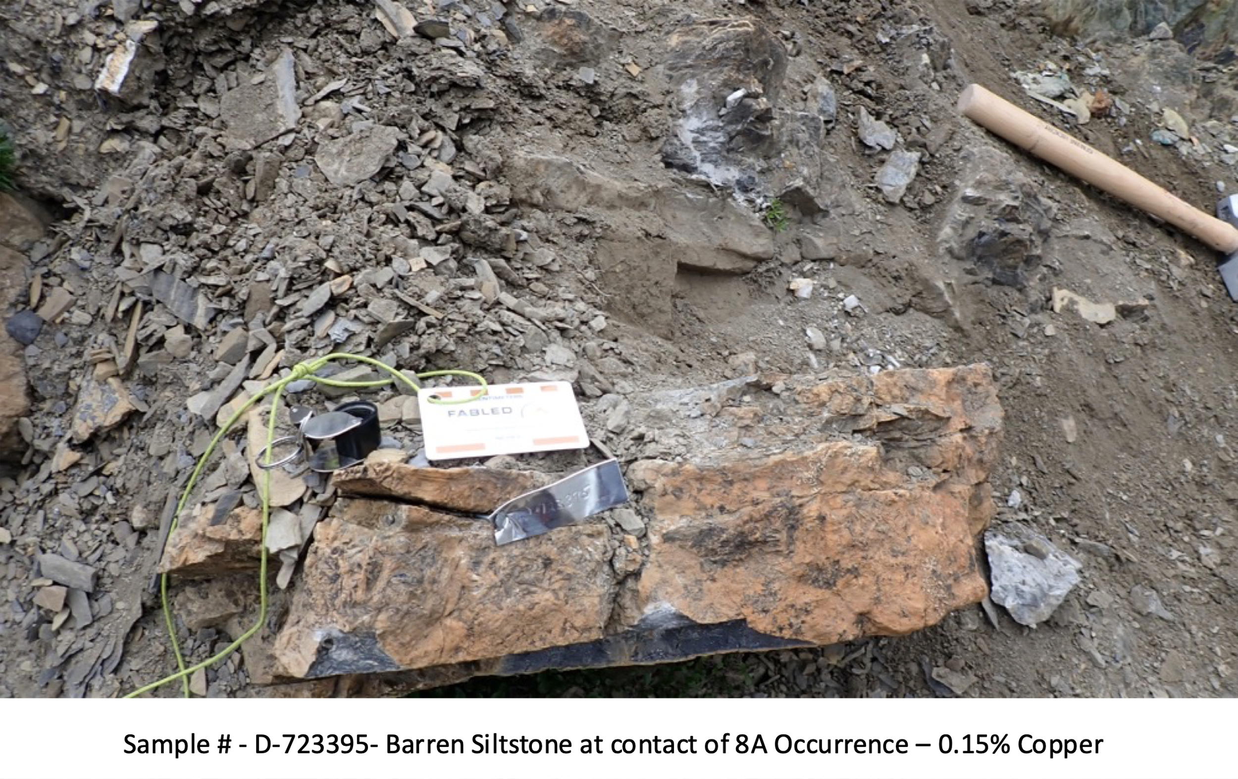
Another grab sample D-723396, taken at the same elevation, but composed of the contact mineralization. 60% of the sample was composed of quartz with iron carbonate containing minor dissolution cavities, limonite patches with less than 1% disseminated chalcopyrite and malachite staining. The other 40% of the sample was composed of the siltstone wall rock containing minor malachite copper alteration. This sample assayed 1.36% copper. See Table 1 below.
Grab sample # D-723397 was the last sample taken at the 1,900 meter level and was composed of the 8A vein / structure where the quartz, on a weathered surface, was black to dark rusty red-brown, while on a fresh surface it was mottled white to brassy yellow. Mineralization consisted of 8-10% disseminated chalcopyrite, with patches, and less than 1% bornite associated with the chalcopyrite. This sample of mineralization returned 14.30% copper. See Table 1 below.
Float sample # D-723402 was taken 6 meters above the previously described samples. It was taken from the main 8A structure / vein mineralization and was composed of semi-massive sulphides, and on the weather surface was chocolate brown with patches of green and buff yellow. On a broken fresh surface the color was mottled white to buff / brassy yellow, vuggy with minor dissolution cavities. Patches of limonite alteration with fine micro seams of graphitic shale were observed, and all over abundant malachite copper alteration containing 20% chalcopyrite returned an impressive 25.60% copper. See Photo 2, Table 1 below.

Photo 2 – 8A Occurrence – 1,906 meters vertically
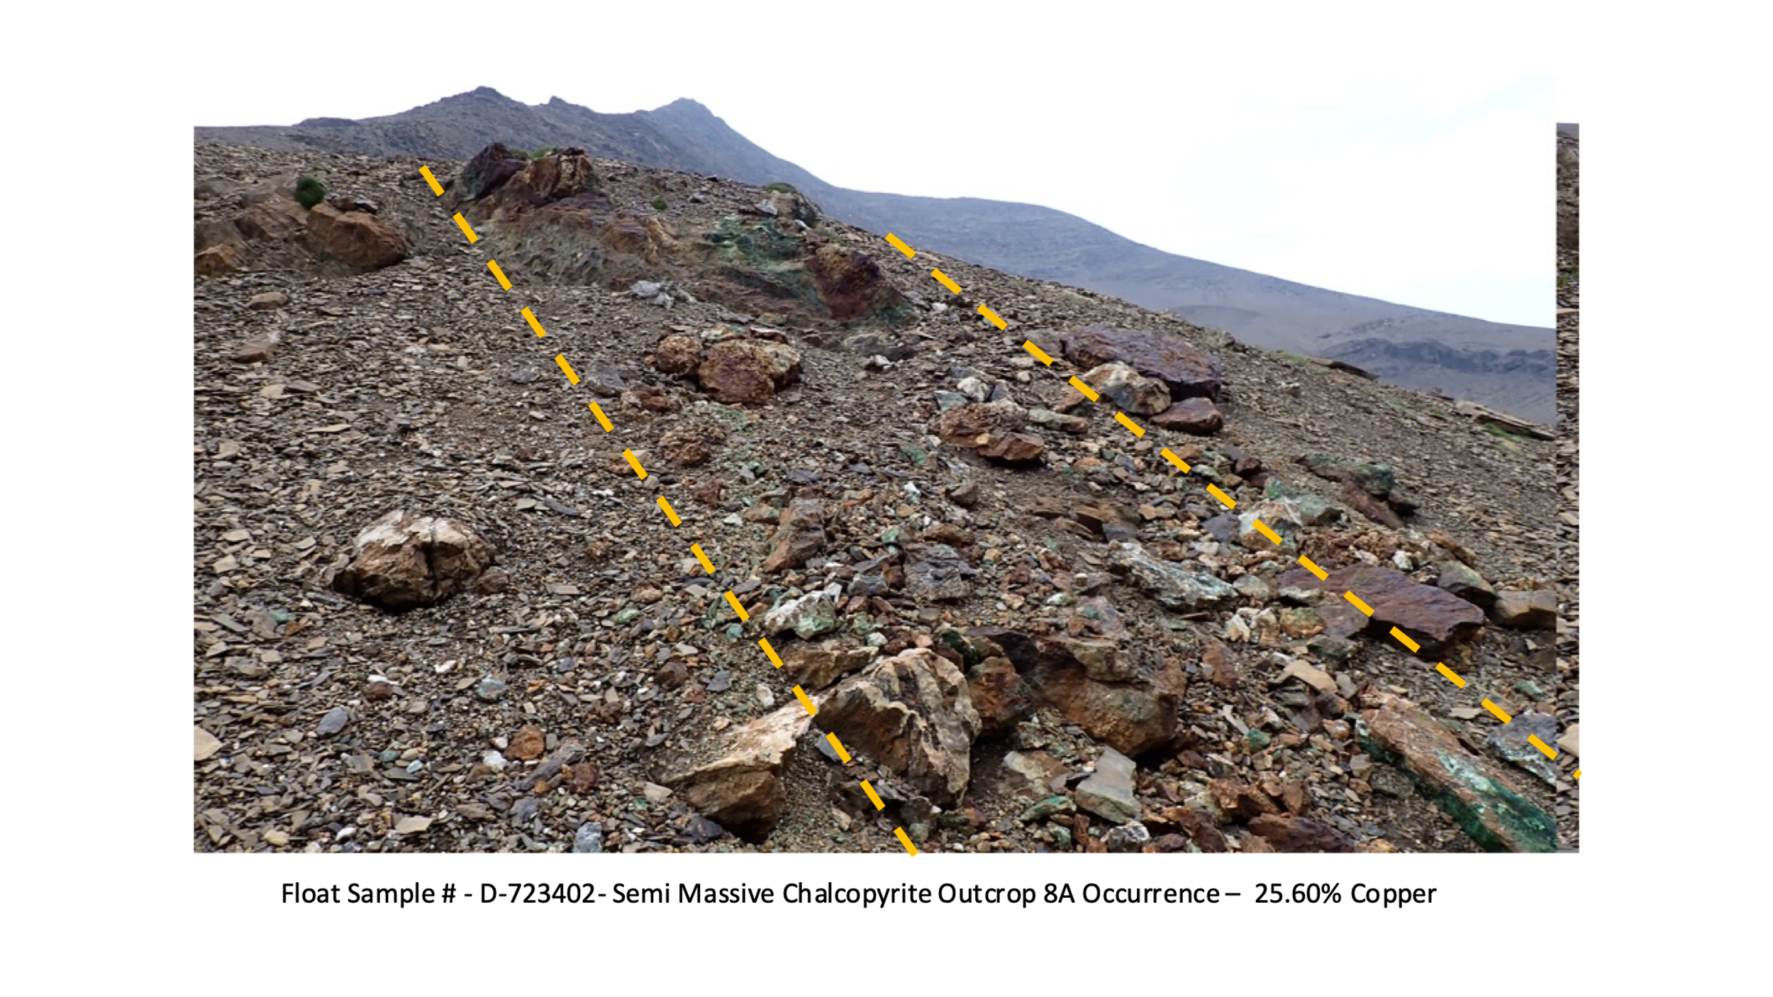
Float Sample # D-723401 was taken at 1,913 vertical meters, or 7 meters higher than the previously described sample. It was composed of barren siltstone wall rock with abundant white quartz – carbonate veinlets and stringers. No apparent sulphides were present and as expected returned 0.02% copper. See Table 1 below.
Float sample 723403 was taken at 1,928 vertical meters, or 15 meters higher than the previously described sample. It was composed of semi-massive sulphides, and was weathered black – rusty brown on the surface, with a slag like texture. The broken fresh surface was mottled white to brassy yellow in color. Minor vugs were common, and it showed moderate malachite copper alteration overall. Mineralization consisted of 25 – 30% chalcopyrite with less than 1% bornite. This sample returned 19.40% copper. See Photo 3 and Table 1 below.

Photo 3 – 8A Occurrence – 1,928 meters vertically
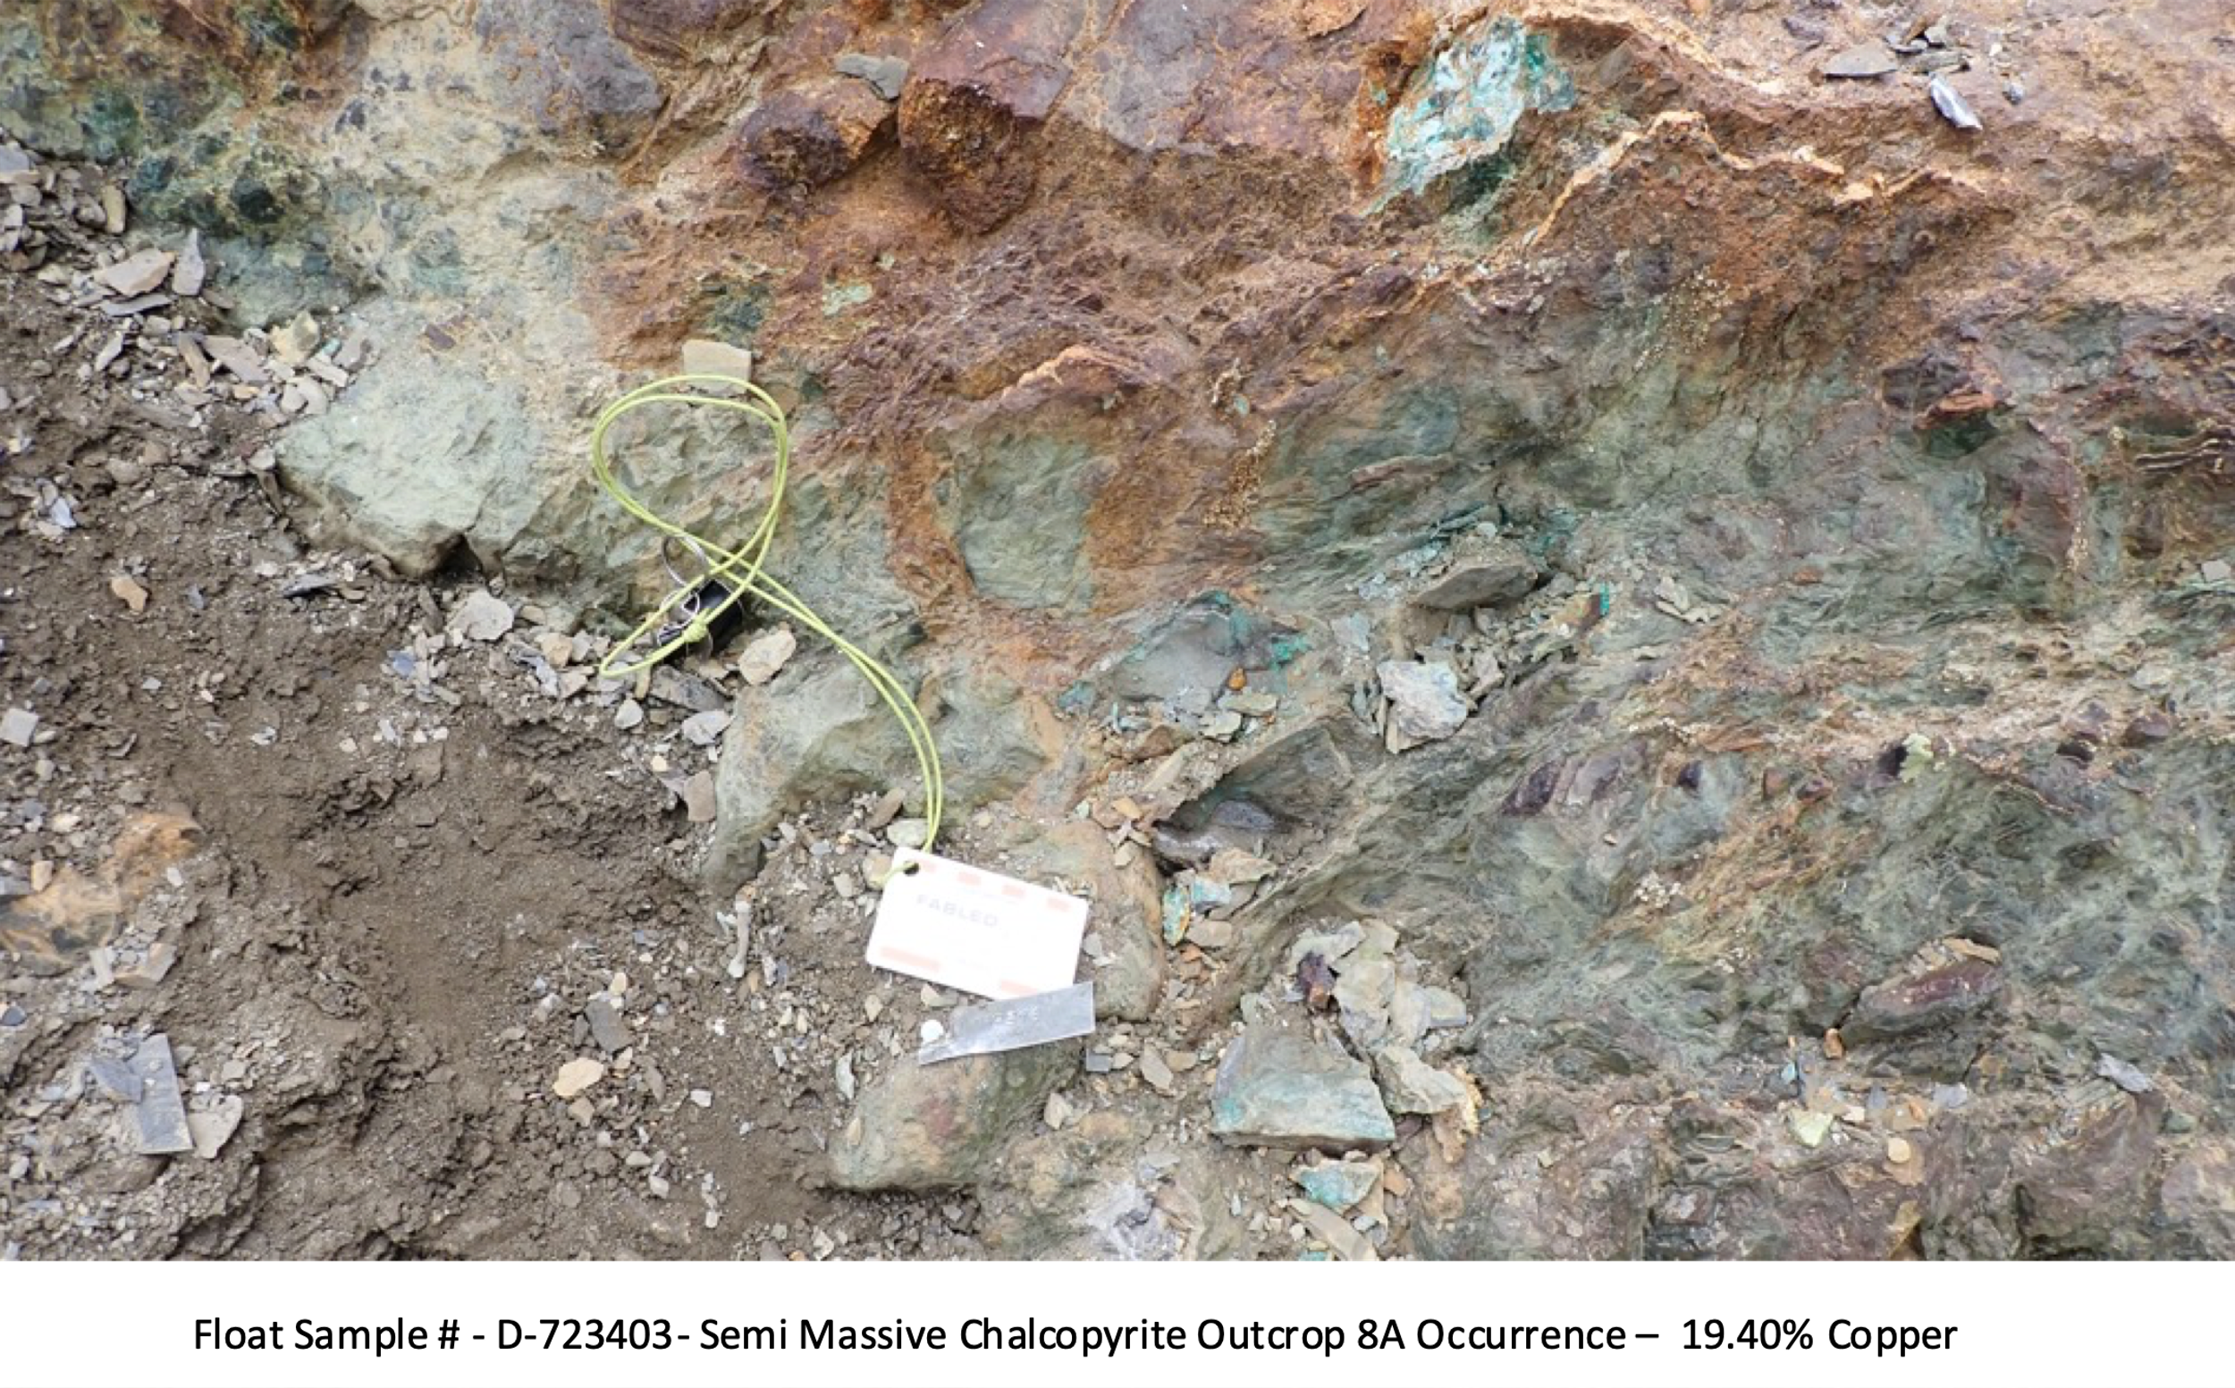
Float sample D-723399 was taken at 2,001 vertical meters, 73 meters higher than sample D-723403 described above. This sample of barren siltstone breccia contained a quartz – carbonate matrix renealing the siltstone fragments, carbonate dissolution cavities and vugs. A trace of malachite staining and chalcopyrite was seen. This sample, as expected returned 0.08% copper. See Table 1 below.
Float Sample # D-723400 was taken at 2,003 vertical meters, 2 meters higher than the previously described sample. It was composed of sheared and fractured siltstone in contact with shale, moderate quartz carbonate veinlets, and stringers, along slickenslides, (fault rock movement indicators) with no apparent sulphides. As expected, this returned 0.07% copper. See Table 1 below.

Table 1 – 8A Occurrence 2021 Surface Samples
Sample No. | Elevation (m) | Type of Sample | Copper (Cu) Grade %
D - 723394 | 1,900 | Float | 0.90
D - 723395 | 1,900 | Grab | 0.15
D - 723396 | 1,900 | Grab | 1.36
D - 723397 | 1,900 | Grab | 14.30
D - 723402 | 1,906 | Grab | 25.60
D - 723401 | 1,913 | Float | 0.02
D - 723403 | 1,928 | Float | 19.40
D – 723399 | 2,001 | Float | 0.08
D - 723400 | 2,003 | Float | 0.07
- Samples taken over 1,003 meters vertically
- 1% Copper per tonne = 22.20 lbs.
Moving Forwards
The impressive grades over 1,003 meters vertically, (1 kilometer) on the 8A copper occurrence once again warrant follow up in the 2022 season. The 8A vein / breccia structure has never been drilled and remains open in all directions.
QA QC Procedure

Analytical results of sampling reported by Fabled Copper Corp represent rock samples submitted by Fabled Copper Corp staff directly to ALS Chemex, Vancouver, British Columbia Canada. Samples were crushed, split, and pulverized as per ALS Chemex method PREP-31, then analyzed for ME-ICP61 33 element package by four acid digestion with ICP-AES Finish. ME-GRA21 method for Au and Ag by fire assay and gravimetric finish, 30g nominal sample weight.
Over Limit Methods
For samples triggering precious metal over-limit thresholds of 10 g/t Au or 100 g/t Ag, the following is being used:
Au-GRA21 Au by fire assay and gravimetric finish with 30 g sample.
Ag-GRA21 Ag by fire assay and gravimetric finish.

Fabled Copper Corp. monitors QA/QC using commercially sourced standards and locally sourced blank materials inserted within the sample sequence at regular intervals.
About Fabled Copper Corp.

Fabled Copper is a junior mining exploration company. Its current focus is to creating value for stakeholders through the exploration and development of its existing copper properties located in northern British Columbia. The Muskwa Project comprises a total of 76 claims in two non-contiguous blocks and totals approximately 8,064.9 hectares, located in the Liard Mining Division in northern British Columbia.

Mr. Peter J. Hawley, President and C.E.O.
Fabled Copper Corp.
Phone: (819) 316-0919
peter@fabledcopper.org

For further information please contact:

info@fabledcopper.org

The technical information contained in this news release has been approved by Peter J. Hawley, P.Geo. President and C.E.O. of Fabled, who is a Qualified Person as defined in National Instrument 43-101 - Standards of Disclosure for Mineral Projects.

The Canadian Securities Exchange does not accept responsibility for the adequacy or accuracy of this release.

Certain statements contained in this news release constitute "forward-looking information" as such term is used in applicable Canadian securities laws. Forward-looking information is based on plans, expectations and estimates of management at the date the information is provided and is subject to certain factors and assumptions, including, that the Company's financial condition and development plans do not change as a result of unforeseen events and that the Company obtains any required regulatory approvals.

Forward-looking information is subject to a variety of risks and uncertainties and other factors that could cause plans, estimates and actual results to vary materially from those projected in such forward-looking information. Some of the risks and other factors that could cause results to differ materially from those expressed in the forward-looking statements include, but are not limited to: impacts from the coronavirus or other epidemics, general economic conditions in Canada, the United States and globally; industry conditions, including fluctuations in commodity prices; governmental regulation of the mining industry, including environmental regulation; geological, technical and drilling problems; unanticipated operating events; competition for and/or inability to retain drilling rigs and other services; the availability of capital
on acceptable terms; the need to obtain required approvals from regulatory authorities; stock market volatility; volatility in market prices for commodities; liabilities inherent in mining operations; changes in tax laws and incentive programs relating to the mining industry; as well as the other risks and uncertainties applicable to the Company as set forth in the Company's continuous disclosure filings filed under the Company's profile at www.sedar.com. The Company undertakes no obligation to update these forward-looking statements, other than as required by applicable law.

