Exploits Discovery Corp Releases Area Play Map for Newfoundland Exploits Subzone Gold District
Vancouver, BC, September 24, 2020 – News Release. Exploits Discovery Corp (CSE: NFLD) (“Exploits”) is pleased to announce the release of an area play map for the Exploits Subzone Gold District showing that Exploit is now a major player in the developing gold district. This area map highlights the current land holder claim extents, key showings, exploration highlights and ticker symbols for all significant players.
Companies featured on this map include:
Exploits Discovery Corp, New Found Gold Corp., Crest Resources Inc., Marathon Gold, Maritime Resources Corp., Great Atlantic Resources Corp., Labrador Gold Corp., Golden Ridge Resources, Canstar Resources Inc., Sokoman Minerals Corp., White Metal Resources, Buchans Resources Inc., Vulcan Minerals Inc., Sky Gold Corp., District Copper Corp., Spruce Ridge Resources LTD., Zonte Metals Inc., Trius Investments Inc., Callinex Mines Inc., Gossan Resources.
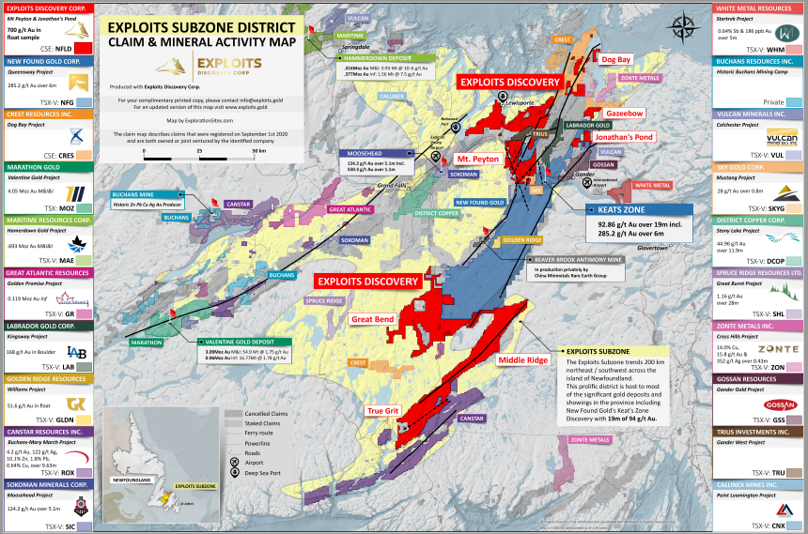
An up to date high resolution digital copy of this map will always be available to download at www.exploits.gold.
The Exploits Subzone is a prime environment for true discovery in one of the last easily accessible gold exploration districts in the world. The subzone area trends 200km northeast / southwest across the island of Newfoundland, and this prolific district hosts most of the significant gold deposits in the province.
CEO of Exploits, Michael Collins comments; “Exploits Discovery Corp has accumulated its’ land package working with local prospectors over the past 8 months on grounds that had been staked before New Found Gold’s discovery hole, and their subsequent regional staking. These acquisitions consolidate major prospective historical showings while integrating new information, and the Epizonal exploration model. We already have teams on the ground, and are excited to bring news to the market over the coming months.”
The projects acquired by Exploits include the following select property highlights where work has begun for fall/winter 2020:
Jonathan’s Pond: Historical trenching done by local prospectors revealed visible gold in quartz veins but was never assayed (Keats, 2004).
- Outcrop and float samples with visible gold up to 29 g/t Au and 700 g/t Au, respectively, in trenches and till samples up to 27,000 ppb Au on west claims (Keats, 2004).
- Magnetic geophysical signatures outline multiple highly prospective structures beneath overburden.
Mt. Peyton: Structurally hosted gold targets around the NW-SE trending Mt. Peyton Linear.
- Historic field work defined high-grade mineralization along the Mt. Peyton Linear with a strike length of over 20km.
- High-grade gold in outcrop sampled by previous operator contains values up to 164 g/t Au (Noranda, 1991).
- Historical drilling in the southernmost claims yielded 6 g/t Au over 2m near surface (Noranda, 1991).
- As + Sb signatures in tills correspond with VLF conductors and are proven to be closely associated with gold mineralization in the area (Rubicon Minerals, 2003).
True Grit: This property is accessible by the Bay d’Espoir Highway and located in south central Newfoundland.
- True Grit hosts diamond drilling intercepts of up to 117m of 0.60 g/t Au, including 26m of 0.83 g/t Au from surface (Moydow Mines, 2002), channel samples of 15.6 g/t Au over 1.0m (Teck, 1990) and grab samples of 30.2 g/t Au (Teck, 1990).
- The property hosts geophysical anomalies coincident with Au-Sb-As soil anomalies which measure over 2.6km by 0.80km.
- New structural model focusing on epizonal orogenic gold within the secondary and tertiary structures stemming along the GRUB line provides a pathway to discovery for new gold deposits and reinterpretations of historically conducted work
For more property highlights on our Middle Ridge, Great Bend, Gazeebow, and Dog Bay projects, please visit www.exploits.gold and download the latest company presentation.

National Instrument 43-101 disclosure
Ian Herbranson, P.Geo, is a consultant for the company, shareholder, a party to the transaction and qualified person as defined by NI 43-101. Mr. Herbranson supervised the preparation of the technical information in this news release.
About Exploits Discovery Corp.
Exploits Discovery Corp. is a Canadian mineral exploration company focused on the acquisition and development of mineral projects in Newfoundland, Canada. The Company holds the Middle Ridge, True Grit, Great Bend, Mt. Peyton, Jonathan’s Pond, and Gazeebow projects, which cumulatively cover an area of 1,760 km². All projects within Exploits’ portfolio lie within the Exploits Subzone and Gander River Ultramafic Belt (GRUB) of the Dunnage Zone, which contain the majority of Newfoundland’s gold mineral occurrences and exploration efforts, including New Found Gold’s 2019 discovery of 92.86 g/t Au over 19.0 meters near surface. The Exploits Subzone and GRUB regions have been the focus of major staking and financing throughout 2020, with increased exploration activities forecasted in the area moving into 2021.
We seek Safe Harbor.

