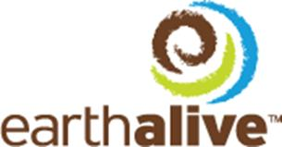

PRESS RELEASE

EARTH ALIVE ANNOUNCES GRANT OF OPTIONS

Montreal, Quebec, Canada, September 28, 2018—Earth Alive Clean Technologies Inc. (CSE: EAC) (“Earth Alive” or the “Corporation”), is pleased to announce that it has granted the aggregate of 3,904,000 share purchase options to certain directors, officers, employees and consultants. Each share purchase options allows the holder to purchase one common share of Earth Alive, at the exercise price of 0.35$, until September 20, 2023, subject to certain vesting requirements.

About Earth Alive Clean Technologies
Earth Alive aims to be a key player in world markets of environmentally sustainable industrial solutions. The Company works with the latest innovations in microbial technology to formulate and patent innovative products that can tackle the most difficult industrial challenges, once only reserved to environmentally harmful chemicals and additives. The Company is focused on environmental sustainability in the agriculture industry and dust control for the mining industry. For additional company information, please visit: www.earthalivect.com

For additional company information, please visit: www.earthalivect.com
The CSE has neither approved nor disapproved the contents of this press release. The CSE does not accept responsibility for the adequacy or accuracy of this release.
Earth Alive Clean Technologies Inc.  9641 rue Clément  Lasalle (Qc) Canada  H8R 4B4  T.(438) 333-1680 | For information, please contact:  Mr. Michael Warren  (e) mwarren@earthalivect.com  (p) 514-941-7350

