CRESCO LABS ANNOUNCES LAUNCH OF KHALIFA KUSH PRODUCTS AT COOKIES DISPENSARIES THROUGHOUT CALIFORNIA
Wiz Khalifa’s bestselling cannabis brand expanded to California through an exclusive cultivation & product collaboration partnership with FloraCal Farms and Continuum
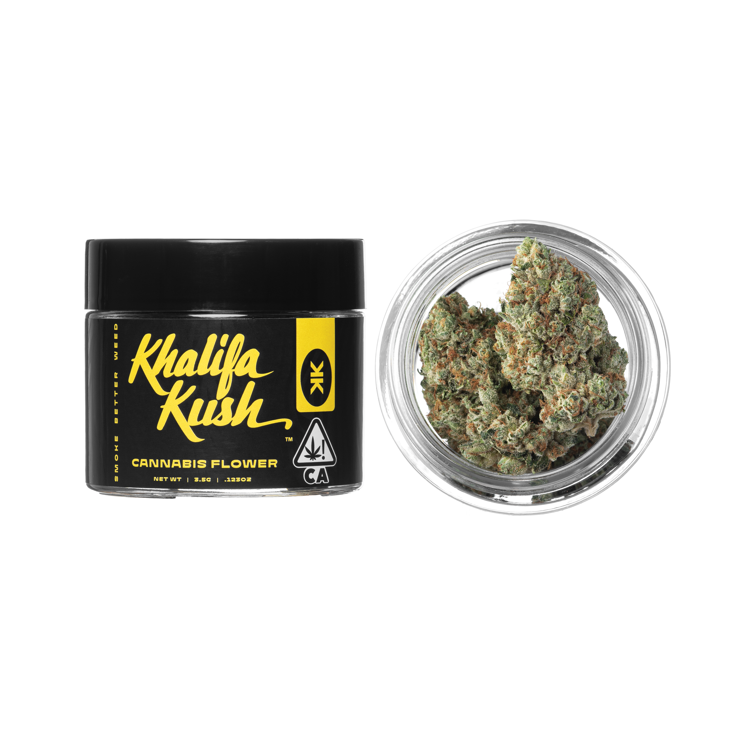
Photo Caption: Through a cultivation & product collaboration partnership with Cresco Labs’ FloraCal Farms and Continuum, flower and pre-rolls from Khalifa Kush are now for sale at Cookies stores throughout California.

CHICAGO – January 28, 2022 — Cresco Labs (CSE:CL) (OTCQX:CRLBF) (“Cresco Labs” or “the Company”), a vertically integrated multistate operator and the number one U.S. wholesaler of branded cannabis products, today announced flower and pre-rolls from Khalifa Kush are available for sale at Cookies stores throughout California. Cresco Labs has an exclusive cultivation and product collaboration agreement with multi-platinum-selling, GRAMMY® and Golden Globe® Award-nominated recording artist Wiz Khalifa’s cannabis brand. Through the partnership, FloraCal Farms and Continuum will be the sole producer and distributor, respectively, of premium branded products featuring Khalifa Kush’s signature “KK” strain in California. An expanded line is expected to arrive at additional retail partners throughout the year.

“Wiz Khalifa has been a longtime advocate for cannabis legalization, with a namesake OG strain beloved by many in other states. Today, we’re thrilled to bring his brand to cannabis lovers and his fans in California,” said David Gacom, West Region Regional President at Cresco Labs. “We’re focused on bringing a curated portfolio of leading brands to California retailers, and Khalifa Kush is a natural addition with its focus on delivering top quality cannabis. We’re excited to work with the talented Khalifa Kush team to grow its cannabis and commercialize its products.”

"We're excited to launch Khalifa Kush in California with Cresco Labs; we've been working for years on this project." said Wiz Khalifa. "The KK grown at FloraCal is the best I've smoked, and I’m excited for the people of California to enjoy the original KK."

“FloraCal Farms and Continuum, with their best-in-class cultivation capabilities and significant scale and penetration, have proven to be the premier cultivator and distribution platform in the largest and most competitive market in the country, and we’re honored to partner with their teams to expand Khalifa Kush’s footprint in California,” said DJ Saul, CEO of Khalifa Kush.

About Cresco Labs Inc.
Cresco Labs is one of the largest vertically integrated multistate cannabis operators in the United States, with a mission to normalize and professionalize the cannabis industry. Employing a consumer-packaged goods (“CPG”) approach, Cresco Labs is the largest wholesaler of branded cannabis products in the U.S. Its brands are designed to meet the needs of all consumer segments and comprised of some of the most recognized and trusted national brands including Cresco, High Supply, Mindy's Edibles, Good News, Remedi, Wonder Wellness Co. and FloraCal Farms. Sunnyside, Cresco Labs’ national dispensary brand, is a wellness-focused retailer created to build trust, education and convenience for both existing and new cannabis consumers. Recognizing that the cannabis industry is poised to become one of the leading job creators in the country, Cresco Labs operates the industry’s largest Social Equity and Educational Development initiative, SEED, which was established to ensure that all members of society have the skills, knowledge and opportunity to work and own businesses in the cannabis industry. Learn more about Cresco Labs at www.crescolabs.com. Follow Cresco Labs on Facebook, Instagram, Twitter and LinkedIn.

About Khalifa Kush
Khalifa Kush products were first commercialized in the U.S. in 2015 by global icon Wiz Khalifa. The company has achieved continued growth and success by focusing on high quality and highly sought-after products in legalized cannabis markets. The Khalifa Kush brand offers a growing lineup of flower, pre-rolls, vapes, edibles, and concentrates, powered by proprietary genetics, in partnership with Compound Genetics. Khalifa Kush is available in select markets including Nevada, Arizona and Utah. Learn more about the upcoming California launch, Michigan launch and shop apparel at KHALIFAKUSH.COM.

###

Media Contacts
Media:
Jason Erkes, Cresco Labs
Chief Communications Officer
press@crescolabs.com

Investors:
investors@crescolabs.com

Khalifa Kush / Wiz Khalifa press:
Dvora Englefield Dvora.Englefield@ledecompany.com
Courtni Asbury Courtni.Asbury@ledecompany.com
Chris Iacullo Chris.Iacullo@ledecompany.com

For general Cresco Labs inquiries:
312-929-0993
info@crescolabs.com

