CRESCO LABS ANNOUNCES OPENING OF 10TH PENNSYLVANIA DISPENSARY IN AMBLER

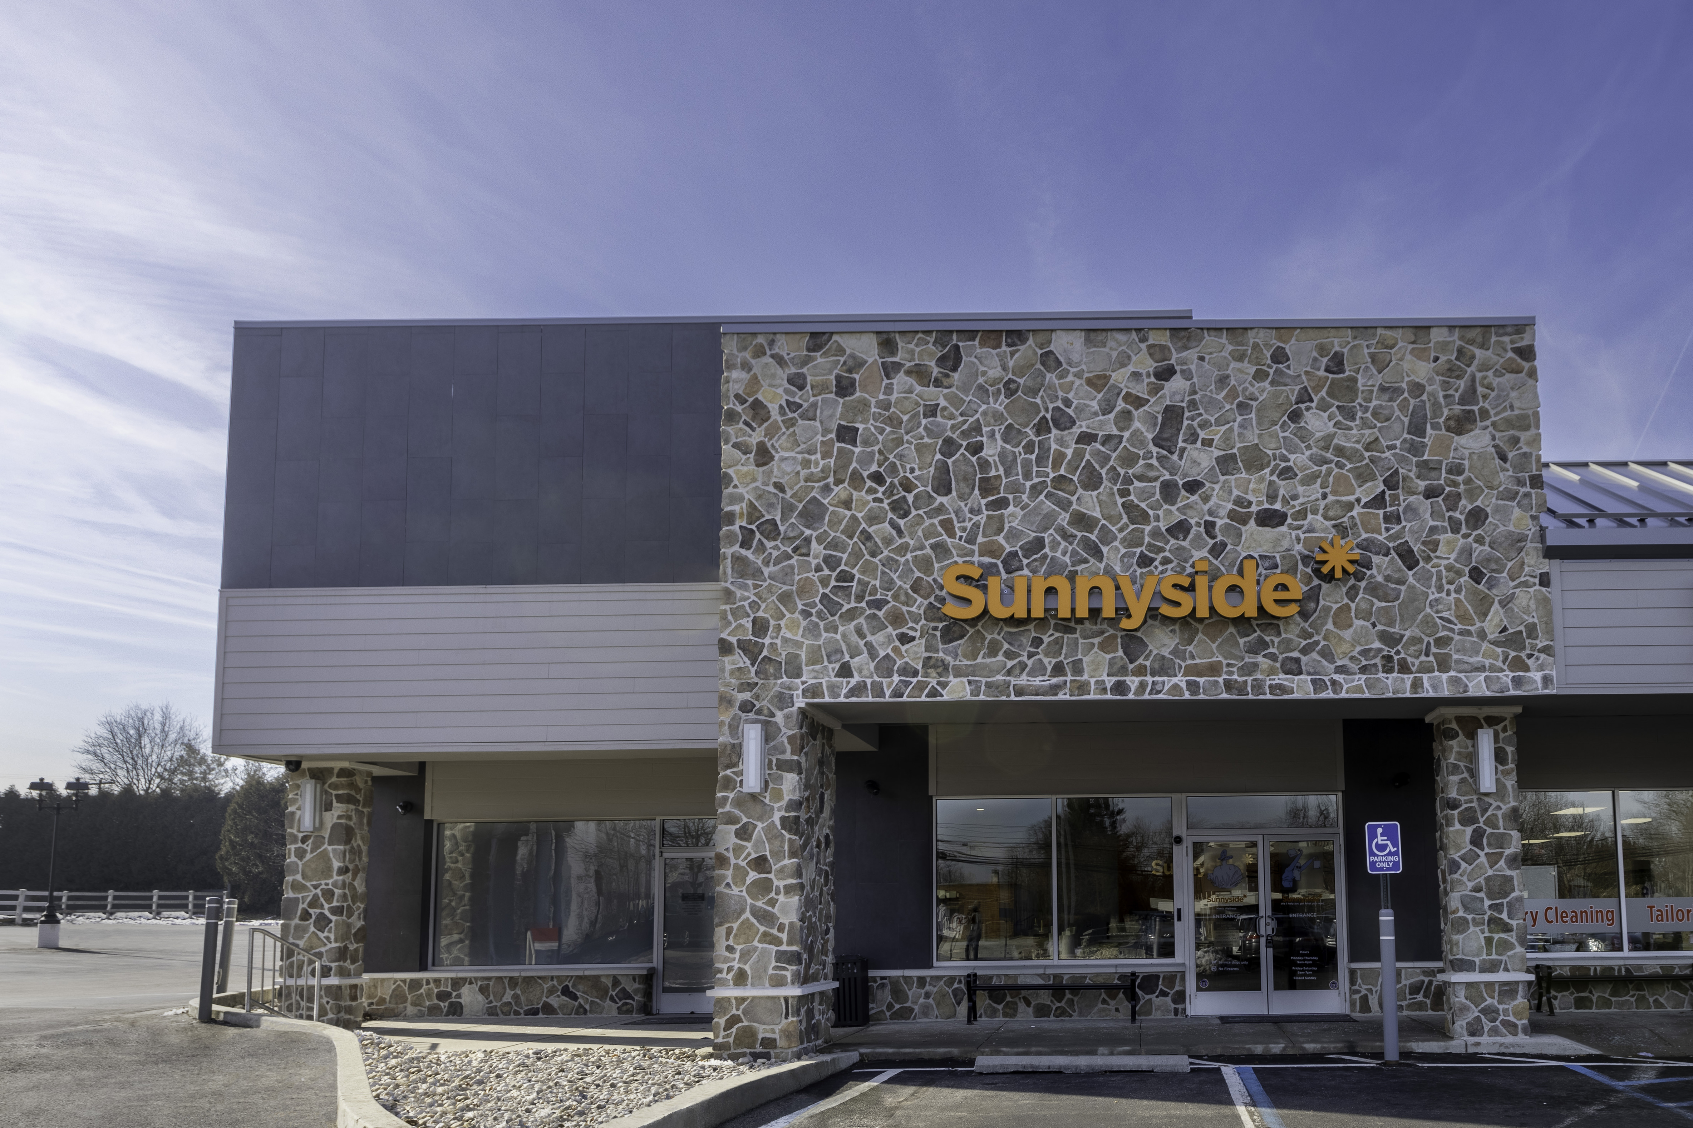
Photo Caption: Cresco Labs’ new Ambler dispensary marks its 10th Pennsylvania location and 47th store nationwide.

CHICAGO – January 18, 2022 — Cresco Labs (CSE:CL) (OTCQX:CRLBF) (“Cresco Labs” or “the Company”), a vertically integrated multistate operator and the number one U.S. wholesaler of branded cannabis products, is expanding its Sunnyside brand in Pennsylvania with a new store located at 28 W Skippack Pike in Ambler. This location becomes the Company’s 10th store in Pennsylvania and 47th dispensary nationwide.

“We are thrilled to be opening our 10th store in Pennsylvania, a continuation of our strategy of going deeper in our footprint and tailoring to individual state dynamics,” said Charlie Bachtell, Cresco Labs’ CEO & Co-founder. “With our CPG and wholesale focus, we’ve been able to take the top market share in Pennsylvania according to Headset. Adding additional fully-owned retail will support our brand building and provide more access to Cresco Labs’ amazing products for patients across Pennsylvania.”

Located in the borough of Ambler north of Philadelphia, the dispensary is a few miles away from the Pennsylvania Turnpike, a superhighway transporting thousands of people daily east-west across the state. Sunnyside Ambler resides in an area home to large facilities operated by major pharmaceutical companies, including Johnson & Johnson, Merck and Janssen.

The dispensary will be open Monday through Thursday, 9 a.m. to 6 p.m., and Friday and Saturday, 9 a.m. to 7 p.m. Patients can place online orders, browsing live inventory, on www.Sunnyside.shop and pick up orders in-store the same day. Store phone is 267-405-2622.

For more information about Sunnyside, visit www.sunnyside.shop.

About Cresco Labs Inc.
Cresco Labs is one of the largest vertically integrated multistate cannabis operators in the United States, with a mission to normalize and professionalize the cannabis industry. Employing a consumer-packaged goods (“CPG”) approach, Cresco Labs is the largest wholesaler of branded cannabis products in the U.S. Its brands are designed to meet the needs of all consumer segments and comprised of some of the most recognized and trusted national brands including Cresco, High Supply, Mindy's Edibles, Good News, Remedi, Wonder Wellness Co. and FloraCal Farms. Sunnyside, Cresco Labs’ national dispensary brand, is a wellness-focused retailer created to build trust, education and convenience for both existing and new cannabis consumers. Recognizing that the cannabis industry is poised to become one of the leading job creators in the country, Cresco Labs operates the industry’s largest Social Equity and Educational Development initiative, SEED, which was established to ensure that all members of society have the skills, knowledge and opportunity to work and own businesses in the cannabis industry. Learn more about Cresco Labs at www.crescolabs.com.

Forward Looking Statements
This press release contains “forward-looking information” within the meaning of applicable Canadian securities legislation and may also contain statements that may constitute “forward-looking statements” within the meaning of the safe harbor provisions of the United States Private Securities Litigation Reform Act of 1995. Such forward-looking information and forward-looking statements are not representative of historical facts or information or current condition, but instead represent only the Company’s beliefs regarding future events, plans or objectives, many of which, by their nature, are inherently uncertain and outside of the Company’s control. Generally, such forward-looking information or forward-looking statements can be identified by the use of forward-looking terminology such as, ‘may,’ ‘will,’ ‘should,’ ‘could,’ ‘would,’ ‘expects,’ ‘plans,’ ‘anticipates,’ ‘believes,’ ‘estimates,’ ‘projects,’ ‘predicts,’ ‘potential’ or ‘continue’ or the negative of those forms or other comparable terms. The Company’s forward-looking statements involve known and unknown risks, uncertainties and other factors which may cause the Company’s actual results, performance or achievements to be materially different from any future results, performance or achievements expressed or implied by the forward-looking statements, including but not limited to those risks discussed under “Risk Factors” in the Company’s Annual Information Form for the year ended December 31, 2020 filed on March 26, 2021, and other documents filed by the Company with Canadian securities regulatory authorities; and other factors, many of which are beyond the control of the Company. Readers are cautioned that the foregoing list of factors is not exhaustive. Because of these uncertainties, you should not place undue reliance on the Company’s forward-looking statements. No assurances are given as to the future trading price or trading volumes of Cresco Labs’ shares, nor as to the Company’s financial performance in future financial periods. The Company does not intend to update any of these factors or to publicly announce the result of any revisions to any of the Company’s forward-looking statements contained herein, whether as a result of new information, any future event or otherwise. Except as otherwise indicated, this press release speaks as of the date hereof. The distribution of this press release does not imply that there has been no change in the affairs of the Company after the date hereof or create any duty or commitment to update or supplement any information provided in this press release or otherwise.

Contacts
Media:
Jason Erkes, Cresco Labs
Chief Communications Officer
press@crescolabs.com

Investors:
investors@crescolabs.com

For general Cresco Labs inquiries:
312-929-0993
info@crescolabs.com

