FORM 7
MONTHLY PROGRESS REPORT

September 2016

Name of Listed Issuer: IGEN NETWORKS CORP. (the “Issuer”).
Trading Symbol: IGN
Number of Outstanding Listed Securities: 30,432,935

Date: October 6, 2016
Report on Business
- General overview and discussion of the development of the Issuer’s business and operations over the previous month.
There were no significant developments or changes in the Company’s business or operations.

- General overview and discussion of the activities of management.
Operationally management continued to focus on efforts to increase revenues, reduce costs, improve inventory management and improve internal controls and reporting. Management has continued to be active in ongoing fund raising, primarily through private placements.

- Details of any new products or services developed or offered.
None
- Products or services that were discontinued.
None.
- New business relationships entered into between the Issuer, the Issuer’s affiliates or third parties including contracts to supply products or services, joint venture agreements and licensing agreements etc. State whether the relationship is with a Related Person of the Issuer and provide details of the relationship.
None
- Expiry or termination of any contracts or agreements between the Issuer, the Issuer’s affiliates or third parties or cancellation of any financing arrangements that have been previously announced.
None
- Acquisitions by the Issuer or dispositions of the Issuer’s assets that occurred during the preceding month. Provide details of the nature of the assets acquired or disposed of and provide details of the consideration paid or payable together with a schedule of payments if applicable, and of any valuation. State how the consideration was determined and whether the acquisition was from or the disposition was to a Related Person of the Issuer and provide details of the relationship..
None
- Acquisition of new customers or loss of customers.
None
- New developments or effects on intangible products such as brand names, circulation lists, copyrights, franchises, licenses, patents, software, subscription lists and trade-marks.
None
- Employee hirings, terminations or lay-offs with details of anticipated length of lay-offs.
None
- Labour disputes and resolutions of those disputes if applicable.
None
- Legal proceedings to which the Issuer became a party, including the name of the court or agency, the date instituted, the principal parties to the proceedings, the nature of the claim, the amount claimed, if any, if the proceedings are being contested, and the present status of the proceedings.
None
- Indebtedness incurred or repaid by the Issuer together with the terms of such indebtedness.
None
- Details of securities issued and options or warrants granted:
None
- Loans to or by Related Persons.
None
- Changes in directors, officers or committee members.
None
- Trends which are likely to impact the Issuer including trends in the Issuer’s market(s) or political/regulatory trends.
No new trends of note, to the best of the Company’s knowledge.
Certificate Of Compliance
The undersigned hereby certifies that:
- The undersigned is a director and/or senior officer of the Issuer and has been duly authorized by a resolution of the board of directors of the Issuer to sign this Certificate of Compliance.
- As of the date hereof there were is no material information concerning the Issuer which has not been publicly disclosed.
- The undersigned hereby certifies to the Exchange that the Issuer is in compliance with the requirements of applicable securities legislation (as such term is defined in National Instrument 14-101) and all Exchange Requirements (as defined in CNSX Policy 1).
- All of the information in this Form 7 Monthly Progress Report is true.
Dated: Oct 6, 2016
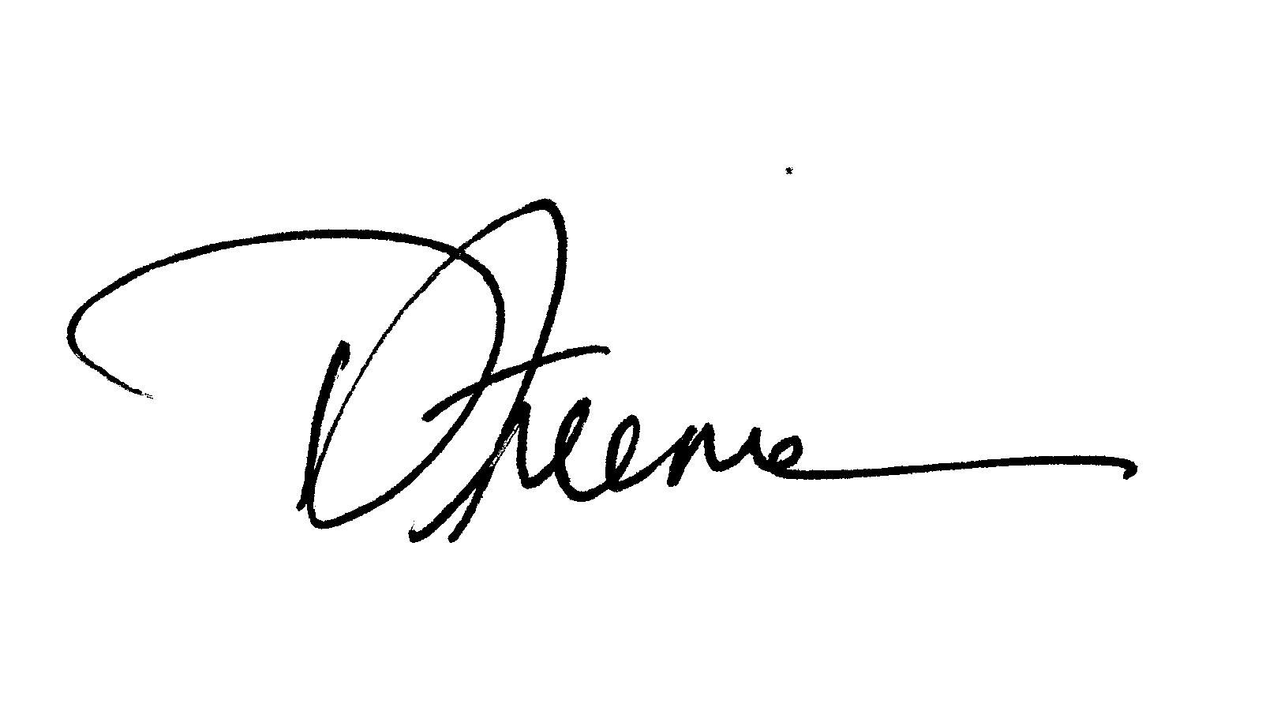
Richard Freeman
Name of Director or Senior Officer
Signature
COO, Director
Official Capacity

Issuer Details  Name of Issuer  IGEN NETWORKS CORP | For Month End  Oct 2016 | Date of Report  YY/MM/D  16/10/06
Issuer Address

1025-1185 W Georgia St
City/Province/Postal Code  Vancouver, BC V6E4E6 | Issuer Fax No.  ( ) | Issuer Telephone No.  ( 888 )244-3650
Contact Name  Richard Freeman | Contact Position  COO/Director | Contact Telephone No.  888-244-3650
Contact Email Address  rfreeman@igen-networks.com | Web Site Address  www.igen-networks.com

