FORM 6

CERTIFICATE OF COMPLIANCE

TO: CANADIAN SECURITIES EXCHANGE (“CSE”)

Platinex Inc. (the “Listed Issuer”) hereby certifies to CSE that the Issuer is in compliance with the requirements of applicable securities legislation (as such term is defined in National Instrument 14-101) and all Exchange Requirements (as defined in Policy 1).

Date: December 31, 2020

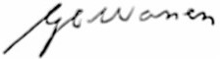
Signed:
(Signature)

Graham C. Warren
(Print Name)

Chief Financial Officer
(Print Office)

