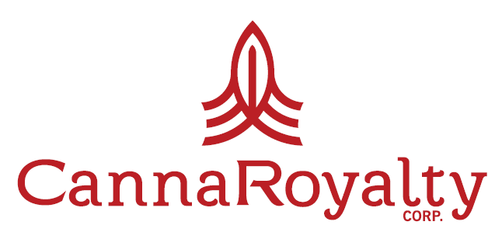

CannaRoyalty Investee and Licensing Partner Natural Ventures Reports Weather Damage to Puerto Rico Facility following Hurricane Maria
Ottawa, Canada – September 28, 2017 – CannaRoyalty Corp. (CSE: CRZ) (OTCQX: CNNRF) (“CannaRoyalty” or the “Company”), an active investor and operator in the legal cannabis industry, today confirmed that its investee and licensing partner, Natural Ventures PR, LLC (“Natural Ventures”) facility in Puerto Rico sustained some weather-related damage due to Hurricane Maria. All employees of Natural Ventures are safe and hard at work getting operations back online. Facility repairs are projected to be completed in the coming weeks and are expected to be covered by Natural Ventures’ insurance policy.
Natural Ventures is an active licensee, manufacturer and distributor of CR Brands’ Soul Sugar Kitchen™ gourmet edibles and GreenRock Botanicals™ premium vape pens in Puerto Rico. Currently, Natural Ventures is selling Soul Sugar Brand peanut butter cups and expects to launch branded jellies and snack mix in the near future. The GreenRock Botanicals line features premium hardware from 100% CannaRoyalty-owned DreamCatcher Labs, paired with premium oils in a range of local flavors including Guava, Mango, Pina Colada, Strawberry, Grape, Tangilope, Banana and others.
CannaRoyalty has a 10-year, 2.5% royalty on Natural Ventures’ total net income and also earns a further 10% licensing royalty on gross revenues generated from the CR Brands portfolio of products licensed by Natural Ventures from CannaRoyalty for the Puerto Rico market.

About Natural Ventures
CannaRoyalty investee Natural Ventures is Puerto Rico’s largest licensed cultivator, manufacturer and distributor of cannabis products with a 100,000 square-foot indoor cultivation facility. Natural Ventures is also one of only two companies in Puerto Rico that has received a manufacturer’s license. It has a 30,000 square-foot state of the art lab for processing, testing and distribution. Natural Ventures has full market distribution and is currently selling to every active dispensary in Puerto Rico. Natural Ventures launched CR Brands in Puerto Rico during Q2-2017, starting with Soul Sugar Kitchen gourmet-edibles and GreenRock Botanicals premium vape pens. Puerto Rico is one of the fastest growing medical cannabis markets in North America.
About CannaRoyalty
CannaRoyalty is an active investor and operator in the legal cannabis sector. Our focus is building and supporting a diversified portfolio of growth-ready assets in high-value segments of the cannabis sector, including research, consumer brands, devices and intellectual property. Our management team combines a hands-on understanding of the cannabis industry with seasoned financial know-how, assembling a platform of holdings via royalty agreements, equity interests, secured convertible debt, licensing agreements and its own branded portfolio.

For further inquiries, please contact:
Marc Lustig, CEO
info@cannaroyalty.com
1-844-556-5070
www.cannaroyalty.com

Jonathan Ross
LodeRock Advisors Inc.
jon.ross@loderockadvisors.com
416-283-0178

Forward Looking Statements
Statements in this news release that are forward-looking statements are subject to various risks and uncertainties concerning the specific factors disclosed here and elsewhere in CannaRoyalty's periodic filings with Canadian securities regulators. When used in this news release, words such as "will, could, plan, estimate, expect, intend, may, potential, believe, should," and similar expressions, are forward- looking statements.

Forward-looking statements may include, without limitation, statements including the Company’s expectations with respect to pursuing new opportunities and its future growth and other statements of fact.

Although CannaRoyalty has attempted to identify important factors that could cause actual results, performance or achievements to differ materially from those contained in the forward-looking statements, there can be other factors that cause results, performance or achievements not to be as anticipated, estimated or intended, including, but not limited to: dependence on obtaining regulatory approvals; investing in target companies or projects which have limited or no operating history and are engaged in activities currently considered illegal under US Federal Laws; changes in laws; limited operating history; reliance on management; requirements for additional financing; competition; hindering market growth and state adoption due to inconsistent public opinion and perception of the medical-use and adult-use marijuana industry and; regulatory or political change.

There can be no assurance that such information will prove to be accurate or that management's expectations or estimates of future developments, circumstances or results will materialize. As a result of these risks and uncertainties, the results or events predicted in these forward-looking statements may differ materially from actual results or events.

Accordingly, readers should not place undue reliance on forward-looking statements. The forward-looking statements in this news release are made as of the date of this release. CannaRoyalty disclaims any intention or obligation to update or revise such information, except as required by applicable law, and CannaRoyalty does not assume any liability for disclosure relating to any other company mentioned herein.

