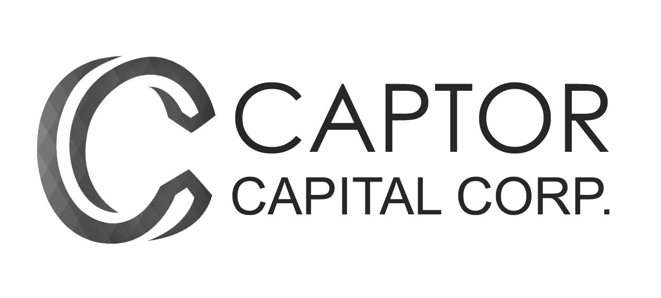
_______________________________________

FOR IMMEDIATE RELEASE

Almost 30,000 Visitors to Recently Acquired California Dispensaries in February

March 7, 2018

Toronto, Ontario – Captor Capital Corp. (“Captor” or the “Company”) (CSE:CPTR; FRANKFURT:NMV; USOTC:NWURF) today announced that its West Hollywood and Santa Ana cannabis dispensaries managed by MedMen enjoyed heavy foot traffic in the month of February with the two stores welcoming a combined total of 27,282 visitors. This is an average of almost 1,000 visitors per day between the two stores during the 28 days of February – traditionally one of the slowest retail months of the year.
MedMen reported to Captor that there has been revenue growth of 380 percent during the month of February (unaudited) at the West Hollywood location compared to February, 2017. The West Hollywood store also welcomed 22,690 visitors last month, up 345 percent compared to February, 2017.
At the Santa Ana dispensary, which opened its doors in June of 2017, MedMen reported to Captor that revenue in the month of February (unaudited) was 175 percent greater than the average monthly revenue during the period from from July to December 2017. There were 4,592 visitors at the Santa Ana store last month, up 202 percent compared to the monthly average number of visitors during the period from July to December 2017.
“Our MedMen branded dispensaries reported strong numbers and growth in the normally quiet retail month of February”, said John Zorbas, President of Captor. “We believe what we are seeing in the early months of 2018 is indicative of the potential of the recreational cannabis market in California, which for Captor is a strategic area of focus,” continued Mr. Zorbas. “
Captor acquired both cannabis dispensaries through its acquisition of all of the securities of I-5 Holdings Ltd., which closed in escrow on February 23, 2018. The closing remains ins escrow pending the satisfaction of certain conditions precedent.

About Captor Capital
Captor Capital Corp. is a Canadian investment firm listed on the Canadian Securities Exchange and the Frankfurt Stock Exchange. The company follows a strategy of acquiring profitable, established companies and organizations with growth potential that require capital to scale. Captor currently has investments in a number of companies and industries, including Millennial Esports in the technology sector, I-5 Holdings in the cannabis sector, and URU Metals in the natural resources sector.

Investor Contact
John Zorbas, President
Captor Capital Corp.
416.504.3978
Johnz@captorcapital.com

Media Contact
Gavin Davidson, Communications
Captor Capital Corp.
705.446.6630
gavin@captorcapital.com

Forward-Looking Statements
NEITHER THE CANADIAN SECURITIES EXCHANGE NOR ITS REGULATIONS SERVICES PROVIDER HAVE REVIEWED OR ACCEPT RESPONSIBILITY FOR THE ADEQUACY OR ACCURACY OF THIS RELEASE.
This press release contains or refers to forward-looking information, and is based on current expectations that involve a number of business risks and uncertainties. Factors that could cause actual results to differ materially from any forward-looking statement include, but are not limited to availability of investment opportunities, economic circumstances, market fluctuations and uncertainties, uncertainties relating to the availability and costs of financing needed in the future, changes in equity markets, inflation, changes in exchange rates, and the other risks involved in the investment industry and junior capital markets. Forward-looking statements are subject to significant risks and uncertainties, and other factors that could cause actual results to differ materially from expected results. Readers should not place undue reliance on forward-looking statements. These forward-looking statements are made as of the date hereof and the Company assumes no responsibility to update them or revise them to reflect new events or circumstances other than as required by law.

