BLUE LAGOON REACHES 100 TONNES PER DAY MILESTONE,
DOUBLES PRODUCTION CREW WITH SECOND MINING CONTRACTOR AND ADVANCES TOWARD 150 TONNES PER DAY
April 17, 2026 – Vancouver, British Columbia – Blue Lagoon Resources Inc. (the “Company”) (CSE:BLLG; OTCQB: BLAGF; FSE:7BL) is pleased to provide an operational update from its 100-per-cent-owned Dome Mountain gold and silver mine near Smithers, B.C., reporting a series of significant operational and organizational milestones as the ramp-up toward steady-state production continues.
Production reaches 100 tonnes per day
Dome Mountain has achieved consistent underground production of 100 tonnes per day, a key near-term target outlined in Blue Lagoon's January operational update (see news release January 5, 2026). This milestone reflects the resolution of early-stage commissioning constraints and the subsequent establishment of consistent underground production cycles.
The Company has engaged a second mining contractor, doubling the underground production crew from two to four shifts, and will be deploying additional mobile equipment to the mine site. With multiple working spaces now open across the mine, the increased crew capacity and equipment will enable the Company to advance toward the 150 tonnes per day target in the coming weeks.
Milling and revenue update
To date, Blue Lagoon has completed three sales of Dome Mountain gold and silver concentrates to Ocean Partners U.K. Ltd., for a total sum of approximately US$4.1 million. Additional quantities of mineralized material have been processed by the Company’s milling partner, Nicola Mining, and are awaiting delivery and final settlement. Further sales of concentrates will be announced in due course.
Approximately 2,000 tonnes of mineralized material is currently stockpiled at the mine site and the Nicola mill site, with regular trucking shipments to Nicola ongoing.
Assay laboratory is now operational
The Company has also built a local fire assay laboratory near the town of Smithers, which is now fully operational. The lab is accelerating the turnaround of grade-control assays, directly supporting mine planning and operational decision-making at Dome Mountain. In addition, the lab will now conduct mill production and settlement assays for Dome Mountain material processed at Nicola, a function previously performed externally. This brings a meaningful improvement to the speed and efficiency of the reconciliation and invoicing process and is expected to materially reduce the time between milling and final settlement with Ocean Partners going forward.
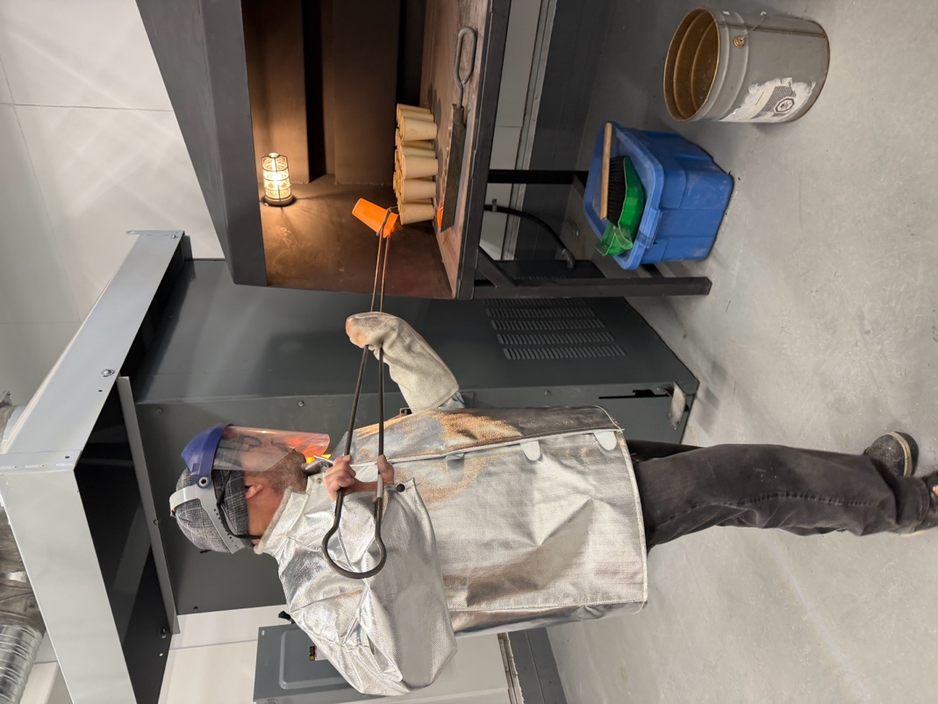
Samples being loaded into the furnace at the Company's newly
commissioned fire assay laboratory near Smithers, B.C.

Team expansion and planning ahead
Blue Lagoon has made a number of additional hires across operations as the Company continues to grow its operational team in line with the expanding scope of underground activities. Planning is underway for an exploration drill program at Dome Mountain, expected to commence in late Q3 2026 and funded from internally generated cash flow. The drilling campaign is intended to include both infill drilling and a work program targeting new areas along Dome Mountain's largely unexplored 18-kilometre strike length.
To ensure the site can support ongoing production with an expanded workforce alongside an active drill program, a site infrastructure upgrade plan is being scoped and will be advanced in the coming months.
The Company also announces the grant of an aggregate of 3,850,000 stock options to certain directors, officers, employees and consultants of the Company pursuant to its omnibus equity incentive plan. The options are exercisable at a price of $0.77 per share and will expire five years from the date of issuance. The grant is subject to approval by the Canadian Securities Exchange.
Additionally, the Company received a $500,000 unsecured, interest-free bridge loan from its President & CEO to support short-term working capital requirements while awaiting concentrates settlement. During the start-up phase of mining operations, the cash settlement cycle from mining through to final payment by Ocean Partners was significantly extended beyond typical timelines. This insider loan serves to bridge this transitional period, with no similar requirement anticipated going forward.

The interest free loan is due on March 20, 2027, or may be paid earlier at the Company's option. Pursuant to the loan agreement, the Company will issue an aggregate of 129,870 bonus common shares and 129,870 warrants to the lender, at a price of $0.77 cents per share, being the market price at the time the loan agreement was entered into. The lender is a related party to the Company and the loan constitutes a related party transaction pursuant to Multilateral Instrument 61-101 – Protection of Minority Security Holders in Special Transactions. The Company is relying on the exemptions from the formal valuation requirements contained in Section 5.5(b) of MI 61-101 and the minority shareholder approval requirements contained in Section 5.7(1)(b) of MI 61-101.

For further information, please contact:
Rana Vig
President and Chief Executive Officer
Telephone: 604-218-4766
Email: rana@bllg.ca

About Blue Lagoon Resources Inc.
Blue Lagoon Resources Inc. (CSE: BLLG; FSE: 7BL; OTCQB: BLAGF) is a Canadian-based, well-funded, growth-oriented mining company producing from its 100% owned Dome Mountain Gold Mine near Smithers, British Columbia. Led by a team with deep mining and finance experience, the Company operates in one of the world’s most attractive mining jurisdictions.
In February 2025, Blue Lagoon achieved a major milestone with the granting of a full mining permit - one of only nine issued in British Columbia since 2015 – and has since commenced underground mining operations. Mineralized material from Dome Mountain is processed under a long-term milling agreement with Nicola Mining. Beginning in H2 2026, the Company plans to reinvest internally generated cash flow into near-mine and regional exploration to further expand its resource base on its extensive property.
With a strong commitment to sustainability, community, and First Nation engagement, Blue Lagoon’s objective is to be a profitable, cash-flowing gold producer while creating lasting value for shareholders and stakeholders alike.
The Company is not basing its production decision at Dome Mountain on a feasibility study of mineral reserves demonstrating economic and technical viability. The production decision is based on having existing mining infrastructure, past bulk sampling and processing activity, and the established mineral resource. The Company understands that there is increased uncertainty, and consequently a higher risk of failure, when production is undertaken in advance of a feasibility study.

The CSE has not reviewed and does not accept responsibility for the adequacy or accuracy of this release.

Forward-Looking Statement
This news release contains forward-looking statements and forward-looking information within the meaning of applicable securities laws. Forward-looking statements include, but are not limited to, statements regarding future gold and silver prices, production levels, cash-flow generation, operational expansion, permitting amendments, infrastructure enhancements, exploration potential, and the Company’s plans, objectives, and expectations for future operations at the Dome Mountain Gold and Silver Project. Forward-looking statements are based on management’s current expectations and assumptions, including assumptions regarding commodity prices, operating conditions, regulatory approvals, availability of labour and equipment, and continued support from stakeholders, including Indigenous partners. Forward-looking statements involve known and unknown risks, uncertainties, and other factors that may cause actual results or events to differ materially from those expressed or implied by such statements. These risks include, but are not limited to, changes in commodity prices, operational and technical challenges, regulatory or permitting delays, environmental risks, changes in laws or government policy, availability of financing, and general economic and market conditions. Readers are cautioned not to place undue reliance on forward-looking statements. The Company does not undertake any obligation to update or revise forward-looking statements, except as required by applicable securities laws.

