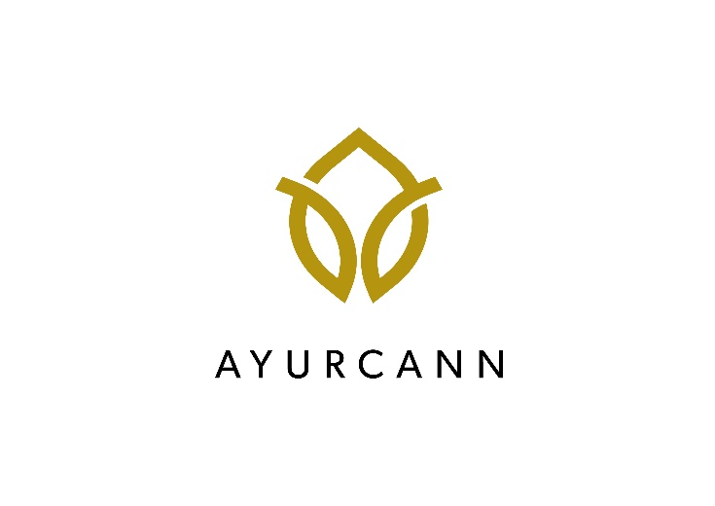
AYURCANN HOLDINGS CORP. PROVIDES CORPORATE UPDATE, GROWTH STRATEGY AND GRANTS RSUS

Toronto, Ontario, July 28, 2022 - Ayurcann Holdings Corp. (CSE: AYUR, OTCQB: AYURF, FSE: 3ZQ0) (“Ayurcann” or the “Company”), a leading Canadian cannabis extraction company specializing in the processing and co-manufacturing of pharma grade cannabis and hemp to produce various derivative cannabis 2.0 and 3.0 products in the medical and recreational market, is pleased to provide a corporate update and growth strategy in recreational cannabis in Canada.

Corporate Update

Canadian market penetration by Ayurcann in the recreational space, specifically in the vape segment, has seen tremendous growth, consistently having top selling brands across the country. Fuego has established itself as a top tier high potency value offering. Hustle and Shake is a true to flower experience, Bravo6 is a gaming segment entry and Xplor is a health and wellness offering.

Ayurcann has been working with provincial boards across the country and has been rewarded with new SKUs coming to market over the next three months in high potency distillate vapes, concentrates and tinctures. Ayurcann anticipates multiple additional orders from the provincial boards across the country for the rest of the year including orders for its entry into the flower and pre-roll segment.

Upcoming Summer launches include, but are not limited to:

- Fuego – Strawberry Cannacolada Vape
- Fuego – Death Baba Dablicator
- Hustle & Shake – BOBM high potency Vape
- Joints – Sunrise Surprise cannabinoids rich Vape
- Joints – Respite CBD oil 15g
- Oy Vapes – Kosher Honey Apple Kush Vape
- Coterie – Sour Tangerine Live Resin Vape
- Her Highness – Intimacy Oil

Management Agreements

Pursuant to certain consulting agreements entered into between the Company and the Company’s acting directors, officers and consultants (together, “Management”), the Company and Management have agreed that the aggregate quarterly management fee payment obligation in the amount of C$83,750 (each, a “Quarterly Payment”) will be settled in common shares in the capital of the Company (“Common Shares”) going forward, beginning on September 30, 2022. Each Quarterly Payment is to be satisfied through the issuance of Common Shares calculated according to the greater of: (i) ten-day volume weighted average price of the Common Shares on the Canadian Securities Exchange (“CSE”) ending on the quarter end date; (ii) the discounted market price pursuant to the policies of the CSE; and (iii) C$0.05. The Common Shares will be subject to a four month and one day hold period pursuant to the polices of the CSE and applicable securities laws.
RSU Grant

The Company is also pleased to announce the grant of an aggregate of 1,226,350 restricted share units (each an “RSU”) to certain directors, officers, employees, and consultants of the Company pursuant to the Company’s RSU plan. Each RSU granted vests immediately and all of the RSUs (and any Common Shares issuable upon redemption) will be subject to a four month and one day hold period pursuant to the polices of the CSE and applicable securities laws.

About Ayurcann:

Ayurcann is a leading post-harvest solution provider with a focus on providing and creating custom processes and pharma grade products for the adult use and medical cannabis industry in Canada. Ayurcann is striving to become a partner of choice for leading Canadian and international cannabis brands by providing best-in-class, proprietary services including extraction, formulation, product development and custom manufacturing.

For additional information, please contact:

Ayurcann Holdings Corp.
Igal Sudman, Chief Executive Officer
905.492.3322
info@ayurcann.com

Investor Relations:
Email: ir@ayurcann.com

Neither the CSE nor its Regulation Services Provider have reviewed or accept responsibility for the adequacy or accuracy of this release.

Forward-Looking Statements

This news release contains “forward-looking statements” within the meaning of applicable securities laws. All statements contained herein that are not clearly historical in nature may constitute forward-looking statements. Generally, such forward-looking information or forward-looking statements can be identified by the use of forward-looking terminology such as “plans”, “expects” or “does not expect”, “is expected”, “budget”, “scheduled”, “estimates”, “forecasts”, “intends”, “anticipates” or “does not anticipate”, or “believes”, or variations of such words and phrases or may contain statements that certain actions, events or results “may”, “could”, “would”, “might” or “will be taken”, “will continue”, “will occur” or “will be achieved”. The forward-looking information and forward-looking statements contained herein include, but are not limited to, statements regarding: Ayurcann growing its exposure and market share throughout the country; Ayurcann maintaining a continuous path of profitability and growth; future product and SKU launches of the Company; future orders by provincial boards; the Company entering into the flower and pre-roll segments; ongoing obligations of the Company due to future Quarterly Payments; and the ability of the Company to become the partner of choice for leading Canadian cannabis brands.

Forward-looking information in this news release are based on certain assumptions and expected future events, namely: the Company will expand and be able to maintain production capacity; the Company’s ability to continue as a going concern; continued approval of the Company’s activities by the relevant governmental and/or regulatory authorities; the continued growth of the Company; the Company’s successful implementation of its strategy to expand market share in extract and extract derivatives while providing exceptional products to consumers; the Company’s continuing ability to meet the requirements necessary to remain listed on the CSE and alternative exchanges; Ayurcann growing its exposure and market share throughout the country; Ayurcann maintaining a continuous path of profitability and growth; the Company will launch future products and SKUs; provincial boards will continue placing orders with the Company; the Company will enter into the flower and pre-roll segments; the Company will fulfill its obligations under future Quarterly Payments; and the Company becoming the partner of choice for leading Canadian cannabis brands.

These statements involve known and unknown risks, uncertainties and other factors, which may cause actual results, performance or achievements to differ materially from those expressed or implied by such statements, including but not limited to: the Company’s inability to expand and/or maintain production capacity; the potential inability of the Company to continue as a going concern; the risks associated with the cannabis industry in general; increased competition in the cannabis extraction market; the potential future unviability of the cannabis market; risks associated with potential governmental and/or regulatory action with respect to the cannabis industry; the Company’s inability to obtain continued regulatory approvals; the Company’s inability to successfully implement its strategy to expand market share in extract and extract derivatives while providing exceptional products to consumers; the Company’s inability to meet the requirements necessary to remain listed on the CSE and alternative exchange; the Company’s inability to grow its exposure and market share; the Company being unable to maintain a continuous path of profitability and growth; the Company will be unable to launch future products and SKUs; provincial boards will not place future orders; the Company will be unable to enter into the flower and pre-roll segments; the Company will be unable to fulfill its obligations surrounding future Quarterly Payments; and the inability of the Company to become the partner of choice for leading Canadian cannabis brands.

Readers are cautioned that the foregoing list is not exhaustive. Readers are further cautioned not to place undue reliance on forward-looking statements, as there can be no assurance that the plans, intentions, or expectations upon which they are placed will occur. Such information, although considered reasonable by management at the time of preparation, may prove to be incorrect and actual results may differ materially from those anticipated.

Forward-looking statements contained in this news release are expressly qualified by this cautionary statement and reflect the Company’s expectations as of the date hereof and are subject to change thereafter. The Company undertakes no obligation to update or revise any forward-looking statements, whether as a result of new information, estimates or opinions, future events, or results or otherwise or to explain any material difference between subsequent actual events and such forward-looking information, except as required by applicable law.

This press release shall not constitute an offer to sell or the solicitation of an offer to buy nor shall there be any sale of the securities in any state in which such offer, solicitation or sale would be unlawful. The securities being offered have not been, nor will they be, registered under the United States Securities Act of 1933, as amended, and may not be offered or sold in the United States absent registration or an applicable exemption from the registration requirements of the United States Securities Act of 1933, as amended, and applicable state securities laws.

