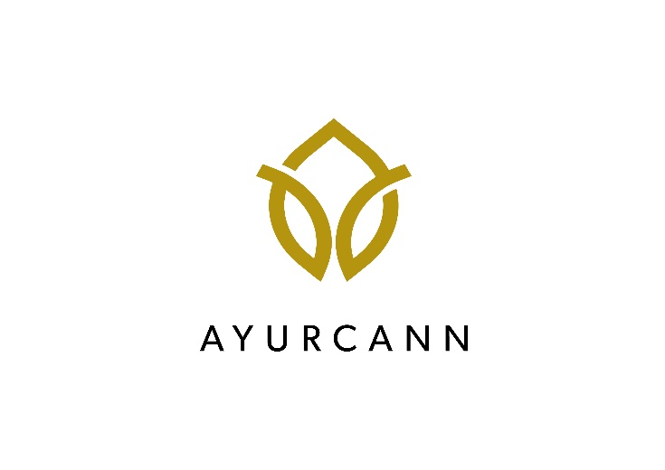
AYURCANN HOLDINGS CORP. ANNOUNCES
2021 AGSM MEETING RESULTS AND RSU GRANTS

Toronto, Ontario, December 30, 2021 - Ayurcann Holdings Corp. (CSE: AYUR, OTCQB: CDCLF, FSE: 3ZQ0) (the “Company”), a leading Canadian cannabis extraction company specializing in the processing and co-manufacturing of pharma grade cannabis and hemp to produce various derivative cannabis 2.0 products in the medical and recreational market, is pleased to announce the results of voting at its annual general and special meeting of shareholders which was held on December 20, 2021 in Toronto, Ontario (the “Meeting”).

All the resolutions, as described in the Company’s management information circular dated November 19, 2021, were approved by the requisite majority of votes cast at the Meeting. At the Meeting, the shareholders voted to: (i) fix the number of directors of the Company at five (5); (ii) reelect Igal Sudman, Roman Buzaker, Maor Shayit, David Hackett and Alison Gordon as directors of the Company for the ensuing year; (iii) and reappoint Clearhouse LLP as the auditors of the Company for the ensuing year.

RSU Grant

The Company is pleased to announce the granting of an aggregate of 785,405 restricted share units (each, an “RSU”) to certain directors, officers, employees and consultants of the Company, pursuant to the Company’s RSU plan. All RSUs granted vest immediately and the common shares issuable upon redemption will be subject to a four (1) month and one (1) day hold period under applicable securities laws.

About Ayurcann Holdings Corp.

Ayurcann is a leading post-harvest solution provider with a focus on providing and creating custom processes and pharma grade products for the adult use and medical cannabis industry in Canada. Ayurcann is striving to become a partner of choice for leading Canadian and international cannabis brands by providing best-in-class, proprietary services including extraction, formulation, product development and custom manufacturing.

For additional information, please contact:

Ayurcann Holdings Corp.
Igal Sudman, Chief Executive Officer
905-492-3322
info@ayurcann.com

Investor Relations:
Email: ir@ayurcann.com

Neither the Canadian Securities Exchange nor its Regulation Services Provider have reviewed or accept responsibility for the adequacy or accuracy of this release.

Certain statements included in this press release constitute forward-looking information or statements (collectively, “forward-looking statements”), including those identified by the expressions “anticipate”, “believe”, “plan”, “estimate”, “expect”, “intend”, “may”, “should” and similar expressions to the extent they relate to the Company or its management. The forward- looking statements are not historical facts but reflect current expectations regarding future results or events. This press release contains forward looking statements, including but not limited to statements relating to the Company’s expansion plans, future production capacity, the Company becoming a partner of choice for leading Canadian and international cannabis brands and the Company’s intended directors and auditor for the ensuing year. These forward-looking statements are based on current expectations and various estimates, factors and assumptions and involve known and unknown risks, uncertainties, and other factors.

Forward-looking information in this news release are based on certain assumptions and expected future events, namely: the Company will expand and be able to maintain production capacity; the Company’s ability to continue as a going concern; continued approval of the Company’s activities by the relevant governmental and/or regulatory authorities; the continued growth of the Company; the Company will become a partner of choice for leading Canadian and international cannabis brands; and the Company will maintain the same directors and auditor for the ensuing year.

Forward-looking statements are not guarantees of future performance and involve risks, uncertainties and assumptions which are difficult to predict. Factors that could cause the actual results to differ materially from those in forward-looking statements include, but are not limited to, failure to obtain regulatory approval, ability to increase production at the Company’s facilities, the continued availability of capital and financing, general economic, market or business conditions, risk that the Company may not become a partner of choice for leading Canadian and international cannabis brands and risks that Company may change its directors and/or auditor prior to the next shareholder meeting. Forward-looking statements contained in this press release are expressly qualified by this cautionary statement. These statements should not be read as guarantees of future performance or results. Such statements involve known and unknown risks, uncertainties and other factors that may cause actual results, performance, or achievements to be materially different from those implied by such statements. Although such statements are based on management’s reasonable assumptions, there can be no assurance that the statements will prove to be accurate or that management’s expectations or estimates of future developments, circumstances or results will materialize. Although the Company has attempted to identify important risks, uncertainties and factors which could cause actual results to differ materially, there may be others that cause results not to be as anticipated, estimated or intended and such changes could be material. Public health crises, including the ongoing novel coronavirus (COVID-19) pandemic, could have significant economic and geopolitical impacts that may adversely affect the Company’s business, financial condition and/or results of operations. The Company assumes no responsibility to update or revise forward-looking information to reflect new events or circumstances unless required by law.

Readers are cautioned that the foregoing list is not exhaustive. Readers are further cautioned not to place undue reliance on forward-looking statements, as there can be no assurance that the plans, intentions or expectations upon which they are placed will occur. Such information, although considered reasonable by management at the time of preparation, may prove to be incorrect and actual results may differ materially from those anticipated.

This press release shall not constitute an offer to sell or the solicitation of an offer to buy nor shall there be any sale of the securities in any state in which such offer, solicitation or sale would be unlawful. The securities being offered have not been, nor will they be, registered under the United States Securities Act of 1933, as amended, and may not be offered or sold in the United States absent registration or an applicable exemption from the registration requirements of the United States Securities Act of 1933, as amended, and applicable state securities laws.

