AURWEST SAMPLES 144.7 G/T GOLD (4.65 OUNCES PER TON) AT PARADISE LAKE GOLD PROJ ECT, CENTRAL NEWFOUNDLAND.

CALGARY, ALBERTA (February 28, 2022) – Aurwest Resources Corporation (“Aurwest” or the “Company”) (CSE: AWR) is very pleased to report the last of the 2021 rock sampling results for the Paradise Lake project. Highlight from the recent analytical results are:
Highlights:
- Recent surface samples of quartz vein material (2-3% combined pyrite/arsenopyrite) in the Twin Ponds area has returned three samples exceeding 1g/t; including samples yielding 144.7 g/t (4.64 opt) and 7.37g/t gold.
- The high-grade sample is located approximately 400m north of and along strike of the initial 700m of drilling recently completed on the Twin Ponds drill target of which 3,000m is proposed.
- These sample results are located along the same interpreted basement structure where earlier rock sampling returned gold concentrations of up to 11.3g/t and 14.22g/t, in quartz vein material with 2-3% combined pyrite and arsenopyrite.
- Compilation of sampling results, show that eight samples with gold concentrations exceeding 1g/t gold cluster over the Paradise Lake area and exhibit a strong spatial association with a coincident 5.5 kms long positive chargeability anomaly and negative magnetic anomaly.
Mr. Colin Christensen stated, “These analytical results have extended the strike length of the gold mineralization associated with the leakage halo identified in the Twin Ponds area by approximately 400m along strike and demonstrates the potential for high-grade gold mineralization. The recent results compliment previously reported gold concentrations of 11.3g/t and 14.2 g/t located along a 5.5 kms long northeast trending positive chargeability anomaly; several late stage intrusives; and a magnetic low along an interpreted basement structure. The gold-pyrite-arsenopyrite mineral association is interpreted to be the source of the positive chargeability anomaly. Aurwest is amending its Phase I drilling strategy to test the depth extension of the high-grade mineralization at depth ”.

Recent Analytical Results:
New analytical results of rock samples collected in 2021 have been received for the Paradise Lake Project. Three samples contain gold concentration that ranged from 1.76 g/t to 144.7g/t gold. These sample results are in addition to the rock sampling results reported in November 2021 that returned up to 14.22 g/t gold, (see news release dated November 22, 2021). Further assay results from surface sampling in 2021 are expected in March 2022.

Analytical Procedures:
Sample preparation and analytical work was completed by Eastern Analytical (“Eastern”) located in Springdale, Newfoundland Labrador. Gold concentrations were determined in parts per billion (“ppb”) using 30g fire assay with atomic absorption finish. Trace elements concentration are determined in parts per million (“ppm”) on 200 milligram samples, using four acid digestion and analyses by ICP-OES. Aurwest’s QA/QC protocol includes insertion of Standard Reference Material and blanks in the sample streams. Eastern has an ISO/IEC 17025 accreditation.

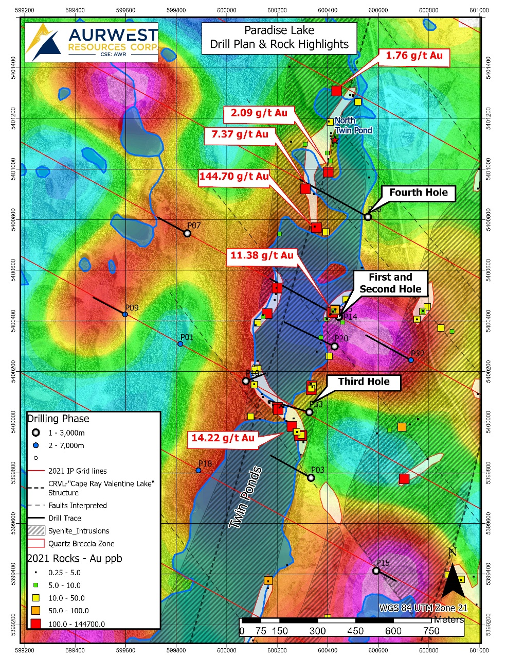

Qualified Person:
Elmer B. Stewart, MSc. P. Geol., is the Company’s independent, nominated Qualified Person pursuant to National Instrument 43-101, Standards for Disclosure for Mineral Projects, and has reviewed and approves the scientific and technical information disclosed in this news release

On Behalf Of Aurwest resources Corporation

“Colin Christensen”
President and Chief Executive Officer
For additional information please contact:
Colin Christensen
Telephone: (403) 483-8363
Email: cchristensen@aurwestresources.com
Website: aurwestresources.com

About Aurwest Resources Corporation
Aurwest is a Canadian-based junior resource company focused on the acquisition, exploration, and development of gold properties in Canada. The Company currently has three Option Agreements to earn a 100% interest in Paradise Lake and Stony Caldera projects covering a 47,800-hectare (478 sq kms) package of gold exploration licenses within the emerging Central Newfoundland gold district. The Company also currently holds a 100% interest in the 28,294-hectare Stellar/Stars porphyry copper project, located approximately 25 kilometers southwest of Houston, British Columbia.

Forward-Looking Information
Statements included in this announcement, including statements concerning our plans, intentions, and expectations, which are not historical in nature are intended to be, and are hereby identified as “forward-looking statements”. Forward looking statements may be identified by words including “anticipates”, “believes”, “intends”, “estimates”, “expects” and similar expressions. The Company cautions readers that forward-looking statements, including without limitation those relating to the Company’s future operations and business prospects, are subject to certain risks and uncertainties that could cause actual results to differ materially from those indicated in the forward-looking statements. Readers are advised to rely on their own evaluation of such risks and uncertainties and should not place undue reliance on forward-looking statements. Any forward-looking statements are made as of the date of this news release, and the Company assumes no obligation to update the forward-looking statements, except in accordance with the applicable laws.

The Canadian Securities Exchange has not reviewed and does not accept responsibility for the adequacy or accuracy of this release.

