AURWEST COMMENCES DRILLING AT PARADISE LAKE GOLD PROPERTY, CENTRAL NEWFOUNDLAND

CALGARY, ALBERTA (January 26, 2022) – Aurwest Resources Corporation (“Aurwest” or the “Company”) (CSE: AWR) is pleased to report that diamond drilling has commenced on a planned Phase 1 – 3,000-meter drill program at its flagship Paradise Lake gold project in Central Newfoundland. The first drill hole is located near Twin Pond, approximately 21 km south of Grand Falls, targeting a high priority gold anomaly from the recently completed IP survey.
Mr. Colin Christensen stated, “We are extremely excited to have our maiden drill program underway. The 2021 exploration program located several leakage halos on surface carrying up to 14.2 g/t gold in this area. The drilling will target an area exhibiting post-Botwood intrusive activity, positive chargeability signatures and silicified areas with gold-pyrite mineralization on surface. The combination of these features represents priority drillings targets to test the down dip extensions of interpreted leakage halos originating from the Lawrenceton volcanics below the Botwood sediments”.

The initial drilling program will focus on the Twin Ponds-Paradise Lake area where 2021 exploration located a 5kms long northeast trending positive chargeability anomaly; several late stage intrusives; and a magnetic low along an interpreted basement structure. Within this northeast trending area, surface exploration located numerous areas of quartz vein/breccias in outcrop/subcrop that returned up to 14.2 g/t gold. These areas also host pyrite-arsenopyrite bearing Botwood sediments interpreted to be the surface expression of late-stage re-activated faults along which hydrothermal fluids carrying gold and silica emanated upwards from the underlying Lawrenceton volcanics.
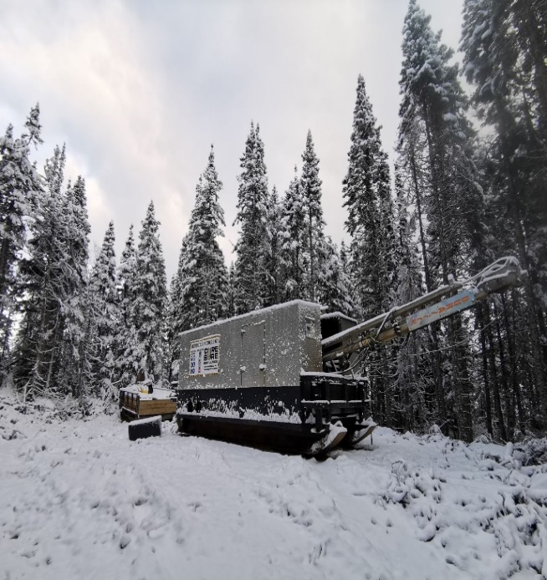
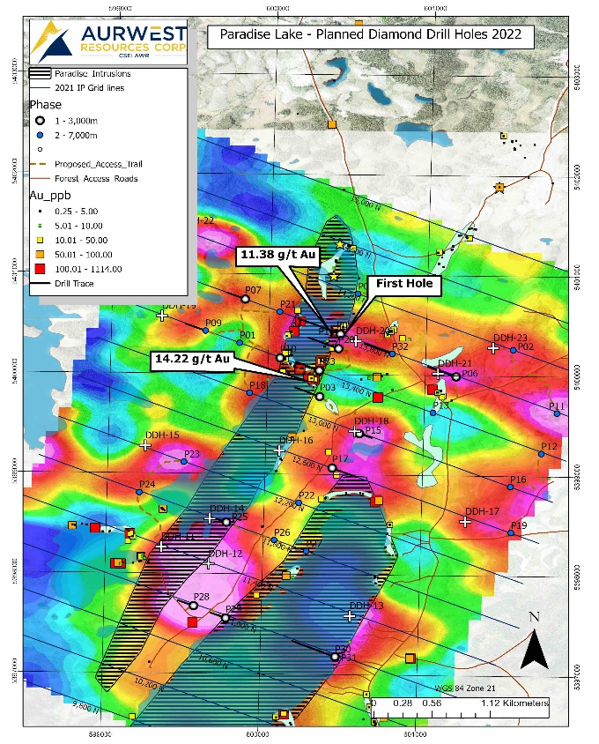

Qualified Person:
Elmer B. Stewart, MSc. P. Geol., is the Company’s independent, nominated Qualified Person pursuant to National Instrument 43-101, Standards for Disclosure for Mineral Projects, and has reviewed and approves the scientific and technical information disclosed in this news release

On Behalf Of Aurwest resources Corporation

“Colin Christensen”
President and Chief Executive Officer
For additional information please contact:
Colin Christensen
Telephone: (403) 483-8363
Email: cchristensen@aurwestresources.com
Website: aurwestresources.com

About Aurwest Resources Corporation
Aurwest is a Canadian-based junior resource company focused on the acquisition, exploration, and development of gold properties in Canada. The Company currently has three Option Agreements to earn a 100% interest in Paradise Lake and Stony Caldera projects covering a 47,800-hectare (478 sq kms) package of gold exploration licenses within the emerging Central Newfoundland gold district. The Company also currently holds a 100% interest in the 28,294-hectare Stellar/Stars porphyry copper project, located approximately 25 kilometers southwest of Houston, British Columbia.

Forward-Looking Information
Statements included in this announcement, including statements concerning our plans, intentions, and expectations, which are not historical in nature are intended to be, and are hereby identified as “forward-looking statements”. Forward looking statements may be identified by words including “anticipates”, “believes”, “intends”, “estimates”, “expects” and similar expressions. The Company cautions readers that forward-looking statements, including without limitation those relating to the Company’s future operations and business prospects, are subject to certain risks and uncertainties that could cause actual results to differ materially from those indicated in the forward-looking statements. Readers are advised to rely on their own evaluation of such risks and uncertainties and should not place undue reliance on forward-looking statements. Any forward-looking statements are made as of the date of this news release, and the Company assumes no obligation to update the forward-looking statements, except in accordance with the applicable laws.

The Canadian Securities Exchange has not reviewed and does not accept responsibility for the adequacy or accuracy of this release.

