AURWEST CLOSES ACQUISITION OF 50% OF STARS PORPHYRY COPPER PROPERTY

Calgary, Alberta (September 30, 2021) – Aurwest Resources Corporation (“Aurwest” or the “Company”) (CSE: AWR) is pleased to announce that it has closed the purchase transaction, originally announced on September 27, 2021, with Pacific Empire Minerals Corp (the “Vendor”) (TSXV: PEMC) to acquire the Vendors 50% interest in the Stars Property, a copper porphyry project, covering 2,136 hectares contiguous to Aurwest’s Stellar Property in central British Columbia (See figure 1).

Colin Christensen, President & CEO of Aurwest commented, “We’re excited to have completed this transaction which provides Aurwest a significant strategic participation in an early-stage porphyry copper discovery, complimenting the exciting upside we see developing on our Stellar Property”.

Acquisition Terms
Aurwest acquired the Vendor’s 50% interest in the Stars Property by way of a Purchase and Sale Agreement, with an effective closing date of September 30, 2021. Terms of the transaction included a cash payment of C$350,000 to the Vendor, and also granted to the Vendor a 2% net smelter return (“NSR”) on the property. Aurwest has the right to repurchase at any time one per cent of the NSR (1.0%) for consideration of C$1,000,000.

Figure 1: Expanded land position with the 50% interest in the Stars Property

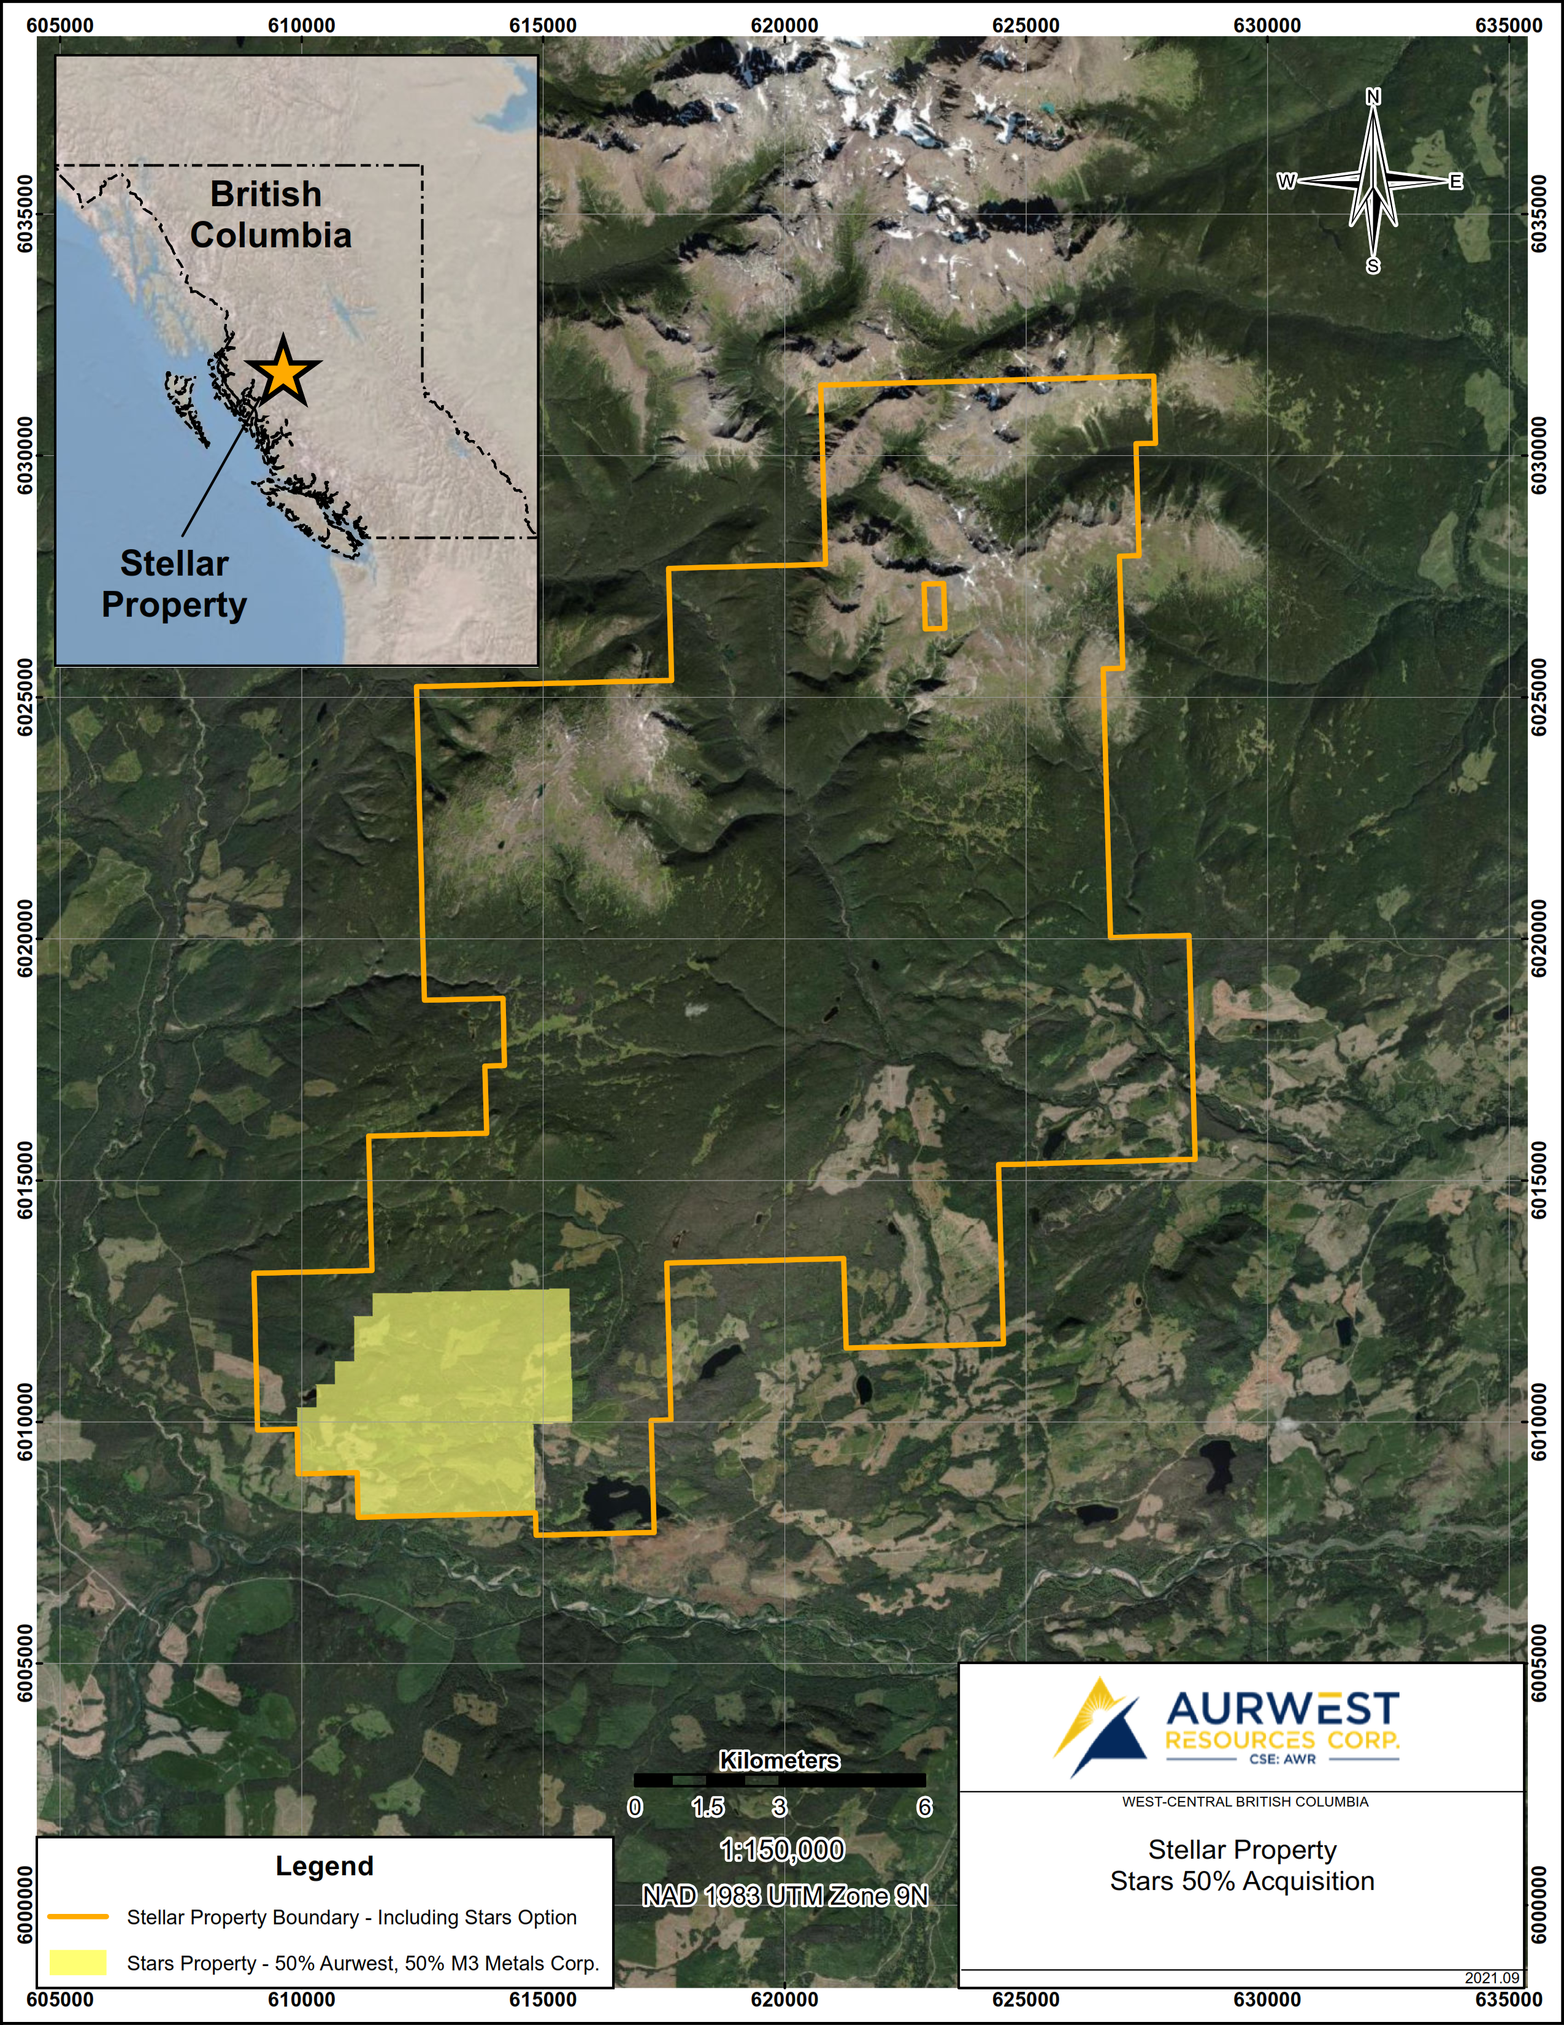

Aurwest also wishes to announce that it intends to commence a normal course issuer bid (“NCIB”), under which the Company may purchase up to 4,801,431 of the Company’s common shares, representing approximately 5% of its issued and outstanding common shares. The Company is commencing the NCIB because it believes that, from time to time, the market price of its Shares may not fully reflect the underlying value of the Company’s business and future prospects. The Company believes that, at such times, the repurchase of its Shares for cancellation represents an appropriate use of the Company’s financial resources and will enhance shareholder value.

The Company intends to appoint PI Financial Corp. as its broker to conduct the NCIB on its behalf. The NCIB is expected to commence on September 30, 2021 and terminate on September 30, 2022, or an earlier date in the event that the number of Shares sought in the NCIB has been repurchased or if the Company feels that it is appropriate. All Shares purchased under the NCIB will be purchased on the open market through the facilities of the Canadian Securities Exchange. All purchases made under the NCIB will be at the prevailing CSE market price for the Shares at the time of purchase. Shares acquired by the Company under the NCIB are being purchased for cancellation.

On Behalf Of Aurwest resources Corporation

“Colin Christensen”

President and Chief Executive Officer

For additional information please contact:
Colin Christensen
Telephone: (403) 483-8363
Email: cchristensen@aurwestresources.com
Website: www.aurwestresources.com

About Aurwest Resources Corporation
Aurwest is a Canadian-based junior resource company focused on the acquisition, exploration, and development of gold properties in Canada. The Company currently has three Option Agreements to earn a 100% interest in Paradise Lake and Stony Caldera projects covering a 47,800-hectare (478 sq kms) package of gold exploration licenses within the emerging Central Newfoundland gold district. The Company also currently holds a 100% interest in the 24,533 hectare Stellar copper/gold Project plus an additional 2,136 hectares of contiguous claims in the acquired 50% interest in the Stars property, located approximately 25-65 kilometers southwest of Houston British Columbia.

Forward-Looking Information
Statements included in this announcement, including statements concerning our plans, intentions, and expectations, which are not historical in nature are intended to be, and are hereby identified as “forward-looking statements”. Forward looking statements may be identified by words including “anticipates”, “believes”, “intends”, “estimates”, “expects” and similar expressions. The Company cautions readers that forward-looking statements, including without limitation: historical exploration results; positive diamond drilling results; styles of copper-molybdenum mineralization; and future work programs.

In connection with the forward-looking information contained in this news release, Aurwest has made numerous assumptions regarding, among other things: the geological advice that Aurwest has received is reliable and is based upon practices and methodologies which are consistent with industry standards; and the reliability of historical reports. While Aurwest considers these assumptions to be reasonable, these assumptions are inherently subject to significant uncertainties and contingencies.

Additionally, there are known and unknown risk factors which could cause Aurwest’s actual results, performance, or achievements to be materially different from any future results, performance or achievements expressed or implied by the forward-looking information contained herein. Known risk factors include but are not limited to, additional exploration of the properties may not locate significant copper-molybdenum mineralization: historical exploration results may not be accurate; exploration of the areas of copper mineralization may not locate significant mineralization; the positive diamond drilling results may not be accurate; styles of copper-molybdenum mineralization; and future work programs may not result in the location of significant copper-molybdenum mineralization future work programs may not be completed as planned or at all; receipt of permits to conduct the exploration plans and matters relating to the Company’s future operations and business prospects; certain risks and uncertainties that could cause actual results to differ materially from those indicated in the forward-looking statements. Readers are advised to rely on their own evaluation of such risks and uncertainties and should not place undue reliance on forward-looking statements. Any forward-looking statements are made as of the date of this news release, and the Company assumes no obligation to update the forward-looking statements, except in accordance with the applicable laws.

The Canadian Securities Exchange has not reviewed and does not accept responsibility for the adequacy or accuracy of this release.

