AURWEST RESOURCES ANNOUCES EXECUTION OF DEFINITIVE AGREEMENT ON WEAVER LAKE GOLD PROJECT

Calgary, Alberta (April 14, 2026) – Aurwest Resources Corporation (“Aurwest” or the “Company”) (CSE: AWR) is pleased to announce that the Company has entered into a Definitive Option and Joint Venture Agreement (the “Agreement”) with Pacific Bay Minerals Ltd. (TSXV: PBM) whereby Aurwest has acquired an option to earn, subject to the satisfaction of conditions, an undivided interest of up to 50% in the Weaver Gold gold/silver property (the “Transaction”) in British Columbia.

Transaction Summary

Pursuant to the terms of the definitive agreement, Pacific Bay is appointment as the operator of the project in consideration of payments, issuance of common shares of the Company (“AWR Common Shares”) and exploration work. The Company may earn up to a 50% undivided interest in the Weaver Lake project up each of the yearly anniversaries of the signature of the definitive agreement during a three-year period following the entering into the Transaction. Such payments and AWR Common Shares issuances are allocated as follows (in each case subject to and in accordance with the rules and policies of the Canadian Securities Exchange “(the “CSE”));

- Upon signing of this Agreement, $10,000 and 500,000 shares of Aurwest; (completed);
- Upon receipt of regulatory approval, payment to PBM of $20,000 worth of common shares of Aurwest based on the 20-day Volume Weighted Average Price of Aurwest (“VWAP”)
- On or before the first anniversary of the LOI: $15,000 cash; $25,000 worth of Aurwest shares based on the VWAP; and $75,000 in exploration work on the Property
- On or before the second anniversary of the LOI: $20,000 cash; $75,000 worth of Aurwest shares based on the VWAP; and an additional $100,000 in exploration work on the Property.
- On or before the third anniversary of the LOI: $25,000 cash; and $75,000 worth of Aurwest shares based on the VWAP; and an additional $150,000 in exploration work on the Property.

The Agreement also contemplates the following:

- Automatic Joint Venture Formation Upon Option Exercise: Upon Aurwest satisfying all option payments and work commitments, the parties will automatically form a 50/50 joint venture, with Pacific Bay Minerals acting as the initial Operator and a two-member Management Committee governing major decisions.

- Existing 3% NSR Royalty with Buydown Rights: The Property is subject to a 3.0% Net Smelter Returns Royalty in favour of David Schussler. Pacific Bay retains the right to purchase up to 2% of that royalty at $1.5 million per 1% increment and holds a right of first refusal on the remaining 1%.

- Dilution Mechanics and Minimum Interest Threshold: If either joint venture partner fails to fund its share of approved programs post-formation, its interest will be diluted proportionally. A partner whose interest falls to 15% or below is automatically converted to a 2% NSR royalty, with the other party holding a buyout option on that royalty for $2,000,000.

- Governance and Transfer Restrictions: Major decisions — including asset dispositions or borrowings exceeding $2,000,000 and litigation settlements above $500,000 — require unanimous Management Committee approval. Neither party may transfer its interest without first offering a right of first refusal to the other, and any transferee must assume all obligations under the agreement.

Weaver Gold Project

Located in southwestern British Columbia's prolific East Harrison Lake Belt, the Property hosts strong potential for orogenic gold-silver mineralization hosted in structurally controlled quartz-carbonate vein systems, with historical exploration yielding impressive high-grade results, including up to 63.77 g/t gold and 2,009.44 g/t silver from trench sampling, and multiple drill intercepts with multi-gram gold and silver over metre-scale widths.

Situated near excellent infrastructure with year-round access via paved highways and forestry roads, the 725-hectare Property also offers secondary upside for magmatic nickel-copper sulphide mineralization, drawing parallels to the nearby Pacific Nickel (Giant Mascot) Mine. The Whitehead report concludes that Weaver Lake is a property of merit warranting continued exploration, supported by its favorable geological setting, confirmed mineralization continuity, and untapped potential along strike and at depth.

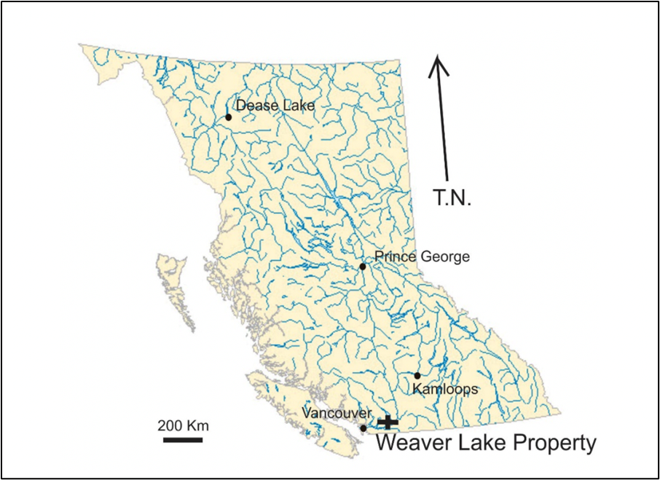 | 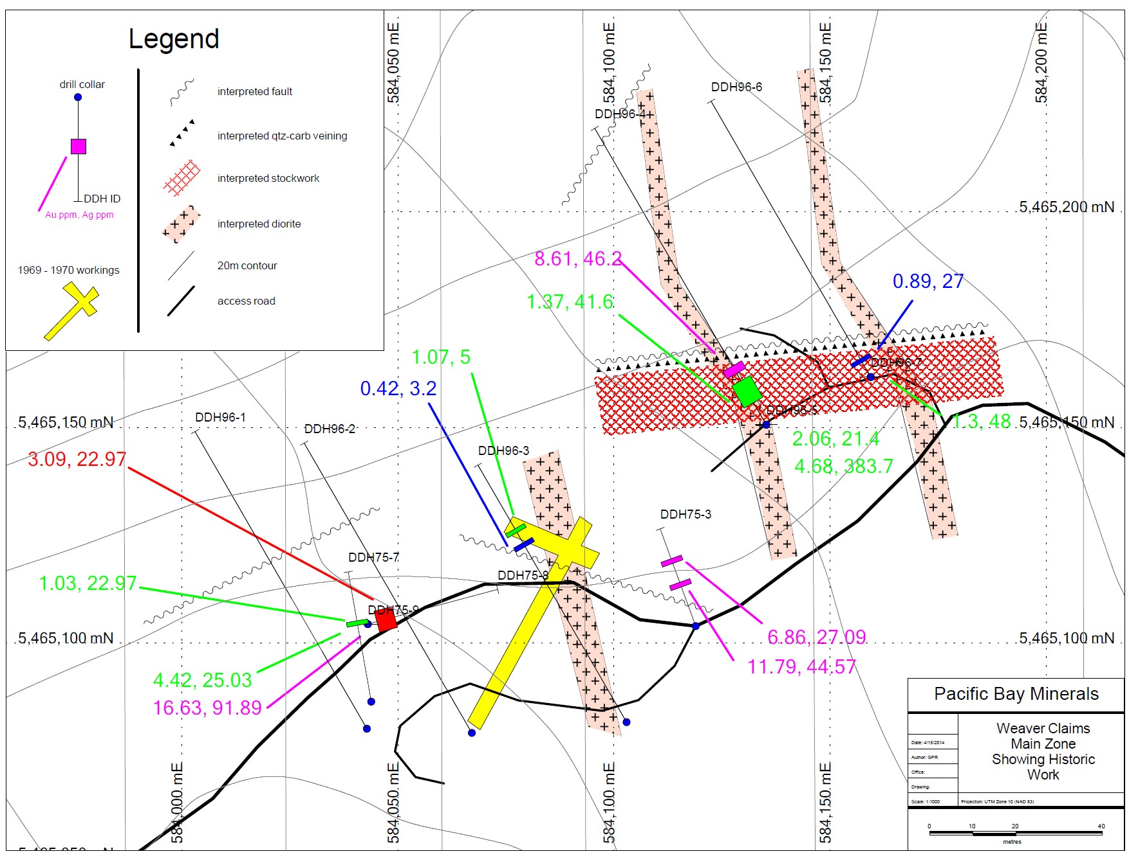
Figure 1 - Location Map Figure 2 - Weaver Gold Prior Drilling & Workings

“The Weaver Gold Project represents and exciting opportunity for Aurwest to get into the gold exploration sector in B.C.,” said Aurwest CEO Cameron MacDonald. “We’re looking forward to getting to work on this high-potential project.”

Qualified Person
The scientific and technical information contained herein has been reviewed and approved by Mr. David Bridge, P.Geo., an independent technical advisor to the Company, who is a “Qualified Person” as defined in National Instrument 43-101 – Standards of Disclosure of Mineral Projects.

On Behalf Of Aurwest resources Corporation

“Cameron MacDonald”

Interim President and Chief Executive Officer

For Additional Information Please Contact
Cameron MacDonald
Telephone: (403) 585-9875
Email: cmacdonald@aurwestresources.com
Website: www.aurwestresources.com

About Aurwest Resources Corporation
Aurwest is a Canadian-based junior resource company focused on the acquisition, exploration, and development of gold properties in Canada.

Forward-Looking Information
Statements included in this announcement, including statements concerning our plans, intentions, and expectations, which are not historical in nature are intended to be, and are hereby identified as “forward-looking statements”. Forward looking statements may be identified by words including “anticipates”, “believes”, “intends”, “estimates”, “expects” and similar expressions. The Company cautions readers that forward-looking statements, including without limitation: the Acquisition and closing of such, certain regulatory, exchange and/or shareholder approvals for the Acquisition, and certain risks and uncertainties that could cause actual results to differ materially from those indicated in the forward-looking statements. Readers are advised to rely on their own evaluation of such risks and uncertainties and should not place undue reliance on forward-looking statements. Any forward-looking statements are made as of the date of this news release, and the Company assumes no obligation to update the forward-looking statements, except in accordance with the applicable laws.

The Canadian Securities Exchange has not reviewed and does not accept responsibility for the adequacy or accuracy of this release.

