**AURWEST RESOURCES PROVIDES UPDATE**

**ON STELLAR COPPER-GOLD PROPERTY**

**CALGARY, ALBERTA (August 19, 2020) –** Aurwest Resources Corporation (“**Aurwest**” or the “**Company**”) (**CSE: AWR**) is pleased to provide the results of its recently completed compilation of historical and recent exploration data for its 100% owned Stellar Project. This 22,700-hectare property is in west-central British Columbia within the Omineca Mining Division and is approximately 25 km southwest of the town of Houston, BC. The historical exploration data and analytical results reported in this news release with the exception of the airborne geophysical survey completed in 2019, (see News Release dated February 25, 2019) were taken from the numerous assessment reports filed with the department of Mines and Energy for British Columbia over the past 50 years and on BC MINFILES. Neither Aurwest nor a qualified person has verified the historical sampling, analytical, and test data contained in this news release. The historical grab sampling results reported in this news release are selected samples and are not necessarily indicative of the mineralization hosted on the property.

**Background**

The Stellar property is an early stage exploration project with significant potential to host porphyry copper and structurally controlled gold deposits. The property has been explored intermittently since the late 1960’s, and most recently in 2019, when Aurwest completed a 1,049 km airborne geophysical survey over the property. The highlights of this compilation are as follows:

**Key Highlights**

* Four porphyry copper targets have been identified, each exhibiting an aeromagnetic signature suggestive of a porphyry copper system.
* The property is underlain by Hazelton Group mafic volcanics intruded by Bulkley intrusives and numerous felsic (some porphyritic) dikes.
* Widespread copper-gold-silver mineralization with numerous rock samples containing greater than 1.0% copper, and in some cases molybdenum, occurs within the Lynx target.
* The high-grade copper-silver veins in skarn (chalcopyrite-bornite) suggests proximity to a porphyry copper system within the Erin zone.
* A 2.4 km long, structurally controlled Quartz vein system is located in the Lynx target, with gold values up to 37.6 g/t (1.2 oz/t).

Colin Christensen, President and CEO of Aurwest, stated, “The compilation and re-interpretation of the exploration data has substantially re-defined the Stellar project geology, and has materially expanded the mineral potential of the property with four porphyry copper and one gold-silver targets for follow-up exploration.”

|  |  |
| --- | --- |
| ***Figure 1: Stellar Project Location Map*** | ***Figure 2: Steller Project Mineral Tenures*** |

**Porphyry Copper Targets**

The exploration model being used at Stellar is the Stars discovery, modelled after the Huckleberry copper porphyry deposit/mine located to the south of the Stars project. The Stars discovery is situated on claims that adjoin the Company’s southern boundary and occurs in a large (~5km diameter) positive circular magnetic feature. The copper mineralization is hosted in a potassic altered monzodiorite intrusion, and in porphyry dikes which cut the larger intrusion, and in hornfelsed and silicified Hazelton Group volcanics along the volcanic/monzodiorite contact. At Stellar, four under explored targets with magnetic signatures typically associated with a porphyry system have been delineated: Lynx/Erin-Cassiopeia-Orion and Big Dipper. Most of the available historical exploration data covers areas within the Lynx/Erin target. The Orion and Big Dipper targets, located on strike with the Stars discovery, display several Cretaceous stocks and several northwest or northeast trending linear magnetic anomalies, which may reflect porphyritic dikes and stocks. Cassiopeia is a large circular magnetic feature located south of the Lynx/Erin target. A summary of the Lynx/Erin target is set out below:

**Lynx:** This target is a circular magnetic anomaly like that described at the Stars copper discovery with supporting soil and rock sampling results but limited geophysical surveys and diamond drilling. This target covers an early Cretaceous quartz monzonite stock and contains the Lunlik, Carbonate and Number 51 showings.

The ***Lunlik Showing* -** is underlain by a granodiorite with minor chalcopyrite and pyrite. Historical diamond drill logs show intervals of weak chalcopyrite-pyrite mineralization hosted in quartz veins and veinlets with K-spar alteration envelopes in the granodiorite. No analytical results were reported. A historical select grab sample from this showing returned 0.857 g/t Au and 0.0169 % Cu

The ***Carbonate Showing* -** is a breccia with abundant secondary copper oxide minerals hosted in a gossan (oxidized pyrite) where historical select grab samples yielded analytical results up to 0.56 % Cu, 17 ppb Au, 11.7 g/t Ag, 0.095 % As and 0.16 % Sb.

The ***Number 51 Showing* -** is reported to contain molybdenum mineralization within a porphyry stock intruding Hazelton Group volcanics. Analytical values are not reported.

**Erin:** This target is located on the west edge of the Lynx target and covers shear-hosted copper-gold-silver mineralization within Hazelton volcanics intruded by a Bulkley Intrusive. Historical exploration consisted of trenching, mapping, and sampling over an area measuring 1500 metres by 700 metres that located copper mineralization in veins and as dissemination in skarn and hornfelsed Hazleton volcanics. Of the 31 historical select grab samples collected, 25 samples assayed greater than 0.1% Cu, and of these, 18 samples assayed greater than 1.0% Cu. A high grade select grab sample collected in 1988 from one trench yielded 43% copper, 11,073 g/t Ag (356 oz/t), and 6.5 g/t Au (0.21 oz/t) . This target area also includes the Del Showing, which consists of disseminated chalcopyrite, bornite, malachite, azurite, and pyrite in Hazelton Group volcanics. Histroical select grab samples assayed from 0.21% to 6.14% Cu and up to 25.3 g/t Ag.

**Gold-Silver Target**

This target is located within the Lynx Target and covers an area that measures approximately 2,400m by 1,000m and includes the Jewelry Box, Central, Ridge, and East Ridge gold showings. Historical soil sampling surveys have outlined widespread gold-silver in soil geochemical anomalies underlain by silicified volcanics of the Telkwa Formation (Hazelton Group) along three NNE trending faults. These Hazelton Group rocks are intruded by dikes, sills and stocks of granite and monzonite composition. Epidote-quartz-pyrite, silicification and iron carbonate are the main types of alteration within this target.

**Jewelry Box:** Gold mineralization occurs with disseminations, fracture fillings, bands of pyrite and in quartz-pyrite veins in silicified breccias and silicified pyritized hornfels. Select historical grab sampling of outcrops returned values from 0.35g/t to 37.6 g/t Au, from 2.7g/t to 75.5 g/t Ag and from 150 to 13,000 parts per million (“ppm”) (1.3%) Cu. Quartz vein float containing 1,335 ppm Cu and 2,940 ppb (2.94g/t) Au approximately 50m east of the Jewelry Box showing suggests the zone may be more extensive. In 2012 International Samuel drilled two diamond drill holes in the Jewelry Box showing that returned 0.35 m averaging 2.23 g/t Au and 0.3% Cu, 2.6 m grading 0.16% Cu and 0.4 g/t Au and 0.26% Cu over 0.45m. These drilling results have not been verified by Aurwest and do not explain the widespread gold-silver copper mineralization in outcrop and soil geochemical anomalies.

**Central:** Located between the Jewelry Box and Ridge showings, select rock sampling returned from 0.017g/t to 4.92g/t Au, from 0.2g/t to 133.4 g/t Ag and from 40 to 865 ppm Cu. A historical select grab sample collected approximately 100 m north of the Jewelry Box showing from a quartz-iron-carbonatealtered breccia returned 19,960 ppm (1.99%) Cu, 972 ppm arsenic and 2,350 ppb (2.35g/t) Au. This area is within the major NNE structure that hosts the Ridge and Jewelry Box showings.

**Ridge:** Histroicalselected grab samples returned values from 4.2g/t to 18.3g/t Au and from trace to 25.5 g/t Ag.

**East Ridge:** Located approximately 500m east of the Ridge showing and historical select grab sampling returned 2.6 g/t and 3.02 g/t Au.

**Future Plans**

In next phase of exploration, Aurwest intends to verify the historical results set out his this news release by focusing on additional mapping to better define the lithologies, alterations and styles of mineralization on the Lynx target, and stream sediment sampling and mapping programs in the vicinity of the Orion, Big Dipper and Cassiopeia targets. Detailed mapping of lithologies and alterations followed by ground geophysical survey are contemplated on the precious metal target.

***Figure 3: Stellar Project Airborne Geophysical Survey***

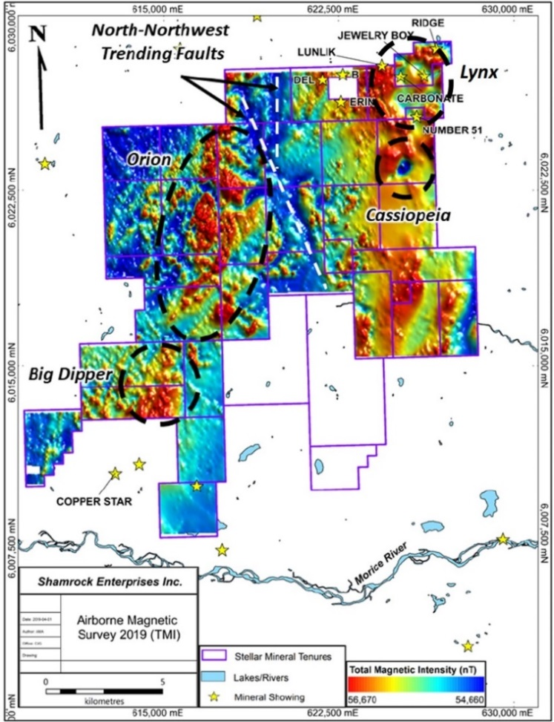

Elmer B. Stewart, MSc. P. Geol., a director is the Company’s non-independent, nominated Qualified Person pursuant to National Instrument 43-101, Standards for Disclosure for Mineral Projects, and has reviewed and approves the scientific and technical information disclosed in this news release.

**On Behalf Of Aurwest resources Corporation**

*Colin Christensen*

President and Chief Executive Officer

For additional information please contact:  
Colin Christensen  
Telephone: (403) 483-8363  
Email: [cchristensen@aurwestresources.com](mailto:cchristensen@aurwestresources.com)

Website: aurwestresources.com

**About Aurwest Resources Corporation**

Aurwest is a Canadian-based junior mining/exploration company focused on the procurement, exploration and development of gold, silver, and other precious and base metal properties in North America. The Company currently holds a 100% interest in the Stellar copper/gold Project, located approximately 25 kilometers southwest of Houston British Columbia.

**The Canadian Securities Exchange has not reviewed and does not accept responsibility for the adequacy or accuracy of this release.**

**Cautionary Note Regarding Forward-Looking Information**

This news release contains forward-looking statements within the meaning of the Section 27A of the Securities Act of 1933 and Section 21E of the Securities Exchange Act of 1934, and forward-looking information within the meaning of the Canadian securities laws (collectively, “forward-looking information”). Forward-looking information is generally identifiable by use of the words “believes,” “may,” “plans,” “will,” “anticipates,” “intends,” “budgets”, “could”, “estimates”, “expects”, “forecasts”, “projects” and similar expressions, and the negative of such expressions.

In connection with the forward-looking information contained in this news release, Aurwest Resources and its subsidiaries have made numerous assumptions regarding, among other things: the geological advice that Aurwest Resources has received is reliable and is based upon practices and methodologies which are consistent with industry standards and the reliability of historical reports. While Aurwest Resources considers these assumptions to be reasonable, these assumptions are inherently subject to significant uncertainties and contingencies.

Additionally, there are known and unknown risk factors which could cause Aurwest Resources actual results, performance or achievements to be materially different from any future results, performance or achievements expressed or implied by the forward-looking information contained herein. Known risk factors include, among others: the dimensions and shape of the mineralized areas may not be as estimated; the surface mineralization, alteration and goethite veining may not represent buried porphyry style mineralization; uncertainties relating to interpretation of the outcrop sampling results; the geology, continuity and concentration of the mineralization; the financial markets and the overall economy may deteriorate; the need to obtain additional financing; uncertainty as to timely availability of permits and other governmental approvals.

A more complete discussion of the risks and uncertainties facing Aurwest Resources is disclosed in Aurwest Resources continuous disclosure filings with Canadian securities regulatory authorities at [www.sedar.com](http://www.sedar.com/). All forward-looking information herein is qualified in its entirety by this cautionary statement, and Aurwest disclaims any obligation to revise or update any such forward-looking information or to publicly announce the result of any revisions to any of the forward-looking information contained herein to reflect future results, events or developments, except as required by law.