AURWEST ACQUIRES AND CONSOLIDATES 100% INTEREST IN STARS PORPHYRY COPPER PROPERTY

Calgary, Alberta (December 13, 2021) – Aurwest Resources Corporation (“Aurwest” or the “Company”) (CSE: AWR) is pleased to announce that it has purchased the remaining 50% interest in the Stars Property from M3 Metals Corp. (the “Vendor”), giving it a 100% ownership interest in the property (see news release dated September 30, 2021 regarding the acquisition of the initial 50% interest in the Stars Property). The Stars Property includes an early-stage porphyry copper-molybdenum discovery, covering 3,761 hectares contiguous to Aurwest’s Stellar Property in central British Columbia (See figure 1). The historical exploration activities and analytical results reported in this news release were taken from assessment reports filed with the department of Mines and Energy for British Columbia, BC MINFILES, and public company disclosure. Neither Aurwest nor a qualified person has verified the sampling, analytical, and exploration data contained in this news release.

STRATEGIC RATIONALE

Strategic, financial and operating advantages for the acquisition include:

A unique Opportunity to unlock a District Scale Copper Porphyry Project
- Consolidated district scale play: ongoing exploration activity paired with the 2018 airborne magnetic survey has identified several large signatures within the area, which exhibits a correlation with the Bulkley intrusive suite, the main host for porphyry copper deposits in central British Columbia.
- The Stars discovery is situated on claims that adjoin the Company’s southern boundary and occurs in a large (~5km diameter) positive circular magnetic feature.
- British Columbia regional exploration activity has significantly increased in the area, given the geological corridor is known for several existing and historical mine operations, including Imperial Metals Corp’s Huckleberry Copper mine.
- Developed infrastructure including power and major transport routes with year-round access.
- Aurwest will continue to systematically execute on its exploration work to move the property towards a potential preliminary defined resource. With the 100% ownership of Stars, which compliments the existing Stellar project, the company will be updating its National Instrument 43-101 (“NI 43-101) technical report, which will support a widespread copper-molybdenum-gold-silver porphyry potential of the properties.

Significant Growth Potential
- The acquisition of the remaining 50% of the Stars property further de-risks Aurwest’s strategy to consolidate a district scale copper- porphyry opportunity with 100% ownership in a consolidated land position of 28,294 hectares.
- Stars historical diamond drilling (16 holes, totaling 6,472m) in 2018 discovered the “Tana Zone” a continuously expanding mineralized porphyry intrusion intersected over 400 meters of copper mineralization extending the entire length of hole #10, ending in mineralization at a final depth of 490 meters. Further selected historical drill results from 2018 diamond drilling program are below.
- Aurwest commenced its 2021 exploration program at Stellar (Press Release July 13, 2021) with further extensive systematic exploration, including mapping, sampling, prospecting, and a 15.6-line km deep Induced Polarization (IP) geophysical survey.
- Expanding mineralization underlain by Hazelton Group mafic volcanics intruded by Bulkley intrusives, wide-spread copper mineralization confirms proximity to a large porphyry copper system. A 2.4km long, structurally controlled Quartz vein system, also confirmed gold values of up to 37.6 g/t Au.

Colin Christensen, President & CEO of Aurwest Resources commented, “Consolidating the ownership of the Stars Property compliments the exciting porphyry copper potential we see developing on our contiguous Stellar property. The presence of significant concentrations of molybdenum in several the drill holes suggests the introduction of multiple episodes of copper-molybdenum mineralization. Given the global movement towards electrification, environmental concerns, infrastructure development, and the forecasted demand for copper, the combined properties make a very compelling exploration package.”

Acquisition Terms
Aurwest acquired the Vendor’s 50% interest in the Stars Property and one additional adjoining claim by way of a Purchase and Sale Agreement. Terms of the transaction included a cash payment of $C450,000 on closing, 1,500,000 Common Shares, and granted the Vendor a 2% net smelter return. Aurwest has the right to repurchase at any time 1% per cent of the Royalty for consideration of $C1,000,000. The Common Shares issued in consideration of the acquisition will be escrowed and released in equal quarterly tranches over the next twelve months.

The Stars Property
The Stars Property acquisition consists of four mineral tenures (3,761ha), located in the Omineca Mining District, located approximately 40 km southwest of Houston, British Columbia. The Property is located at UTM coordinates 612,900 mE and 6,010,400 mN, on NTS map sheet 093L / 03 and can be accessed by all-season forest roads, including the Chisholm Mainline FSR, which runs directly through the southern portion of the Property.

Historical Exploration
The Stars property has been explored intermittently since the early 1970’s. Historical exploration consisted of mapping, sampling, prospecting, airborne and ground magnetic surveys, Induced Polarization surveys, and several reverse circulation and diamond drilling programs. The most recent drilling on the Stars Property was completed during 2018-2019 and included a total of 6,472m in sixteen diamond drillholes. The mineralization was intersected over an area of approximately 700m long by 300m deep and 700m wide. The mineralization remains open in several directions and down dip. Selected historical mineralized intervals from this program is set out below.

2018 – 2019 “Tana Zone” Drilling Highlights
DD18SS004 – 204 m of 0.45 % Cu from 23.5 m to 227.7 m, including 40.2 m of 0.93% Cu and 3.27 g/t Ag.
DD18SS010 – 405 m of 0.20 % Cu from 29.6 m to 435.0 m, including 30.5 m of 0.40% Cu and 1.34 g/t Ag.
DD18SS013 – 73 m of 0.30 % Cu from 54.3 m to 127.4 m, including 15.5m of 0.40% Cu and 1.46 g/t Ag.
DD18SS015 – 67 m of 0.35 % Cu from 231.0 m to 298.1 m, with an additional 9.9m (444.4 m – End of Hole)
interval of 0.45 % Cu.
Source: BC Geological Survey, Assessment report #38189, dated April 1st, 2019.

The property is underlain by Hazelton Group volcanic and subordinate sedimentary units, intruded by stocks and other intrusions attributed to the Late-Triassic to Early-Jurassic Topley Intrusions as the oldest, followed by the Late-Cretaceous Bulkley Intrusions, and finally the youngest Eocene-aged Babine Plutonic Suite.

The porphyry style mineralization consists of vein hosted and disseminated chalcopyrite/bornite, and quartz vein hosted molybdenite, along with, low but significant concentrations of gold and silver. Broad intervals of significant molybdenum occur with the copper and silver mineralization. For example, the core interval from 208.12m to 407.83m (199.05m) in DDH18SS010 yielded a weighted average of 132 parts per million (“ppm”) or 0.0132% Mo. The core interval in DDH18SS015 from 163.98m to 356.01m (192.03m) yielded a weighted average of 112 ppm (0.011% Mo). The spatial distribution of the molybdenum in the drill holes suggests the injection of multiple episodes of copper-molybdenum into the Stars porphyry system. The mineralization is hosted in both volcanic and intrusive rocks, exhibiting variable alteration suites and silicification.

Future work
Aurwest plans to compile all historical exploration data including, verification of the analytical database and 3D modeling of the copper-molybdenum mineralization. The 3D modelling is expected to provide opportunities to expand the limits of the mineralized zone and confirm the orientation and size of a proposed deep penetrating geophysical survey to map the chargeability and resistivity signatures of the mineralized zone and potential extensions. These work programs will be used to prepare a comprehensive exploration program and budget to continue exploration of the larger Stellar/Stars Property package.

Figure 1.

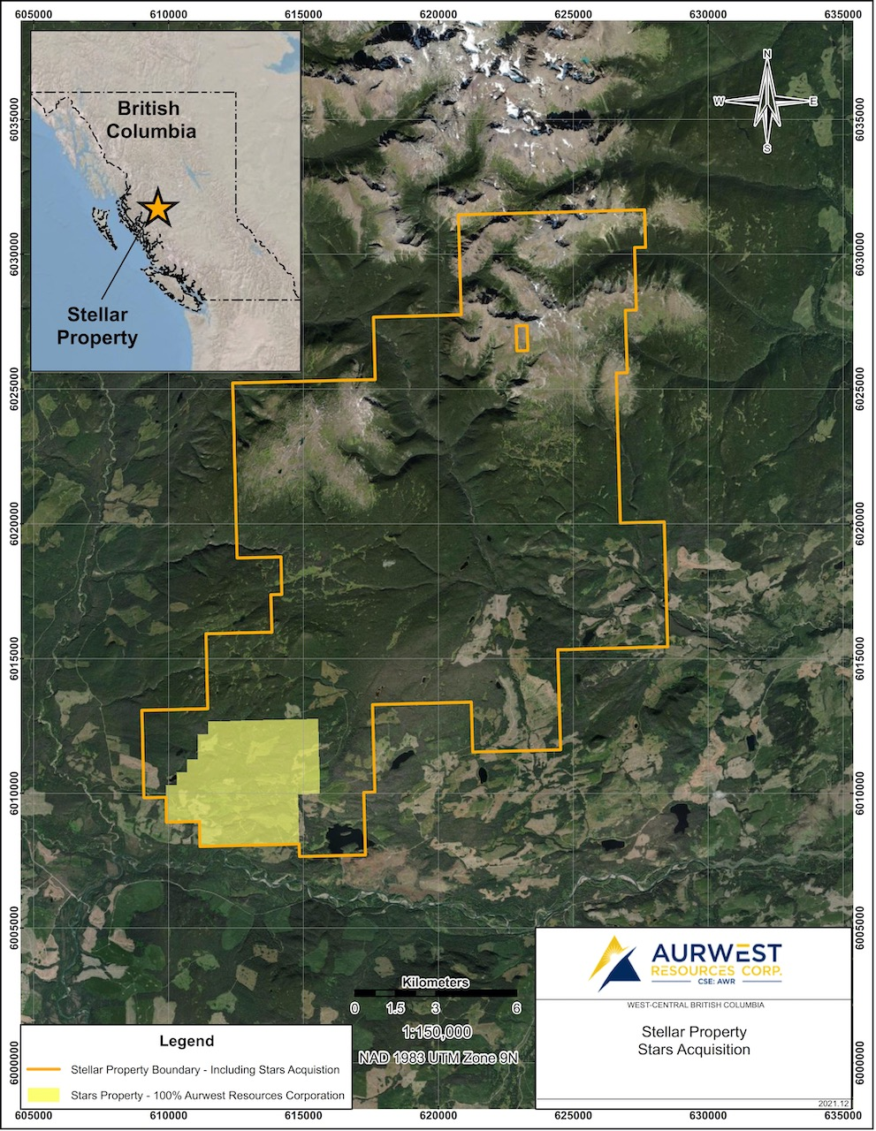

Figure 2.
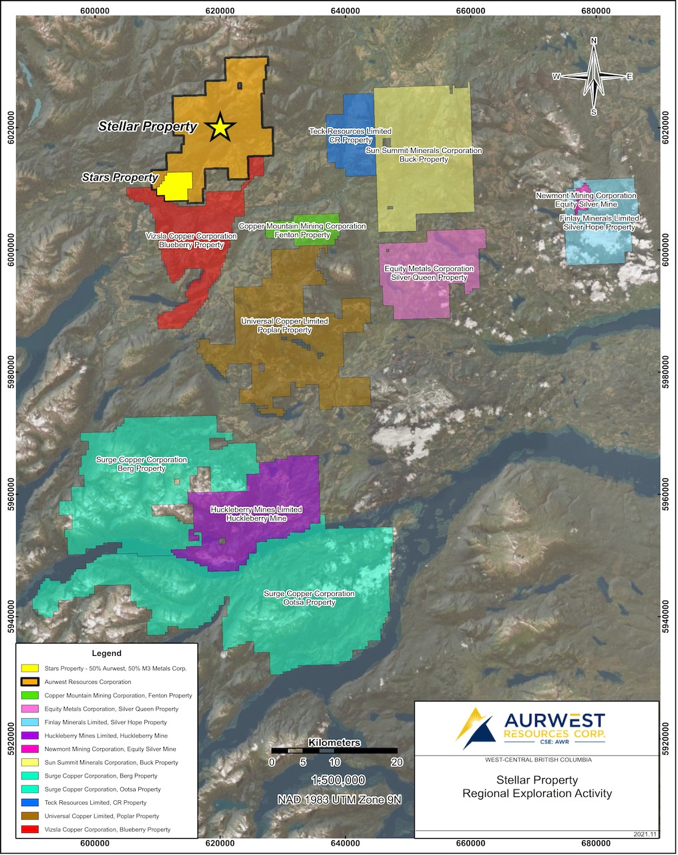

Elmer B. Stewart, MSc. P. Geol., is the Company’s independent, nominated Qualified Person pursuant to National Instrument 43-101, Standards for Disclosure for Mineral Projects, and has reviewed and approves the scientific and technical information disclosed in this news release.

On Behalf Of Aurwest resources Corporation

“Colin Christensen”
President and Chief Executive Officer

For additional information please contact:

Colin Christensen
Telephone: (403) 483-8363
Email: cchristensen@aurwestresources.com
Website: www.aurwestresources.com

About Aurwest Resources Corporation
Aurwest is a Canadian-based junior resource company focused on the acquisition, exploration, and development of gold properties in Canada. The Company currently has three Option Agreements to earn a 100% interest in Paradise Lake and Stony Caldera projects covering a 47,800-hectare (478 sq kms) package of gold exploration licenses within the emerging Central Newfoundland gold district. The Company also currently holds a 100% interest in the 28,294-hectare Stellar porphyry copper project, located approximately 25 kilometers southwest of Houston British Columbia.

Forward-Looking Information
Statements included in this announcement, including statements concerning our plans, intentions, and expectations, which are not historical in nature are intended to be, and are hereby identified as “forward-looking statements”. Forward looking statements may be identified by words including “anticipates”, “believes”, “intends”, “estimates”, “expects” and similar expressions. The Company cautions readers that forward-looking statements, including without limitation: historical exploration results; positive diamond drilling results; styles of copper-molybdenum mineralization; and future work programs.

In connection with the forward-looking information contained in this news release, Aurwest has made numerous assumptions regarding, among other things: the geological advice that Aurwest has received is reliable and is based upon practices and methodologies which are consistent with industry standards; and the reliability of historical reports. While Aurwest considers these assumptions to be reasonable, these assumptions are inherently subject to significant uncertainties and contingencies.

Additionally, there are known and unknown risk factors which could cause Aurwest’s actual results, performance, or achievements to be materially different from any future results, performance or achievements expressed or implied by the forward-looking information contained herein. Known risk factors include, additional exploration of the Properties may not locate significant copper-molybdenum mineralization; historical exploration results may not be; accurate; additional exploration of the areas of copper mineralization may not locate significant mineralization; the positive diamond drilling results may not be accurate; styles of copper-molybdenum mineralization; and future work programs may not result in the location of significant copper-molybdenum mineralization future work programs may not be completed as planned or at all; receipt of permits to conduct the exploration plans and matters relating to the Company’s future operations and business prospects; certain risks and uncertainties that could cause actual results to differ materially from those indicated in the forward-looking statements. Readers are advised to rely on their own evaluation of such risks and uncertainties and should not place undue reliance on forward-looking statements. Any forward-looking statements are made as of the date of this news release, and the Company assumes no obligation to update the forward-looking statements, except in accordance with the applicable laws.

The Canadian Securities Exchange has not reviewed and does not accept responsibility for the adequacy or accuracy of this release.

