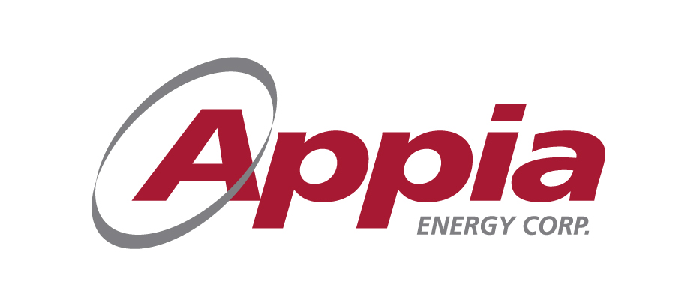 | 500-2 Toronto St.  Toronto, ON  M5C 2B6  PH; 416 876-3957  FAX: 416 218-9772  Email: appia@appiaenergy.ca

NEWS RELEASE
APPIA ANNOUNCES NON-BROKERED OFFERING

Toronto, Ontario, June 15, 2016 - Appia Energy Corp. (the “Company” or “Appia”) (CSE:API) is pleased to announce that the Company is offering up to a up to 5,000,000 working capital units (the “WC Units”) of the Company at a price of $0.20 per WC Unit for up to $1,000,000 and up to 5,000,000 flow-through units (the “FT Units”) of the Company at a price of $0.20 per FT Unit for up to $1,000,000 (collectively, the “Offering”).

The funds will be used to explore the recently acquired Otherside and Loranger properties (see Press Release dated April 26, 2016) to the drilling stage and for working capital.

Each WC Unit is priced at $0.20 and consists of one (1) common share and one (1) common share purchase warrant (a “WC Warrant”). Each WC Warrant entitles the holder to purchase one (1) common share (a “WC Warrant Share”) at a price of $0.30 per WC Warrant Share exercisable until the earlier of: (i) three (3) years; and (ii) in the event that the closing price of the Common Shares on the Canadian Securities Exchange is at least $0.50 for twenty (20) consecutive trading days, and the 20th trading day (the “Final Trading Day”) is at least four (4) months from the Closing Date, the date which is thirty (30) days from the Final Trading Day (the “Trigger Date”).

Each FT Unit is priced at $0.20 and consists of one (1) common share and one-half (½) of one warrant. Each full warrant (a “Warrant”) entitles the holder to purchase one (1) common share (a “Warrant Share”) at a price of $0.35 per Warrant Share exercisable for a period of eighteen (18) months following the Closing Date, subject to earlier expiry on the Trigger Date.

Eligible Finders may receive up to 7% of the value of proceeds of the sale of WC Units or FT Units in cash and up to 7% of the number of WC Units or FT Units sold in the form of broker warrants. Each broker warrant entitles the holder to acquire one (1) common share of Appia at $0.20 for WC Units and FT Units sold for a period of eighteen (18) months from the Closing Date.

Insiders of the Company may subscribe for the Offering. The insider private placements are exempt from the valuation and minority shareholder approval requirements of Multilateral Instrument 61-101 (“MI 61-101”) by virtue of the exemptions contain in section 5.5(a) and 5.7(1) (a) of MI 61-101 in that the fair market value of the consideration for the securities of the Company issued to the insiders did not exceed 25% of its market capitalization.

All securities issued pursuant to the above referenced private placements are subject to a statutory four month hold period.

The Company currently has interests in about 86,683 hectares (214,196 acres) of claims in the Athabasca Basin, Saskatchewan, some near the Patterson Lake South area as well as around other parts of the Basin.

Appia also controls 13,008 hectares (32,143 acres), including Rare Earth and Uranium Deposits, over five mineralized zones in the Elliot Lake Camp, Ontario, which historically produced over 300 million pounds of U₃O₈. Watts, Griffis and McOuat Limited completed a NI 43-101 technical report on the Teasdale Zone (the “Technical Report”) entitled, "A Technical Review of the Appia Energy Corp. Rare Earth and Uranium Property, Elliot Lake District, North-Central Ontario, Canada." dated July 18, 2011, with certificates dated November 7, 2012, written by Al Workman, P. Geo and Kurt Breede, P. Eng. Details of the Technical Report can be found on the SEDAR website, www.sedar.com.

Appia currently has 41.6 million common shares outstanding, 43.3 million shares fully diluted.

For further information, please contact: Tom Drivas, President, CEO and Director: (tel) 416-546-2707, (fax) 416-218-9772 or (email) appia@appiaenergy.ca or,

Frank van de Water, Chief Financial Officer and Director, (tel) 416-546-2707, (fax) 416-218- 9772 or (email) fvandewater@rogers.com

Cautionary Note Regarding Forward-Looking Statements: This News Release contains forward-looking statements that involve risks and uncertainties, which may cause actual results to differ materially from the statements made. When used in this document, the words "may", "would", "could", "will", "intend", "plan", "anticipate", "believe", "estimate", "expect" and similar expressions are intended to identify forward-looking statements. Such statements reflect our current views with respect to future events and are subject to such risks and uncertainties. Many factors could cause our actual results to differ materially from the statements made, including those factors discussed in filings made by us with the Canadian securities regulatory authorities. Should one or more of these risks and uncertainties, such actual results of current exploration programs, the general risks associated with the mining industry, the price of gold and other metals, currency and interest rate fluctuations, increased competition and general economic and market factors, occur or should assumptions underlying the forward looking statements prove incorrect, actual results may vary materially from those described herein as intended, planned, anticipated, or expected. We do not intend and do not assume any obligation to update these forward-looking statements, except as required by law. Shareholders are cautioned not to put undue reliance on such forward-looking statements.

