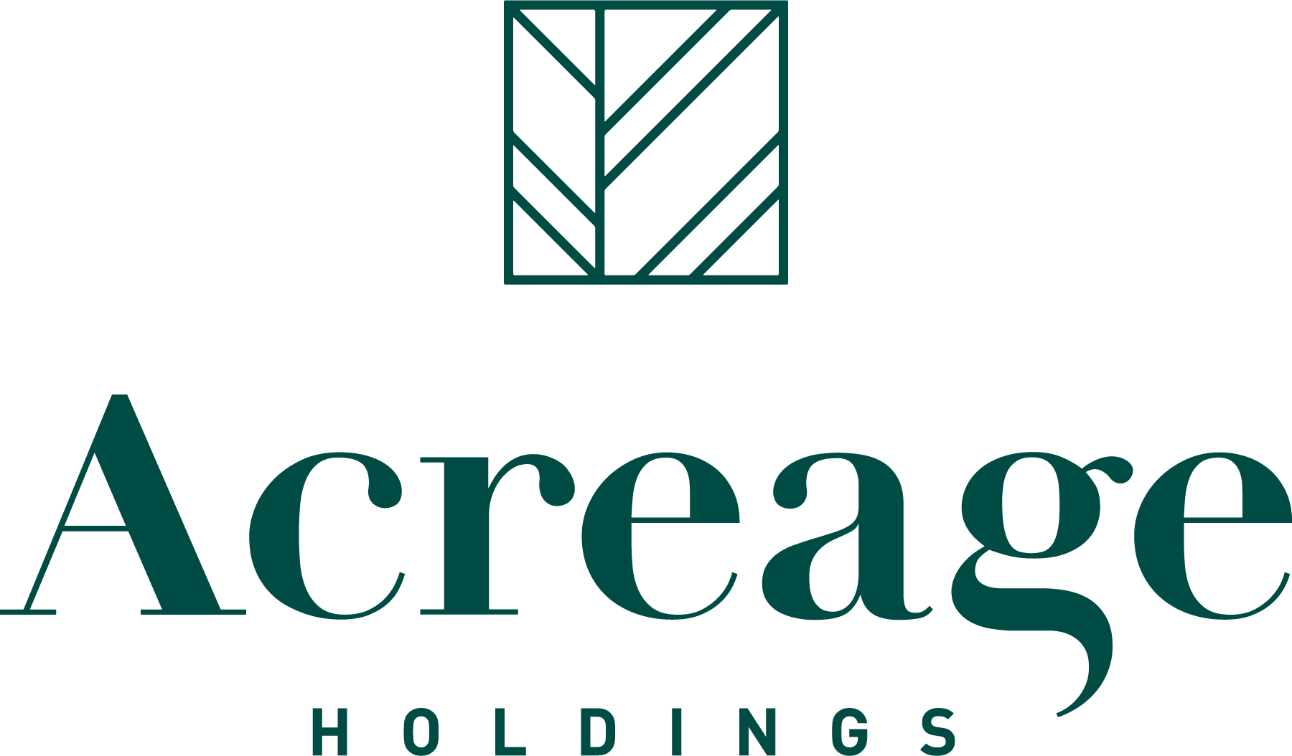

Acreage Holdings Launches Acreage Oregon, Its First Cannabis Cultivation Facility in the Pacific Northwest

Opening of New Facility Will Also Mark the Introduction of Canopy Growth’s Tweed Brand to the U.S.

MEDFORD, OR - December 17, 2019 - Acreage Holdings, Inc. (“Acreage”) (CSE: ACRG.U) (OTCQX: ACRGF) (FSE: 0VZ) one of the largest vertically integrated, multi-state operators of cannabis licenses and assets in the U.S., today announced the grand opening of its first cannabis cultivation facility in the Pacific Northwest. Located in Medford, Oregon, the new 30,000 square-foot indoor cultivation facility will grow cannabis to be used in a wide range of new products we are excited to launch in Oregon, including:

- The Botanist, an Acreage-developed brand rooted in health and wellness;
- Tweed, a Canopy Growth Corporation brand licensed to Acreage, focused on quality products and meaningful customer relationships. This launch will mark Tweed’s introduction in the U.S.; and
- Other products expected to launch soon that are being developed specifically with the likes and tastes of the Oregon cannabis consumer in mind.

The state-of-the-art indoor facility will yield its first harvest this month. The Botanist and Tweed products are expected to be available soon thereafter in Acreage’s five Cannabliss-branded dispensaries as well as other dispensaries throughout the state.

“We are proud to open our new Oregon facility in an area renowned for producing some of the best cannabis in the world,” said Acreage Chairman and CEO Kevin Murphy. “We are particularly excited to introduce the Tweed brand to U.S. consumers for the first time. It’s a further indication that our arrangement with Canopy Growth is yielding opportunities to accelerate Acreage’s growth.”

ABOUT ACREAGE
Headquartered in New York City, Acreage is one of the largest vertically integrated, multi-state operators of cannabis licenses and assets in the U.S., according to publicly available information. Acreage owns licenses to operate or has management or consulting services or other agreements in place with license holders to assist in operations in 20 states (including pending acquisitions) with a population of approximately 180 million Americans, and an estimated 2022 total addressable market of $16.7 billion in legal cannabis sales, according to Arcview Market Research. Acreage is dedicated to building and scaling operations to create a seamless, consumer-focused branded cannabis experience. Acreage's national retail store brand, The Botanist, debuted in 2018.

On June 27, 2019 Acreage implemented an arrangement under section 288 of the Business Corporations Act (British Columbia) (the “Arrangement”) with Canopy Growth Corporation (“Canopy Growth”). Pursuant to the Arrangement, the Acreage articles were amended to provide Canopy Growth with an option to acquire all of the issued and outstanding shares in the capital of Acreage, with a requirement to do so, upon a change in federal laws in the United States to permit the general cultivation, distribution and possession of marijuana (as defined in the relevant legislation) or to remove the regulation of such activities from the federal laws of the United States (the “Triggering Event”), subject to the satisfaction of the conditions set out in the arrangement agreement entered into between Acreage and Canopy Growth on April 18, 2019, as amended on May 15, 2019 (the “Arrangement Agreement”). Acreage will continue to operate as a stand-alone entity and to conduct its business independently, subject to compliance with certain covenants contained in the Arrangement Agreement. Upon the occurrence or waiver of the Triggering Event, Canopy Growth will exercise the option and, subject to the satisfaction or waiver of certain conditions to closing set out in the Arrangement Agreement, acquire (the “Acquisition”) each of the Subordinate Voting Shares (following the automatic conversion of the Class B proportionate voting shares and Class C multiple voting shares of Acreage into Subordinate Voting Shares) in exchange for the payment of 0.5818 of a common share of Canopy Growth per Subordinate Voting Share (subject to adjustment in accordance with the terms of the Arrangement Agreement). If the Acquisition is completed, Canopy Growth will acquire all of the Acreage Shares, Acreage will become a wholly owned subsidiary of Canopy Growth and Canopy Growth will continue the operations of Canopy Growth and Acreage on a combined basis. For more information about the Arrangement and the Acquisition please see the respective information circulars of each of Acreage and Canopy Growth dated May 17, 2019, which are available on Canopy Growth’s and Acreage’s respective profiles on SEDAR at www.sedar.com. For additional information regarding Canopy Growth, please see Canopy Growth’s profile on SEDAR at www.sedar.com.

FORWARD LOOKING STATEMENTS

This news release and each of the documents referred to herein contains “forward-looking information” within the meaning of applicable Canadian and United States securities legislation. All statements, other than statements of historical fact, included herein are forward-looking information, including, for greater certainty, statements regarding the proposed transaction with Canopy Growth, including the anticipated benefits and likelihood of completion thereof.

Generally, forward-looking information may be identified by the use of forward-looking terminology such as “plans”, “expects” or “does not expect”, “proposed”, “is expected”, “budgets”, “scheduled”, “estimates”, “forecasts”, “intends”, “anticipates” or “does not anticipate”, or “believes”, or variations of such words and phrases, or by the use of words or phrases which state that certain actions, events or results may, could, would, or might occur or be achieved. There can be no assurance that such forward-looking information will prove to be accurate, and actual results and future events could differ materially from those anticipated in such forward-looking information. This forward-looking information reflects Acreage’s current beliefs and is based on information currently available to Acreage and on assumptions Acreage believes are reasonable. Forward-looking information is subject to known and unknown risks, uncertainties and other factors that may cause the actual results, level of activity, performance or achievements of Acreage to be materially different from those expressed or implied by such forward-looking information. Such risks and other factors may include, but are not limited to: the ability of the parties to receive, in a timely manner and on satisfactory terms, the necessary regulatory approvals; the available funds of Acreage and the anticipated use of such funds; the availability of financing opportunities; the ability of Acreage and Canopy Growth to satisfy, in a timely manner, the conditions to the completion of the Acquisition; the likelihood of completion of the Acquisition; other expectations and assumptions concerning the transactions contemplated between Acreage and Canopy Growth; legal and regulatory risks inherent in the cannabis industry; risks associated with economic conditions, dependence on management and currency risk; risks relating to U.S. regulatory landscape and enforcement related to cannabis, including political risks; risks relating to anti-money laundering laws and regulation; other governmental and environmental regulation; public opinion and perception of the cannabis industry; risks related to contracts with third-party service providers; risks related to the enforceability of contracts; reliance on the expertise and judgment of senior management of Acreage; risks related to proprietary intellectual property and potential infringement by third parties; the concentrated voting control of Acreage’s founder and the unpredictability caused by Acreage’s capital structure; risks relating to the management of growth; increasing competition in the industry; risks inherent in an agricultural business; risks relating to energy costs; risks associated to cannabis products manufactured for human consumption including potential product recalls; reliance on key inputs, suppliers and skilled labor; cybersecurity risks; ability and constraints on marketing products; fraudulent activity by employees, contractors and consultants; tax and insurance related risks; risks related to the economy generally; risk of litigation; conflicts of interest; risks relating to certain remedies being limited and the difficulty of enforcement of judgments and effect service outside of Canada; risks related to future acquisitions or dispositions; sales by existing shareholders; and limited research and data relating to cannabis. A description of additional assumptions used to develop such forward-looking information and a description of additional risk factors that may cause actual results to differ materially from forward-looking information can be found in Acreage’s disclosure documents, including the Circular and Acreage’s Annual Information Form for the year ended December 31, 2018 filed on April 29, 2019, on the SEDAR website at www.sedar.com. Although Acreage has attempted to identify important factors that could cause actual results to differ materially from those contained in forward-looking information, there may be other factors that cause results not to be as anticipated, estimated or intended. Readers are cautioned that the foregoing list of factors is not exhaustive. Readers are further cautioned not to place undue reliance on forward-looking information as there can be no assurance that the plans, intentions or expectations upon which they are placed will occur. Forward-looking information contained in this news release is expressly qualified by this cautionary statement. The forward-looking information contained in this news release represents the expectations of Acreage as of the date of this news release and, accordingly, is subject to change after such date. However, Acreage expressly disclaims any intention or obligation to update or revise any forward-looking information, whether as a result of new information, future events or otherwise, except as expressly required by applicable securities law.

Neither the Canadian Securities Exchange nor its Regulation Service Provider has reviewed and does not accept responsibility for the adequacy or accuracy of the content of this news release.

###
Media Contact:  Howard Schacter  Vice President of Communications  h.schacter@acreageholdings.com  646-600-9181  Robert Vanisko  Director of Communications  r.vanisko@acreageholdings.com  646-600-9181 | Investor Contact:  Steve West  Vice President, Investor Relations  Investors@acreageholdings.com  646-600-9181

