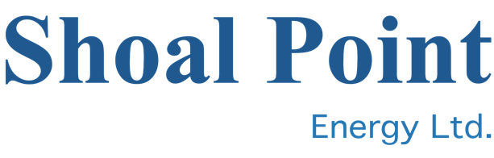
April 18 2023 CSE: SHP

Shoal Point engages with Newfoundland regarding compensation

Vancouver – Mark Jarvis, CEO of Shoal Point Energy Ltd. (CSE – SHP) ("Shoal Point" or the "Company"), announced today that it has been engaging with the Government of Newfoundland and Labrador regarding compensation for its frustrated efforts to develop its hydrocarbon assets on the west coast of Newfoundland.

"Our Company has spent more than $40 million on attempting to develop the Humber Arm Formation shale play offshore of the Port au Port peninsula," said Mr. Jarvis. "Our efforts have been stopped for 10 years by a fracking moratorium that was introduced by the Province in 2013. Under recent Supreme Court of Canada case law, we feel we are entitled to compensation for the Province's actions, formally known as constructive expropriation. In addition to our sunk costs, our lost opportunity costs are considerable. If our dialogue with the Province fails to bear fruit, we will be considering our options."

The Company confirms that, while it is pursuing compensation from the Province, to date these efforts have been unsuccessful and there is no certainty that a settlement will be reached.

About Shoal Point Energy Ltd.

Shoal Point Energy Ltd. is a public company listed on the CSE exchange under the symbol "SHP". The Company is focused on oil and gas exploration in Kansas and retains its oil and gas interests in the Humber Arm Allochthon play in western Newfoundland. The Company is also actively evaluating new opportunities.

For further information, please contact:
Mr. Mark Jarvis, Chief Executive Officer
Tel - 416-637-2181 extension 310

CAUTION REGARDING FORWARD-LOOKING STATEMENTS
This press release contains certain forward-looking statements within the meaning of applicable securities laws with respect to the Company. These forward-looking statements generally are identified by words such as "believe," "project," "expect," "anticipate," "estimate," "intend," "strategy," "future," "opportunity," "plan," "may," "should," "will," "would," and similar expressions. Forward-looking statements in this press release include statements relating to the payment of compensation from the Government of Newfoundland and Labrador for the constructive expropriation of its hydrocarbon assets. Although the Company believes that the expectations and assumptions on which such forward-looking statements and information are based are reasonable, undue reliance should not be placed on the forward- looking statements and information because the Company can give no assurance that they will prove to be correct. Since forward-looking statements and information address future events and conditions, by their very

nature they involve inherent risks and uncertainties. Many factors could cause actual future events to differ materially from the forward-looking statements in this press release including, without limitation, failure by the Company to reach a settlement with the Government of Newfoundland and Labrador, the evolving nature of Canadian common law and inherent risks in litigation, as well as other factors beyond the Company's control. Readers are cautioned that the foregoing list of factors is not exhaustive. The forward-looking statements included in this news release are expressly qualified by this cautionary statement. The forward-looking statements and information contained in this news release are made as of the date hereof and the Company undertakes no obligation to update publicly or revise any forward-looking statements or information, whether as a result of new information, future events or otherwise, unless so required by applicable laws.

The Canadian Securities Exchange (CSE) has neither approved nor disapproved the contents of this news release.

