THIS NEWS RELEASE IS NOT FOR DISTRIBUTION TO U.S. NEWSWIRE SERVICES FOR DISSEMINATION IN THE UNITED STATES
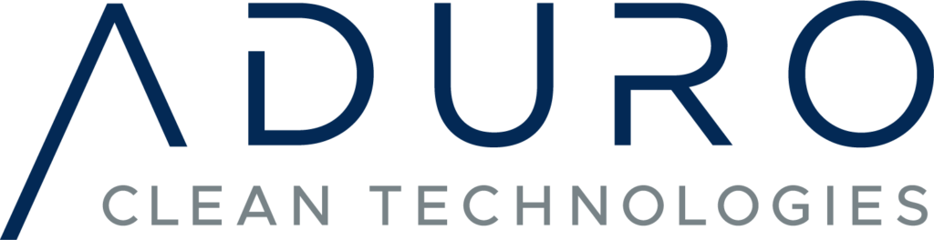
Suite 104, 1086 Modeland Road
Sarnia, Ontario N7S 6L2
Aduro Clean Technologies Inc. Engages NATIONAL Capital Markets
to Provide Public Relations and Investor Relations Services
Sarnia, ON – May 25, 2021 – Aduro Clean Technologies Inc. (CSE: ACT) (the “Company” or “Aduro Clean Technologies, a unique technology developer for chemical recycling of low-value waste hydrocarbons, announces that it has appointed NATIONAL Capital Markets to provide public relations and investor relations services. NATIONAL Capital Markets is a strategic investor relations advisory practice within NATIONAL, Canada’s leading PR firm, with 300 professionals based in nine offices from coast to coast.
“After recently listing on the CSE, we are now focusing on milestones that will demonstrate the proof of concept and future commercial application of our technology,” said Ofer Vicus, CEO of Aduro Clean Technologies. “NATIONAL Capital Markets will help us amplify our presence with the investment community and the broader public that is interested in clean technology and its potential to address significant global challenges.”
The Company’s patented Hydrochemolytic™ technology (HCT), is a unique chemical conversion platform that transforms low-value waste hydrocarbons into higher-value products and feedstocks at a significantly lower cost and environmental impact than alternative methods. The Company is currently developing a pre-pilot reactor system to upgrade heavy petroleum feedstock to lighter petroleum oil.
The Company also announces it has granted incentive stock options (the “Options“) to Park Place Limited (the “Optionees“), entitling the Optionees to purchase an aggregate of 200,000 Common Shares of the Company. The Options are being granted pursuant to the Company’s stock option plan and will be exercisable for a period of two years ending on May 20, 2023, at an exercise price of $0.76 per common share, being the closing market price of the Common Shares on the date of grant of the Options.
Under the terms of the agreement with NATIONAL Capital Markets, which will continue until either party has terminated the contract with thirty (30) days' notice, Aduro Clean Technologies will pay a monthly fee of $11,000 for ongoing strategic communication services. At the time of this agreement, neither NATIONAL Capital Markets nor its principals have any direct or indirect interest in the securities of Aduro Clean Technologies Inc.
About Aduro Clean Technologies
Aduro Clean Technologies is based in Sarnia, Ontario, Canada and has developed a novel chemical conversion process to transform waste plastics and low-grade renewable oils into renewable fuels and specialty chemicals. The Company’s green technology is also poised to make bitumen upgrading more environmentally responsible and cost-effective. Additional information on Aduro Clean Technologies is available on the Company’s website at www.adurocleantech.com.
For further information, please contact:
Craig MacPhail, Investor Relations | Chris Parr, Director
ir@adurocleantech.com | cparr@adurocleantech.com
604-362-7011

This news release contains forward-looking statements. All statements, other than statements of historical fact that address activities, events or developments that the Company believes, expects or anticipates will or may occur in the future, are forward-looking statements. The forward-looking statements reflect management’s current expectations based on information currently available and are subject to a number of risks and uncertainties that may cause outcomes to differ materially from those discussed in the forward-looking statements.
Although the Company believes that the assumptions inherent in the forward-looking statements are reasonable, forward-looking statements are not guarantees of future performance and, accordingly, undue reliance should not be put on such statements due to their inherent uncertainty. The Company expressly disclaims any intention or obligation to update or revise any forward-looking statements whether as a result of new information, future events or otherwise, except as required by applicable law.
The CSE has not reviewed, approved or disapproved the content of this news release.

NOT FOR DISTRIBUTION TO U.S. NEWSWIRE SERVICES OR FOR DISSEMINATION IN THE UNITED STATES

