

GoldHaven Highlights Strategic Tungsten and Indium Exposure at Magno Amid Growing Focus on Critical Mineral Supply Chains

Vancouver, British Columbia, May 25, 2026 – GoldHaven Resources Corp. ("GoldHaven" or the "Company") (CSE: GOH) (OTCQB: GHVNF) (FSE: 4QS) is pleased to highlight the growing strategic significance of tungsten and indium identified at its district-scale Magno Project in northern British Columbia amid intensifying Western efforts to secure critical mineral supply chains outside of China.

Highlights:

- Growing Western focus on securing tungsten and critical mineral supply chains outside China
- Magno hosts multiple tungsten-bearing skarn targets with values up to 6,550 ppm tungsten
- Elevated indium values up to 334 ppm identified within zinc-rich mineralization
- District-scale 37,000+ hectare project prospective for CRD, skarn, and porphyry mineralization
- 2026 exploration planning underway including airborne geophysics and drill targeting

CEO Commentary

“Global markets are increasingly recognizing the strategic importance of securing Western sources of tungsten and other critical minerals amid growing supply chain concerns,” stated Rob Birmingham, Chief Executive Officer of GoldHaven. “We believe Magno represents a district-scale critical minerals opportunity combining tungsten-bearing skarn systems, high-grade silver-zinc-lead CRD mineralization, and elevated indium values within one of Canada’s premier mining jurisdictions. As we advance airborne geophysics, and 2026 drill targeting, we believe Magno continues to demonstrate the characteristics of a large-scale multi-phase mineralizing system with significant critical minerals potential.”

With airborne geophysics underway, the Company is currently advancing permitting and exploration planning for its 2026 exploration campaign, which is expected to include airborne geophysics and drill testing targeting multiple high-priority tungsten-bearing skarn systems, silver-lead-zinc carbonate replacement deposit (“CRD”) zones, and broader porphyry copper-molybdenum targets identified across the Project.

Global tungsten markets have experienced significant price appreciation over the past year as supply concerns continue to escalate. China currently dominates global tungsten and indium production and downstream processing capacity, while recent geopolitical developments and proposed Western procurement restrictions targeting foreign adversary sourced critical minerals have accelerated interest in North American and allied-source critical mineral projects. GoldHaven believes the Magno Project is uniquely positioned within this emerging thematic due to its combination of tungsten-bearing skarn mineralization, high-grade silver-zinc-lead CRD mineralization, and elevated indium values associated with zinc-rich sulphide systems. The Project remains at an exploration stage and additional work is required to determine the extent and economic significance of identified mineralization.

GoldHaven has identified tungsten mineralization across multiple target areas at Magno, including recent 2025 surface sampling that returned values of up to 6,550 ppm tungsten. Historical drilling and sampling at the Kuhn Zone reportedly returned intervals including 13.0 metres grading 0.55% WO3, 4.0 metres grading 1.32% WO3 and 0.26% MoS2, and 2.5 metres grading 0.95% WO3. Elevated indium values of up to 334 ppm have also been identified within sphalerite-bearing mineralization, further strengthening the Project’s strategic critical mineral profile. The Company's 2026 exploration program has been designed, in part, to confirm these historical results.

The historical drilling results referenced above are historical in nature and have been obtained from publicly available assessment reports from the government of BC geological databases. and have not been independently verified by the Company or the Qualified Person, however, the Company believes the information is relevant as it assists in defining exploration targets and guiding ongoing geological modelling and targeting efforts.
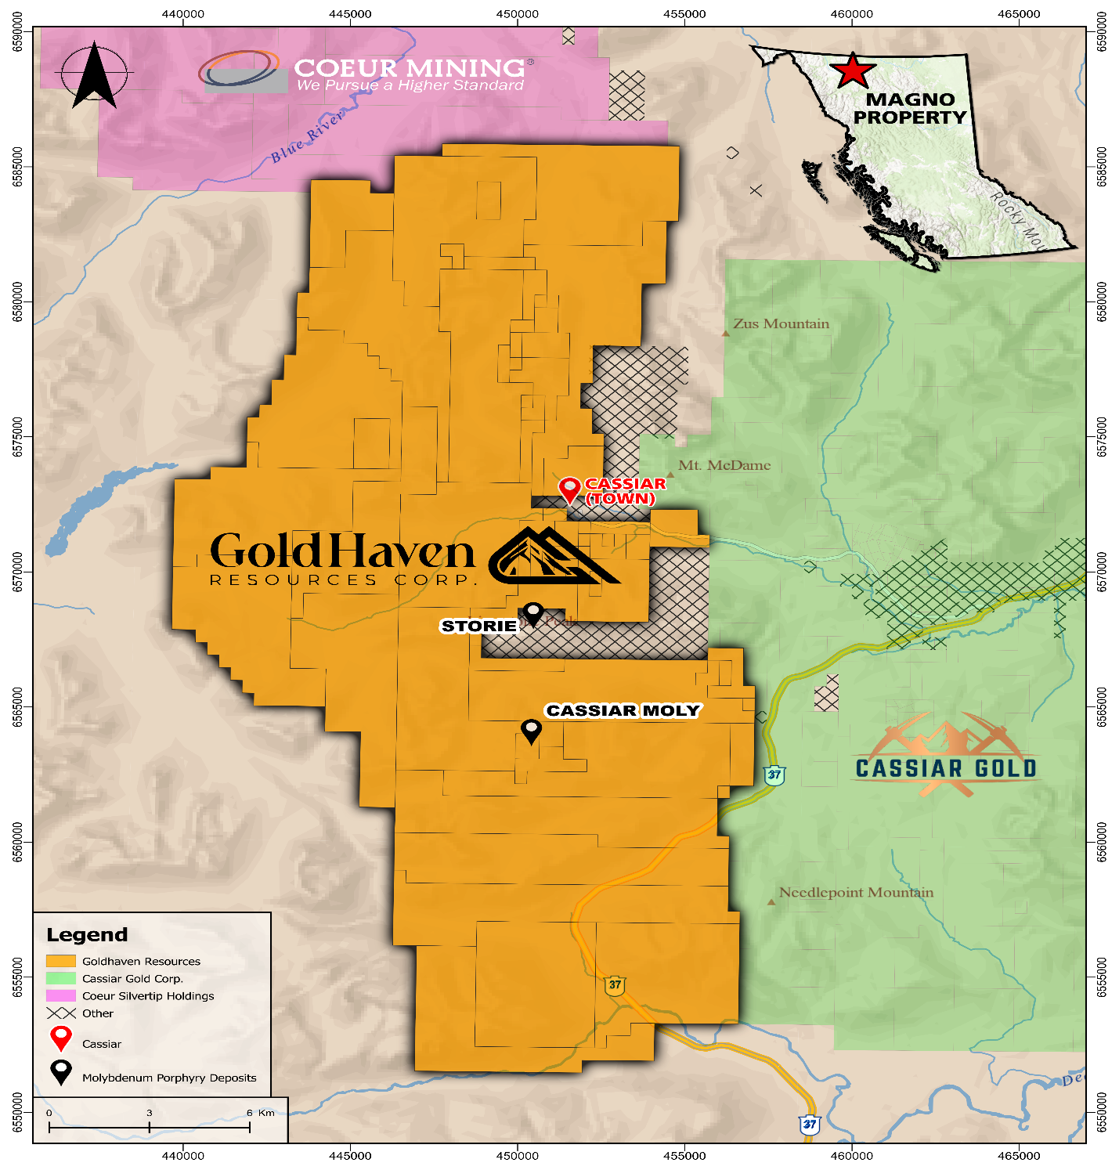

Figure 1: Magno project location in Northern BC with proximity to nearby companies.

Marketing Agreement
The Company also announces that it has entered into a digital marketing services agreement with Machai Capital Inc. (“Machai”) pursuant to which Machai will provide marketing, advertising and public awareness services to the Company, including digital media marketing, branding, social media marketing, investor awareness campaigns, and other related services. The engagement is subject to the approval of the Canadian Securities Exchange.
The services will be conducted in accordance with the applicable policies of the Canadian Securities Exchange (the “CSE”) and applicable securities laws. Machai will only provide public awareness services and will not provide investor relations or market-making services.
Machai has been engaged for a one-month term commencing immediately. In consideration for the services provided, the Company will pay Machai a fee of $200,000 plus GST from the Company’s general working capital. The Company has approved a marketing budget of up to $200,000 pursuant to the engagement.
Qualified Person:
The technical and scientific information contained in this news release has been reviewed and approved by Raymond Wladichuk P.Geo. who is a non-independent Qualified Person as defined under NI 43-101 and a consultant of the Company.

About GoldHaven Resources Corp.

GoldHaven Resources Corp. is a Canadian junior exploration company focused on advancing highly prospective mineral projects in North and South America. The Company’s flagship asset is the district-scale Magno Project in the Cassiar District of northern British Columbia. GoldHaven also owns the Three Guardsmen copper-gold project in British Columbia and the Copeçal Gold Project in Mato Grosso, Brazil. In addition, the Company holds a portfolio of critical mineral projects in Brazil.

On Behalf of the Board of Directors

Rob Birmingham, Chief Executive Officer

For further information, please contact:
Rob Birmingham, CEO
www.GoldHavenresources.com
info@goldhavenresources.com
Office Direct: (604) 629-8254

Neither the CSE nor its Regulation Services Provider (as that term is defined in the policies of the CSE- Canadian Securities Exchange) accepts responsibility for the adequacy or accuracy of this release.

Cautionary Statements Regarding Forward Looking Information

This news release contains forward-looking statements and forward-looking information (collectively, "forward looking statements") within the meaning of applicable Canadian and U.S. securities legislation, including the United States Private Securities Litigation Reform Act of 1995. All statements, other than statements of historical fact, included herein including, without limitation, those listed below under the heading “Forward-Looking Statements in This News Release” are forward-looking statements. Although the Company believes that such statements are reasonable, it can give no assurance that such expectations will prove to be correct. Forward-looking statements are typically identified by words such as: "believes", "will", "expects", "anticipates", "intends", "estimates", "plans", "may", "should", "potential", "scheduled", or variations of such words and phrases and similar expressions, which, by their nature, refer to future events or results that may, could, would, might or will occur or be taken or achieved. In making the forward-looking statements in this news release, the Company has applied several material assumptions, including without limitation, that there will be investor interest in future financings, market fundamentals will result in sustained precious metals demand and prices, the receipt of any necessary permits, licenses and regulatory approvals in connection with the future exploration and development of any future projects in a timely manner, the availability of financing on suitable terms for exploration and development of future projects and the Company's ability to comply with environmental, health and safety laws.

The Company cautions investors that any forward-looking statements by the Company are not guarantees of future results or performance, and that actual results may differ materially from those in forward-looking statements as a result of various factors, including, operating and technical difficulties in connection with mineral exploration and development activities, actual results of exploration activities, the estimation or realization of mineral reserves and mineral resources, the inability of the Company to obtain the necessary financing required to conduct its business and affairs, as currently contemplated, , the inability of the Company to enter into definitive agreements in respect of possible Letters of Intent, the timing and amount of estimated future production, the costs of production, capital expenditures, the costs and timing of the development of new deposits, requirements for additional capital, future prices of precious metals, changes in general economic conditions, changes in the financial markets and in the demand and market price for commodities, lack of investor interest in future financings, accidents, labour disputes and other risks of the mining industry, delays in obtaining governmental approvals, permits or financing or in the completion of development or construction activities, changes in laws, regulations and policies affecting mining operations, title disputes, the inability of the Company to obtain any necessary permits, consents, approvals or authorizations, including by the Exchange, the timing and possible outcome of any pending litigation, environmental issues and liabilities, and risks related to joint venture operations, and other risks and uncertainties disclosed in the Company's latest interim Management's Discussion and Analysis and filed with certain securities commissions in Canada. All of the Company's Canadian public disclosure filings may be accessed via www.sedarplus.ca and readers are urged to review these materials.

Readers are cautioned not to place undue reliance on forward-looking statements. The Company undertakes no obligation to update any of the forward-looking statements. The Company undertakes no obligation to update any of the forward-looking statements in this news release or incorporated by reference herein, except as otherwise required by law.

Forward-Looking Statements in This News Release

The following statements in this news release constitute forward-looking information:
- Anticipation that the 2026 campaign at Magno is expected to include airborne geophysics and drill testing targeting multiple high-priority tungsten-bearing skarn systems, silver-lead-zinc CRD zones, and broader porphyry copper-molybdenum targets;
- The 2026 exploration program confirming historical drilling results at the Kuhn Zone and other target areas;
- Magno is uniquely positioned to benefit from growing Western demand for non-Chinese sources of tungsten and indium; and
- Magno continues to demonstrate the characteristics of a large-scale multi-phase mineralizing system with significant critical minerals potential.

