GoldHaven Advances Copeçal Toward Q3 Drilling; Identifies Priority Eastern Targets
Vancouver, British Columbia, June 4th, 2026 – GoldHaven Resources Corp. (“GoldHaven” or the “Company”) is pleased to provide an update on preparations for a planned Phase II drill program at its 100%-owned Copeçal Gold-Copper Project in Brazil. Subject to the successful completion of the Company's ongoing LIFE financing, GoldHaven intends to advance drill planning and target refinement with the objective of commencing a follow-up drill campaign during Q3 2026.
Highlights:
- GoldHaven targeting commencement of Phase II drilling at Copeçal during Q3 2026
- Independent geological review identifies eastern extension of East Target as a priority drill target
- Follow-up drilling planned to test mineralization along strike and at depth from hole COP-009
- Ongoing geological interpretation supports an copper-gold exploration model
- Recently announced LIFE Offering expected to provide flexibility for expanded exploration activities
Following completion of an independent review and ongoing GIS modelling work, GoldHaven has refined its understanding of the Copeçal mineralizing system and is advancing preparations for a follow-up drill campaign targeted for Q3 2026.
The Company's ongoing interpretation supports the presence of a large hydrothermal system and has identified the eastern extension of the East Target as a priority area for future drilling. This target area remains largely untested by diamond drilling and is considered prospective for evaluating the continuity and scale of alteration and sulphide mineralization identified during the initial drill campaign.
"With our LIFE financing nearing completion, we are turning our attention toward the next phase of exploration at Copeçal," stated Rob Birmingham, CEO of GoldHaven. "The work completed to date has strengthened our understanding of the hydrothermal system and identified the eastern extension of the East Target as a priority drill area. We believe the upcoming Q3 program will be an important step in determining whether the alteration, structural controls and copper-bearing sulphides identified to date represent the peripheral expression of a larger copper-gold system."
Recent work has focused on the significance of localized bornite and chalcopyrite mineralization encountered within hydrothermal breccia and alteration zones at the East Target. While the mineralization intersected to date remains limited in extent and grade, management believes the occurrence is significant because it demonstrates the presence of copper-bearing fluids within the system and provides an important vector for future exploration.
GoldHaven cautions that the presence of alteration and copper-bearing sulphide minerals does not necessarily indicate the existence of an economically recoverable mineral resource. Additional drilling and technical evaluation will be required to determine the significance and extent of the mineralization encountered to date.
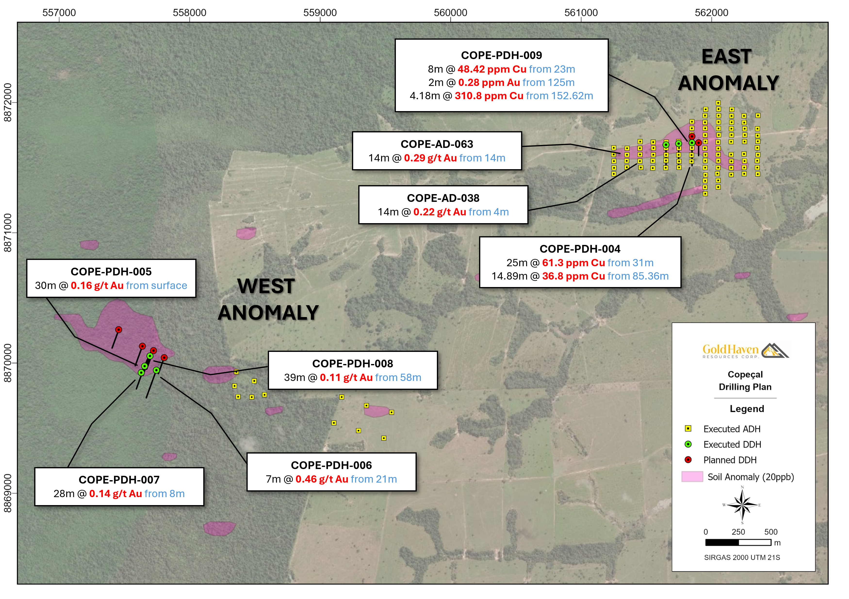
Figure 1: Location of the Copeçal Gold Project showing the relative position of the East and West Anomaly Targets respectively.
The Company continues to advance Copeçal through a multi-disciplinary exploration approach that integrates modern geological interpretation with historical datasets generated by prior operators, including AngloGold Ashanti. This approach combines historical drilling, geochemical and geophysical information with recent field mapping, soil sampling, and diamond drilling results to enhance targeting and improve vectoring toward potentially mineralized centres.
The second phase drilling program is currently planned to commence during the third quarter of 2026, subject to final logistical planning and contractor availability.
The Company expects to finalize Phase II drill targeting in the coming months and will provide updates regarding mobilization, financing milestones, and exploration activities as they become available.

About the Copeçal Gold Project: A Brief History
The Copeçal Gold Project is strategically situated within the Alta Floresta Gold Province, a historically productive region that has yielded substantial gold discoveries since the late 1970s. GoldHaven’ s tenements cover a total of 3,681 hectares in a geologically favourable setting within the Juruena Gold Province of Brazil.
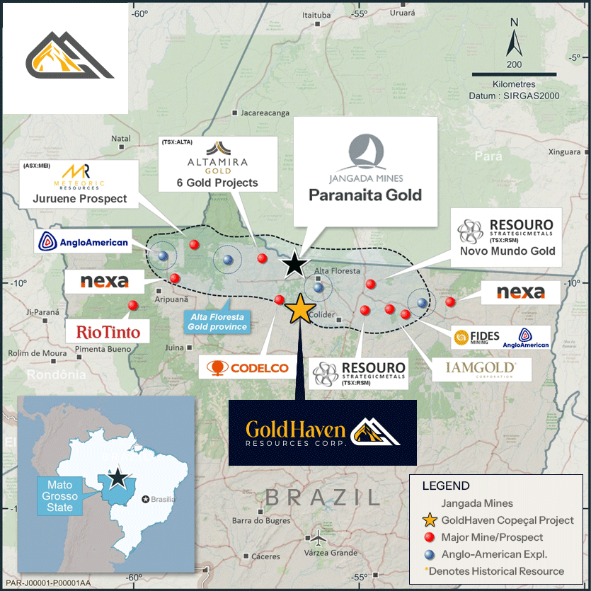
Figure 2: Location of the Copeçal Gold Project within Alta Floresta gold province, with competitor locations.
The Juruena Gold Province, also known as the Juruena Magmatic Arc, is an orogenic belt highly prospective for mesothermal shear-related and intrusion-related gold deposits, such as G-Mining’s Tocantinzinho deposit. Additionally, the region hosts recently identified porphyry-style deposits (e.g., Serabi, Jaca) and epithermal-style deposits (e.g., X1, Aura). The presence of multiple deposit styles, along with the confirmation of large-scale gold deposits in the Juruena Province of Brazilzil, underscores the significant potential of the Copeçal Gold Project.
Recent exploration programs, including geochemical soil sampling, drone-mounted magnetometry surveys, and historical drilling data, indicate the presence of multiple gold-bearing structures. Notably, AngloGold Ashanti previously conducted systematic exploration on the property from 2010 to 2016, including auger and air-core drilling, geophysical surveys, and rock geochemistry, identifying multiple zones of anomalous gold mineralization.
The Copeçal Gold Project benefits from extensive historical work, with AngloGold Ashanti’s exploration confirming gold and arsenic anomalies, indicative of significant mineralization potential. Soil sampling grids and follow-up auger drilling in key areas revealed consistent gold values over wide zones, further supporting the presence of a substantial mineralized system.
About GoldHaven Resources Corp.
GoldHaven Resources Corp. is a Canadian junior exploration Company focused on acquiring and exploring highly prospective land packages in North and South America. The Company’s projects include (i) the flagship Magno Project, a district-scale polymetallic property adjacent to the historic Cassiar mining district in British Columbia; (ii) the Three Guardsman Project, which exhibits significant potential for copper and gold-skarn mineralization; (iii) the Copeçal Gold Project, a drill-ready gold project located in Mato Grosso, Brazil with a 6km strike of anomalous gold in soil samples; and (iv) three critical mineral projects with extensive tenement packages totalling 123,900 hectares: Bahia South, Bahia North and Igautu projects located in Brazil.
Qualified Person:
The scientific and technical information disclosed in this document has been reviewed and approved by Jonathan Victor Hill, B.Sc. Hons, FAusIMM, a non-independent Qualified Person consistent with NI 43-101 and Country Manager of GoldHaven.
On Behalf of the Board of Directors
Rob Birmingham, Chief Executive Officer
For further information, please contact:

Rob Birmingham, CEO
www.GoldHavenresources.com
info@goldhavenresources.com
Office Direct: (604) 629-8254
The CSE and Information Service Provider have not reviewed and does not accept responsibility for the accuracy or adequacy of this release.

Cautionary Statements Regarding Forward Looking Information

This news release contains forward-looking statements and forward-looking information (collectively, "forward looking statements") within the meaning of applicable Canadian and U.S. securities legislation, including the United States Private Securities Litigation Reform Act of 1995. All statements, other than statements of historical fact, included herein including, without limitation, those listed below under the heading “Forward-Looking Statements in This News Release” are forward-looking statements. Although the Company believes that such statements are reasonable, it can give no assurance that such expectations will prove to be correct. Forward-looking statements are typically identified by words such as: "believes", "will", "expects", "anticipates", "intends", "estimates", "plans", "may", "should", "potential", "scheduled", or variations of such words and phrases and similar expressions, which, by their nature, refer to future events or results that may, could, would, might or will occur or be taken or achieved. In making the forward-looking statements in this news release, the Company has applied several material assumptions, including without limitation, that there will be investor interest in future financings, market fundamentals will result in sustained precious metals demand and prices, the receipt of any necessary permits, licenses and regulatory approvals in connection with the future exploration and development of any future projects in a timely manner, the availability of financing on suitable terms for exploration and development of future projects and the Company's ability to comply with environmental, health and safety laws.

The Company cautions investors that any forward-looking statements by the Company are not guarantees of future results or performance, and that actual results may differ materially from those in forward-looking statements as a result of various factors, including, operating and technical difficulties in connection with mineral exploration and development activities, actual results of exploration activities, the estimation or realization of mineral reserves and mineral resources, the inability of the Company to obtain the necessary financing required to conduct its business and affairs, as currently contemplated, , the inability of the Company to enter into definitive agreements in respect of possible Letters of Intent, the timing and amount of estimated future production, the costs of production, capital expenditures, the costs and timing of the development of new deposits, requirements for additional capital, future prices of precious metals, changes in general economic conditions, changes in the financial markets and in the demand and market price for commodities, lack of investor interest in future financings, accidents, labour disputes and other risks of the mining industry, delays in obtaining governmental approvals, permits or financing or in the completion of development or construction activities, changes in laws, regulations and policies affecting mining operations, title disputes, the inability of the Company to obtain any necessary permits, consents, approvals or authorizations, including by the Exchange, the timing and possible outcome of any pending litigation, environmental issues and liabilities, and risks related to joint venture operations, and other risks and uncertainties disclosed in the Company's latest interim Management's Discussion and Analysis and filed with certain securities commissions in Canada. All of the Company's Canadian public disclosure filings may be accessed via www.sedarplus.ca and readers are urged to review these materials.

Readers are cautioned not to place undue reliance on forward-looking statements. The Company undertakes no obligation to update any of the forward-looking statements. The Company undertakes no obligation to update any of the forward-looking statements in this news release or incorporated by reference herein, except as otherwise required by law.

Forward-Looking Statements in This News Release

The following statements in this news release constitute forward-looking information:
● GoldHaven's intention to advance drill planning and target refinement with the objective of commencing a Phase II drill campaign at Copeçal during Q3 2026, subject to successful completion of the LIFE financing
● The eastern extension of the East Target has been identified as a priority area for future drilling and is considered prospective for evaluating the continuity and scale of alteration and sulphide mineralization
● Follow-up drilling is planned to test mineralization along strike and at depth from hole COP-009
● The upcoming Q3 program is expected to be an important step in determining whether the alteration, structural controls and copper-bearing sulphides identified to date represent the peripheral expression of a larger copper-gold system
● Additional drilling and technical evaluation will be required to determine the significance and extent of the mineralization encountered to date
● The Company expects to finalize Phase II drill targeting in the coming months and will provide updates regarding mobilization, financing milestones, and exploration activities as they become available
● The second phase drilling program is currently planned to commence during the third quarter of 2026, subject to final logistical planning and contractor availability
● The recently announced LIFE Offering is expected to provide flexibility for expanded exploration activities

