

GoldHaven Targets Historic Kuhn Tungsten Zone in Fully Funded 2026 Drill Program

Vancouver, British Columbia – June 2nd, 2026 – GoldHaven Resources Corp. ("GoldHaven" or the "Company") (CSE: GOH) (OTCQB: GHVNF) (FSE: 4QS) is pleased to provide additional details regarding its planned 2026 diamond drill program at the Company's 100%-owned Magno Project, located in the Cassiar District of northern British Columbia.

The fully funded drill program is designed to verify and expand historical tungsten mineralization at the Kuhn Zone while also advancing additional priority targets across the district-scale Magno Project. The program will focus on twinning selected historical drill holes, testing interpreted extensions of known mineralization, and evaluating the broader scale potential of the tungsten-bearing skarn system.

Highlights

- Fully funded 2026 drill program targeting the Kuhn and Dead Goat tungsten zones.
- Historical estimate of 616,500 tonnes grading 0.48% WO₃ across four modeled mineralized lenses*
- Previous drilling returned up to 4.0 metres grading 1.32% WO₃ and 0.26% MoS₂.
- Multiple tungsten-bearing intervals exceeding 0.5% WO₃ intersected across the Kuhn Zone.
- Planned drilling to twin key holes and test extensions of known tungsten mineralization.
- Tungsten-bearing skarn mineralization is associated with intrusive activity, supporting an intrusion-related mineralizing system.
- Ongoing airborne geophysics and geological modelling are refining drill targets.
- Additional drilling planned at the Magno and D Zones.

*See "Historical Estimate Disclosure" below. GoldHaven is not treating the historical estimate as a current mineral resource or mineral reserve.

Tungsten is recognized as a critical mineral by both Canada and the United States due to its importance in defense, aerospace, industrial manufacturing, and advanced technology applications. GoldHaven believes the Magno Project represents a unique opportunity to evaluate a historically defined tungsten-bearing skarn system within a stable mining jurisdiction.

"The Kuhn Zone represents an exciting opportunity to evaluate a historically defined tungsten-bearing skarn system at a time when demand for critical minerals continues to increase," stated Rob Birmingham, Chief Executive Officer of GoldHaven. "Our fully funded 2026 drill program is designed to verify previous drilling, test extensions of known mineralization, and improve our understanding of what we believe could be a larger tungsten-molybdenum system. With multiple mineralized lenses identified and indications that the system remains open at depth, we believe Kuhn has the potential to become an important critical minerals target within the Magno Project.

Historical Tungsten Estimate

Historical exploration completed by previous operators included drilling, underground development, geological mapping and lens modelling that identified multiple tungsten-bearing skarn horizons within the Kuhn and Dead Goat areas of the Magno Project. The historical work outlined several mineralized lenses that form the basis for GoldHaven's planned verification drilling program.

The historical estimate includes:

Zone | Historical Tonnage | Historical Grade
Kuhn North Lower 3A | 409,300 tonnes | 0.48% WO₃
Kuhn North Upper 3A | 78,700 tonnes | 0.50% WO₃
Dead Goat | 100,900 tonnes | 0.49% WO₃
Dead Goat Deeper Lens | 27,600 tonnes | 0.39% WO₃

Collectively, these zones represent a historical estimate of approximately 616,500 tonnes grading 0.48% WO₃.

The historical estimate was generated by previous operators and provides evidence of a tungsten-bearing skarn system developed within favorable carbonate host rocks adjacent to intrusive bodies. GoldHaven believes the historical work highlights the exploration potential of the Kuhn and Dead Goat areas and provides a valuable framework for the Company's upcoming drill program.

The planned 2026 drilling is designed to twin selected historical drill holes, verify historical mineralization, evaluate continuity of the mineralized skarn horizons, and test for extensions of the system both along strike and at depth.

A Qualified Person has not completed sufficient work to classify the historical estimate as a current mineral resource or mineral reserve, and GoldHaven is not treating the historical estimate as a current mineral resource or mineral reserve. The historical estimate is considered relevant to investors as it demonstrates the presence of a significant tungsten-bearing system and assists in guiding exploration and drill targeting.

Kuhn Zone Tungsten Target

The Kuhn Zone hosts tungsten-bearing skarn mineralization developed along contacts between intrusive rocks and reactive carbonate units, a geological setting commonly associated with significant tungsten deposits worldwide. The zone forms part of a broader corridor of skarn mineralization identified across the Magno Project. Mineralization is spatially associated with altered carbonate rocks located adjacent to intrusive bodies believed to have acted as the source of mineralizing fluids.

Historical drilling completed by previous operators intersected intervals of tungsten mineralization within skarn horizons developed along favorable stratigraphic and structural contacts. GoldHaven's planned drill program will target these historical intercepts while also testing interpreted extensions of the mineralized system both along strike and at depth. Recent airborne magnetic and QMAGT

survey results, together with ongoing geological modelling, are being incorporated into final drill targeting and may provide additional insight into the structural and intrusive controls on mineralization.

Historical Drilling

Previous drilling at the Kuhn North Zone intersected multiple tungsten-bearing skarn horizons within the Upper 3A and Lower 3A lenses and outlined mineralization over a vertical extent exceeding 100 metres, demonstrating continuity within several modeled skarn lenses.

Historical intercepts included:

- 13.0 metres grading 0.55% WO₃
- 11.3 metres grading 0.59% WO₃ and 0.10% MoS₂
- 6.0 metres grading 0.58% WO₃
- 6.0 metres grading 0.58% WO₃ and 0.12% MoS₂
- 4.4 metres grading 0.75% WO₃ and 0.17% Cu
- 4.0 metres grading 1.32% WO₃ and 0.26% MoS₂

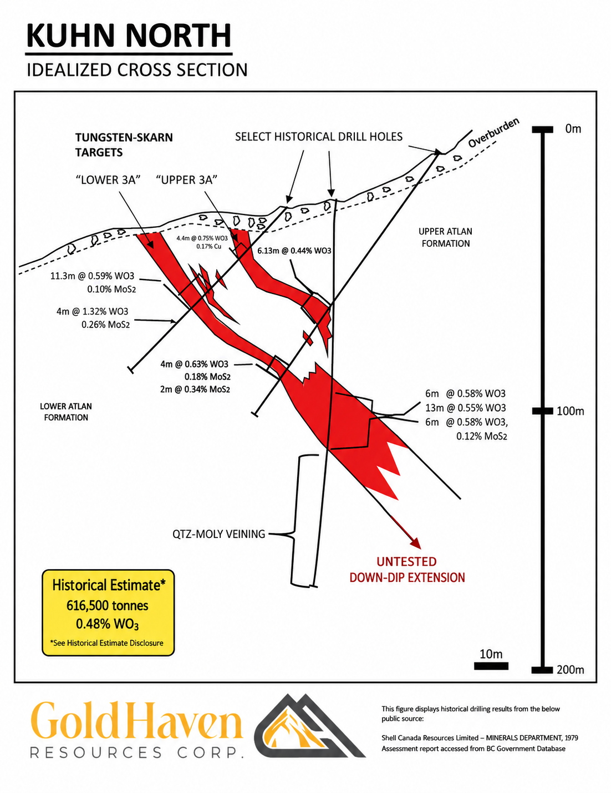Figure 1. Idealized cross section of the Kuhn North Zone showing historical tungsten-bearing skarn horizons within the Upper 3A and Lower 3A lenses. Historical drilling intersected multiple tungsten-bearing intervals and geological interpretations suggest the mineralized system remains open down dip and at depth. Historical results shown are derived from public assessment reports and have not been independently verified by GoldHaven.

GoldHaven believes the down-dip extensions of these mineralized skarn horizons represent compelling targets for the upcoming drill program.

Historical geological interpretations suggest the tungsten-bearing skarn horizons remain open at depth and may be associated with a broader intrusion-related mineralizing system. Quartz-molybdenum veining identified beneath the known skarn mineralization further supports the potential for a larger mineralized system. GoldHaven's planned drill program is designed to verify these historical results, test down-dip and along-strike extensions of known mineralization and improve the geological understanding of the Kuhn tungsten target.

The Company notes that the historical drilling results referenced herein have not been independently verified by GoldHaven. The planned drill program is intended, in part, to verify these historical results.

Geological Model

GoldHaven's exploration team interprets the Kuhn Zone as part of a larger intrusion-related mineral system developed within carbonate host rocks of the Cassiar Terrane. Mineralization is believed to occur within skarn horizons formed by interaction between mineralized intrusive fluids and reactive carbonate units.

The Company's geological model suggests that historical drilling may have only tested a portion of the mineralized system. Planned drilling is designed to evaluate both lateral and vertical continuity while testing for higher-grade zones associated with structural controls and potential feeder pathways.

2026 Drill Program

The initial phase of drilling at Kuhn is expected to focus on twinning key historical holes, testing interpreted extensions of known mineralization, and improving the geological understanding of the tungsten-bearing skarn system. Final drill collar locations and metreage will be refined following integration of airborne geophysical data and ongoing geological modelling. The program will include:

- Twinning of selected historical drill holes.
- Follow-up drilling on historical mineralized intercepts.
- Step-out drilling along strike and down dip.
- Testing of geophysical and geological targets generated through recent exploration work.
- Collection of modern geological, structural, and geochemical data to support future resource evaluation.

The Kuhn Zone will form part of GoldHaven's broader 2026 exploration strategy, which also includes planned drilling at the Magno and D Zones, where previous exploration identified high-grade silver-lead-zinc carbonate replacement style mineralization.

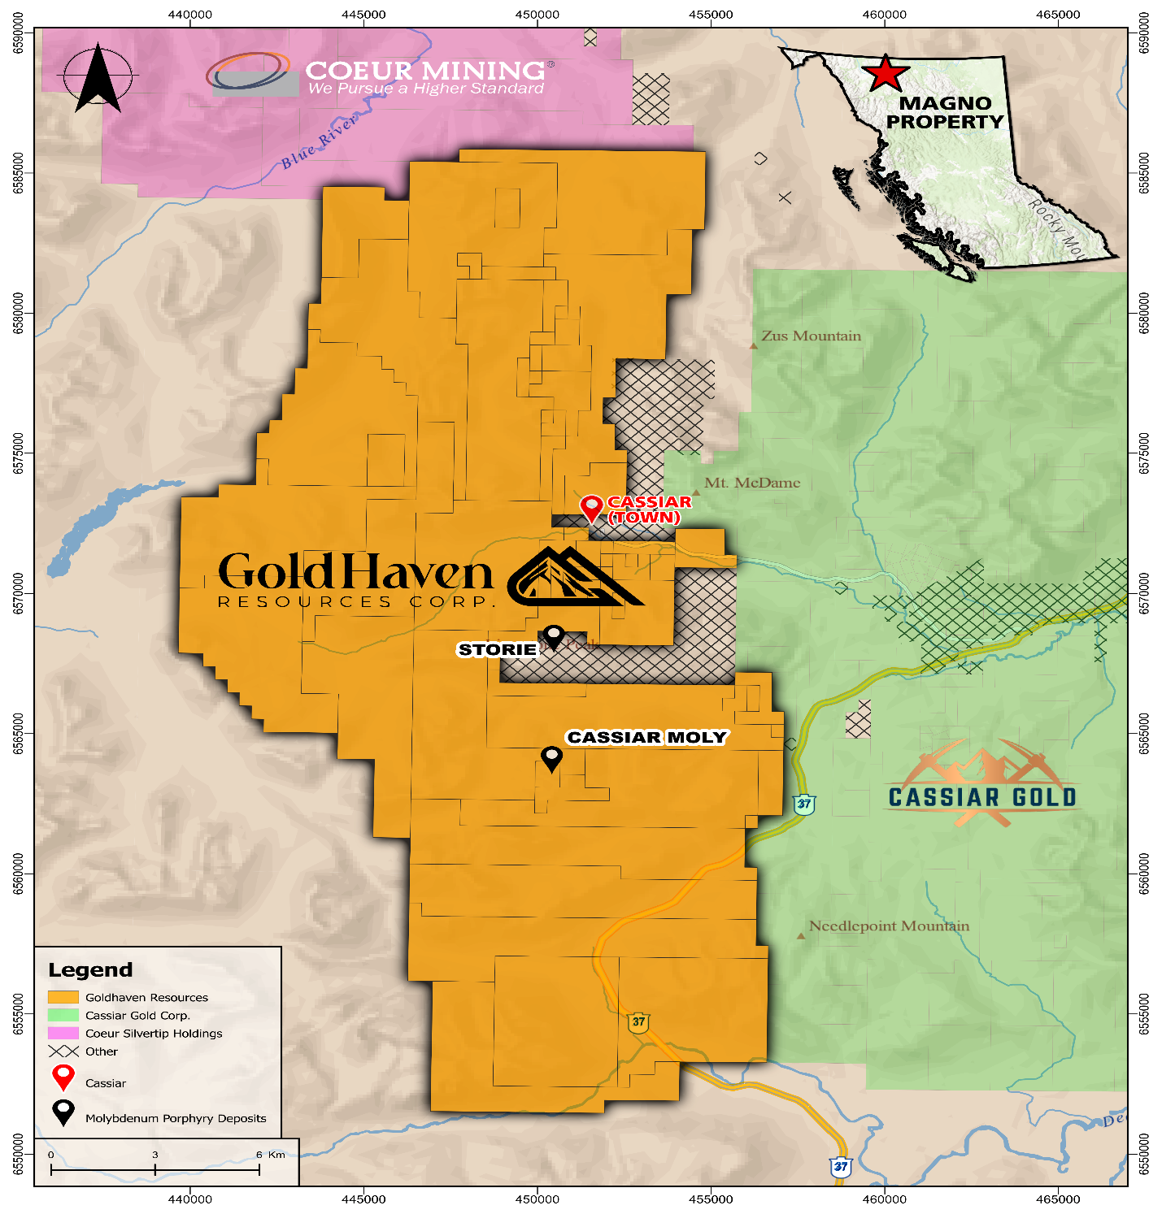
Figure 2: Magno project location in Northern BC with proximity to nearby companies.

Qualified Person:
The technical and scientific information contained in this news release has been reviewed and approved by Raymond Wladichuk P.Geo. who is a non-independent Qualified Person as defined under NI 43-101 and a consultant of the Company.

About GoldHaven Resources Corp.

GoldHaven Resources Corp. is a Canadian junior exploration company focused on advancing highly prospective mineral projects in North and South America. The Company’s flagship asset is the district-scale Magno Project in the Cassiar District of northern British Columbia. GoldHaven also owns the Three Guardsmen copper-gold project in British Columbia and the Copeçal Gold Project in Mato Grosso, Brazil. In addition, the Company holds a portfolio of critical mineral projects in Brazil.

On Behalf of the Board of Directors

Rob Birmingham, Chief Executive Officer

For further information, please contact:
Rob Birmingham, CEO
www.GoldHavenresources.com
info@goldhavenresources.com
Office Direct: (604) 629-8254

Neither the CSE nor its Regulation Services Provider (as that term is defined in the policies of the CSE- Canadian Securities Exchange) accepts responsibility for the adequacy or accuracy of this release.

Cautionary Statements Regarding Forward Looking Information

This news release contains forward-looking statements and forward-looking information (collectively, "forward looking statements") within the meaning of applicable Canadian and U.S. securities legislation, including the United States Private Securities Litigation Reform Act of 1995. All statements, other than statements of historical fact, included herein including, without limitation, those listed below under the heading “Forward-Looking Statements in This News Release” are forward-looking statements. Although the Company believes that such statements are reasonable, it can give no assurance that such expectations will prove to be correct. Forward-looking statements are typically identified by words such as: "believes", "will", "expects", "anticipates", "intends", "estimates", "plans", "may", "should", "potential", "scheduled", or variations of such words and phrases and similar expressions, which, by their nature, refer to future events or results that may, could, would, might or will occur or be taken or achieved. In making the forward-looking statements in this news release, the Company has applied several material assumptions, including without limitation, that there will be investor interest in future financings, market fundamentals will result in sustained precious metals demand and prices, the receipt of any necessary permits, licenses and regulatory approvals in connection with the future exploration and development of any future projects in a timely manner, the availability of financing on suitable terms for exploration and development of future projects and the Company's ability to comply with environmental, health and safety laws.

The Company cautions investors that any forward-looking statements by the Company are not guarantees of future results or performance, and that actual results may differ materially from those in forward-looking statements as a result of various factors, including, operating and technical difficulties in connection with mineral exploration and development activities, actual results of exploration activities, the estimation or realization of mineral reserves and mineral resources, the inability of the Company to obtain the necessary financing required to conduct its business and affairs, as currently contemplated, the inability of the Company to enter into definitive agreements in respect of possible Letters of Intent, the timing and amount of estimated

future production, the costs of production, capital expenditures, the costs and timing of the development of new deposits, requirements for additional capital, future prices of precious metals, changes in general economic conditions, changes in the financial markets and in the demand and market price for commodities, lack of investor interest in future financings, accidents, labour disputes and other risks of the mining industry, delays in obtaining governmental approvals, permits or financing or in the completion of development or construction activities, changes in laws, regulations and policies affecting mining operations, title disputes, the inability of the Company to obtain any necessary permits, consents, approvals or authorizations, including by the Exchange, the timing and possible outcome of any pending litigation, environmental issues and liabilities, and risks related to joint venture operations, and other risks and uncertainties disclosed in the Company's latest interim Management's Discussion and Analysis and filed with certain securities commissions in Canada. All of the Company's Canadian public disclosure filings may be accessed via www.sedarplus.ca and readers are urged to review these materials.

Readers are cautioned not to place undue reliance on forward-looking statements. The Company undertakes no obligation to update any of the forward-looking statements in this news release or incorporated by reference herein, except as otherwise required by law.

Forward-Looking Statements in This News Release
The following statements in this news release constitute forward-looking information:
● The fully funded 2026 drill program is designed to verify and expand historical tungsten mineralization at the Kuhn Zone and advance additional priority targets across the Magno Project
● The program will focus on twinning selected historical drill holes, testing interpreted extensions of known mineralization, and evaluating the broader scale potential of the tungsten-bearing skarn system
● Ongoing airborne geophysics and geological modelling are expected to refine drill targets
● Additional drilling is planned at the Magno and D Zones
● The down-dip extensions of mineralized skarn horizons are expected to represent compelling targets for the upcoming drill program
● The tungsten-bearing skarn horizons are believed to remain open at depth and may be associated with a broader intrusion-related mineralizing system
● Planned drilling is designed to evaluate lateral and vertical continuity while testing for higher-grade zones associated with structural controls and potential feeder pathways
● The timing of permit approvals, geophysical survey completion, target generation and the commencement of drilling activities
● The Company expects to be successful in enacting its business plans in the anticipated timeframes

