

GoldHaven Expands District-Scale Airborne Survey at Magno to 2,237 Line-Kilometres to Advance 2026 Drill Targeting
Vancouver, British Columbia – May 28, 2026 – GoldHaven Resources Corp. (“GoldHaven” or the “Company”) (CSE: GOH) (OTCQB: GHVNF) (FSE: 4QS) is pleased to announce the expansion and ongoing completion of its high-resolution airborne geophysical survey across the Company’s 100%-owned Magno Project located in the Cassiar District of northern British Columbia.
The survey, being completed by Dias Airborne Limited (“Dias”), has been expanded to approximately 2,237 line-kilometres from the originally planned 1,741 line-kilometre program, substantially increasing coverage across priority mineralized corridors and prospective intrusive contact zones identified throughout the district-scale property package.

Highlights
- Expanded airborne survey increased to approximately 2,237 line-kilometres from the previously announced 1,741 line-kilometre program
- Survey designed to support a planned 5,000 metre 2026 diamond drill program targeting the Magno, Kuhn, and D Zones
- Expanded coverage across prospective CRD, tungsten-bearing skarn, and porphyry-style mineralized corridors
- High-grade surface sampling includes values up to 2,370 g/t Ag and 6,550 ppm tungsten (W)
- Dias’ QMAGT technology was utilized in geophysical targeting work associated with the Hercules Metals Leviathan discovery in Idaho
“This expanded airborne program represents a major advancement in our systematic approach to unlocking the district-scale potential at Magno,” stated Rob Birmingham, CEO of GoldHaven. “Dias’ technology was successfully utilized in advancing targeting work associated with the Hercules discovery, and we believe deploying the same next-generation system at Magno significantly strengthens our ability to define and prioritize high-confidence drill targets ahead of our planned 2026 drill campaign focused on the Magno, Kuhn, and D Zones.”
The helicopter-borne survey utilizes Dias’ proprietary QMAGT (Quantum Magnetic Gradiometry Tensor) technology, an advanced full tensor magnetic gradiometry system designed to enhance the detection and modelling of subsurface geological structures, alteration corridors, intrusive contacts, and potential mineralized feeder systems.
The airborne survey is focused on defining structural controls, intrusive contacts, and alteration pathways associated with the Company’s growing inventory of silver-lead-zinc CRD mineralization, tungsten-bearing skarn systems, and interpreted porphyry-related mineralized centres.

The expanded survey area covers a broad north-south mineralized corridor associated with carbonate and sedimentary rocks in contact with intrusive granitic units, which management believes represents a highly prospective environment for multiple styles of mineralization.
Recent surface exploration completed by the Company identified multiple high-priority target areas highlighted by rock sample results including silver values up to 2,370 g/t Ag, tungsten values up to 6,550 ppm W, and indium values up to 334 ppm In. These results, together with historical exploration datasets and geological mapping, have been incorporated directly into the airborne survey design and targeting process.
The survey is being flown at 100 metre line spacing with approximately 344 survey lines and average line lengths of approximately 6.5 kilometres. The program is designed to generate a detailed magnetic dataset capable of assisting with the identification of fault structures, lithological boundaries, intrusive geometries, and potential mineralized trends beneath areas of limited outcrop exposure.
GoldHaven believes the integration of this new geophysical dataset with geological mapping, surface geochemistry, historical drilling, and ongoing 3D modelling initiatives has the potential to significantly refine and prioritize drill targets ahead of the Company’s planned 2026 exploration activities.
GoldHaven selected Dias based in part on the geological similarities between Magno’s evolving CRD-skarn-porphyry system and the Hercules Metals Corp. Leviathan discovery in Idaho, where Dias’ advanced airborne geophysical technology played an important role in refining concealed drill targets associated with the discovery¹. Management believes the application of comparable high-resolution geophysical techniques at Magno has the potential to materially improve target definition across multiple mineralized corridors.
¹ https://diasgeo.com/portfolio-items/hercules_metals/

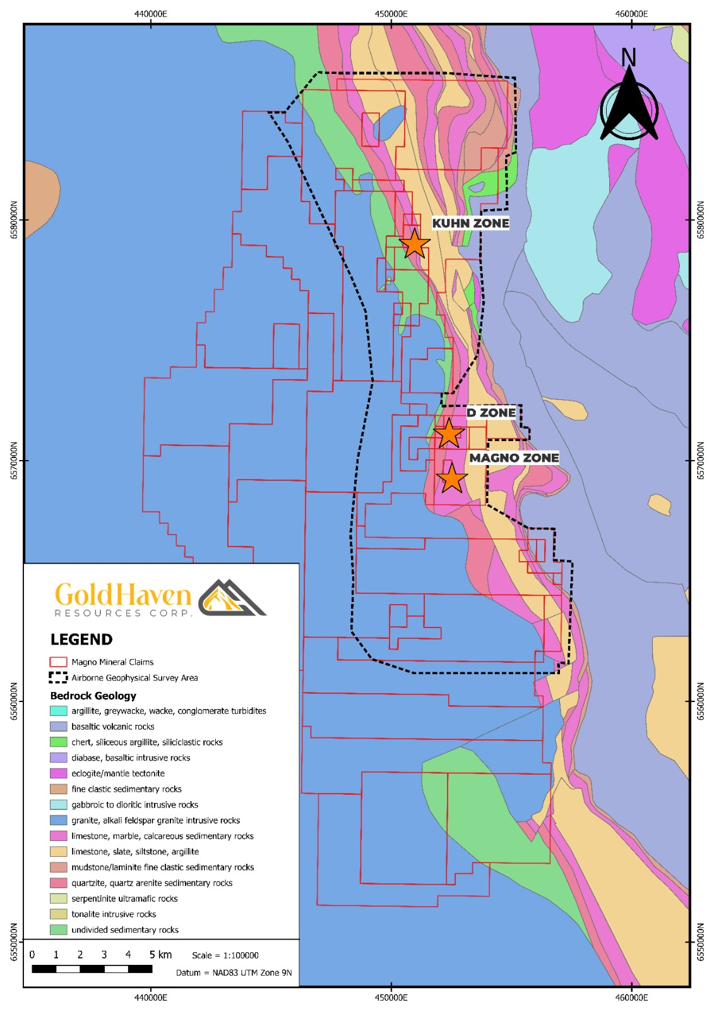

Figure 1: Geology map showing the area of the airborne survey as well as the high-priority zones within the Magno project emphasizing the Kuhn, D Zone, Magno zones.

About the QMAGT Survey System
Dias Airborne’s QMAGT system is a helicopter-borne full tensor magnetic gradiometry platform utilizing SQUID (superconducting quantum interference device) sensor technology. Unlike conventional magnetic surveys, QMAGT measures the full tensor of the Earth’s magnetic field, providing enhanced directional and structural information that can improve subsurface geological interpretation and targeting.
The system is designed to operate effectively in complex terrain environments and has been utilized in modern mineral exploration programs focused on identifying concealed intrusive systems, structural corridors, and mineralized targets.
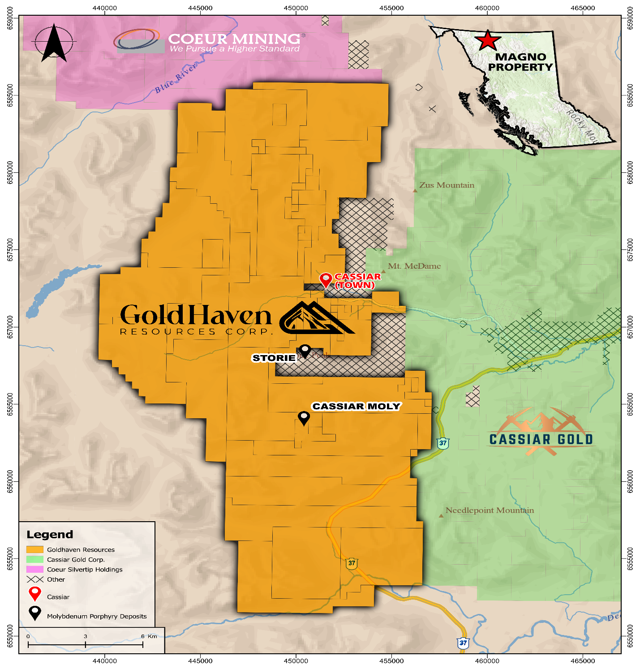
Figure 2: Magno project location in Northern BC with proximity to nearby companies.

Qualified Person:
The technical and scientific information contained in this news release has been reviewed and approved by Raymond Wladichuk P.Geo. who is a non-independent Qualified Person as defined under NI 43-101 and a consultant of the Company.

About GoldHaven Resources Corp.

GoldHaven Resources Corp. is a Canadian junior exploration company focused on advancing highly prospective mineral projects in North and South America. The Company’s flagship asset is the district-scale Magno Project in the Cassiar District of northern British Columbia. GoldHaven also owns the Three Guardsmen copper-gold project in British Columbia and the Copeçal Gold Project in Mato Grosso, Brazil. In addition, the Company holds a portfolio of critical mineral projects in Brazil.

On Behalf of the Board of Directors

Rob Birmingham, Chief Executive Officer

For further information, please contact:
Rob Birmingham, CEO
www.GoldHavenresources.com
info@goldhavenresources.com
Office Direct: (604) 629-8254

Neither the CSE nor its Regulation Services Provider (as that term is defined in the policies of the CSE - Canadian Securities Exchange) accepts responsibility for the adequacy or accuracy of this release.

Cautionary Statements Regarding Forward Looking Information

This news release contains forward-looking statements and forward-looking information (collectively, "forward looking statements") within the meaning of applicable Canadian and U.S. securities legislation, including the United States Private Securities Litigation Reform Act of 1995. All statements, other than statements of historical fact, included herein including, without limitation, those listed below under the heading “Forward-Looking Statements in This News Release” are forward-looking statements. Although the Company believes that such statements are reasonable, it can give no assurance that such expectations will prove to be correct. Forward-looking statements are typically identified by words such as: "believes", "will", "expects", "anticipates", "intends", "estimates", "plans", "may", "should", "potential", "scheduled", or variations of such words and phrases and similar expressions, which, by their nature, refer to future events or results that may, could, would, might or will occur or be taken or achieved. In making the forward-looking statements in this news release, the Company has applied several material assumptions, including without limitation, that there will be investor interest in future financings, market fundamentals will result in sustained precious metals demand and prices, the receipt of any necessary permits, licenses and regulatory approvals in connection with the future exploration and development of any future projects in a timely manner, the availability of financing on suitable terms for exploration and development of future projects and the Company's ability to comply with environmental, health and safety laws.

The Company cautions investors that any forward-looking statements by the Company are not guarantees of future results or performance, and that actual results may differ materially from those in forward-looking statements as a result of various factors, including, operating and technical difficulties in connection with mineral exploration and development activities, actual results of exploration activities, the estimation or realization of mineral reserves and mineral resources, the inability of the Company to obtain the necessary financing required to conduct its business and affairs, as currently contemplated, the inability of the Company to enter into definitive agreements in respect of possible Letters of Intent, the timing and amount of estimated future production, the costs of production, capital expenditures, the costs and timing of the development of new deposits, requirements for additional capital, future prices of precious metals, changes in general economic conditions, changes in the financial markets and in the demand and market price for commodities, lack of investor interest in future financings, accidents, labour disputes and other risks of the mining industry, delays in obtaining governmental approvals, permits or financing or in the completion of development or construction activities, changes in laws, regulations and policies affecting mining operations, title disputes, the inability of the Company to obtain any necessary permits, consents, approvals or authorizations, including by the Exchange, the timing and possible outcome of any pending litigation, environmental issues and liabilities, and risks related to joint venture operations, and other risks and uncertainties disclosed in the Company's latest interim Management's Discussion and Analysis and filed with certain securities commissions in Canada. All of the Company's Canadian public disclosure filings may be accessed via www.sedarplus.ca and readers are urged to review these materials.

Readers are cautioned not to place undue reliance on forward-looking statements. The Company undertakes no obligation to update any of the forward-looking statements in this news release or incorporated by reference herein, except as otherwise required by law.

Forward-Looking Statements in This News Release

The following statements in this news release constitute forward-looking information:
- The expanded survey supporting a planned 5,000 metre 2026 diamond drill program targeting the Magno, Kuhn, and D Zones;
- Integration of the new geophysical dataset having the potential to significantly refine and prioritize drill targets ahead of 2026 exploration activities;
- Application of high-resolution geophysical techniques at Magno having the potential to materially improve target definition across multiple mineralized corridors; and
- The QMAGT system significantly strengthening the ability to define and prioritize high-confidence drill targets ahead of the planned 2026 drill campaign.

