

GoldHaven Closes Additional Flow-Through Financing Bringing Total Flow-Through Proceeds to Approximately $3.26 Million to Advance Planned 5,000+ Metre Magno Drill Program

Vancouver, British Columbia – May 14th, 2026 – GoldHaven Resources Corp. (CSE: GOH) (OTCQB: GHVNF) (FSE: 4QS) (the “Company” or “GoldHaven”) is pleased to announce that it has closed a further tranche of its non-brokered flow-through financing (the “Flow-Through Offering”) through the issuance of 4,589,510 flow-through common shares (the “FT Shares”) at a price of $0.265 per FT Share for aggregate gross proceeds of $1,216,220.

HIGHLIGHTS

- Closed additional gross proceeds of approximately $1.22 million
- Total aggregate flow-through proceeds raised now approximately $3.26 million
- Funding supports a planned 5,000+ metre exploration drill program at the Magno Project, subject to permitting
- Magno hosts high-grade silver, zinc, lead, tungsten, and critical mineral mineralization
- Additional airborne geophysical surveys and target refinement planned across the district-scale property

CEO COMMENTARY

“We are very pleased to complete this financing, which further strengthens GoldHaven’s treasury as we continue advancing the Magno Project,” stated Rob Birmingham, President and CEO of GoldHaven.

“Magno continues to demonstrate significant potential as a district-scale polymetallic and critical minerals system, with strong silver-lead-zinc mineralization alongside emerging tungsten and indium upside. This financing positions the Company well as we continue exploration planning and target advancement across the project.”

FLOW-THROUGH FINANCING

Under the Flow-Through Offering, the Company issued 4,589,510 FT Shares at a price of $0.265 per FT Share for aggregate gross proceeds of $1,216,220. Following the issuance, the Company has 62,897,172 common shares issued and outstanding.

In connection with the closing, the Company paid cash finder’s fees totaling $83,813 and issued 303,766 non-transferable finder warrants (each, a “Finder Warrant”) to a certain eligible arm’s-length finder who introduced a subscriber to the Offering. Each Finder Warrant entitles the holder to purchase one common share (a “Finder Share”) at a price of C$0.35 per Finder Share for a period of 24 months from the date of issuance.

All securities issued pursuant to the Offering are subject to a statutory hold period expiring September 15, 2026, in accordance with applicable securities laws and Canadian Securities Exchange requirements.

USE OF PROCEEDS
The gross proceeds from the Offering will be used to incur eligible Canadian exploration expenses that will qualify as “flow-through mining expenditures” as defined under the Income Tax Act (Canada). The expenditures will be renounced to subscribers effective December 31, 2026.

Funds from the Offering are expected to support ongoing advancement of the Company’s Magno Project, including:

- Drill targeting and exploration planning
- Airborne geophysical surveys
- Geological mapping and sampling
- 3D geological and structural modelling
- Follow-up work on high-grade silver and tungsten targets across the Magno property

MAGNO PROJECT

GoldHaven’s Magno Project is a district-scale polymetallic exploration asset located in the Cassiar region of northwestern British Columbia. The project hosts multiple styles of mineralization including silver-lead-zinc carbonate replacement mineralization, tungsten-rich skarn systems, and copper-bearing intrusive-related targets.

Recent work has confirmed widespread critical mineral enrichment including tungsten values up to 6,550 ppm W and indium values up to 334 ppm, alongside high-grade silver values up to 2,370 g/t Ag.

The technical and scientific information contained in this news release has been reviewed and approved by Raymond Wladichuk, P.Geo., who is a non-independent Qualified Person as defined under NI 43-101 and a consultant of the Company.

Neither the CSE nor its Regulation Services Provider (as that term is defined in the policies of the CSE) accepts responsibility for the adequacy or accuracy of this release.

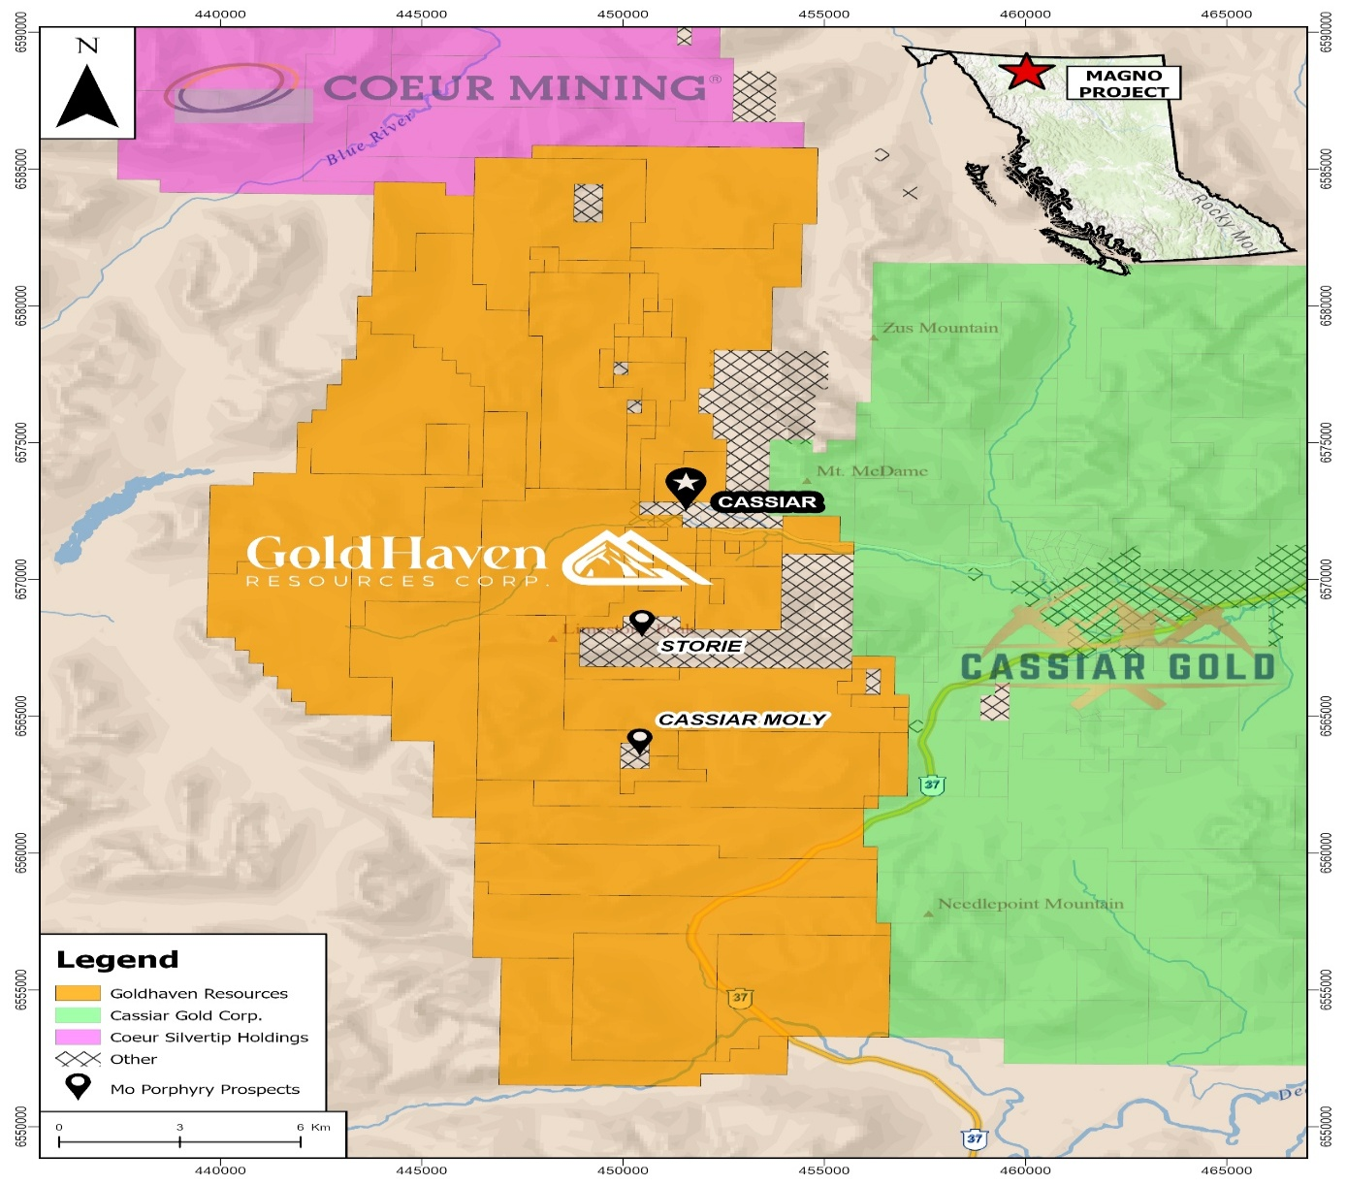Figure 1: Magno map location with proximity to nearby companies

About GoldHaven Resources Corp.

GoldHaven Resources Corp. is a Canadian junior exploration Company focused on acquiring and exploring highly prospective land packages in North and South America. The Company’s projects include the flagship Magno Project, a district-scale polymetallic property adjacent to the historic Cassiar mining district in British Columbia. The Three Guardsman Project, which exhibits significant potential for copper and gold-skarn mineralization. The Copeçal Gold Project, a drill-ready gold project located in Mato Grosso, Brazil with a 6km strike of anomalous gold in soil samples. Three Critical Mineral projects with extensive tenement packages totalling 123,900 hectares: Bahia South, Bahia North and Iguatu projects located in Brazil.

On Behalf of the Board of Directors

Rob Birmingham, Chief Executive Officer

For further information, please contact:
Rob Birmingham, CEO
www.GoldHavenresources.com
info@goldhavenresources.com
Office Direct: (604) 629-8254

Qualified Person:
The technical and scientific information contained in this news release has been reviewed and approved by Raymond Wladichuk P.Geo. who is a non-independent Qualified Person as defined under NI 43-101 and a consultant of the Company.

Neither the CSE nor its Regulation Services Provider (as that term is defined in the policies of the CSE- Canadian Securities Exchange) accepts responsibility for the adequacy or accuracy of this release.

Cautionary Statements Regarding Forward Looking Information

This news release contains forward-looking statements and forward-looking information (collectively, "forward looking statements") within the meaning of applicable Canadian and U.S. securities legislation, including the United States Private Securities Litigation Reform Act of 1995. All statements, other than statements of historical fact, included herein including, without limitation, those listed below under the heading “Forward-Looking Statements in This News Release” are forward-looking statements. Although the Company believes that such statements are reasonable, it can give no assurance that such expectations will prove to be correct. Forward-looking statements are typically identified by words such as: "believes", "will", "expects", "anticipates", "intends", "estimates", "plans", "may", "should", "potential", "scheduled", or variations of such words and phrases and similar expressions, which, by their nature, refer to future events or results that may, could, would, might or will occur or be taken or achieved. In making the forward-looking statements in this news release, the Company has applied several material assumptions, including without limitation, that there will be investor interest in future financings, market fundamentals will result in sustained precious metals demand and prices, the receipt of any necessary permits, licenses and regulatory approvals in connection with the future exploration and development of any future projects in a timely manner, the availability of financing on suitable terms for exploration and development of future projects and the Company's ability to comply with environmental, health and safety laws.

The Company cautions investors that any forward-looking statements by the Company are not guarantees of future results or performance, and that actual results may differ materially from those in forward-looking statements as a result of various factors, including, operating and technical difficulties in connection with mineral exploration and development activities, actual results of exploration activities, the estimation or realization of mineral reserves and mineral resources, the inability of the Company to obtain the necessary financing required to conduct its business and affairs, as currently contemplated, , the inability of the Company to enter into definitive agreements in respect of possible Letters of Intent, the timing and amount of estimated future production, the costs of production, capital expenditures, the costs and timing of the development of new deposits, requirements for additional capital, future prices of precious metals, changes in general economic conditions, changes in the financial markets and in the demand and market price for commodities, lack of investor interest in future financings, accidents, labour disputes and other risks of the mining industry, delays in obtaining governmental approvals, permits or financing or in the completion of development or construction

activities, changes in laws, regulations and policies affecting mining operations, title disputes, the inability of the Company to obtain any necessary permits, consents, approvals or authorizations, including by the Exchange, the timing and possible outcome of any pending litigation, environmental issues and liabilities, and risks related to joint venture operations, and other risks and uncertainties disclosed in the Company's latest interim Management's Discussion and Analysis and filed with certain securities commissions in Canada. All of the Company's Canadian public disclosure filings may be accessed via www.sedarplus.ca and readers are urged to review these materials.

Readers are cautioned not to place undue reliance on forward-looking statements. The Company undertakes no obligation to update any of the forward-looking statements. The Company undertakes no obligation to update any of the forward-looking statements in this news release or incorporated by reference herein, except as otherwise required by law.

Forward-Looking Statements in This News Release

The following statements in this news release constitute forward-looking information:
- Funds are expected to support a planned 5,000+ metre exploration drill program at the Magno Project, subject to permitting;
- Proceeds will be used to advance drill targeting, exploration planning, airborne geophysical surveys, geological mapping and sampling, 3D geological and structural modelling, and follow-up work on high-grade silver and tungsten targets across the Magno property;
- Flow-through expenditures will be renounced to subscribers effective December 31, 2026.

