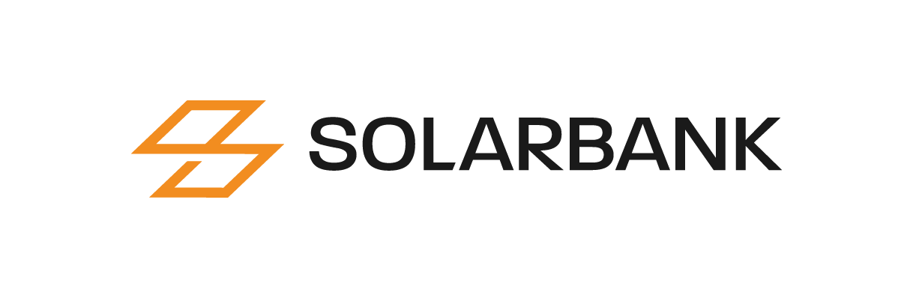

SolarBank now Trades as “SUUNF” on the OTCQX Best Market

Toronto, Ontario, June 2, 2023 — SolarBank Corporation (CSE: SUNN; OTCQX: SUUNF; FSE: GY2) (“SolarBank” or the "Company") announces that its symbol on the OTCQX International has changed to SUUNF. SolarBank trades on the OTC Market’s prestigious tier, OTCQX International. Investors can find current financial disclosure and Real-Time Level 2 quotes for the Company on www.otcmarkets.com. To qualify for OTCQX, companies must meet high financial standards, follow best practice corporate governance and demonstrate compliance with applicable securities laws.
OTC Markets Group Inc. (OTCQX: OTCM) operates regulated markets for trading 12,000 U.S. and international securities. Its data-driven disclosure standards form the foundation of its three public markets: OTCQX® Best Market, OTCQB® Venture Market and Pink® Open Market.

The Company also announces that it has acquired from existing limited partners an aggregate of 31,430 limited partnership units allocated amongst three series of Solar Flow-Through Limited Partnerships (“SFT”) for an aggregate purchase price of $722,490. SFT finances and develops solar photovoltaic (PV) power facilities in Canada.

About SolarBank Corporation
SolarBank Corporation is an independent renewable and clean energy project developer focusing on distributed and community solar projects in Canada and the USA. The Company develops solar projects that sell electricity to utilities, commercial, industrial, municipal and residential off-takers. The Company maximizes returns via a diverse portfolio of projects across multiple leading solar markets including projects with utilities, host off-takers, community solar, and virtual net metering projects. The Company has developed over 1,000 renewable and clean energy projects with a combined capacity of over 60 megawatts built. It currently has a potential development pipeline of over 700 megawatts. To learn more about SolarBank, please visit www.solarbankcorp.com.
For further information, please contact:‎
SolarBank Corporation
Tracy Zheng
Email: tracy.zheng@solarbankcorp.com
Phone: 416.494.9559

FORWARD-LOOKING STATEMENTS
This news release contains forward-looking statements and forward-looking information ‎within the meaning of Canadian securities legislation (collectively, "forward-looking ‎statements") that relate to the Company's current expectations and views of future events. ‎Any statements that express, or involve discussions as to, expectations, beliefs, plans, ‎objectives, assumptions or future events or performance (often, but not always, through the ‎use of words or phrases such as "will likely result", "are expected to", "expects", "will ‎continue", "is anticipated", "anticipates", "believes", "estimated", "intends", "plans", "forecast", ‎‎"projection", "strategy", "objective" and "outlook") are not historical facts and may be ‎forward-looking statements and may involve estimates, assumptions and uncertainties ‎which could cause actual results or outcomes to differ materially from those expressed in ‎such forward-looking statements. In particular and without limitation, this news release ‎contains forward-looking statements pertaining to the Company’s expectations regarding its industry trends and overall market growth; the Company’s growth strategies; and the size of the Company’s development pipeline. No assurance ‎can be given that these expectations will prove to be correct and such forward-looking ‎statements included in this news release should not be unduly relied upon. These ‎statements speak only as of the date of this news release.‎
Forward-looking statements are based on certain assumptions and analyses made by the Company in light of the experience and perception of historical trends, current conditions and expected future developments and other factors it believes are appropriate, and are subject to risks and uncertainties. In making the forward looking statements included in this news release, the Company has made various material assumptions, including but not limited to: obtaining the necessary regulatory approvals; that regulatory requirements will be maintained; general business and economic conditions; the Company’s ability to successfully execute its plans and intentions; the availability of financing on reasonable terms; the Company’s ability to attract and retain skilled staff; market competition; the products and services offered by the Company’s competitors; that the Company’s current good relationships with its service providers and other third parties will be maintained; and government subsidies and funding for renewable energy will continue as currently contemplated. Although the Company believes that the assumptions underlying these statements are reasonable, they may prove to be incorrect, and the Company cannot assure that actual results will be consistent with these forward-looking statements. Given these risks, uncertainties and assumptions, investors should not place undue reliance on these forward-looking statements.
Whether actual results, performance or achievements will conform to the Company’s expectations and predictions is subject to a number of known and unknown risks, uncertainties, assumptions and other factors, including those listed under "Forward-‎Looking Statements" and "Risk ‎Factors" in the final long form prospectus of the Company dated February 10, 2023, and other public filings of the Company, which include: the Company may be adversely affected by volatile solar power market and industry conditions; the execution of the Company’s growth strategy depends upon the continued availability of third-party financing arrangements; the Company’s future success depends partly on its ability to expand the pipeline of its energy business in several key markets; governments may revise, reduce or eliminate incentives and policy support schemes for solar and battery storage power; general global economic conditions may have an adverse impact on our operating performance and results of operations; the Company’s project development and construction activities may not be successful; developing and operating solar projects exposes the Company to various risks; the Company faces a number of risks involving Power Purchase Agreements (“PPAs”) and project-level financing arrangements; any changes to the laws, regulations and policies that the Company is subject to may present technical, regulatory and economic barriers to the purchase and use of solar power; the markets in which the Company competes are highly competitive and evolving quickly; an anti-circumvention investigation could adversely affect the Company by potentially raising the prices of key supplies for the construction of solar power projects; foreign exchange rate fluctuations; a change in the Company’s effective tax rate can have a significant adverse impact on its business; seasonal variations in demand linked to construction cycles and weather conditions may influence the Company’s results of operations; the Company may be unable to generate sufficient cash flows or have access to external financing; the Company may incur substantial additional indebtedness in the future; the Company is subject to risks from supply chain issues; risks related to inflation; unexpected warranty expenses that may not be adequately covered by the Company’s insurance policies; if the Company is unable to attract and retain key personnel, it may not be able to compete effectively in the renewable energy market; there are a limited number of purchasers of utility-scale quantities of electricity; compliance with environmental laws and regulations can be expensive; corporate responsibility may adversely impose additional costs; the future impact of COVID-19 on the Company is unknown at this time; the Company has limited insurance coverage; the Company will be reliant on information technology systems and may be subject to damaging cyberattacks; the Company may become subject to litigation; there is no guarantee on how the Company will use its available funds; the Company will continue to sell securities for cash to fund operations, capital expansion, mergers and acquisitions that will dilute the current shareholders; and future dilution as a result of financings.
The Company undertakes no obligation to update or revise any ‎forward-looking statements, whether as a result of new information, future events or ‎otherwise, except as may be required by law. New factors emerge from time to time, and it ‎is not possible for the Company to predict all of them, or assess the impact of each such ‎factor or the extent to which any factor, or combination of factors, may cause results to ‎differ materially from those contained in any forward-looking statement. Any forward-‎looking statements contained in this news release are expressly qualified in their entirety by ‎this cautionary statement.‎

