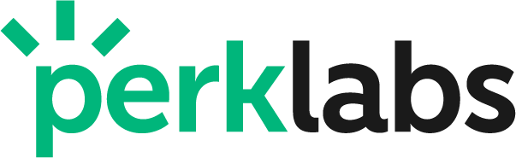

Perk Labs Announces Closing of Non-Brokered Private Placement
and Debt Conversion

Vancouver, Canada / April 25, 2023 / Perk Labs Inc. (CSE:PERK / OTCQB:PKLBF / FKT:PKLB) (“Perk” or the “Company”) the company that specializes in technology, logistics, and connecting communities, announced today that it has closed a private placement of 11,609,909 units (“Units”) at a price of $0.0164 per Unit for aggregate gross proceeds of ~$190,000 (the “Private Placement”). Each Unit consists of one common share of the Company (a “Common Share”) and one Common Share purchase warrant (a “Warrant”). Each Warrant will entitle the holder to purchase one additional Common Share at a price of $0.05 per Common Share for a period of 36 months. Directors and officers of the Company subscribed for 1,219,514 of the Units.

Additionally, the Company announced that in connection with the Private Placement, it entered into a Debt Settlement Agreement with an arms-length creditor (the “Creditor”) for the settlement of a total of ~$85,900 debt in consulting and design services provided by the Creditor to the Company. In settlement and full satisfaction of the debt in the amount of ~$85,900, the Company issued 5,238,414 Units to the Creditor.

All securities issued pursuant to the Private Placement will be subject to a statutory hold period of four months and one day following the Closing. The net proceeds from the Private Placement will be used for sales and marketing and for working capital.

The Company also announced today that Gary Zhang has transitioned from his role as Chief Technology Officer to an advisory role.

About Perk Labs Inc.
Perk Labs, the owner of Getit Technologies Inc. and Perk Hero Software Inc, specializes in technology, logistics, and connecting communities. Our digital payments and loyalty software empowers merchants to optimize their business and customer journey. Our marketplace and driver network connects and supports their business with additional sales and flexible last mile delivery options.

For more information, contact:
Ryan Hardy
CEO
(833) 338-0299
investors@perklabs.io

Neither the Canadian Securities Exchange nor its Regulation Services Provider (as that term is defined in the policies of the Canadian Securities Exchange) accepts responsibility for the adequacy or accuracy of this release.
Forward-Looking Statements
This press release contains forward-looking information or forward-looking statements (collectively "forward-looking information") within the meaning of applicable securities laws. Forward-looking information is typically identified by words such as: “may”, "believe", “thinks”, "expect", “exploring”, “expand”, “could”, "anticipate", "intend", "estimate", “plan”, “pursue”, "potentially", “projected”, “should”, “will” and similar expressions, or are those, which, by their nature, refer to future events. These forward-looking statements, which involve risks and uncertainties, relate to, among other things, the discussion of the Company’s business strategies and its expectations concerning future operations. Although the Company considers these forward-looking statements to be reasonable based on information currently available to it, they may prove to be incorrect, and the forward-looking statements in this release are subject to numerous risks, uncertainties and other factors that may cause future results to differ materially from those expressed or implied in such forward-looking statements. The Company cautions investors that any forward-looking information provided by the Company is not a guarantee of future results or performance, and that actual results may differ materially from those in forward-looking statements. Undue reliance should not be placed on such forward-looking information, as there can be no assurance that the plans, intentions or expectations upon which they are based will occur.

