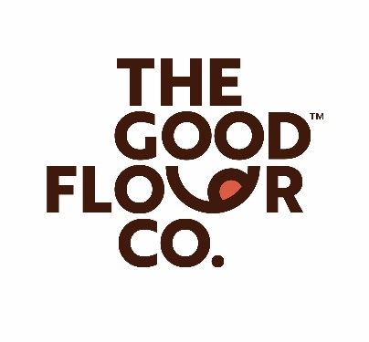
Heinen’s Grocery Store Now Has Good Flour Co. Products on Shelves
at 23 Locations in the USA
VANCOUVER, BRITISH COLUMBIA February 14, 2023 – The Good Flour Corp. (CSE: GFCO) (OTCQB: GFCOF) (FSE: 3KZ) (“GFCO”) is pleased to announce that its Artisan Fried Chicken Mix and Artisan Pancake and Waffle Mix are now on shelves and available for purchase at Heinen’s Grocery Store (“Heinen’s”). Heinen’s is a family-owned grocery store that has been in existence for over 93 years with 23 locations in Ohio and Illinois.

“GFCO was able to move quickly from the initial indication of interest from Heinen’s to actually having products available for sale in store. The automated production facility for GFCO products is a tremendous asset in terms of speed to market of product offerings. GFCO is looking forward to a successful relationship with Heinen’s,” states Matthew Clayton, CEO of GFCO.

About Heinen’s
In 1929, local butcher Joe Heinen opened a butcher shop in Shaker Heights after discovering a passion for the trade. In 1933, Joe Heinen pioneered Cleveland’s first supermarket across the street from his shop, selling traditional grocery items alongside hand-butchered meats. In the 1930s, bringing these two shopping experiences together was revolutionary in the grocery industry, but what truly set Heinen apart was his commitment to quality.
Joe Heinen’s vision lives on 93 years later under the leadership of his twin grandsons, Jeff and Tom Heinen and their children, Kim, Kelsey and Jake Heinen. Together, this family of grocers is focused on making Heinen’s relevant in the ever-changing industry through reimagining the traditional grocery store as a destination for quick and easy meals, fresh-overnight seafood, wellness guidance, dietary friendly solutions and traditional in-store butchers.
For additional information: https://www.heinens.com/.
About The Good Flour Corp.
GFCO’s mission is to provide a gluten-free, allergen free, hassle-free all-purpose baking flour blend that allows individuals with gluten and other food allergies to enjoy life without giving up their favorite foods or settling for low-quality alternatives. GFCO also provides gluten and allergen free fried chicken batter, fish & chip batter, pizza & pasta mix, tempura batter, pancake and waffle blend, cake mix and pizza crusts.
For additional information on The Good Flour Corp. please refer to www.goodflour.co.
Company Contact
investors@goodflour.co
604-423-4400
Cautionary Note Regarding Forward-Looking Information
This news release contains "forward-looking information" concerning anticipated developments and events related to GFCO that may occur in the future. Forward looking information contained in this news release includes, but is not limited to, statements with respect to demand for GFCO’s products, benefits of the retail arrangement with Heinen’s and GFCO’s future sales and business objectives.
In certain cases, forward-looking information can be identified by the use of words such as "expects", "intends", "anticipates" or variations of such words and phrases or state that certain actions, events or results "may", "would", or "might" suggesting future outcomes, or other expectations, assumptions, intentions or statements about future events or performance. Forward-looking information contained in this news release is based on certain factors and assumptions regarding, among other things, the timely receipt of regulatory approvals; the ability to source ingredients; the ability to attract qualified management and staff; the ability to effectively expand manufacturing and production capacity; the success of market initiatives and the ability to grow brand awareness; the ability to distribute Company’s products; the ability to attract, maintain and expand relationships with key strategic restaurant and food service partners and GFCO will continue to have access to financing until it achieves profitability. While GFCO considers these assumptions to be reasonable, they may be incorrect.
Forward looking information involves known and unknown risks, uncertainties and other factors which may cause the actual results to be materially different from any future results expressed by the forward-looking information. Such factors include risks related to general business, economic and social uncertainties; local and global market and economic uncertainties arising in respect of the COVID-19 pandemic; risks associated with supply chain for machinery and equipment; litigation, availability of key product ingredients; legislative, environmental and other judicial, regulatory, political and competitive developments; failure to effectively expand production capacity; the ability to obtain retail partners to distribute Company’s products; failure to attract, maintain and expand relationships with key restaurant and food service partners; changing consumer taste preferences; delay or failure to receive regulatory approvals; the sufficiency of our cash to meet liquidity needs; failure to attract qualified management and staff, labour disputes; and the additional risks identified in the "Risk Factors" section of GFCO’s filings with applicable Canadian securities regulators.
Although GFCO has attempted to identify factors that could cause actual results to differ materially from those described in forward-looking information, there may be other factors that cause results not to be as anticipated. Readers should not place undue reliance on forward-looking information. The forward-looking information is made as of the date of this news release. Except as required by applicable securities laws, GFCO does not undertake any obligation to publicly update forward-looking information.

