Getchell Gold Corp. Intersects 1.8 g/t Au over 107.5 m at the North Fork Zone, Fondaway Canyon, NV
Vancouver, BC – September 27, 2022 – Getchell Gold Corp. (CSE: GTCH) (OTCQB: GGLDF) ("Getchell" or the "Company") is pleased to provide assay results for drill hole FCG22-19 that successfully intersected and extended the North Fork zone gold mineralization at the Fondaway Canyon gold project in Nevada.
Key Highlights
- Extensive zone of gold mineralization encountered grading 1.8 g/t Au over 107.5 m including
2.9 g/t Au over 32.9 m;
- Drilling continues to expand the North Fork zone;
- Assay results from FCG22-19 will be incorporated into the forthcoming Mineral Resources estimate;
- North Fork gold zone remains open in most directions;
- Drilling remains underway to further delineate the North Fork and Colorado SW gold zones; and
- Assays are pending for holes FCG22-20 through FCG22-25.
“The North Fork zone continues to produce remarkable grades and thicknesses as we step out from our discovery hole.” states Mike Sieb, President, Getchell Gold Corp. “The North Fork zone is developing into a major region of concentrated gold mineralization, and I expect will contribute greatly to the gold model currently being generated.”
To watch a video that provides a detailed summary of the key highlights from the 2020 to 2022 drill programs at Fondaway Canyon, click here: https://youtu.be/jCVNIxheGNM
Drill Hole FCG21-19
Drill hole FCG22-19, the third drill hole of the 2022 drill program at Fondaway Canyon (the “Project”), was designed to follow up on the high-grade gold discovered by FCG21-16 that returned 10.4 g/t Au over 25.0 m within a broader interval grading 6.3 g/t Au over 50.7 m (Company news release dated February 15, 2022).
FCG22-19, drilled vertically from the same drill pad as hole FCG21-16 (Figure 1), targeted the North Fork mineralized zone as a 30m step out to the southwest.
FCG22-19 intersected multiple significant intervals of gold mineralization along a 145.1 m drill length, from 105.8 to 250.9 metres down hole with a core mineralized zone grading 1.8 g/t Au over 107.5 m from 120.0 to 227.5 m down hole (detailed in Figure 2 and Table 1).
North Fork Delineation
Combined with FCG22-17 that intersected 3.8 g/t Au over 85.9 m (Figure 2) and FCG22-18 that intersected 2.5 g/t Au over 43.4 m and 2.1 g/t Au over 46.5 m (Company news release dated Aug. 17, 2022), with respective step-outs of 15 metres to the northwest and 50 metres to the east, FCG22-19 represents the third successful step-out hole from the 2021 North Fork high-grade discovery.
The gold mineralized intervals encountered in hole FCG22-19 will be incorporated and will be the cut off point for data inclusion into the forthcoming Mineral Resources estimate scheduled for completion this Fall.
The North Fork gold zone remains open in most directions and follow up drilling is underway to continue to step out, further delineate, and model the rapidly expanding North Fork zone.
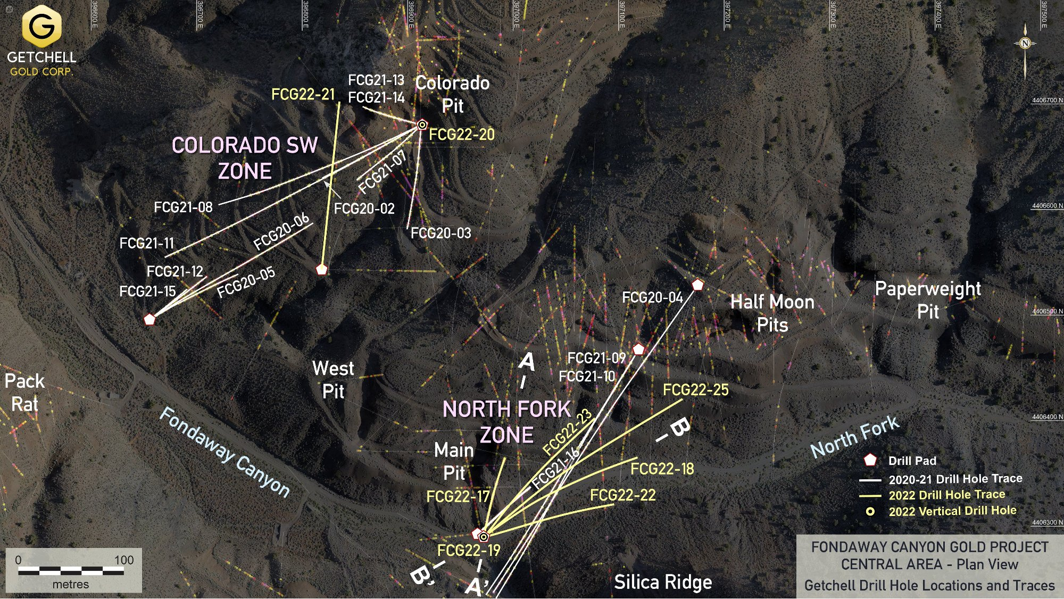
Figure 1: Fondaway Canyon plan map highlighting Getchell’s 2020, 2021, and 2022 drilling.
Table 1: Drill Hole FCG22-19 Notable North Fork Gold Intervals
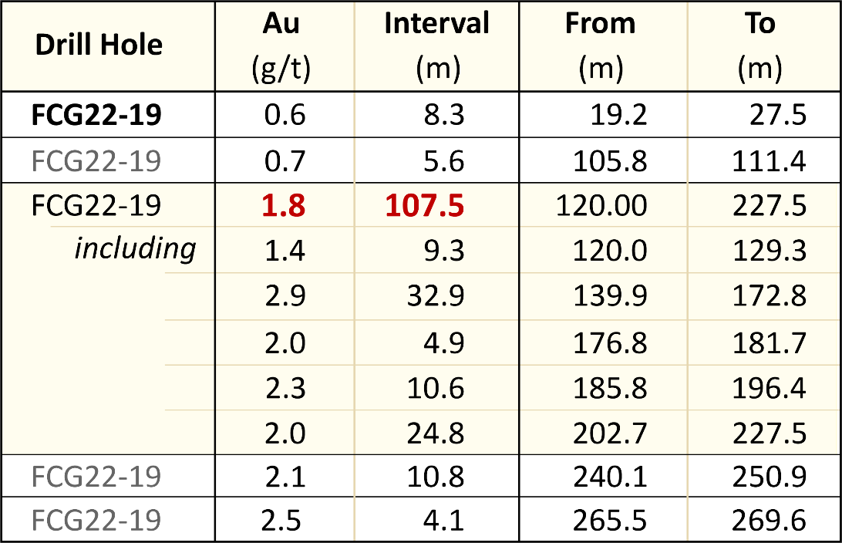
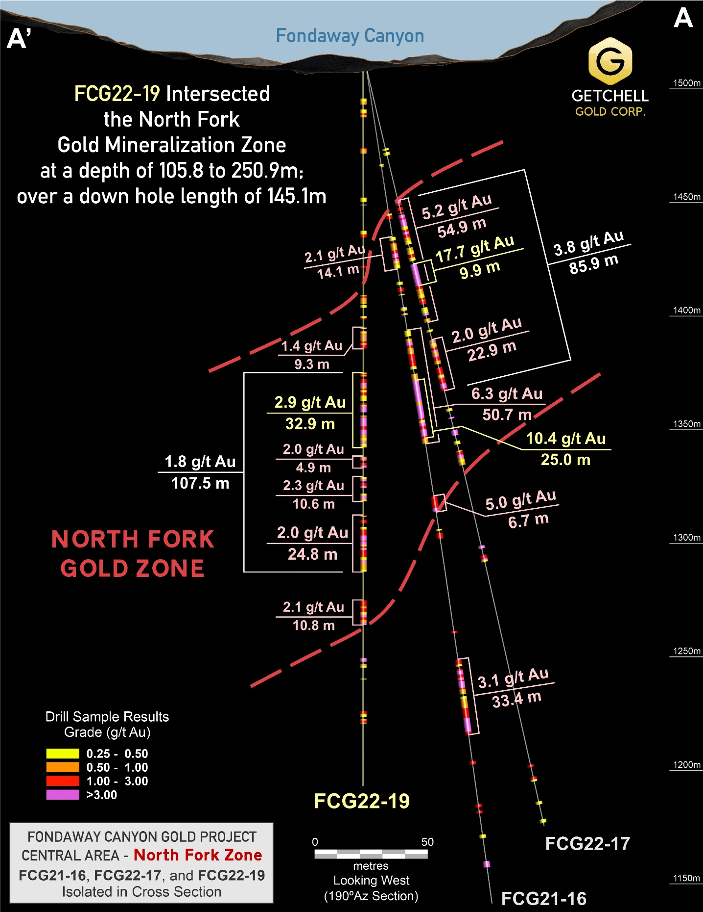
Figure 2: Cross-section highlighting gold intervals in drill holes FCG21-16, FCG22-17, and FCG22-19.
2022 Fondaway Canyon Drill Program Update
Eight holes have been completed (FCG22-17 to 23 and FCG22-25) to date in the Central Area during the 2022 drill program at Fondaway Canyon, totalling 3,260 m. Assay results have been released for three of those holes (FCG22-17 to 19) and assays are pending for holes FCG22-20 through FCG22-25.
Holes FCG22-17, 18, 19, 22, 23, and 25 collared on the same pad as FCG21-16, were designed as step outs to test the extent of the North Fork mineralization encountered in hole FCG21-16. Holes FCG 22, 23, and 25 were additionally designed as step outs to test the extent of the lower North Fork gold zone discovered in FCG22-18 that graded 1.9 g/t Au over 72.6 m.
FCG22-20, a vertical drill hole, was designed to test the mineralization directly below the Colorado Pit in an area relatively absent of drilling.
FCG22-21, stationed midway up the north slope of Fondaway Canyon, was designed to crosscut the Colorado SW zone of mineralization to assist with modelling and to test the extents of the mineralization to the northwest.
FCG22-26, stationed near the canyon floor on the same pad as FCG21-12 and 15, is in progress and is designed to target the eastern extent of the Colorado SW zone.
Drilling is ongoing with plans to drill through to the end of the 2022 field season.
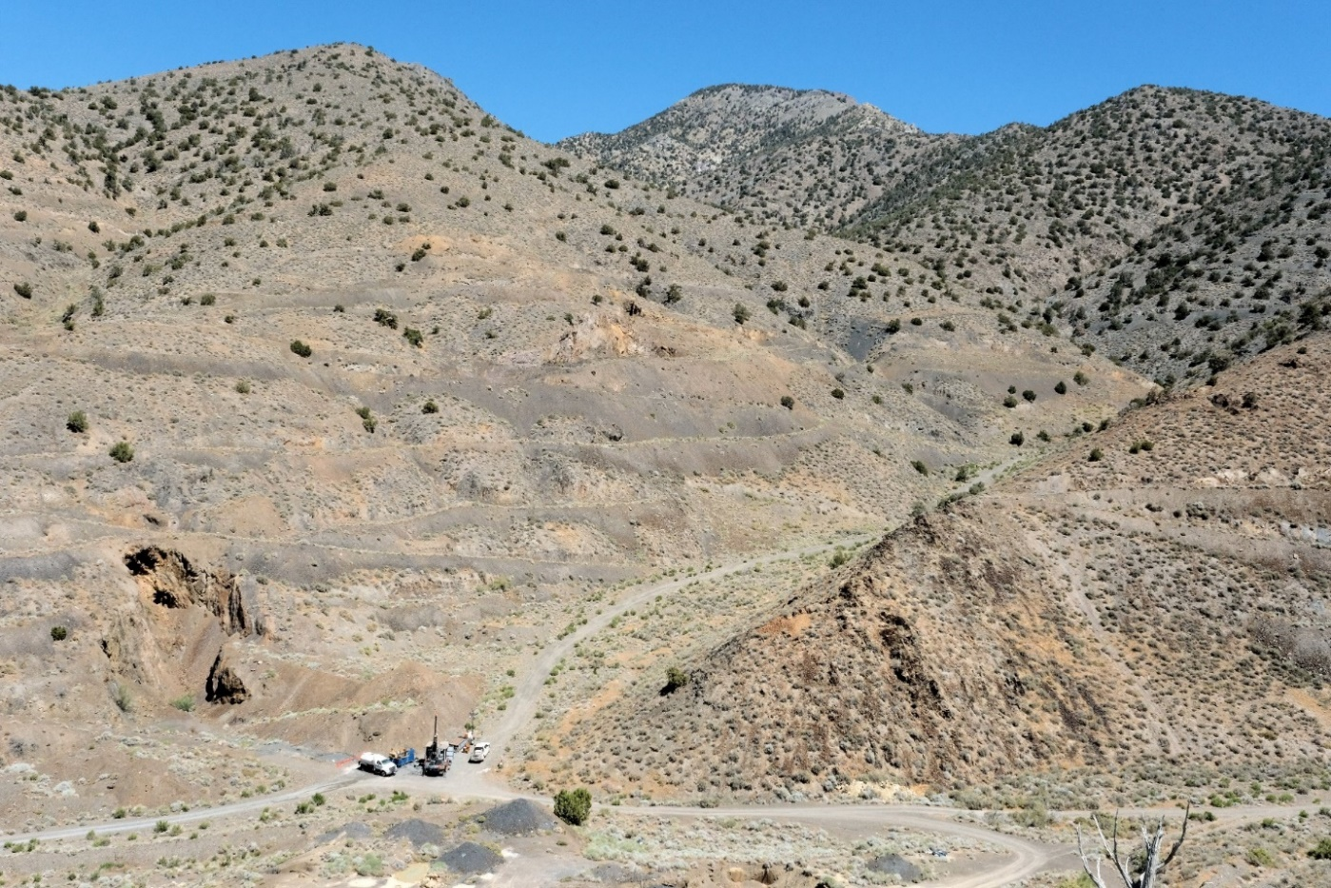
Figure 3: Fondaway Canyon Central Area – Drill Hole FCG22-23 Targeting the North Fork Zone (looking NE)
Pediment Target Area Drilling
A second drill rig has commenced drilling the Pediment target zone at Fondaway Canyon with hole FCG22-24. The Pediment Target is the westernmost known gold mineralized occurrence along the 3.5 km long E-W trending Fondaway Canyon gold mineralization corridor. The area is completely blanketed by a broad alluvium cover which is typical of the range and basin geomorphology for the area.
Two vertical drill holes completed in 2002, 02FC-10 and 02FC-11, were collared 185 metres apart and designed to test potential gold mineralization beneath the sediment cover on trend with the Fondaway Canyon E-W gold corridor. Both holes successfully intersected thick lower grade gold intersections with hole 02FC-10 intersecting 27.4 m grading 0.82 g/t Au and 02FC-11 intersecting 36.6 m grading 0.52 g/t Au.
Scott Frostad, P.Geo., is the Qualified Person (as defined in NI 43-101) who reviewed and approved the content and scientific and technical information in the news release.
The 2022 drill core is being processed using the same methods as the 2020 and 2021 drill programs. The core is cut at Bureau Veritas Laboratories’ (“BVL”) facilities in Sparks, Nevada, with the samples analyzed for gold and multi-element analysis in BVL’s Sparks, Nevada and Vancouver, BC laboratories respectively. Gold values are produced by fire assay with an Atomic Absorption finish on a 30-gram sample (BV code FA430) with over limits re-analyzed using method FA530 (30g Fire Assay with gravimetric finish). The multi-element analyses are performed by ICP-MS following aqua regia digestion on a 30g sample (BV code AQ250). Quality control measures in the field include the systematic insertion of standards and blanks.
Highlighted drill intervals are based on minimum interval lengths of 3.3 metres (10 feet), a 0.25 g/t Au cut-off, and a maximum of 3.3 metres of internal dilution, with no top cut applied. Broader reported Intervals may include internal dilution in the calculated average weighted grades. All intervals are reported as downhole drill lengths and additional work is required to determine the true widths.
About Getchell Gold Corp.
The Company is a Nevada focused gold and copper exploration company trading on the CSE: GTCH and OTCQB: GGLDF. Getchell Gold is primarily directing its efforts on its most advanced stage asset, Fondaway Canyon, a past gold producer with a significant in-the-ground historic resource estimate and on the Star project, a past high-grade copper, gold, and silver small-scale producer. Complementing Getchell’s asset portfolio is Dixie Comstock, a past gold producer with a historic resource and one earlier stage exploration project, Hot Springs Peak (Au). Getchell has the option to acquire 100% of the Fondaway Canyon and Dixie Comstock properties, Churchill County, Nevada.
For further information please visit the Company’s website at www.getchellgold.com or contact the Company by e-mail at info@getchellgold.com or by phone at +1 647 249-4798.

Mr. William Wagener, Chairman & CEO
Getchell Gold Corp.
The Canadian Securities Exchange has not reviewed this press release and does not accept responsibility for the adequacy or accuracy of this news release.

Certain information contained herein constitutes “forward-looking information” under Canadian securities legislation. Forward-looking information includes, but is not limited to, statements with respect to the use of proceeds. Generally, forward-looking information can be identified by the use of forward-looking terminology such as “will” or variations of such words and phrases or statements that certain actions, events or results “will” occur. Forward-looking statements are based on the opinions and estimates of management as of the date such statements are made and they are subject to known and unknown risks, uncertainties and other factors that may cause the actual results to be materially different from those expressed or implied by such forward-looking statements or forward-looking information. Although management of Getchell have attempted to identify important factors that could cause actual results to differ materially from those contained in forward-looking statements or forward-looking information, there may be other factors that cause results not to be as anticipated, estimated or intended. There can be no assurance that such statements will prove to be accurate, as actual results and future events could differ materially from those anticipated in such statements. Accordingly, readers should not place undue reliance on forward-looking statements and forward-looking information. The Company will not update any forward-looking statements or forward-looking information that are incorporated by reference herein, except as required by applicable securities laws.

