Getchell Gold Corp. Continues to Demonstrate Continuity and Thickness of the Colorado SW Zone and Intersects 8.8 g/t Au over 8.2m at the Juniper Zone at the Fondaway Canyon Gold Project, NV
Vancouver, BC – January 12, 2022 – Getchell Gold Corp. (CSE: GTCH) (OTCQB: GGLDF) ("Getchell" or the "Company") is pleased to provide the results for holes FCG21-11 and FCG21-12 targeting the Colorado SW and Juniper gold zones at the Fondaway Canyon Gold project in Nevada.
Key Highlights
- Hole FCG21-11 intersected multiple significant gold intercepts within the Colorado SW zone over a 242 metre down hole distance including 1.4 g/t Au over 14.9m, 1.0 g/t Au over 52.5m and 2.2 g/t Au over 9.1m;
- FCG21-11 also encountered the near surface high-grade Juniper zone grading 8.8 g/t Au over 8.2m;
- Hole FCG21-12 intersected the Colorado SW zone of gold mineralization over a 92 metre down hole distance that included 6.3 g/t Au over 3.6m, 2.5 g/t Au over 24.5m, and 1.6 g/t Au over 25.5m;
- The Colorado SW gold zone, discovered in 2020, has now been tested by Getchell with eight drill holes that confirm its continuity on a 150m wide section along a 300 metre down dip extent;
- Including holes drilled by past operators, the Colorado SW zone is modelled to extend for 800 metres down dip from surface and remains open on strike and at depth; and
- Assays are pending for holes FCG21-13 through FCG21-16.
"The gold assay results from these latest two drill holes continue to demonstrate the strong continuity and potential scale of the mineralizing system at Fondaway Canyon and provide an excellent start to 2022.” states Mike Sieb, President, Getchell Gold Corp.
Fondaway Canyon 2021 Drill Program Update
Ten drill holes, FCG21-07 through FCG21-16, totalling 3,874 metres were drilled last year at the Fondaway Canyon Gold Project. All ten holes are located in the Central Area and followed up on the 2020 discovery of the Colorado SW, the Juniper, and the North Fork gold zones (Figure 1). The two drill holes, FCG21-11 and FCG21-12, reporting results in this news release, primarily targeted the Colorado SW gold zone.
Drill Hole FCG21-11
FCG21-11 was designed to extend the Colorado SW gold zone approximately 30 to 50 metres to the southeast down-dip of hole FCG21-08 and 40 metres to the northwest on-strike from holes FCG20-05 and FCG20-06 (Figure 1 and 2).
FCG21-11, stationed at the Colorado Pit on the same drill pad as FCG21-08 and drilling to the southwest, intersected multiple significant gold intercepts within the Colorado SW zone over a 242 metre down hole distance. Three of the more notable drill intercepts grade:
- 1.4 g/t Au over 14.9m from 250.3 to 265.2m;
- 1.0 g/t Au over 52.5m from 274.4 to 326.9m;
- 2.2 g/t Au over 9.1m from 333.1 to 342.2m; with additional notable intervals presented in Table 1.
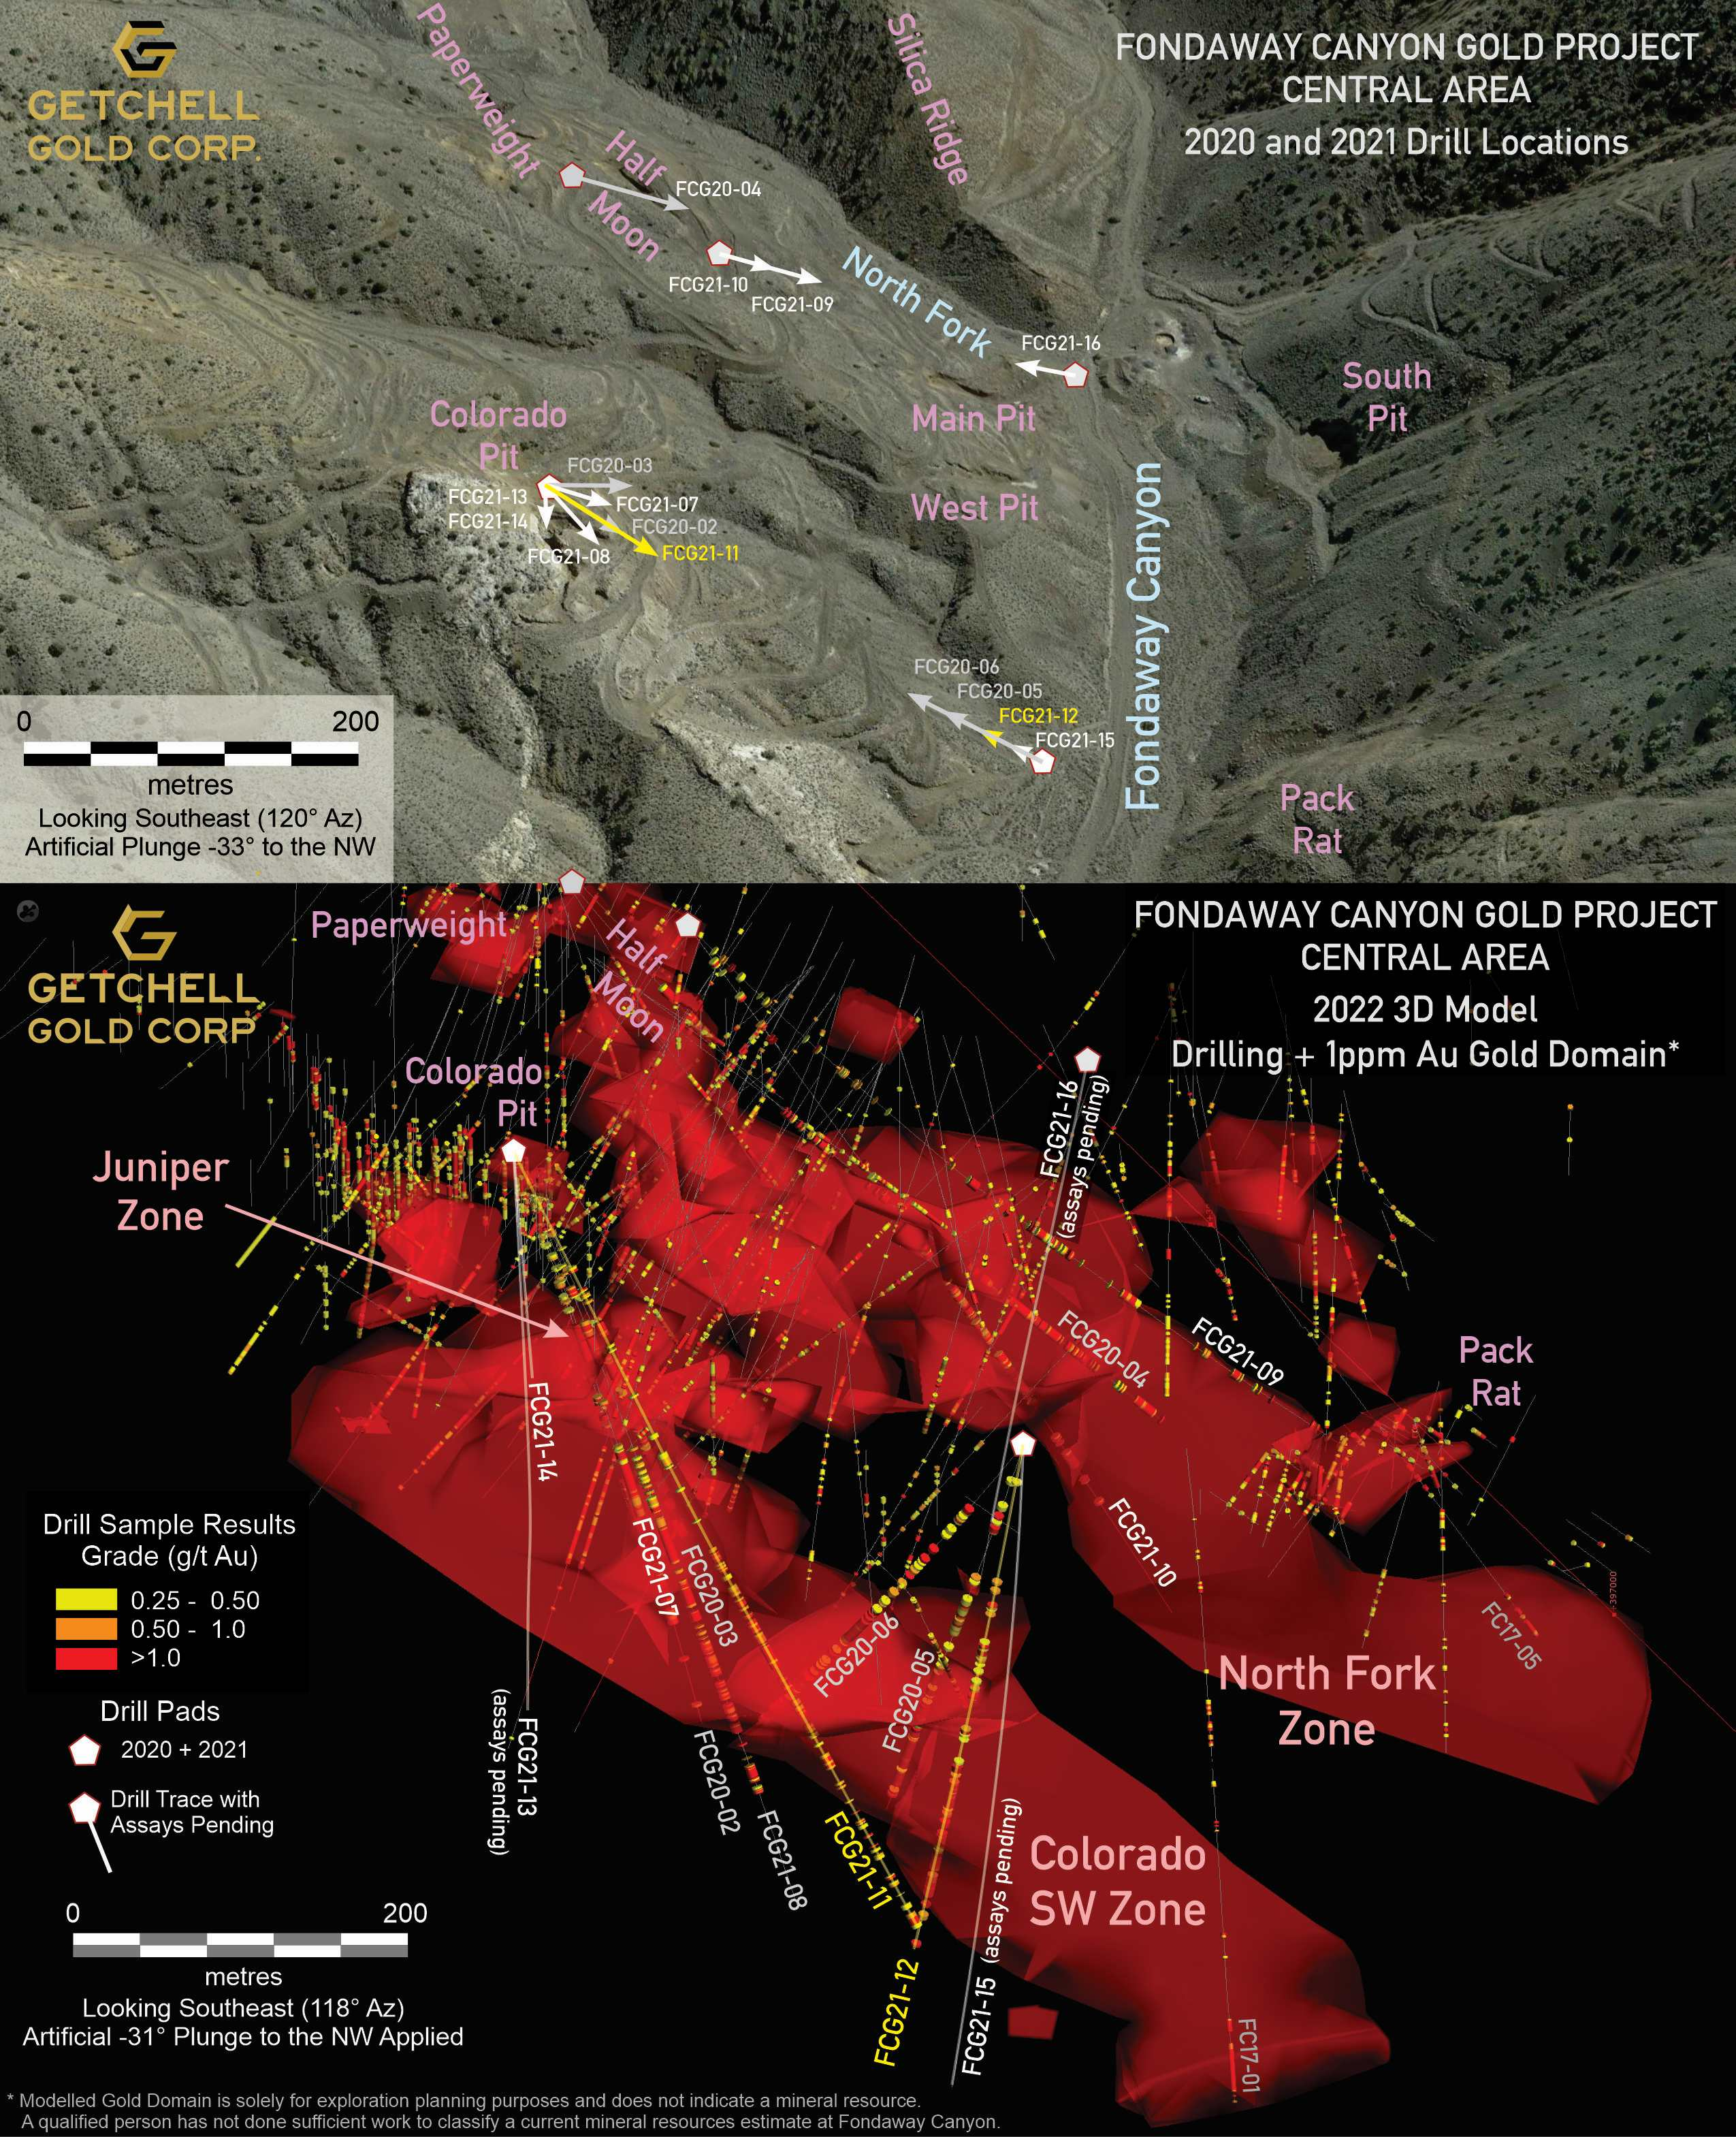
Figure 1: Fondaway Canyon Central Area showing aerial view (above) and current 3D model (below) from the same perspective looking southeast; highlighting the 2020 and 2021 drilling.
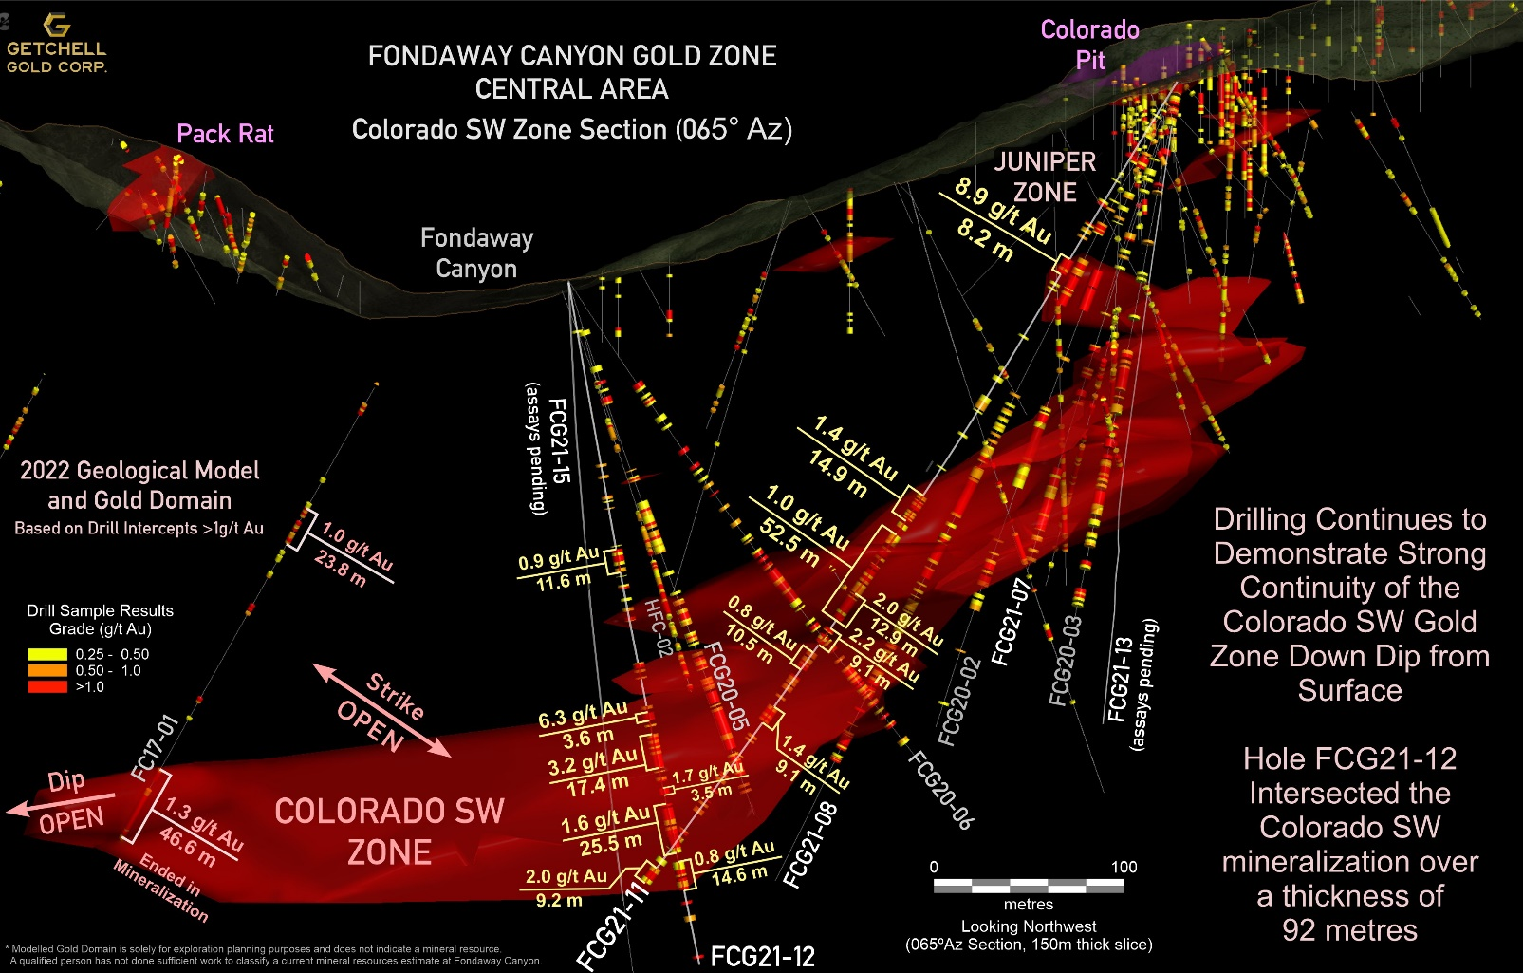
Figure 2: North Fork Gold Zone (NE-SW) 3D Section Highlighting FCG21-11 and FCG21-12 Gold Intervals.
FCG21-11 was also designed to test the near surface high grade Juniper gold zone down dip from FCG21-08 that reported 4.7 g/t Au over 25.9m. FCG21-11 intersected a substantially higher-grade interval reporting 8.8 g/t Au over 8.2m from 107.8 to 116.0 including one sample that graded 22.9 g/t Au over 1.7m.
Drill Hole FCG21-12
FCG21-12, stationed near the canyon floor and drilling steeply to the northeast, was designed to test the down-dip extent of the Colorado SW gold mineralization encountered in FCG20-05 with a 40-metre step out. FCG21-12 intersected the Colorado SW zone of gold mineralization over a 92 metre down hole distance with three of the more notable drill intercepts grading:
- 6.3 g/t Au over 3.6m from 224.4 to 228.0m;
- 2.5 g/t Au over 24.5m from 235.5 to 260.0m;
- 1.6 g/t Au over 25.5m from 271.9 to 297.4m; with additional notable intervals presented in Table 1.
There are now 8 holes drilled by the Company (FCG20-02, FCG20-03, FCG20-05 to FCG21-08, FC21-11, and FC21-12) on a 150 metre wide section that have confirmed continuity of the thick Colorado SW gold zone along a 300 metre down dip extent since its discovery in 2020. Including holes drilled by past operators, the Colorado SW zone is modelled to extend for 800 metres down dip from surface and remains open on strike and down dip.
There are four holes, FCG21-13 through FCG21-16, drilled in 2021 with assays pending and expected over the coming weeks.
- FCG 21-13 and FCG21-14, stationed in the Colorado Pit, were designed to infill an area below the pit that had a gap in the historic drill coverage to assist with the modelling of the upper region of the Colorado SW zone.
- FCG21-15, stationed near the canyon floor on the same drill pad as FCG21-12 and drilling almost vertical to the northeast, was designed to further extend the Colorado SW gold mineralization 30 metres down dip from FCG21-12.
- FCG21-16, stationed on the canyon floor at the junction of the Fondaway Canyon and North Fork drainages and drilled to the northwest, was designed to extend the North Fork gold zone 30 metres off-section to the northwest, from holes FCG20-04, FCG21-09, and FCG21-10.
Table 1: FCG21-11 and FCG21-12 Significant Gold Grade Intervals
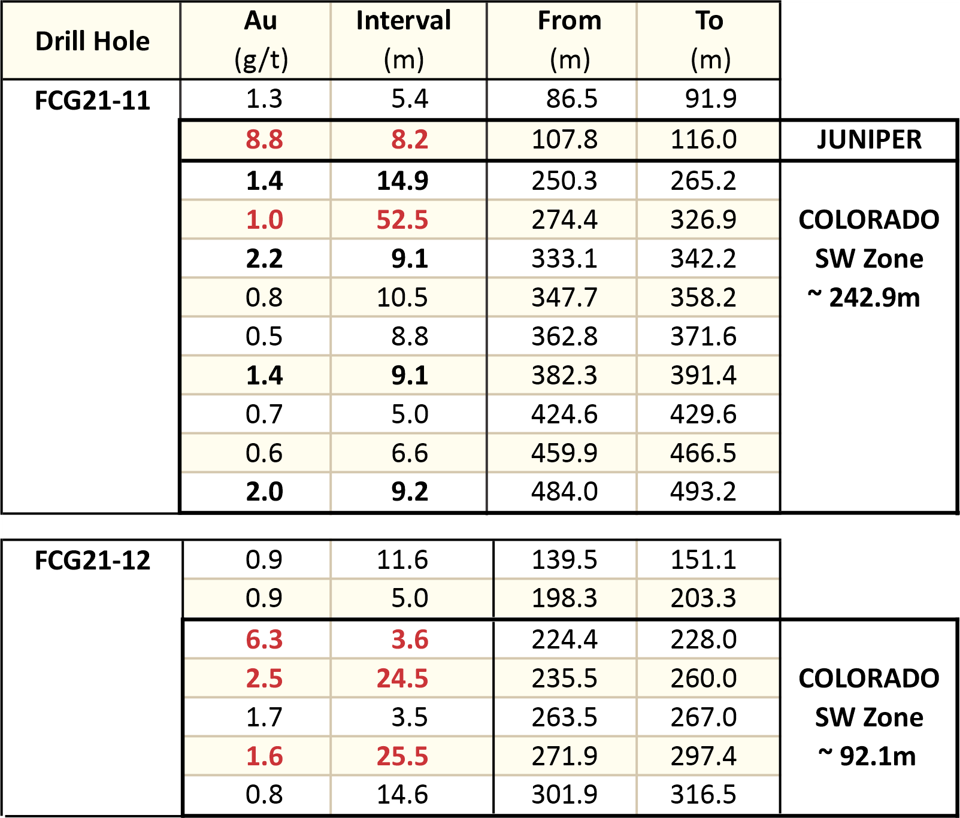
Scott Frostad, P.Geo., is the Qualified Person (as defined in NI 43-101) who reviewed and approved the content and scientific and technical information in the news release.
The 2021 drill core is being processed using the same methods as the 2020 drill program. The core is cut at Bureau Veritas Laboratories’ (“BVL”) facilities in Sparks, Nevada, with the samples analyzed for gold and multi-element analysis in BVL’s Sparks, Nevada and Vancouver, BC laboratories respectively. Gold values are produced by fire assay with an Atomic Absorption finish on a 30-gram sample (BV code FA430) with over limits re-analyzed using method FA530 (30g Fire Assay with gravimetric finish). The multi-element analyses are performed by ICP-MS following aqua regia digestion on a 30g sample (BV code AQ250). Quality control measures in the field include the systematic insertion of standards and blanks.
Highlighted drill intervals are based on a 0.25 g/t Au cut-off, minimum interval lengths of 3.3 metres (10 feet), and a maximum of 3.3 metres of internal dilution, with no top cut applied. All intervals are reported as downhole drill lengths and additional work is required to determine the true width.
About Getchell Gold Corp.
The Company is a Nevada focused gold and copper exploration company trading on the CSE: GTCH and OTCQB: GGLDF. Getchell Gold is primarily directing its efforts on its most advanced stage asset, Fondaway Canyon, a past gold producer with a significant in-the-ground historic resource estimate. Complementing Getchell’s asset portfolio is Dixie Comstock, a past gold producer with a historic resource and two earlier stage exploration projects, Star and Hot Springs Peak. Getchell has the option to acquire 100% of the Fondaway Canyon and Dixie Comstock properties, Churchill County, Nevada.
The Company reiterates that its near-term strategy to advance its assets is not impacted by the COVID-19 Corona virus. The Company continues to monitor the situation and is in compliance with all government guidelines.
***The company invites all interested media and investors to join President Mike Sieb for an online presentation of 2021 drill results at a Live event Thursday, January 13 at 1pm PST. The session will include a live question and answer period. Register here: https://app.livestorm.co/getchell-gold/getchell-gold-drill-results-jan-13-2022?type=detailed
For further information please visit the Company’s website at www.getchellgold.com or contact the Company at info@getchellgold.com or at +1 647 249-4798.
Mr. William Wagener, Chairman & CEO
Getchell Gold Corp.
The Canadian Securities Exchange has not reviewed this press release and does not accept responsibility for the adequacy or accuracy of this news release. Not for distribution to U.S. news wire services or dissemination in the United States.

Certain information contained herein constitutes “forward-looking information” under Canadian securities legislation. Forward-looking information includes, but is not limited to, statements with respect to the private placement and the completion thereof and the use of proceeds. Generally, forward-looking information can be identified by the use of forward-looking terminology such as “will” or variations of such words and phrases or statements that certain actions, events or results “will” occur. Forward-looking statements are based on the opinions and estimates of management as of the date such statements are made and they are subject to known and unknown risks, uncertainties and other factors that may cause the actual results to be materially different from those expressed or implied by such forward-looking statements or forward-looking information, including: the receipt of all necessary regulatory approvals, use of proceeds from the financing, capital expenditures and other costs, and financing and additional capital requirements. Although management of Getchell have attempted to identify important factors that could cause actual results to differ materially from those contained in forward-looking statements or forward-looking information, there may be other factors that cause results not to be as anticipated, estimated or intended. There can be no assurance that such statements will prove to be accurate, as actual results and future events could differ materially from those anticipated in such statements. Accordingly, readers should not place undue reliance on forward-looking statements and forward-looking information. The Company will not update any forward-looking statements or forward-looking information that are incorporated by reference herein, except as required by applicable securities laws.

